Supporting material for CityWat: sub-models

Barnaby Dobson and Ana Mijic, Imperial College London, UK

# Summary

In this document we describe the mass balance and operation equations in CityWat for our model of London’s water cycle. Each section describes a different sub-model that can be called.

# Urban water cycle sub-models

## Abstraction (scripts/models.py/abstraction)

This function evaluates water use restrictions and minimum required flows; and determines how much water to abstract from the River Thames, either to supply reservoir storage or direct to treatment.

### Evaluate water use restrictions and minimum required flow

Our implementation of water use restrictions is based on that presented in (Mortazavi‐Naeini et al., 2019).

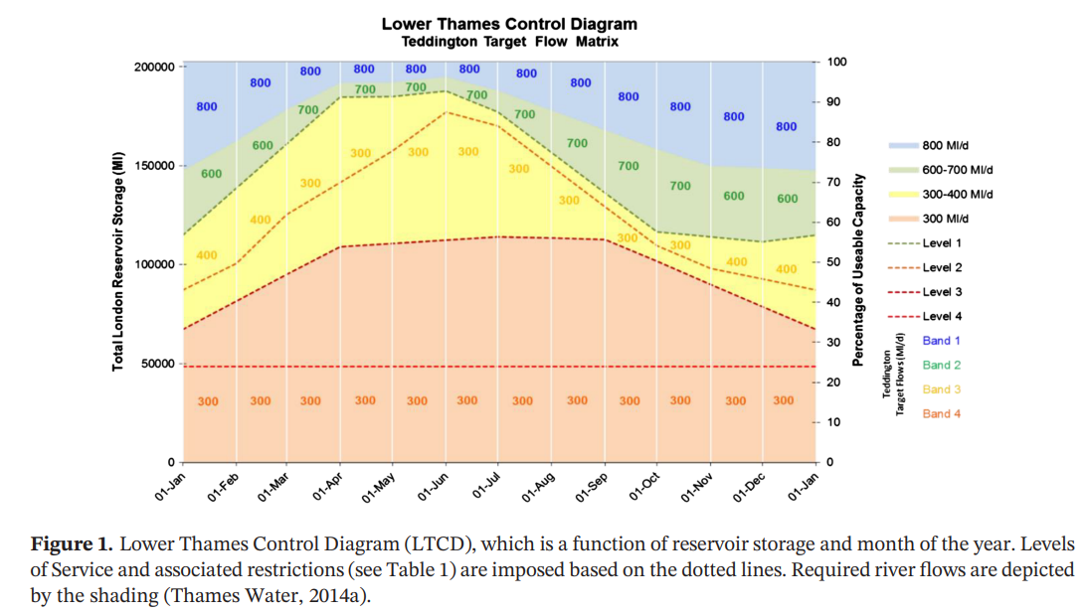

Figure 1: The Lower Thames Operating Agreement, from Figure 1 in (Mortazavi‐Naeini et al., 2019).

This diagram states the minimum required flow and level of water use restrictions depending on the time of year and total supply reservoir storage. Thus, level of restrictions can be described as follows,

Where LORt is the level of restrictions at time t, dependent on supply reservoir storage at the start of the timestep, SS,t-1, the month of the year, month­t, transformed by a function f which is depicted by the dashed lines in Figure 1. Similarly, the minimum required flow in the Thames can be described by,

Where MRFt, is the minimum required flow at time t, transformed by a function g which is depicted by the filled areas in Figure 1.

### Calculate abstraction

Once MRFt has been calculated, the amount of water available for abstraction is known, described by,

Where amax,t is the maximum abstraction at time t, Qa,t is the flow upstream of abstractions, aupstream are the abstractions that take place upstream of London’s abstraction and acap is capacity on the abstractions.

The abstraction is then made to be the maximum beneficial abstraction, i.e. the abstraction that does not draw river flow below MRFt, does not cause reservoirs to spill, nor results in an oversupply to the water treatment works. This can be described as,

Where atarg,t is the maximum allowable and beneficial river abstraction on a given timestep, t, Ss,cap is the storage capacity of supply reservoirs, DFWTW,t-1 is the freshwater treatment works demand on the previous timestep, and agw,targ is the target groundwater abstraction on a given day.

Once the target abstraction has been calculated it is sent to satisfy freshwater treatment plant demand and fill up reservoirs, as follows,

Where aFWTW,t is the river abstraction direct to freshwater treatment, aS,t is the river abstraction to reservoirs.

### Update storage and flow state variables

Finally, the supply reservoir storage’s volume can be updated as follows,

And the river flow downstream of abstraction can also be updated,

## Reservoir release (scripts/models.py/release)

## Calculate consumer demand (scripts/models.py/calculate_consumer_demand)

## Calculate distribution demand (scripts/models.py/calculate_distribution_demand)

## Freshwater treatment (scripts/models.py/freshwater_treatment)

## Distribution (scripts/models.py/distribution)

## Household output (scripts/models.py/calculate_household_output)

## Urban runoff (scripts/models.py/urban_runoff)

## Sewerage (scripts/models.py/sewerage)

## Combined sewer overflow (scripts/models.py/cso)

## Wastewater treatment (scripts/models.py/wastewater_treatment)

## Water quality (scripts/models.py/water_quality)

# Options

## Wastewater reuse (scripts/models.py/wastewater_reuse)

## Abstraction (scripts/models.py/abstraction)

# Summary of variables

## State variables

|  |  |
| --- | --- |
| Symbol | Description |
| SS,t | Storage in supply reservoirs |
| montht | Month on a given day |
| LORt | Level of restrictions on a given day |
| MRFt | Minimum required flow on a given day |
| atarg,t | Maximum allowable and beneficial river abstraction |
| DFWTW,t | Demand at freshwater treatment works on a given day |
| aFWTW,t | Abstraction direct to freshwater treatment on a given day |
| aS,t | Abstraction direct to supply reservoirs on a given day |
| Qd,t | Flow downstream of abstractions |

## Parameters

|  |  |
| --- | --- |
| Symbol | Description |
| acap | Max river abstraction on a given day |
| aupstream | Constant daily abstraction upstream of London abstractions |
| Ss,cap | Storage capacity in supply reservoirs |
| agw,targ | The target daily abstraction from groundwater sources |
|  |  |
|  |  |

## Input data

|  |  |
| --- | --- |
| Symbol | Description |
| Qa,t | Flow upstream of abstractions |
|  |  |
|  |  |

# References

Mortazavi‐Naeini, M., Bussi, G., Elliott, J. A., Hall, J. W., & Whitehead, P. G. (2019). Assessment of risks to public water supply from low flows and harmful water quality in a changing climate. *Water Resources Research*, 2018WR022865. https://doi.org/10.1029/2018WR022865