Supporting Material S1 for CityWat: sub-models

Barnaby Dobson and Ana Mijic, Imperial College London, UK

# Summary

In this document we describe the mass balance and operation equations in CityWat for our model of London’s water cycle. Each section describes a different sub-model that can be called. We first describe the functions for the standard simulation model and then describe how different options alter these functions or add new functions. To improve readability, we have omitted unit conversions in our equations, however variable/parameter units and conversions are all explicit in the code itself.

# Urban water cycle sub-models

## Abstraction (scripts/models.py/abstraction)

This function evaluates water use restrictions and minimum required flows; and determines how much water to abstract from the River Thames, either to supply reservoir storage or direct to treatment.

### Evaluate water use restrictions and minimum required flow

Our implementation of water use restrictions is based on that presented in (Mortazavi‐Naeini et al., 2019).

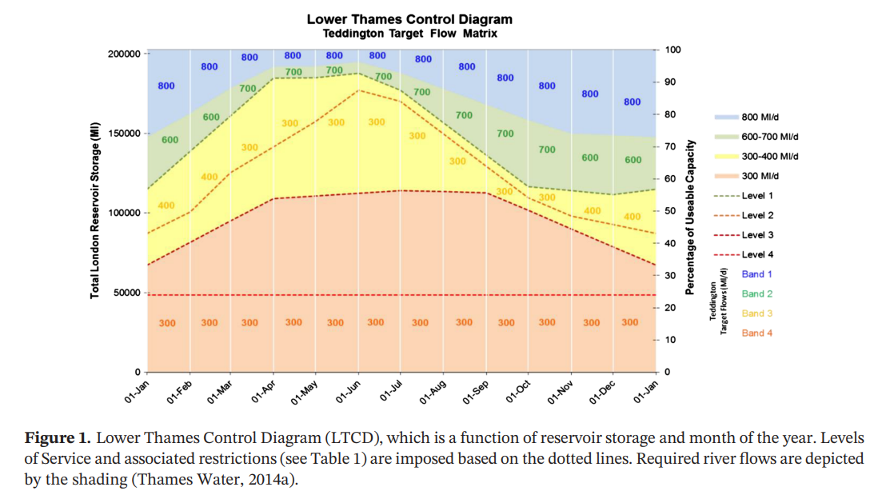

Figure 1: The Lower Thames Operating Agreement, Reproduced from (Mortazavi‐Naeini et al., 2019) John Wiley & Sons. CC BY 4.0.

This diagram states the minimum required flow and level of water use restrictions depending on the time of year and total supply reservoir storage. Thus, level of restrictions can be described as follows,

Where LORt is the level of restrictions at time t, dependent on supply reservoir storage at the start of the timestep, SS,t-1, the month of the year, month­t, transformed by a function f which is depicted by the dashed lines in Figure 1. Similarly, the minimum required flow in the Thames can be described by,

Where MRFt, is the minimum required flow at time t, transformed by a function g which is depicted by the filled areas in Figure 1.

### Calculate abstraction

Once MRFt has been calculated, the amount of water available for abstraction is known, described by,

Where amax,t is the maximum abstraction at time t, Qa,t is the flow upstream of abstractions, aupstream are the abstractions that take place upstream of London’s abstraction and acap is capacity on the abstractions.

The abstraction is then made to be the maximum beneficial abstraction, i.e. the abstraction that does not draw river flow below MRFt, does not cause reservoirs to spill, nor results in an oversupply to the water treatment works. This can be described as,

Where atarg,t is the maximum allowable and beneficial river abstraction on a given timestep, t, Ss,cap is the storage capacity of supply reservoirs, DFWTW,t-1 is the freshwater treatment works demand on the previous timestep, and agw,targ is the target groundwater abstraction on a given day.

Once the target abstraction has been calculated it is sent to satisfy freshwater treatment plant demand and fill up reservoirs, as follows,

Where aFWTW,t is the river abstraction direct to freshwater treatment, aS,t is the river abstraction to reservoirs.

### Update storage and flow state variables

Finally, the supply reservoir storage’s volume can be updated as follows,

And the river flow downstream of abstraction can also be updated,

## Releases (scripts/models.py/release)

This function determines how much water should be sent to freshwater treatment works and what combination of groundwater, river water and reservoir water should be used.

We calculate the ideal reservoir release, assuming groundwater is set at its target abstraction,

We then evaluate where storage is in relation to the Thames storage control curves (the Level 1 restriction curve depicted in Figure 1) if the target release was to be made,

Where SCCt is the volume of storage above the control curve on a given day, h is a function that transforms that is the storage value at the control curve on a given month.

To avoid drawing down the reservoir below the control curve, groundwater abstractions may be increased up to their maximum,

Where agw,cap is the maximum possible daily groundwater abstraction. Once groundwater abstractions have been calculated, reservoir releases must make up the remaining freshwater treatment works demand,

And reservoir storage updated,

## Calculate consumer demand (scripts/models.py/calculate_consumer_demand)

Before updating freshwater treatment demand, we must know how much water is required by consumers. This function applies water use restrictions, seasonal demand profiles and calculates how much of outdoor water demand is satisfied by rainfall.

### Baseline demand

The model first calculates a ‘baseline demand’, that can be thought of as the average annual demand,

### Water use restrictions and seasonal profile

Then, restrictions are implemented. Each level of restrictions reduces demand by a different percentage, as described in Figure 2.

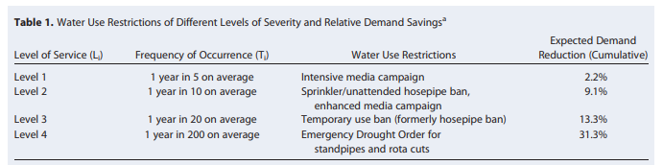

Figure 2: Demand reductions that result from water use restrictions, Reproduced from (Borgomeo et al., 2016) John Wiley & Sons. © 2016. American Geophysical Union. All Rights Reserved.

Thus, the percentage reduction can be described by,

Where k transforms the level of restrictions according to Figure 2. Thus, by multiplying baseline demand with a seasonal demand profile and percentage reductions, the total demand on a given day can be defined by,

Where *l* defines a seasonal profile of water demand.

### Outdoor water demand

We have assumed that outdoor water demand is simply a percentage of Dh,tot,t. Thus, the amount of demand that can be supplied by rainfall is described by,

Where Pt is the precipitation on a given day, Agardens is the area of gardens in the model and Rrain is the percentage of demand that is outdoors (and thus can be satisfied by rainfall).

Thus, the demand from water consumers can be described by,

## Calculate distribution demand (scripts/models.py/calculate_distribution_demand)

Once consumer demand has been calculated, distribution demand can simply be represented by including leakage on top of consumer demand as follows,

## Freshwater treatment (scripts/models.py/freshwater_treatment)

With distribution demand and the freshwater treatment input known, the freshwater treatment output can be calculated and its demand updated.

It is simplest to start by calculating the processing losses as the percentage of freshwater treatment input (i.e. the sum of river and groundwater abstractions, and reservoir releases),

Thus, the treatment output to service reservoirs and direct to distribution can be calculated,

We first send the treatment output to fill reservoirs and then send the remainder to distribution (since the distribution function can draw from service reservoirs anyway),

Where uDres,t is the treated water output to service reservoirs on a given day t, adist,t is the output direct to distribution, and SDres,t-1 is the total storage in service reservoirs at the start of day t.

Freshwater treatment works demand can then be updated. The max beneficial treated output can be described as the Ddist,t and storage deficit in service reservoirs,

This max beneficial output is updated against the constraints of the treatment works,

Where OFWTW,max/OFWTW,min is the freshwater treatment works output maximum and minimum capacity, and ΔFWTW,max is the maximum rate of change in treated output. Finally, to update freshwater treatment plant demand, processing losses are applied,

## Distribution (scripts/models.py/distribution)

The distribution sub-model ensures distribution demand is satisfied, applies leakage and supplies water to consumers.

It first draws any additional required water from service reservoirs,

Where udist,t is water released from service reservoirs to the distribution network and Idist,t is the total water supplied to the distribution network.

Leakage can then be applied,

And the volume of water delivered to consumers calculated,

## Household output (scripts/models.py/calculate_household_output)

Household output is defined based on the volume of water delivered, and how much of that was used outdoors,

Where Oh,t is the volume of effluent released from houses, and Rh,consumed is the proportion of indoor water use that is consumed.

## Urban runoff (scripts/models.py/urban_runoff)

The urban runoff sub-model aims primarily to determine what the sewer input from precipitation is. It also tracks precipitation and pluvial flooding in greenspaces. Both impermeable and greenspace surfaces have a storage volume associated with them. These volumes must be exceeded for runoff or flooding to be generated.

### Precipitation over impermeable surfaces

We start by calculating precipitation on impermeable surfaces,

Where Rimperm is the proportion of area that is impermeable.

We then apply precipitation and evapotranspiration to the total water stored on impermeable surfaces,

Where Eimperm is the total evapotranspiration over London’s impermeable spaces. We then compare the total storage capacity on impermeable surfaces to calculate spill and resultant storage,

Where Oimperm,t is the runoff on impermeable surfaces that goes to sewers, and Simperm,t is the volume of water stored on impermeable surfaces at the end of the timestep.

### Precipitation over greenspaces

We then by calculate precipitation on greenspaces,

We then apply precipitation and evapotranspiration to the total water stored on greenspaces,

Where Eg is the total evapotranspiration over London’s greenspaces. We then compare the total storage capacity on greenspaces to calculate flooding and resultant storage,

Where Og,t is pluvial flooding over greenspaces, and Sg,t is the volume of water stored on greenspaces at the end of the timestep.

## Sewerage (scripts/models.py/sewerage)

With household output and impermeable runoff calculated, the target input to sewers can be derived,

With manhole spills calculated,

And the effective input to the sewers calculated,

Thus, the sewer output to either treatment or spilled directly into rivers is the effective input minus leakage,

## Combined sewer overflow (scripts/models.py/cso)

The combined sewer overflow sub-model allocates sewer output to wastewater treatment, temporary storm tanks and direct spill into rivers. It begins by calculating the maximum wastewater treatment input capacity,

Where IWWTW,t-1 is the wastewater plant input on the previous timestep, ΔWWTW,max is the maximum rate of change of wastewater plant input, and IWWTW,max is the wastewater treatment input capacity. Thus, by accounting for storm tank excess, the untreated spill is calculated,

## Where Sstorm,t-1 is the volume of water stored in storm tanks at the beginning of the timestep, and Sstorm,cap is the maximum storage capacity of storm tanks. The wastewater treatment plant input is updated to treat both sewer output and water in storm tanks (if possible),

And the storm tank storage updated,

## Wastewater treatment (scripts/models.py/wastewater_treatment)

Once the input to the wastewater plant has been calculated leakage is applied,

And the amount of treated effluent discharged into the river can be derived,

## Water quality (scripts/models.py/water_quality)

We calculate water quality metrics as the proportion of flow downstream of discharge that is made up from: treated effluent, untreated effluent and raw river water, as follows

Where Rraw,t, Rtreated,t, Runtreated,t are the raw, treated and untreated concentrations in the river downstream of effluent discharge points, and QT,t is the total flow (including both raw water and effluent) downstream of the effluent discharge point.

We also calculate the phosphorus concentration, simply the phosphorus concentration of each raw, treated and untreated effluent combined in proportion

# Options

Some options cannot simply be implemented by changing parameter values, these are described below.

## Rainwater harvesting (scripts/models.py/calculate_consumer_demand and urban_runoff)

### Changes to consumer demand

The first change required to implement rainwater harvesting is in the consumer demand sub-model. This adds the following calculation to determine how much harvested rainwater is used to satisfy outdoor water demand,

Where Srwh,t-1­ is the total volume of water stored in rainwater harvesting tanks at the start of the timestep, and Rrwh is the proportion of outdoor demand that is served by rainwater harvesting. Once the abstraction from harvested tanks has been calculated, the effective demand is recalculated,

### Changes to urban runoff

The second changes to implement rainwater harvesting is to redirect precipitation on rooves away from the sewer and to rainwater harvesting tanks, provided they have enough excess storage. We begin by calculating precipitation on harvested rooves,

Where Aroof is the total roof area of London. In multiplying the precipitation on total rooves by Rrwh, we assume the proportion of roof area that is served by rainwater harvesting is the same as the outdoor demand that is served by rainwater harvesting. Once precipitation on rooves is calculated, we can update the spill from rooves into sewers and the rainwater harvesting volume,

We also need to update the precipitation on impermeable surfaces,

## Wastewater reuse (scripts/models.py/wastewater_reuse and abstraction)

In implementing wastewater reuse we assume that a proportion of treated effluent may be reused and sent upstream, this volume is described by,

We now update the treated effluent,

And the water available for abstraction and the downstream abstraction,

## Abstraction effluent-dilution (scripts/models.py/abstraction)

A small condition needs to be added to the abstraction sub-model to implement abstraction effluent-dilution, we replace the maximum beneficial abstraction with the following,

# Summary of variables

## State variables

All state variables are defined on a given day, t.

|  |  |
| --- | --- |
| Symbol | Description |
| adist,t | Water sent from freshwater treatment works direct to distribution |
| aFWTW,t | River abstraction direct to freshwater treatment |
| agw,t | Groundwater abstractions direct to freshwater treatment |
| arwh,t | Abstraction from rainwater harvesting storage to supply outdoor demand |
| aS,t | River abstraction direct to supply reservoirs |
| atarg,t | Maximum allowable and beneficial river abstraction |
| Cphosphorus,t | Concentration of phosphorus in the river downstream of effluent discharge |
| Ddist,t | Treated water required by distribution network from service reservoirs |
| DFWTW,t | Demand at freshwater treatment works |
| Dh,base,t | Baseline demand |
| Dh,eff,t | Effective demand required by consumers from distribution network |
| Dh,tot,t | Total water demand on a given day |
| Idist,t | Total water supplied to the distribution network |
| Ih,rain,t | Amount of demand supplied by precipitation |
| Isewer,eff,t | Total effluent received by sewers |
| Isewer,target,t | Total effluent sent towards sewers |
| IWWTW, t | Input to wastewater treatment works |
| IWWTW,max,t | Maximum possible input to wastewater treatment works on a given day |
| LFWTW,t | Processing losses during freshwater treatment |
| LORt | Level of restrictions |
| LWWTW, t | Processing losses during wastewater treatment |
| montht | Month |
| MRFt | Minimum required flow |
| OFWTW,t | Output of freshwater treatment works |
| OFWTW,targ,t | Maximum beneficial freshwater treatment output |
| Og,t | Volume of pluvial flooding over greenspaces |
| Oh,t | Volume of effluent released from houses |
| Oimperm,t | Volume of runoff from impermeable surfaces to sewers |
| Omanhole,t | Water sent to sewers but spilled at manholes due to lack of capacity |
| Oreuse,t | Amount of treated effluent sent upstream for re-abstraction |
| Orwh,t | Spill from rainwater harvesting served rooves to sewers |
| Osewer,t | Total water output by sewers |
| Ountreated,t | Untreated effluent discharged to river |
| OWWTW, t | Treated effluent discharged into river from wastewater treatment |
| Pg,t | Total rainfall on greenspaces |
| Pimperm,t | Total rainfall on impermeable spaces |
| Prwh,t | Precipitation on rooves served by rainwater harvesting |
| Qd,t | Flow downstream of abstractions |
| Rraw,t | Proportion of the river flow downstream of effluent discharge that is raw river water (i.e. not effluent) |
| Rreduction,t | Percentage to reduce demand by due to water use restrictions |
| Rtreated,t | Proportion of the river flow downstream of effluent discharge that is treated effluent |
| Runtreated,t | Proportion of the river flow downstream of effluent discharge that is untreated effluent |
| SDres,t | Storage in service reservoirs |
| Sg,t | Volume of water stored on greenspaces at end of timestep |
| Sg,targ,t | Total volume of water on greenspaces |
| Simperm,t | Volume of water stored on impermeable surfaces at end of timestep |
| Simperm,targ,t | Total volume of water on impermeable surfaces |
| SS,t | Storage in supply reservoirs |
| Sstorm,t | Volume of water stored in storm tanks at end of timestep |
| udist,t | Water released from service reservoirs to the distribution network |
| uDres,t | Release from freshwater treatment works to service reservoirs |
| uFWTW,t | Release from supply reservoirs to freshwater treatment |
| uFWTW,targ,t | Target release from supply reservoirs to freshwater treatment |

## Parameters

|  |  |
| --- | --- |
| Symbol | Description |
| acap | Max river abstraction on a given day |
| Agarden | Area of gardens in London |
| agw,targ | The target daily abstraction from groundwater sources |
| Aroof | Total roof area of London |
| Atotal | Area of London |
| aupstream | Constant daily abstraction upstream of London abstractions |
| Cphosphorus,untreated | Concentration of phosphorus in untreated effluent |
| Dhousehold | Per household consumption per day |
| Dnon_household | Total water demand not in households |
| Eg | Total evapotranspiration over London’s greenspaces |
| Eimperm | Total evapotranspiration over London’s impermeable surfaces |
| Isewer,cap | Sewer input capacity |
| IWWTW,max | Maximum possible input to wastewater treatment works |
| Nhouseholds | Number of households covered by the model |
| OFWTW,max | Maximum possible output of freshwater treatment works |
| OFWTW,min | Minimum allowable output of freshwater treatment works |
| Oreuse,max | Maximum amount of treated effluent that may be reused |
| PAED | Precipitation below which abstraction effluent-dilution cannot take place |
| Rh,consumed | Proportion of indoor water use that is consumed |
| Rimperm | Proportion of area that is impermeable |
| Rleak,dist | Proportion of distribution throughput that becomes leaked water |
| Rleak,FWTW | Proportion of freshwater treatment input that becomes leaked water |
| Rleak,sewer | Proportion of sewer input that becomes leaked |
| Rleak,WWTW | Proportion of wastewater treatment input that is lost during processing |
| Rrain | Proportion of demand satisfiable by rainfall |
| Rreuse | Proportion of treated effluent that can be reused |
| Rrwh | Proportion of outdoor demand (and of roof area) served by rainwater harvesting |
| SAED | Supply reservoir storage below which abstraction effluent-dilution cannot take place |
| SDres,cap | Storage capacity in service reservoirs |
| Sg,cap | Storage capacity of water on greenspaces |
| Simperm,cap | Storage capacity of water on impermeable surfaces |
| Srwh,cap | Storage capacity of rainwater harvesting tanks |
| Ss,cap | Storage capacity in supply reservoirs |
| Sstorm,cap | Storage capacity of water in storm tanks |
| ΔFWTW,max | Maximum rate of change of output of freshwater treatment works |
| ΔWWTW,max | Maximum possible rate of change of input to wastewater treatment works |

## Input data

|  |  |
| --- | --- |
| Symbol | Description |
| Pt | Total precipitation over London over a given day |
| Qa,t | Average flow over a given day upstream of abstractions |
| Cphosphorus,raw,t | Concentration of phosphorus in raw river water |
| Cphosphorus,treated,t | Concentration of phosphorus in treated effluent |

# References

Borgomeo, E., Mortazavi-Naeini, M., Hall, J. W., O’Sullivan, M. J., & Watson, T. (2016). Trading-off tolerable risk with climate change adaptation costs in water supply systems. *Water Resources Research*, *52*(2), 622–643. https://doi.org/10.1002/2015WR018164

Mortazavi‐Naeini, M., Bussi, G., Elliott, J. A., Hall, J. W., & Whitehead, P. G. (2019). Assessment of risks to public water supply from low flows and harmful water quality in a changing climate. *Water Resources Research*, 2018WR022865. https://doi.org/10.1029/2018WR022865