Using the WIMS database for CityWat

Barnaby Dobson, London, 2020

Download the WIMS database:

<https://environment.data.gov.uk/water-quality/view/landing>

Update folder addresses and run the wims_tutorial.py script as far as:



This will save a summary of all the sample sites around England and Wales. The easiest way to view these is in QGIS (for more detail, ask Barney for the full QGIS for CityWat instructions).

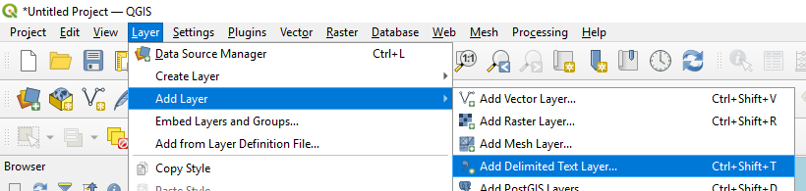

The easiest way to identify possible locations that can be used for data is to classify the symbology of points via ‘n_measurements’, i.e. the number of measurements at a given location and only selecting the larger numbers.

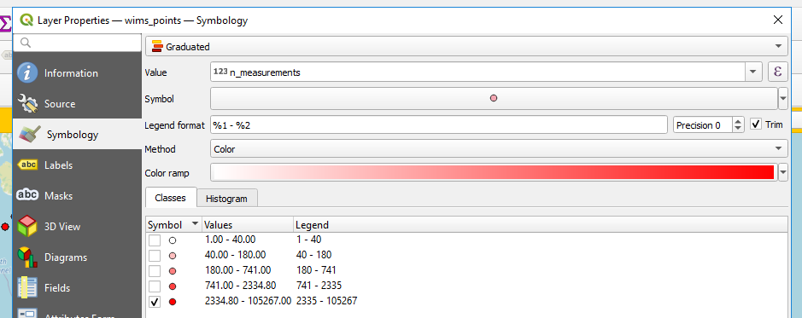

Zoom in on your location of interest (e.g. Norwich) and you can see potential candidate locations.

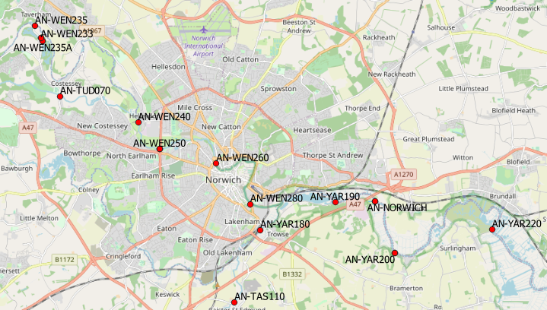

Look at the various stations and pick ones that are in the places you are interested in but also have a large number of samples. In this example, the Rivers Yar and Wensum join in Norwich, so it would make sense to pick one for each and a downstream point. I choose: 'AN-YAR200' – downstream, 'AN-WEN250' – upstream Wensum and ‘AN-YAR180’ – upstream Yar.

Pick some pollutants that are common to all three sampling sites, I pick 'Nitrate-N', 'Phosphorus-P', 'Ammonia(N)' and plot them.

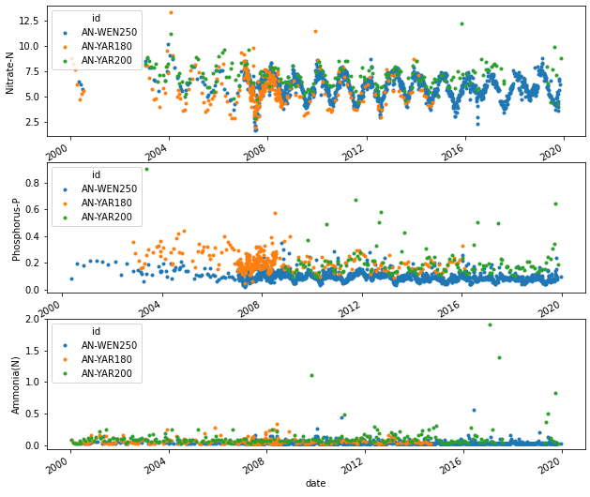.

You can save these as ‘validation samples’ and/or interpolate to form a continuous ‘forcing timeseries’. (Hint: following the code in WIMS data reader you can simply call:

 to plot the interpolated values)