4A15 Hydraulics · Dimensional analysis
Tutorial: a weir model study
A broad-crested weir is to be studied with Froude-scaled physical models at 1:2 and 1:4. The prototype, drawn to scale in the hydraulician app (exercise DA-3), has crest height P = 0.696 m above the approach bed and crest length L_{c} = 1.739 m, and passes q_{p} = 0.78 m²/s per metre width. Answer Questions 1–3 before the session; Question 4 is done in the app; 5 and 6 afterwards.
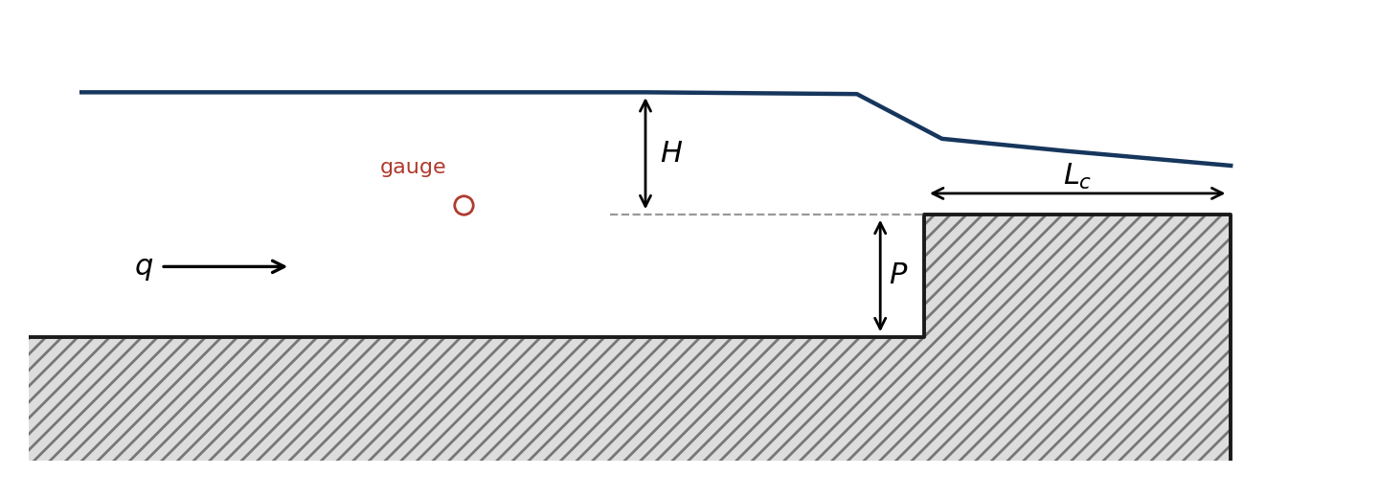
1. Dimensional analysis
The discharge per metre width q over the weir depends on the head H, the crest height P, the crest length L_{c}, gravity g, and the water's density ρ, viscosity μ and surface tension σ.
(a) How many Π groups describe the problem? Using ρ, g and H as repeating variables, find them.
(b) Hence show that q = C_{d} √g H^{3/2} with C_{d} = φ(H/P, L_{c}/H, Re_{H}, We_{H}), where Re_{H} = ρ√g H^{3/2}/μ and We_{H} = ρgH²/σ. Which force ratio does each of Re_{H} and We_{H} compare?
2. Designing the models
(a) Which dimensionless group must be the same in model and prototype for gravity-dominated flow over a weir, and why can Re_{H} and We_{H} not be matched at the same time with water in both?
(b) For λ = ½ and λ = ¼ find the model crest height, crest length and the discharge per metre width that must be supplied. (In this vertical slice q is per metre, so it scales as λ^{3/2}, not λ^{5/2}.)
(c) The prototype takes about 55 s to settle to steady flow. How long should each model take?
3. Predictions
(a) For an ideal broad-crested weir (critical depth over a long crest, no losses, approach velocity neglected) q = (2/3)^{3/2} √g H^{3/2}. Predict the prototype head from q_{p}.
(b) If the prototype head turns out to be H_{p}, what heads do you predict for the two models, and what C_{d}? Write the relationship; you will fill in the numbers in the session.
4. In the app (exercise DA-3)
For each rung (the box on the card: 0 = prototype, 1 = 1:2, 2 = 1:4) set Inflow q to your value from 2(b) (0.780 m²/s for the prototype) and the Reservoir level printed on the card, press R, wait for the settle, then read the steady approach-pool depth d on a gauge at the card's station. Compute H = d − P and C_{d}, and complete the table.
 | prototype λ = 1 | 1:2 model | 1:4 model
q (m²/s) | 0.7800 | 0.2758 | 0.0975
P (m) | 0.696 | 0.348 | 0.174
d measured (m)
H = d − P (m)
H predicted = λH_{p} (m)
C_{d}

5. Scale effects
(a) Evaluate Re_{H} and We_{H} for the prototype and both models, with ν = 1.0×10⁻⁶ m²/s and σ = 0.073 N/m. Would a real 1:4 model of this weir, in water, suffer from viscous or surface-tension scale effects?
(b) A lower limit often used for model weir heads is a few centimetres; take 30 mm. What is the smallest scale at which this weir could be modelled?
6. The simulation's own scale effect
The app has no real viscosity or surface tension at these scales; its equivalent is the grid. Its cells are Δx = 21.7 mm at Medium and do not shrink with the model. How many cells span H on each rung? If H needs at least about 8 cells to be resolved, what is the smallest model this simulation can represent at Medium? What would you expect to happen to C_{d} at λ = ¼ on a coarser grid?

