Hydropower and unsteady flow — tutorial sheet
Complete by hand before the unsteady flow tutorial.

The scheme
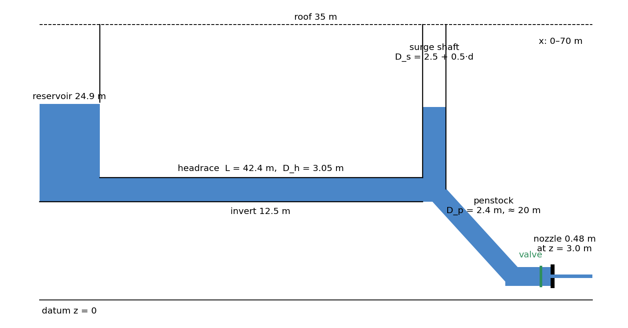
A reservoir feeds a level headrace tunnel; at the knee a surge shaft rises off the tunnel, open to the air, and a penstock drops to a nozzle at the power house. The model is a vertical slice one metre wide: discharges are per metre of width and an "area" is a height, so A/A_s = D_h/D_s. Heights are above the datum, the floor of the picture.
Take q₀ = 7.6 m²/s per metre of width, Darcy f = 0.03, g = 9.81 m/s² and ρ = 1000 kg/m³. For a slot one metre wide the hydraulic diameter is D_H = 2D (R_h = D/2), so h_f = f·(L/D_H)·u²/(2g).
L is measured from the reservoir wall to the shaft centre, the nozzle discharges to atmosphere, and d is the last digit of your student number.

Notation
z is the water level in the shaft measured DOWN from the reservoir level (positive below it): z₀ is the steady running level and z_max the crest of the upsurge above the reservoir. u is the headrace velocity, L and A its length and "area" (= D_h), A_s the shaft "area" (= D_s), k the lumped loss coefficient in z₀ = k·u·|u|, and Z = L·A/(2·g·k·A_s).

Part 1: Hydropower — penstock
The jet speed follows from the energy equation between the reservoir surface and the jet: the gross head H from the reservoir surface down to the nozzle axis, less the friction lost on the way, arrives as velocity head.
The power delivered to the nozzle is the weight of water arriving each second, per metre of width, times the head it still carries.
Friction is the Darcy–Weisbach given above, applied once to the headrace and once to the penstock and added, with u = q/D in each. The loss therefore goes as the square of the discharge:
h_f ∝ q² , h_f / h_f₀ = (q / q₀)²
Find,
- the velocity in the headrace, u₀,
- the friction loss along the headrace, h_f,
- The jet speed, u_{jet}
- The jet power, P
- The flow which provides maximum power

Part 2: Unsteady flow — surge tower
The shaft is open to the air and carries no flow, so it is a piezometer at the knee.
Find
- the steady water level in the surge tower, measured below the reservoir level, z₀,
- the lumped inertia coefficient k (s²/m).
When the valve shuts the water in the headrace decelerates against the head it builds in the shaft. Combining continuity and inertia gives the expressions,
u² = C · e^(z/Z) + (z + Z)/k , Z = L·A / (2·g·k·A_s)
Find
- C (through setting u₀ and z₀),
- z_{max} (through iteration),

Part 3 — In the session
- Before the session, fill the predicted column from Parts 1 and 2 for your own digit. In the session: hover the headrace mid-length for u₀ and the jet just past the nozzle for u_jet; set the gauges to Level η and read the reservoir by the wall and the shaft, differencing them for z₀; then switch to d, press V, and read the first crest above the pre-slam level for z_max.
- Read z₀ on η, not on h: the shaft is open to the air, so its level is the reading you want, and p/ρg part-way down a slowly circulating column is both noisier and biased. The reservoir slider says 25.0 m while a gauge by the wall reads the 24.9 m the calculation uses. Let the settle finish, and press R before each fresh slam.
quantity | predicted | measured
D_s (m), from your digit |  | —
u₀ (m/s)
h_f along the headrace (m)
u_jet (m/s)
P (MW per metre of width)
z₀ (m)
k (s²/m)
z_max (m)

Answers (for the tutor)
Computed from the data in “The scheme”. Two or three significant figures are all the sheet supports. The app column is a sweep of the scene, one run per digit, each settled 60 s, read over a 20 s mean and then slammed. f = 0.03 is the app's own delivered friction: a least-squares fit of the headrace HGL over x = 24–44 m (clear of the entry recovery) on a 60 s mean gives a slope of 1.61 × 10⁻³ at u₀ = 2.51 m/s, which is f = 0.030.
 | Part 1 — Hydropower | predicted | app
(a) | u₀ = q₀/D_h = 7.6/3.05 | 2.49 m/s | 2.51
(b) | h_f = f·(L/D_Hh)·u₀²/2g = 0.03 × (42.4/6.10) × 0.316 | 0.066 m | 0.068 (f = 0.030)
(c) | u_jet = √(2g·(H − h_f)), H = 21.9 m, h_f = 0.066 + 0.064 = 0.130 m | 20.7 m/s | 20.6
(d) | P = ρ·g·q₀·(H − h_f) = ½·ρ·q₀·u_jet² | 1.62 MW/m | 1.62
(e) | P is greatest at h_f = H/3; since h_f ∝ q², q* = q₀·√(H/3h_f) = 7.6 × 7.50 | 57 m²/s | —
 | Part 2 — Unsteady flow | predicted | app
(a) | z₀ = u₀²/2g + h_f = 0.316 + 0.066 | 0.38 m | 0.38 ± 0.02
(b) | k = z₀/u₀² | 0.0616 s²/m | 0.0602
(c) | Z = L·D_h/(2g·k·D_s), C = −(Z/k)·e^(−z₀/Z) — per digit below
(d) | crest where u = 0 in C·e^(z/Z) + (z + Z)/k = 0 — per digit below

Parts 2(c) and 2(d) per digit (u₀ = 2.49 m/s, z₀ = 0.38 m, k = 0.0616 s²/m, L = 42.4 m, D_h = 3.05 m). Only z_max varies between students; everything in Part 1 is the same for everyone.
d | D_s (m) | Z (m) | C (m²/s²) | z_max (m) | app (m) | app / calc
0 | 2.5 | 42.8 | -689 | 5.47 | 5.22 | 0.95
1 | 3.0 | 35.7 | -573 | 4.97 | 4.95 | 1.00
2 | 3.5 | 30.6 | -490 | 4.58 | 4.62 | 1.01
3 | 4.0 | 26.8 | -428 | 4.27 | 4.23 | 0.99
4 | 4.5 | 23.8 | -380 | 4.01 | 4.03 | 1.01
5 | 5.0 | 21.4 | -341 | 3.80 | 3.89 | 1.02
6 | 5.5 | 19.5 | -310 | 3.61 | 3.75 | 1.04
7 | 6.0 | 17.8 | -283 | 3.44 | 3.55 | 1.03
8 | 6.5 | 16.5 | -261 | 3.30 | 3.25 | 0.99
9 | 7.0 | 15.3 | -242 | 3.17 | 3.31 | 1.04

The app reproduces the calculated crest to within 5% across the ladder (app/calc 0.95–1.04, mean 1.01), the largest gap being the narrowest shaft, where the entry into a 2.5 m shaft costs head the rigid column does not model. z₀ agrees to 0.5% when read off the free surface; read off p/ρg part-way down the shaft it comes out ~0.07 m high and twice as scattered, which is a property of the reading, not of the friction.

