4A15 Hydraulics · Dimensional analysis
Tutorial: a weir model study — tutor copy
A broad-crested weir is to be studied with Froude-scaled physical models at 1:2 and 1:4. The prototype, drawn to scale in the hydraulician app (exercise DA-3), has crest height P = 0.696 m above the approach bed and crest length L_{c} = 1.739 m, and passes q_{p} = 0.78 m²/s per metre width. Answer Questions 1–3 before the session; Question 4 is done in the app; 5 and 6 afterwards.
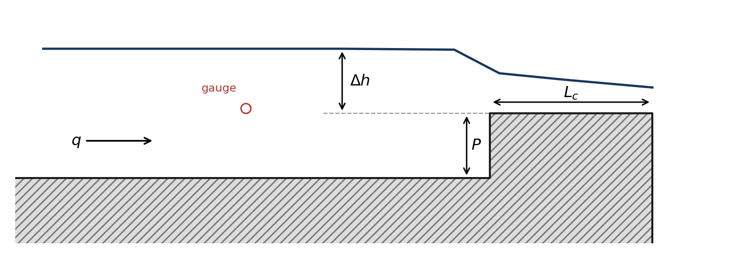
1. Dimensional analysis
The discharge per metre width q over the weir depends on the head Δh, the crest height P, the crest length L_{c}, gravity g, and the water's density ρ, viscosity μ and surface tension σ.
(a) How many Π groups describe the problem? Using ρ, g and Δh as repeating variables, find them.
[Answer: m = 8 variables, n = 3 dimensions, so 5 groups: q/(g^{1/2}Δh^{3/2}), P/Δh, L_{c}/Δh, μ/(ρg^{1/2}Δh^{3/2}) and σ/(ρgΔh²).]
(b) Hence show that q = C_{d} √g Δh^{3/2} with C_{d} = φ(Δh/P, L_{c}/Δh, Re, We), where Re = ρ√g Δh^{3/2}/μ and We = ρgΔh²/σ. Which force ratio does each of Re and We compare?
[Answer: Invert the fourth and fifth groups (any power of a group is a group). With √(gΔh) as the velocity scale, Re = ρ√(gΔh)Δh/μ is inertia/viscous and We = ρ(gΔh)Δh/σ is inertia/surface tension.]
2. Designing the models
(a) Which dimensionless group must be the same in model and prototype for gravity-dominated flow over a weir, and why can Re and We not be matched at the same time with water in both?
[Answer: The Froude number, which for a weir is the group q/(g^{1/2}Δh^{3/2}) = C_{d} itself, with the geometric ratios Δh/P and L_{c}/Δh: gravity drives the flow over the crest. With the same g, ρ, μ and σ, Froude scaling makes Re fall as L_{r}^{3/2} and We as L_{r}²; neither can be held.]
(b) For L_{r} = ½ and L_{r} = ¼ find the model crest height, crest length and the discharge per metre width that must be supplied. (In this vertical slice q is per metre, so it scales as L_{r}^{3/2}, not L_{r}^{5/2}.)
[Answer: L_{r} = ½: P = 0.348 m, L_{c} = 0.870 m, q = 0.2758 m²/s; L_{r} = ¼: P = 0.174 m, L_{c} = 0.435 m, q = 0.0975 m²/s.]
(c) The prototype takes about 55 s to settle to steady flow. How long should each model take?
[Answer: Times scale as √L_{r}: 39 s at L_{r} = ½ and 28 s at L_{r} = ¼ (the card's 40 and 28 s).]
3. Predictions
(a) For an ideal broad-crested weir (critical depth over a long crest, no losses, approach velocity neglected) q = (2/3)^{3/2} √g Δh^{3/2}. Predict the prototype head from q_{p}.
[Answer: C_{d,ideal} = 0.544; Δh = (q/(0.544√g))^{2/3} = 0.594 m.]
(b) If the prototype head turns out to be Δh_{p}, what heads do you predict for the two models, and what C_{d}? Write the relationship; you will fill in the numbers in the session.
[Answer: Δh_{m} = L_{r}Δh_{p} and C_{d,m} = C_{d,p} (Froude similarity with geometric similarity keeps every Π group except Re and We).]
4. In the app (exercise DA-3)
For each rung (the box on the card: 0 = prototype, 1 = 1:2, 2 = 1:4) set Inflow q to your value from 2(b) (0.780 m²/s for the prototype) and the Reservoir level printed on the card, press R, wait for the settle, then read the steady approach-pool depth d on a gauge at the card's station. Compute Δh = d − P and C_{d}, and complete the table.
 | prototype L_{r} = 1 | 1:2 model | 1:4 model
q (m²/s) | 0.7800 | 0.2758 | 0.0975
P (m) | 0.696 | 0.348 | 0.174
d measured (m) | 1.3894 | 0.6939 | 0.3469
Δh = d − P (m) | 0.6937 | 0.3461 | 0.1730
Δh predicted = L_{r}Δh_{p} (m) | 0.6937 | 0.3469 | 0.1734
C_{d} | 0.4310 | 0.4325 | 0.4327

[Answer: The models reproduce the prototype to within 0.3% in Δh and 0.4% in C_{d}: the three rungs are Froude-similar. The measured C_{d} (0.431) is 21% below the ideal 0.544.]
5. Scale effects
(a) Evaluate Re and We for the prototype and both models, with ν = 1.0×10⁻⁶ m²/s and σ = 0.073 N/m. Would a real 1:4 model of this weir, in water, suffer from viscous or surface-tension scale effects?
[Answer: L_{r} = 1: Re = 1.8 × 10⁶, We = 6.5 × 10⁴; L_{r} = ½: Re = 6.4 × 10⁵, We = 1.6 × 10⁴; L_{r} = ¼: Re = 2.3 × 10⁵, We = 4.0 × 10³. All are large (fully turbulent, surface tension negligible), so a 1:4 model is safe.]
(b) A lower limit often used for model weir heads is a few centimetres; take 30 mm. What is the smallest scale at which this weir could be modelled?
[Answer: L_{r} = 0.030/0.694 = 0.043, about 1:23.]
6. The simulation's own scale effect
The app has no real viscosity or surface tension at these scales; its equivalent is the grid. Its cells are Δx = 21.7 mm at Medium and do not shrink with the model. How many cells span Δh on each rung? If Δh needs at least about 8 cells to be resolved, what is the smallest model this simulation can represent at Medium? What would you expect to happen to C_{d} at L_{r} = ¼ on a coarser grid?
[Answer: Δh spans 32, 16 and 8 cells. L_{r,min} = 8Δx/Δh_{p} = 0.25, i.e. the 1:4 rung is right at the limit. A coarser grid (Resolution Low) puts H_¼ under 6 cells and moves C_{d} by a few per cent with nothing physical changed: the numerical counterpart of Re and We falling below their thresholds.]

