4A15 Hydraulics · Dimensional analysis
Tutorial: dimensional analysis and a sloshing tank — tutor copy
A design chart is wanted for the natural sloshing period $T$ of rectangular tanks of length $B$ holding water to depth $d$. An analyst plans to compute $T$ by creating a set of models, with five values each of $B$, $d$ and the initial tilt $a$ of the surface (below). Viscosity and surface tension are negligible.
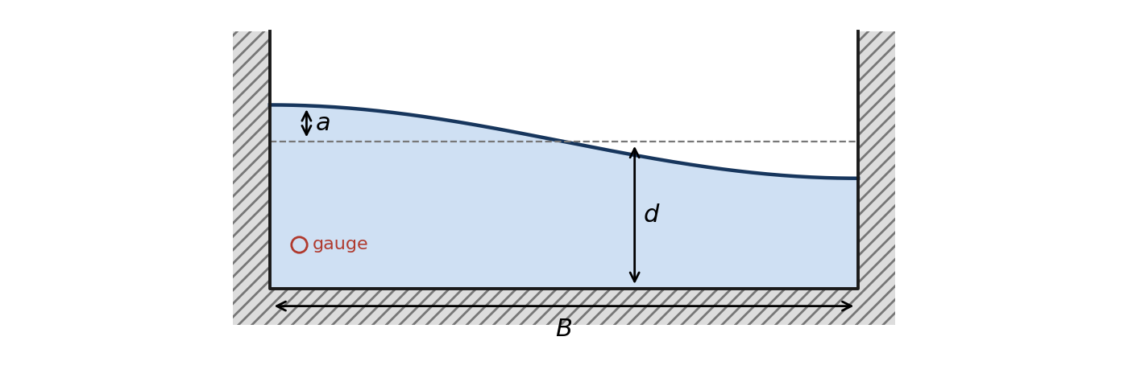
1. Dimensional analysis to guide model building
(a) How many models does the analyst plan?
(b) $T$ depends on $B$, $d$, $a$, $g$ and the density $ρ$. Find the Π groups.
(c) For small tilts the period does not depend on $a$. Show that $T$ can then be written as
$T=K\sqrt{d/g}$, with $K=ϕ(B/d)$,
and say how many models the design chart needs.
(d) In a long, shallow tank the surface disturbance travels at $\sqrt{gd}$ and goes the length of the tank and back in one period. Find $K$.
(e) Deep water is barely disturbed by a wave, so in a deep tank $T$ does not depend on $d$. Use dimensional analysis to find an expression for $T$ in a deep tank, and write it in terms of $K$ from (c).
(f) Linear wave theory gives
$T=2π/\sqrt{gk tanh(kd)}$, with $k=π/B$.
Show that
$$K_{theory}=2π/\sqrt{kd tanh(kd)}$$
depends on $B/d$ only, and that it reduces to (d) and (e).
2. In the session (exercise DA-3)
A model gives a period $T$ in seconds for one particular tank. Dividing by $\sqrt{d/g}$ removes the tank's size and leaves
$$K_{app}=T\sqrt{g/d}$$
a pure number that can be compared directly with any other tank's, and with $K_{theory}$. By 1(c), one model per value of $B/d$ is enough to draw the analyst's design chart: the five models below stand in for all 125.
Place a Depth gauge at $x=0.5$ m, low in the water. For each model set Tank length and Water depth in Controls → Geometry, with Initial tilt $a/d=0.2$. Expand the gauge (⤢) and read the times $t_{1}$ and $t_{4}$ of the first and fourth crests after release; $T=(t_{4}−t_{1})/3$.
Model | $B$ (m) | $d$ (m) | $B/d$ | $t_{1}$ (s) | $t_{4}$ (s) | $T$ (s) | $K_{app}$
A | 1 | 1 | 1
B | 2 | 1 | 2
C | 4 | 1 | 4
D | 8 | 1 | 8
E | 8 | 0.5 | 16

Plot $K_{app}$ against $B/d$ on the chart, which shows $K_{theory}$ and the two limits from 1(d) and 1(e).
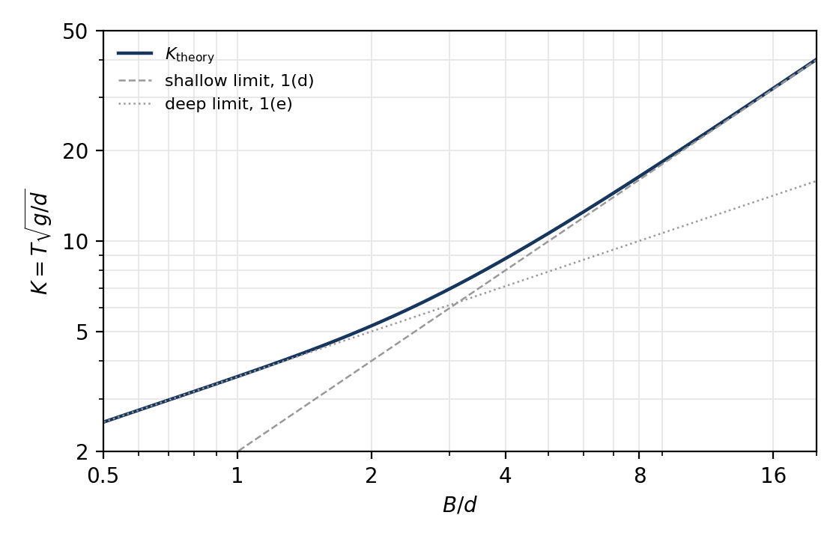
(a) Do your five points lie on one curve? How well does $K_{theory}$ describe it?
(b) Without building a model, use the chart to find the period of a tank 20 m long holding 2.5 m of water.

Answers
1(a) $5×5×5=125$ models.
1(b) 6 variables ($T$, $B$, $d$, $a$, $g$, $ρ$) and 3 dimensions give 3 groups. $T$ needs only length and time, so repeat a length and $g$ ($d$ and $g$): $T\sqrt{g/d}$, $B/d$ and $a/d$. Mass is redundant: $ρ$ is the only variable containing it, so no group can include it.
1(c) $a/d$ drops out, leaving $T\sqrt{g/d}=ϕ(B/d)$; call it $K$, so $T=K\sqrt{d/g}$. $K$ is the period measured in units of $\sqrt{d/g}$, and it is one curve against $B/d$: 5 models, one per value of $B/d$.
1(d) $T=2B/\sqrt{gd}$, so $K=2B/d$.
1(e) Without $d$, $T$ depends on $B$ and $g$ only, so $T=C\sqrt{B/g}$ with $C$ a constant. Then $K=T\sqrt{g/d}=C\sqrt{B/d}$.
1(f) Multiply $T$ by $\sqrt{g/d}$: $K_{theory}=2π/\sqrt{kd tanh(kd)}$, with $kd=πd/B$. Shallow, $kd→0$: $tanhkd→kd$, so $K→2π/kd=2B/d$. Deep, $kd→∞$: $tanhkd→1$, so $K→2π/\sqrt{kd}=2\sqrt{π}\sqrt{B/d}$, so the constant in (e) is $C=2\sqrt{π}=3.5$.
2
Model | $B$ (m) | $d$ (m) | $B/d$ | $t_{1}$ (s) | $t_{4}$ (s) | $T$ (s) | $K_{app}$
A | 1 | 1 | 1 | 1.3 | 4.9 | 1.2 | 3.8
B | 2 | 1 | 2 | 1.9 | 7.0 | 1.7 | 5.4
C | 4 | 1 | 4 | 2.9 | 12 | 2.9 | 8.9
D | 8 | 1 | 8 | 5.1 | 21 | 5.4 | 17
E | 8 | 0.5 | 16 | 7.2 | 30 | 7.5 | 33

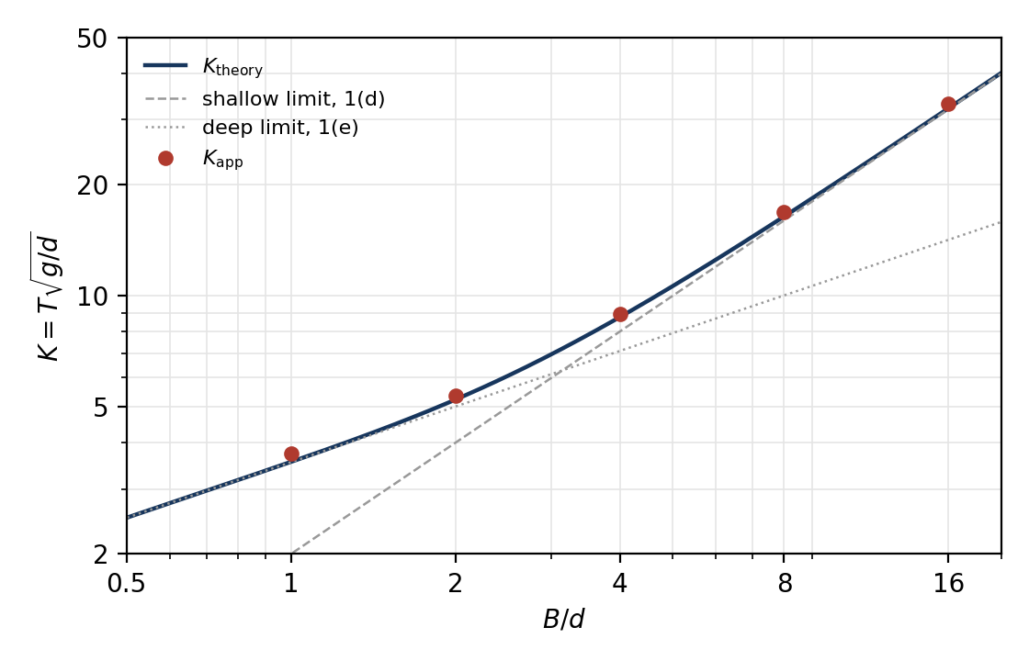
2(a) Yes: one smooth curve, from $K=3.8$ at $B/d=1$ to $33$ at $B/d=16$, although E is a different size from the others. $K_{app}$ sits 2.2–5.6% above $K_{theory}$, closest to the shallow limit for long tanks and turning towards the deep limit for short ones.
2(b) $B/d=8$, so $K≈16$ from the chart, and $T=K\sqrt{d/g}=16×\sqrt{{2.5}/{9.81}}≈8.1$ s. Exactly, $K_{theory}=16.4$ gives $T=8.3$ s.

