Hydropower and unsteady flow — tutorial sheet
Complete by hand before the unsteady flow tutorial. The scheme is hydraulician exercise HP-3, so every answer can be checked on screen.

The scheme
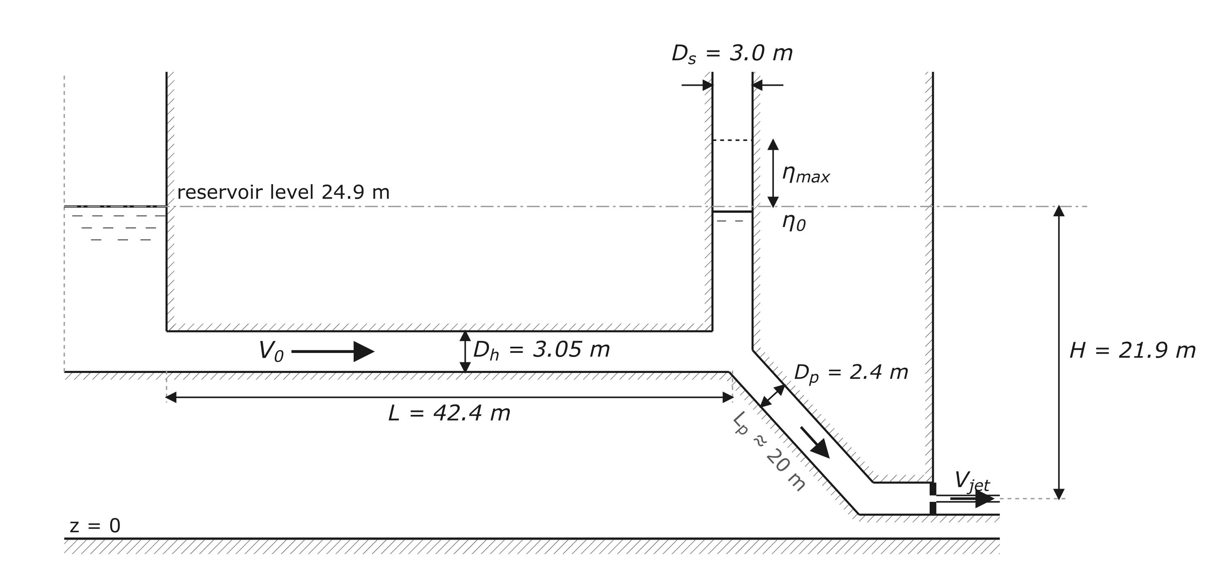
Figure 1: The scheme and its notation, to scale. Heights are metres above the datum z = 0.
Figure 1 shows a hydropower scheme. The reservoir surface stands at 24.9 m. A level headrace, L = 42.4 m long and D_{h} = 3.05 m deep, runs to a surge shaft D_{s} = 3.0 m wide, open to the atmosphere; a penstock (D_{p} = 2.4 m, L_{p} ≈ 20 m) drops to a nozzle 0.48 m wide at z = 3.0 m, discharging to atmosphere. The valve at the nozzle is the turbine, and closes instantaneously on shutdown. The scheme is a slice one metre wide, so discharges are per metre of width (m²/s) and a conduit's area is its depth: A = D_{h} and A_{s} = D_{s}.
Take q₀ = 7.6 m²/s, a Darcy friction factor λ = 0.03 in both conduits, g = 9.81 m/s² and ρ = 1000 kg/m³, and neglect local losses. The conduits are slots of depth D and unit width, not circular pipes: the hydraulic radius is D/2, so the hydraulic diameter 4R_{h} = 2D takes the place of the pipe diameter in Darcy–Weisbach,
h_{f} = λ · (L/2D) · V²/2g

Notation
V = q/D is the mean velocity in a conduit; H = 24.9 − 3.0 = 21.9 m the gross head, reservoir surface to nozzle axis; h_{f} the friction loss. η is the shaft water level relative to the reservoir surface, positive above it: η₀ (negative) is the steady running level and η_{max} the first crest. k is the loss coefficient in η₀ = −k·V₀², and Y = L·A/(2·g·k·A_{s}).

Part 1: Hydropower — penstock
Energy from the reservoir surface to the jet gives V_{jet} = √(2g·(H − h_{f})), h_{f} being the friction in headrace and penstock together, and the power delivered to the nozzle is P = ρ·g·q·(H − h_{f}). Since V ∝ q in both conduits, h_{f} ∝ q².
Find:
- the headrace velocity, V₀;
[Answer: 2.49 m/s]
- the friction loss along the headrace, h_{f};
[Answer: 0.066 m]
- the jet speed, V_{jet};
[Answer: V_{jet} = 20.7 m/s]
- the power P delivered to the nozzle, per metre of width;
[Answer: 1.62 MW/m]
- the discharge q* at which P would be greatest.
[Answer: 57 m²/s]

Part 2: Unsteady flow — surge tower
The shaft carries no flow and is open to the air, so its water stands at the piezometric head at the knee: the velocity head V₀²/2g plus the friction loss h_{f} below the reservoir surface. Write this as η₀ = −k·V₀². (The lectures take k as friction alone, which is fine for a tunnel a thousand bores long; this headrace is 14 bores long and the velocity head is most of the drawdown.)
Find:
- the steady level in the shaft, η₀;
[Answer: −0.38 m]
- the loss coefficient k.
[Answer: 0.0616 s²/m]
After instantaneous shutdown the lecture's V²–η solution gives the first crest, where V = 0, from
η_{max} = Y · [1 − exp((η₀ − η_{max})/Y)]
Find:
- Y;
[Answer: Y = 35.7 m]
- η_{max}, by trial and error.
[Hint: bracket the zero of F(η) = η − Y·[1 − exp((η₀ − η)/Y)], as in the lecture example. Answer: η_{max} = 4.97 m]

Part 3 — In the session
Before the session, fill the predicted column from Parts 1 and 2. In the session: hover the headrace mid-length for V₀ and the jet just past the nozzle for V_{jet}; set the gauges to Level η and read the reservoir by the wall and the shaft: η₀ = shaft − reservoir; then switch to d, press V, and read the first crest's rise above the pre-slam level: η_{max} = rise + η₀.
Read η₀ on η, not on h: the shaft is open to the air, so its level is the reading you want, and p/ρg part-way down a slowly circulating column is both noisier and biased. The reservoir slider says 25.0 m while a gauge by the wall reads the 24.9 m the calculation uses. Let the settle finish, and press R before each fresh slam.
quantity | predicted | measured
V₀ (m/s)
h_{f} along the headrace (m)
V_{jet} (m/s)
P (MW per metre of width)
η₀ (m)
k (s²/m)
η_{max} (m)

Answers (for the tutor)
Computed from the data in “The scheme”. Two or three significant figures are all the sheet supports. The app column is one run of the scene at D_{s} = 3.0 m, settled 60 s, read over a 20 s mean and then slammed. λ = 0.03 is the app's own delivered friction: a least-squares fit of the headrace HGL over x = 24–44 m (clear of the entry recovery) on a 60 s mean gives a slope of 1.61 × 10⁻³ at V₀ = 2.51 m/s, which is λ = 0.030.
 | Part 1 — Hydropower | predicted | app
(a) | V₀ = q₀/D_{h} = 7.6/3.05 | 2.49 m/s | 2.51
(b) | h_{f} = λ·(L/2D_{h})·V₀²/2g = 0.03 × (42.4/6.10) × 0.316 | 0.066 m | 0.068 (λ = 0.030)
(c) | V_{jet} = √(2g·(H − h_{f})), H = 21.9 m, h_{f} = 0.066 + 0.064 = 0.130 m | 20.7 m/s | 20.6
(d) | P = ρ·g·q₀·(H − h_{f}) = ½·ρ·q₀·V_{jet}² | 1.62 MW/m | 1.62
(e) | P is greatest at h_{f} = H/3; since h_{f} ∝ q², q* = q₀·√(H/3h_{f}) = 7.6 × 7.50 | 57 m²/s | —
 | Part 2 — Unsteady flow | predicted | app
(a) | η₀ = −(V₀²/2g + h_{f}) = −(0.316 + 0.066) | −0.38 m | −0.38 ± 0.02
(b) | k = −η₀/V₀² | 0.0616 s²/m | 0.0602
(c) | Y = L·D_{h}/(2g·k·D_{s}) | 35.7 m
(d) | η_{max} = Y·[1 − exp((η₀ − η_{max})/Y)] | 4.97 m | 4.95

The app reproduces the calculated crest to 0.4% (4.95 m against 4.97 m). η₀ agrees to 0.5% when read off the free surface; read off p/ρg part-way down the shaft it comes out ~0.07 m high and twice as scattered, which is a property of the reading, not of the friction. Other widths, when the class ran one per digit: 2.5 m → 5.47 (app 5.22), 3.5 m → 4.58 (app 4.62), 4.0 m → 4.27 (app 4.23), 4.5 m → 4.01 (app 4.03), 5.0 m → 3.80 (app 3.89), 5.5 m → 3.61 (app 3.75), 6.0 m → 3.44 (app 3.55), 6.5 m → 3.30 (app 3.25), 7.0 m → 3.17 (app 3.31).

