One-Dimensional Modeling of CO Methanation in a Fixed-Bed Reactor
Barno and Ashiq
Abstract
A one-dimensional fixed-bed model was used to evaluate CO methanation with the Full M4 kinetics of Celoria et al. Species, energy, and Ergun pressure balances were integrated in Python with SciPy solve_ivp using Radau or BDF. At 350 °C, 1 bar absolute, and 3.12 g catalyst, Full M4 predicts 78.72% CO conversion without parameter adjustment; the reported Experiment 1 value is 40.63%. This comparison is affected by conflicting pressure values in the source report and lies below the model's 5–15 bar fitted pressure range. A separate assumed 5 bar bed predicts 95.81% outlet conversion and a peak gas temperature of 819.7 K (546.5 °C), above the fitted temperature range of 250–400 °C. Sweeps of inlet temperature, pressure, H₂/CO ratio, catalyst space time, and N₂ flow characterize the model's response under specified conditions.
Keywords CO methanation; fixed-bed reactor; Full M4 kinetics; stiff ODE integration; sensitivity analysis

Introduction
CO methanation is strongly exothermic, so local rates change with gas composition and temperature along a packed bed. A reactor calculation must also account for heat exchange and pressure loss.
Here, the Full M4 kinetics of Celoria et al. [1] are applied to a one-dimensional fixed-bed reactor. Its unadjusted prediction at the selected Experiment 1 basis is compared with two other literature rate laws [2, 3] and the reported conversion [5]. A separate assumed 5 bar case and operating sweeps are used to examine axial behavior and input sensitivity.

Methodology

Reactor model and reaction network
The bed is represented as a steady, one-dimensional plug-flow reactor. The Full M4 network contains three reversible reactions, written below in the forward directions used to define the stoichiometric matrix. The published reverse water-gas-shift rate is sign-reversed for the forward direction used here.
- CO₂ + 4 H₂ ⇌ CH₄ + 2 H₂O
- CO + 3 H₂ ⇌ CH₄ + H₂O
- CO + H₂O ⇌ CO₂ + H₂
Full M4 local rates are evaluated from temperature and gas partial pressures using the published Langmuir–Hinshelwood–Hougen–Watson form and central parameter values [1]. For comparison, the Kopyscinski implementation uses the corrected square-root CO adsorption term from its published corrigendum [2]. The Quindimil implementation was fitted to CO₂/H₂ feeds [3]; applying it to the CO/H₂/N₂ comparison is outside that feed scope.

Material, energy, and momentum balances
Species molar flows Fᵢ are integrated with catalyst mass W as the independent coordinate. The activity factor a multiplies each net reaction rate rⱼ. Local partial pressures follow the ideal-gas mixture relation pᵢ = yᵢP, and concentrations are calculated from cᵢ = pᵢ/(RT).
dFᵢ/dW = a ∑ⱼ νᵢⱼ rⱼ (1)
For non-isothermal cases, the gas energy balance includes reaction heat and, when enabled, heat transfer to a wall held at T_w. The model uses the species heat-capacity flow in the denominator and a cylindrical heat-transfer area per bed volume of 4/D_t.
dT/dW = [−a ∑ⱼ ΔHⱼ rⱼ − (4U/(Dₜρ_cat))(T − T_w)] / [∑ᵢ Fᵢ Cₚ,ᵢ] (2)
Pressure loss is computed from the viscous and inertial terms of the Ergun equation. The axial pressure gradient is converted to the catalyst-mass coordinate using the bed cross-sectional area A_c and catalyst loading per bed volume ρ_cat.
dP/dW = −[150μ(1−ε)²u/(dₚ²ε³) + 1.75ρ_g(1−ε)u²/(dₚε³)]/(ρ_cat A_c) (3)
X_CO = 100(F_CO,0 − F_CO,out)/F_CO,0; τ_cat = W_cat/F_CO,0 (4)

Numerical solution and simulation cases
The Python implementation integrates the balance equations with scipy.integrate.solve_ivp from SciPy 1.18.1 [4], using the implicit Radau or BDF method as listed in Table 1. The principal profile runs use relative tolerance 10⁻⁶, absolute flow tolerance 10⁻¹⁰ mol s⁻¹, temperature tolerance 10⁻⁵ K, and pressure tolerance 0.1 Pa. The independent literature-model profiles use Radau with relative tolerance 10⁻⁸ and absolute flow tolerance 10⁻¹⁴ mol s⁻¹. Dense solver output is sampled at 401 positions for reactor profiles and 101 catalyst-mass positions for the three-model comparison. Sweep results are reported at the bed outlet.
A dry CO/H₂ inlet has zero initial H₂O, while the Full M4 CO₂ rate contains a water pressure denominator. The implementation uses a derived near-inlet series start for the stiff integration rather than adding an artificial steam feed.
Table 1. Simulation cases represented in the figures.
Case | Conditions and varied inputs | Integrator and coverage
Three-model comparison | 350 °C; 1 bar abs.; 3.12 g; fixed Experiment 1 inlet flows; isothermal | Radau; 101 profile points per model
Assumed Full M4 profile | 350 °C; 5 bar; CO:H₂:N₂ = 1:4:25; heat exchange; Ergun drop | Radau; 401 axial output points
Temperature–pressure sweep | 22 × 22 grid; inlet temperature 250–400 °C; pressure 1–15 bar | Radau; 484 cases completed
Composition sensitivities | H₂/CO–space time, feed-flow and isolated N₂ sweeps at 1 bar | BDF; 462, 819 and 42 cases completed

The Full M4 kinetic fit covers 250–400 °C and 5–15 bar. The 1 bar Experiment 1 comparison and sensitivity runs are pressure extrapolations. The assumed reactor case uses a 0.0254 m tube, 0.3048 m bed, 0.4 void fraction, 3 mm particles, and 750 kg catalyst m⁻³ bed; these are specified modeling inputs, not dimensions or packing measurements confirmed by Experiment 1.

Results and Discussion

Comparison with Experiment 1
The common comparison basis is 350 °C, 1.00 bar absolute, 3.12 g catalyst, and inlet flows of 0.320 mol h⁻¹ CO, 0.959 mol h⁻¹ H₂, and 0.799 mol h⁻¹ N₂. The source reports 40.63% CO conversion [5]. No rate or activity parameter was fitted to that value.
Table 2. Independent model predictions at the common Experiment 1 basis.
Model | Predicted conversion | Difference | Scope at 1 bar
Full M4 | 78.723% | +38.09 percentage points | Below the 5–15 bar fit range
Kopyscinski | 99.985% | +59.35 percentage points | Within the published 1–2 bar range
Quindimil | 3.369% | −37.26 percentage points | Below the 2–6 bar range; CO/H₂ feed outside its CO₂/H₂ fit scope

Table 2 and Figure 1 show that Full M4 predicts 78.72% conversion at the selected 1 bar basis, 38.09 percentage points above the reported 40.63%. The source describes atmospheric operation in its abstract and discussion but lists 2 bar in Appendix A [5]. The 1 bar calculation is below the Full M4 fitted pressure interval.
Kopyscinski predicts nearly complete conversion, but it describes a different catalyst and reactor. Quindimil's rate law was fitted to CO₂/H₂ feeds and is evaluated below its pressure range here. Its implemented expression is also reduced because the published parameter table lacks an independent K_H₂ required by one denominator term. These results assess transfer of literature kinetics across different conditions; they do not rank models for a common catalyst.
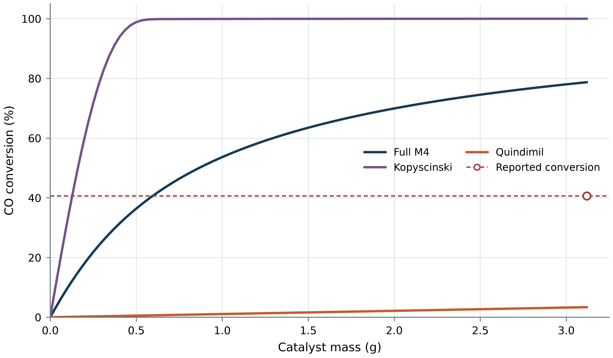
Figure 1. CO conversion versus catalyst mass for three literature models evaluated without refitting. The dashed line and circular point mark the reported Experiment 1 conversion at 3.12 g.

Assumed Full M4 reactor profile
Figure 2 shows the assumed 5 bar Full M4 bed described in Table 1. The total inlet flow is 0.05 mol s⁻¹ with CO:H₂:N₂ = 1:4:25; the wall is held at 350 °C with U = 10 W m⁻² K⁻¹. At 0.11583 kg catalyst, the model predicts 95.81% outlet CO conversion and 87.33% methane yield. Gas temperature peaks at 819.66 K (546.5 °C) about 3.5 cm from the inlet, while pressure falls to 4.9405 bar at the outlet.
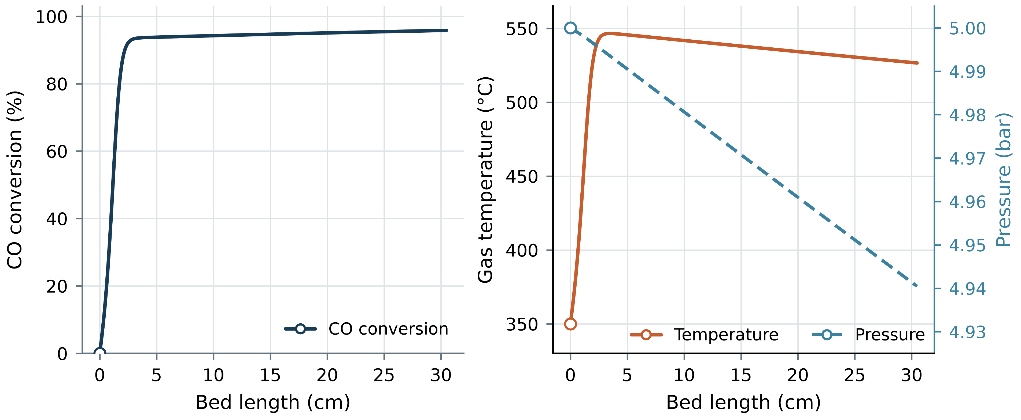
Figure 2. Axial CO conversion, gas temperature and pressure for the assumed Full M4 case. The temperature rise is concentrated near the inlet; the small pressure change is plotted on a separate right-hand axis. A circular point marks the inlet condition in each panel.
In Figure 3, CO depletion coincides with CH₄ and H₂O formation near the inlet. CO₂ remains a minor intermediate; N₂ is included in the material balance but omitted from the plot scale. The calculated hot spot exceeds the 400 °C upper kinetic-fit temperature, so rates in part of the bed require temperature extrapolation.
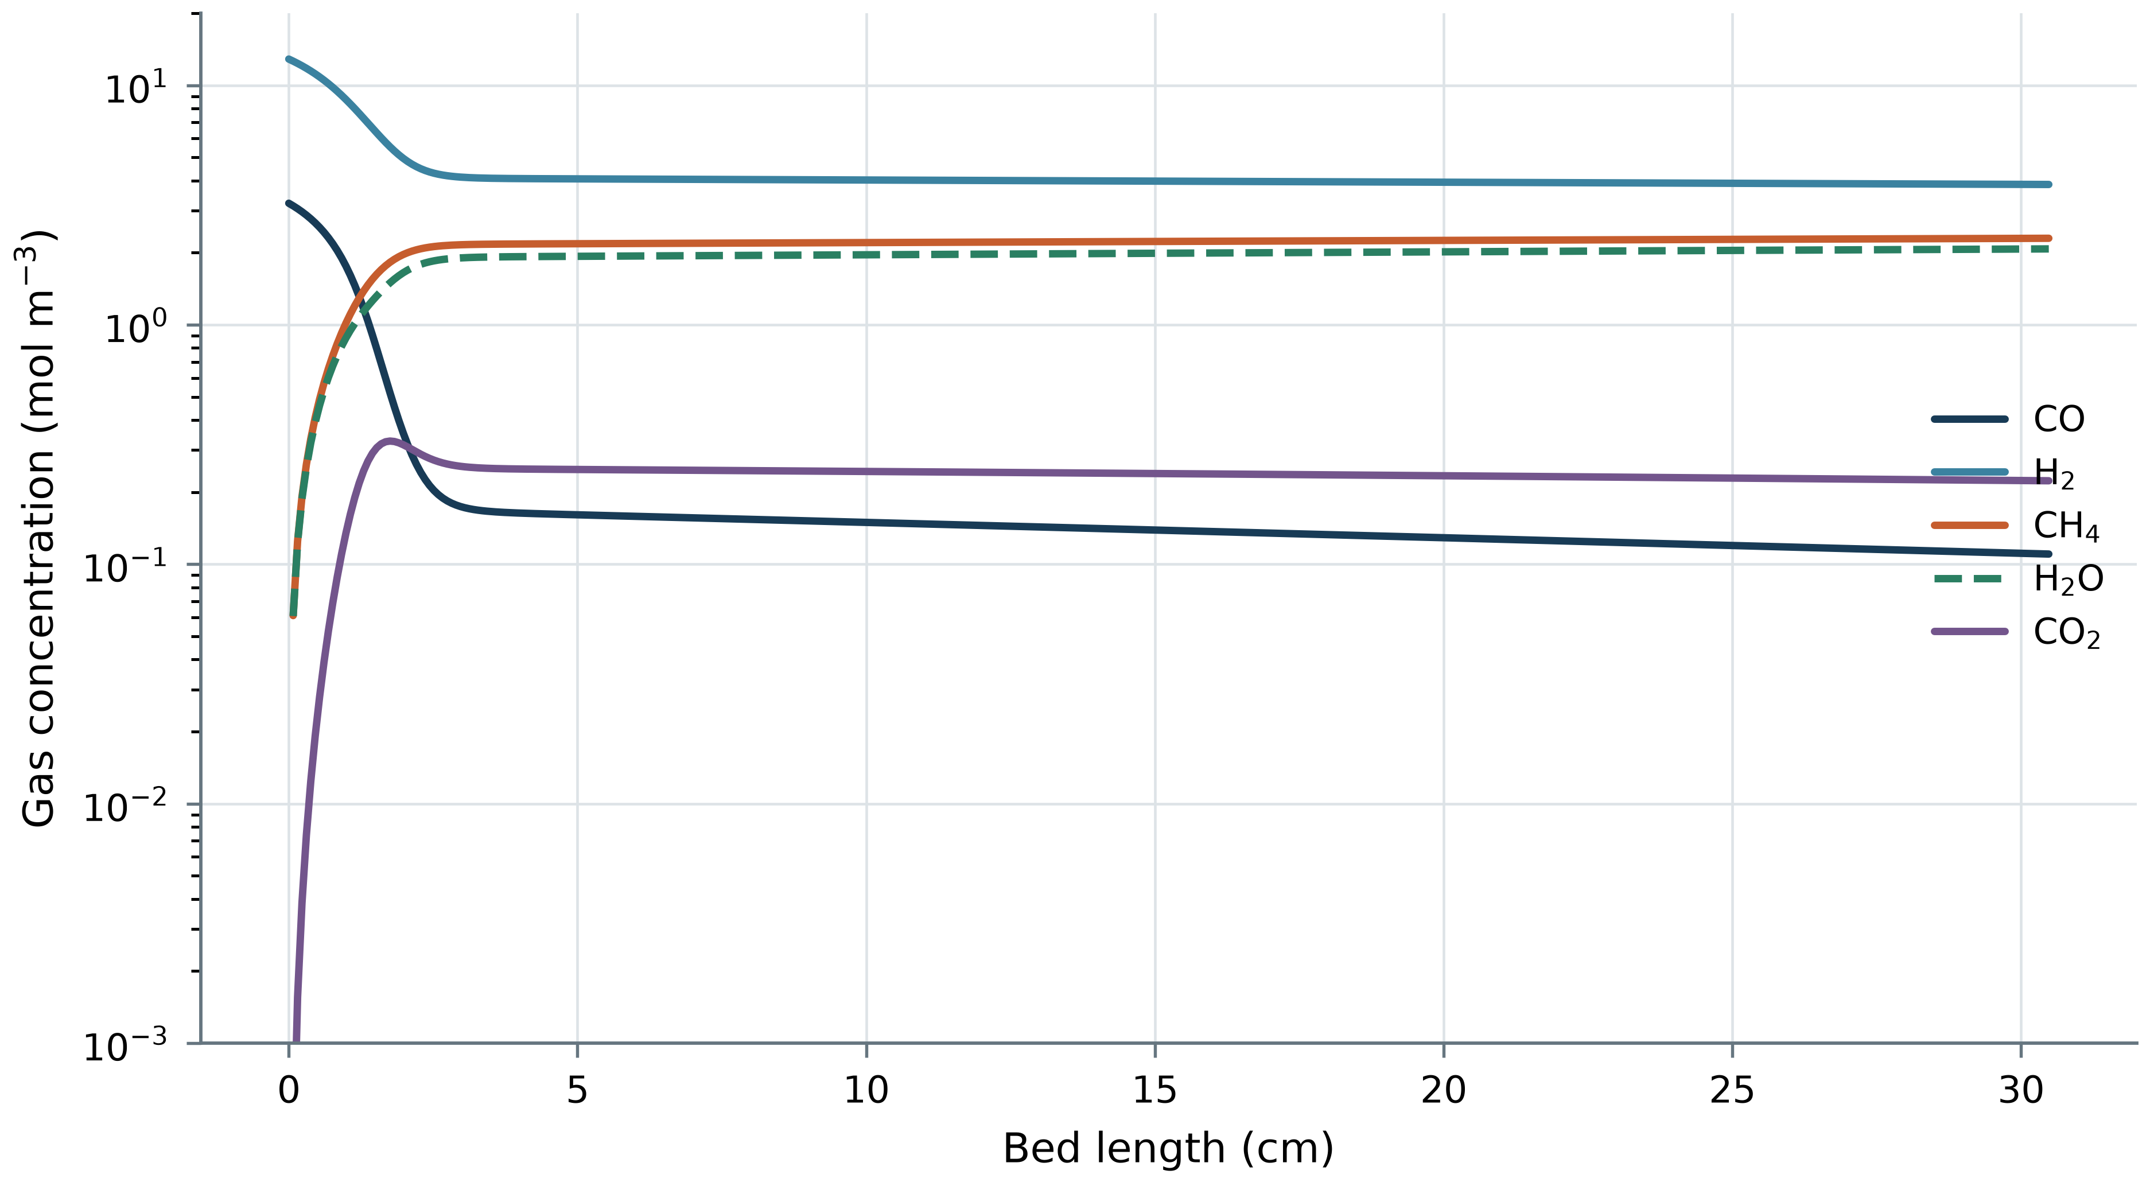
Figure 3. Reactive-species gas concentrations along the assumed Full M4 bed. The logarithmic ordinate omits initial zero concentrations; nitrogen is omitted from the panel for scale clarity and remains in the simulated material balance.

Temperature and pressure sensitivity
Figure 4 shows the 5–15 bar subset of a 22 × 22 Full M4 sweep over 250–400 °C and 1–15 bar. All 484 runs completed. Over the plotted pressure interval, outlet conversion ranges from 92.01% to 99.86%; the nominal 350 °C, 5 bar point gives 95.81%. Cases below 5 bar are omitted because they lie outside the fitted pressure range.
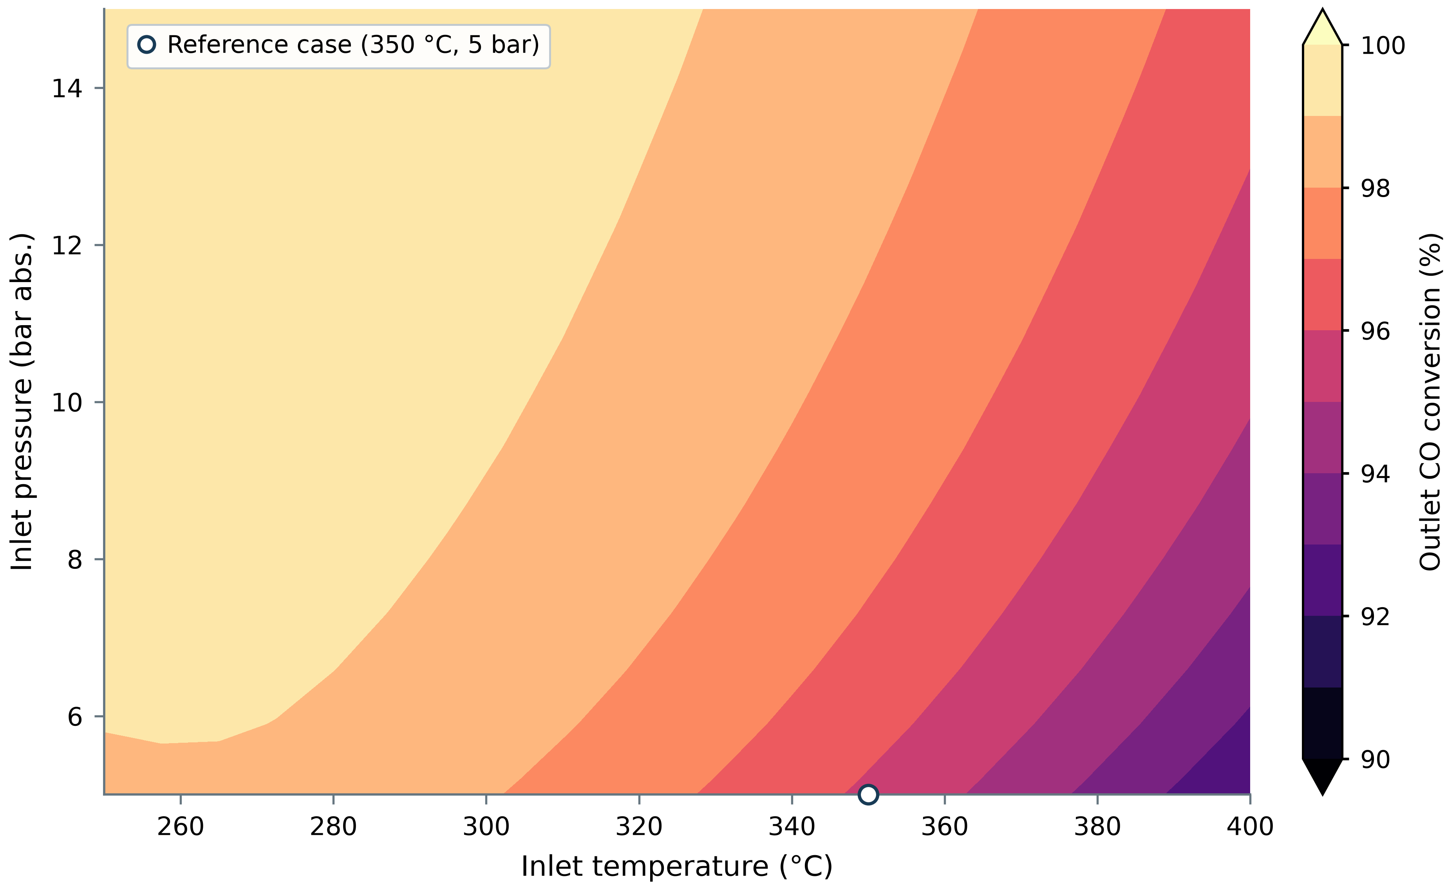
Figure 4. Full M4 outlet CO conversion over the 5–15 bar pressure-fit interval and 250–400 °C inlet-temperature range. The circular marker identifies the 350 °C, 5 bar nominal case. Other assumed bed inputs are held fixed.
Inlet conditions within the fitted interval do not guarantee that the entire bed stays there. Across all 484 runs, including those below 5 bar, 469 reach a sampled peak bed temperature above 400 °C; peak temperatures range from 288.4 to 603.1 °C. Many plotted trajectories therefore involve local temperature extrapolation.

H₂/CO ratio and catalyst space time
Figure 5 summarizes a 462-case isothermal Full M4 sweep of H₂/CO from 1 to 5 and catalyst space time from 8.775 to 140.4 kg_cat s mol_CO⁻¹ at 350 °C and 1 bar. Catalyst mass was held at 3.12 g; CO and N₂ flows were scaled together, H₂ was reset from the selected ratio, and N₂/CO was held at the Experiment 1 value. Outlet conversion ranges from 22.38–99.04%. At the reference ratio of 2.9969 and space time of 35.10 kg_cat s mol_CO⁻¹, the model returns 78.72%. Increasing H₂/CO or space time generally raises conversion over the sampled region, with diminishing change toward the high-conversion boundary.
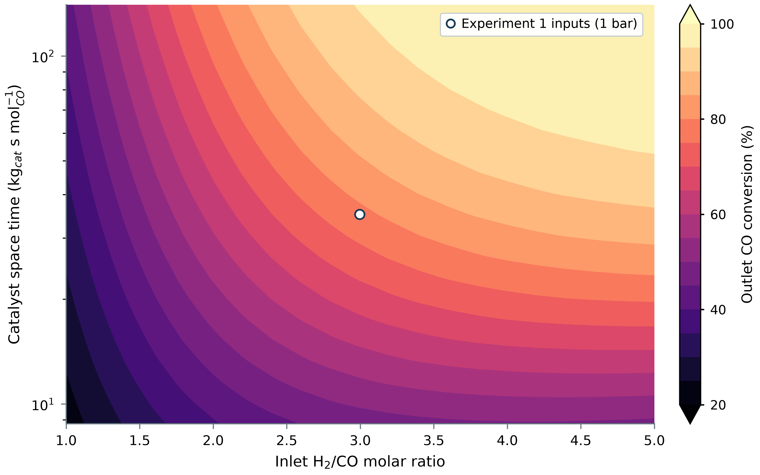
Figure 5. Full M4 outlet conversion across the H₂/CO and catalyst-space-time grid. The circular point marks the 1 bar Experiment 1 reference calculation. All cells are isothermal predictions without refitting and lie below the 5–15 bar Full M4 pressure-fit interval.

Absolute feed-flow sensitivity
Figure 6 varies absolute inlet flows at 350 °C, 1 bar, and 3.12 g catalyst. Panel (a) varies H₂ and CO with N₂ fixed at 0.799 mol h⁻¹; panel (b) varies H₂ and N₂ with CO fixed at 0.320 mol h⁻¹. The two grids contain 819 completed cases, with predicted conversion from 15.91% to 92.30%. The pressure is below the Full M4 fitted interval.
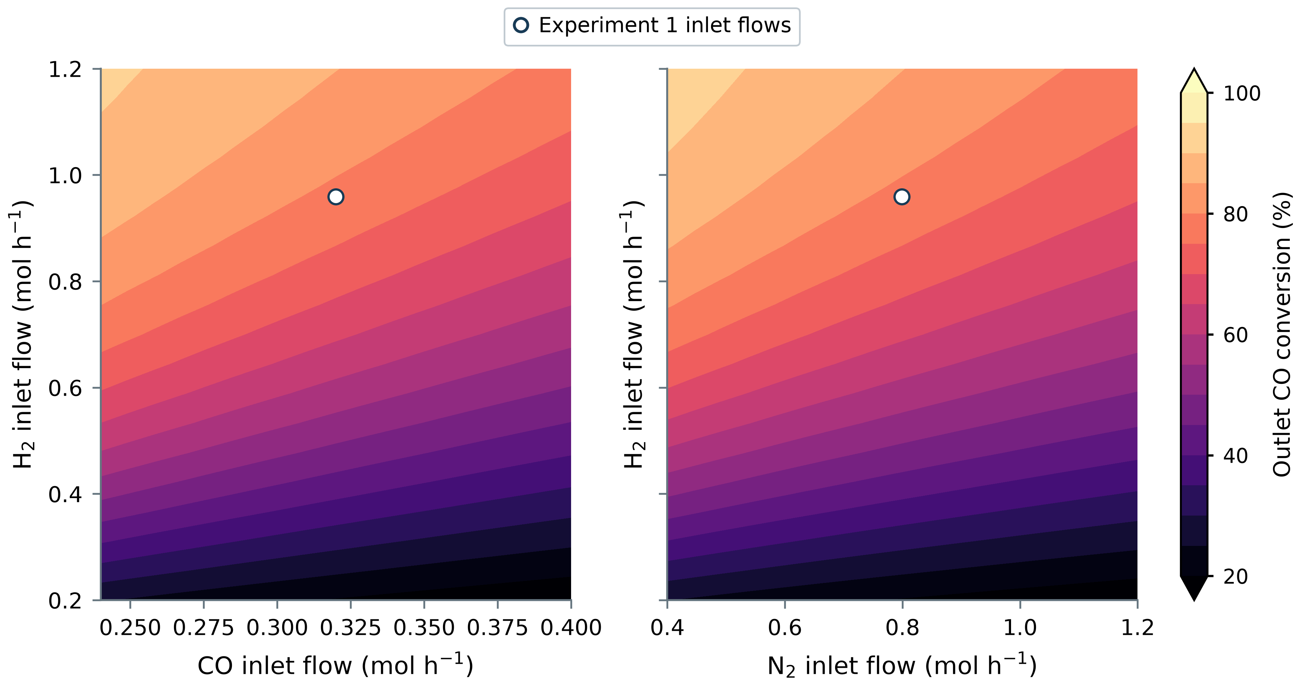
Figure 6. Full M4 feed-flow sensitivity at 1 bar. Panel (a) varies CO and H₂ at fixed N₂; panel (b) varies N₂ and H₂ at fixed CO. Circular points mark the Experiment 1 inlet flows; both panels share a color scale.
At fixed N₂, conversion rises with H₂ supply relative to CO. In panel (b), added N₂ lowers conversion at fixed reactive flows; dilution and total inlet flow both change.

Nitrogen-flow sensitivity at fixed reactive flows
Figure 7 shows a 42-case N₂ sweep with CO held at 0.320 mol h⁻¹ and H₂ at 0.959 mol h⁻¹. As N₂ varies from 0.400 to 1.200 mol h⁻¹, predicted conversion falls from 88.14% to 70.34%; the reference N₂ flow of 0.799 mol h⁻¹ gives 78.72%. Since reactive flows are fixed, the curve captures the combined effect of dilution and increased total flow at 1 bar, below the fitted pressure range.
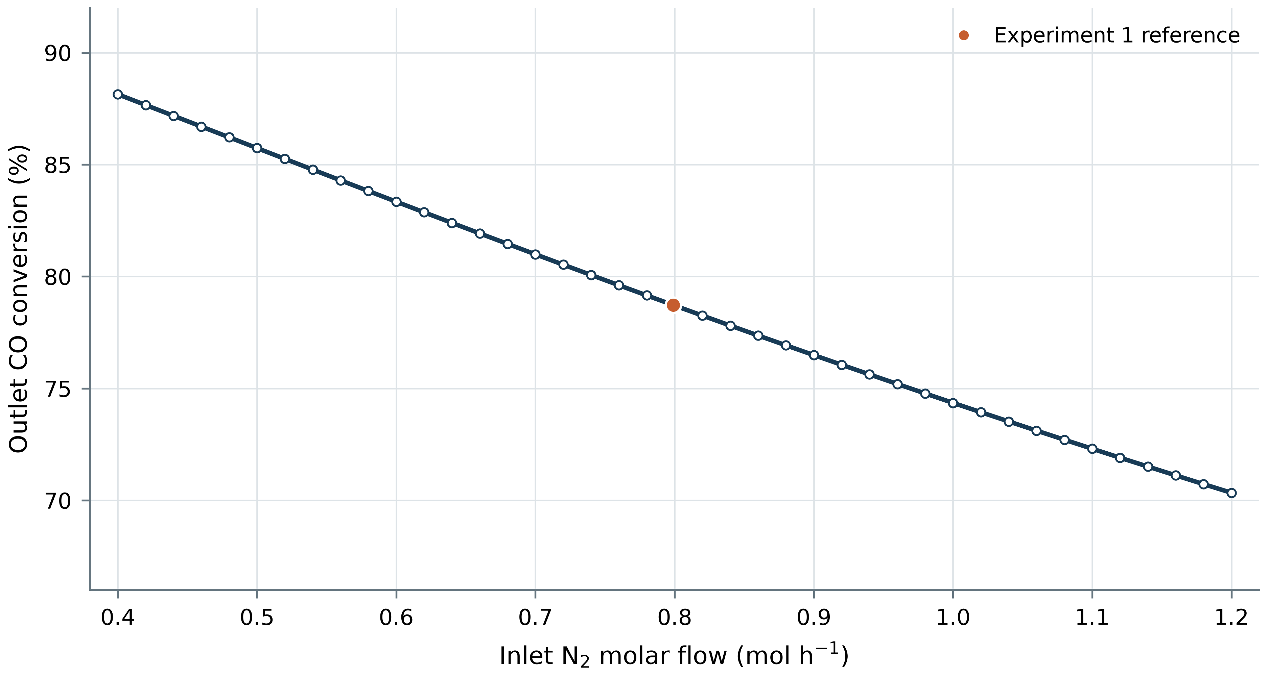
Figure 7. Full M4 conversion as N₂ flow changes with CO and H₂ held at their Experiment 1 values. The circular marker identifies the reference N₂ feed. The model is evaluated isothermally at 350 °C and 1 bar.

Conclusions
At the selected 1 bar Experiment 1 conditions, Full M4 predicts 78.72% CO conversion, compared with the reported 40.63%. Because 1 bar lies below the fitted pressure range and the source gives conflicting pressure values, this difference does not establish predictive accuracy. In the separate assumed 5 bar bed, conversion reaches 95.81%, but the calculated 546.5 °C hot spot exceeds the published temperature-fit range. Over the specified sensitivity cases, conversion rises with H₂/CO and catalyst space time and falls as N₂ flow increases at fixed CO and H₂. An experimental comparison requires a resolved pressure basis, measured reactor geometry and packing, and kinetics for the catalyst and local bed conditions.

References
[1] F. Celoria, F. Salomone, A. Tauro, et al., “Kinetic study and deactivation phenomena for the methanation of CO₂ and CO mixed syngas on a Ni/Al₂O₃ catalyst,” Chemical Engineering Journal, vol. 512, article 162113, 2025. doi: 10.1016/j.cej.2025.162113.
[2] J. Kopyscinski, T. J. Schildhauer, F. Vogel, S. M. A. Biollaz, and A. Wokaun, “Applying spatially resolved concentration and temperature measurements in a catalytic plate reactor for the kinetic study of CO methanation,” Journal of Catalysis, vol. 271, no. 2, pp. 262–279, 2010. doi: 10.1016/j.jcat.2010.02.008. See also the corrigendum, Journal of Catalysis, vol. 273, no. 1, p. 82, 2010. doi: 10.1016/j.jcat.2010.05.001.
[3] A. Quindimil, J. A. Onrubia-Calvo, A. Davó-Quiñonero, et al., “Intrinsic kinetics of CO₂ methanation on low-loaded Ni/Al₂O₃ catalyst: Mechanism, model discrimination and parameter estimation,” Journal of CO₂ Utilization, vol. 57, article 101888, 2022. doi: 10.1016/j.jcou.2022.101888.
[4] P. Virtanen, R. Gommers, T. E. Oliphant, et al., “SciPy 1.0: Fundamental algorithms for scientific computing in Python,” Nature Methods, vol. 17, pp. 261–272, 2020. doi: 10.1038/s41592-019-0686-2.
[5] Experiment 1 source report and data supplied with the project, unpublished project material.

