Four Factor Optimization of CO Methanation in a Fixed Bed Reactor
A 20,412-case grid search of the Full M4 reactor model gave a best sampled setting of 370 °C, 15 bar absolute, H₂/CO = 5.0, and 140.4 kg catalyst·s/mol CO. The predicted outlet CO conversion was 99.999993%. This is a model result for the stated grid.

Methodology
The search used the Full M4 fixed bed model on the Experiment 1 basis. Catalyst mass was 3.12 g, and the inlet N₂/CO molar ratio was fixed at 2.496875. The inherited reactor geometry and an assumed particle density of 1250 kg m⁻³ give a bed voidage of 0.98384. Each case was integrated to the bed outlet under an isothermal assumption with Ergun pressure drop and the BDF solver.
The grid varied inlet H₂/CO ratio, temperature, absolute pressure, and catalyst space time on a CO feed basis. Its 12 × 9 × 9 × 21 combinations all completed. At fixed catalyst mass, space time set the CO inlet flow; the H₂ and N₂ flows followed from their respective inlet ratios. Total inlet flow therefore changed with space time and H₂/CO ratio.
The objective was the completed bed outlet CO conversion, defined as
$$X_{CO,out} = 100(1 − \frac{F_{CO,out}}{F_{CO,in}}) \%$$
The highest conversion was selected, with no hydrogen, pressure, or throughput cost in the objective. Each figure varies one factor across its saved values while the other three remain at the selected point. The pressure grid covers 1–15 bar absolute. Kinetic parameters were fitted over 5–15 bar, so the 1–4 bar predictions are extrapolations.

Results and discussion
Table 1. Search ranges and best sampled model result.
Quantity | Grid or role | Best sampled value
Inlet H₂/CO ratio | 1.0–5.0 (12 levels) | 5.0
Inlet temperature | 250–400 °C (9 levels) | 370 °C
Inlet pressure | 1–15 bar abs (9 levels) | 15 bar abs
Catalyst space time | 8.775–140.4 (21 levels) | 140.4 kg catalyst·s/mol CO
CO / H₂ / N₂ inlet flow | Derived from inputs | 0.080 / 0.400 / 0.19975 mol h⁻¹
Outlet CO conversion | Objective | 99.999993%
Outlet CH₄ yield | Predicted output | 99.999932%
The selected temperature was an interior grid value; H₂/CO ratio, pressure, and space time reached their upper sampled bounds. At the selected values of the other inputs, raising H₂/CO from 1.0 to 1.4 increased conversion from 89.27% to 99.14% (Figure 1). Subsequent gains were smaller. Temperature peaked at the sampled 370 °C point, with a slight decline at 385 and 400 °C (Figure 2).
The pressure and space time slices also approach a plateau (Figures 3 and 4). Over the fitted pressure interval, conversion changed from 99.999112% at 5 bar to 99.999993% at 15 bar. Increasing space time from 8.775 to 140.4 kg catalyst·s/mol CO raised conversion from 99.5533% to 99.999993%. At the selected point, CO feed was 0.080 mol h⁻¹. At the nominal Experiment 1 inputs, the model predicts 96.94% conversion against a source-reported 40.63%. This unresolved difference and the assumed bed geometry limit interpretation of the optimized model result.

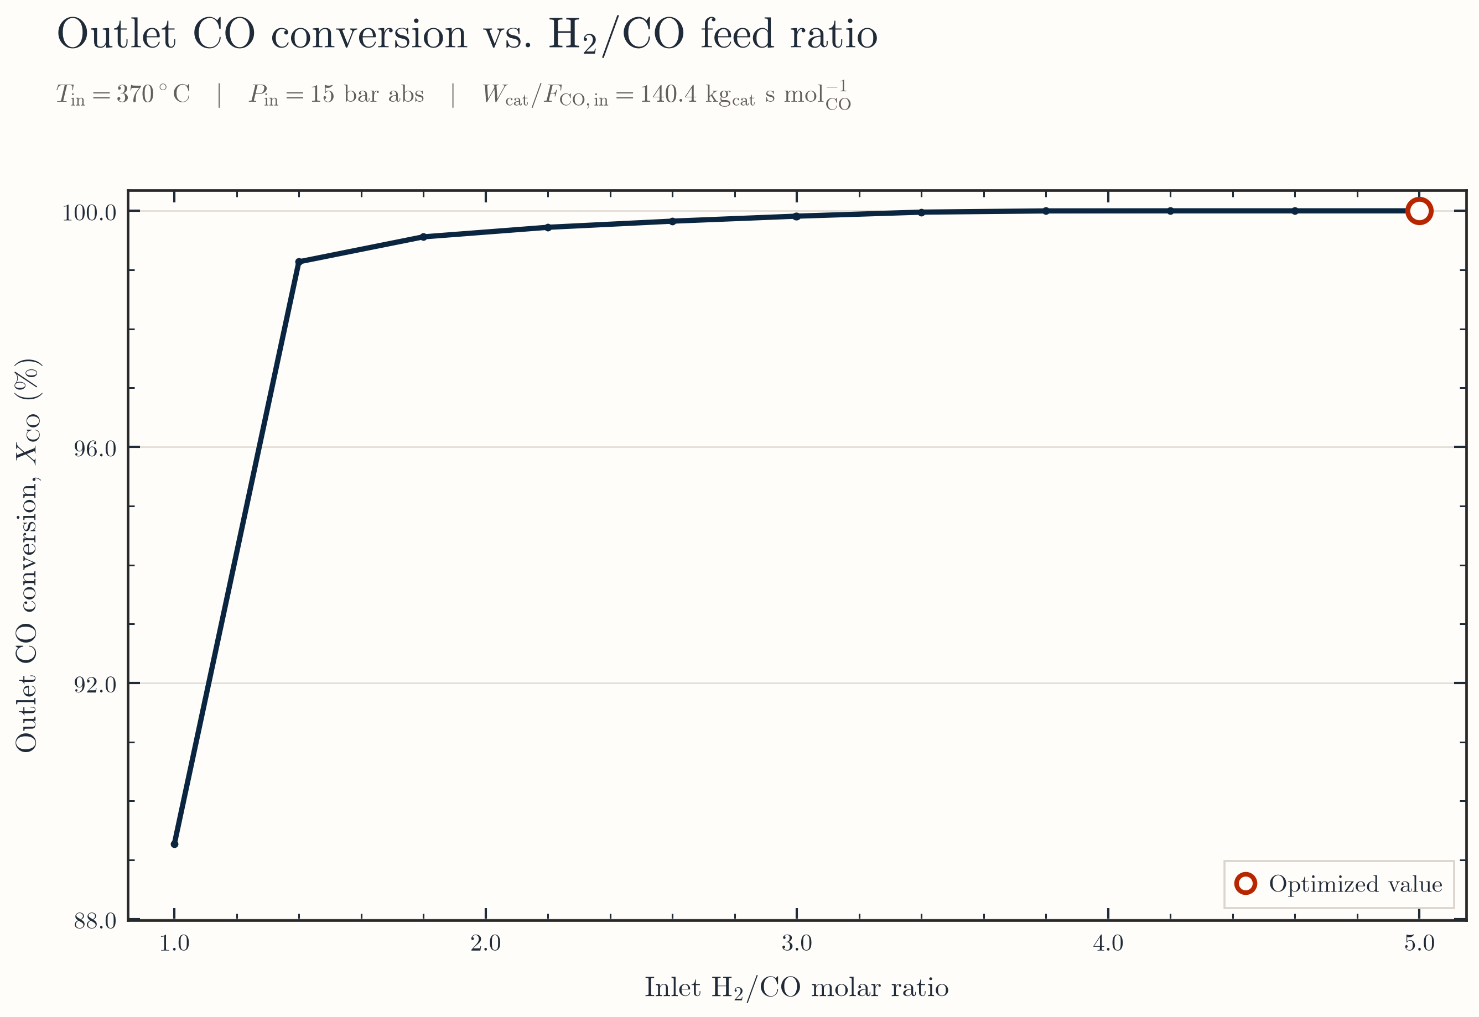
Figure 1. Outlet CO conversion across the sampled H₂/CO ratios.
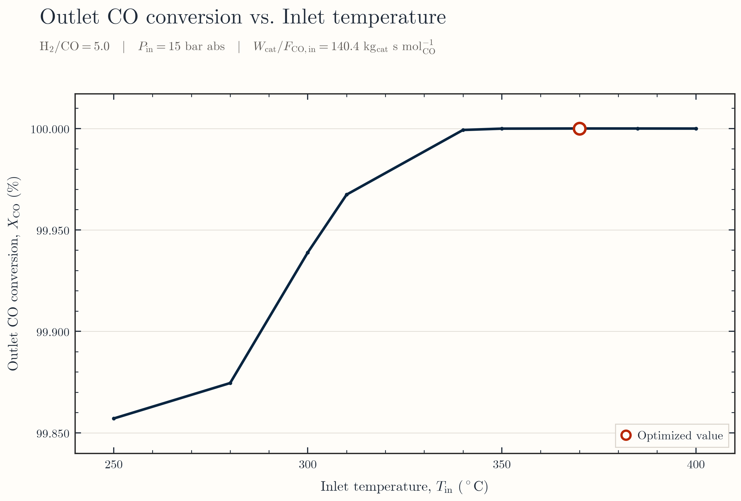
Figure 2. Outlet CO conversion across the sampled inlet temperatures.

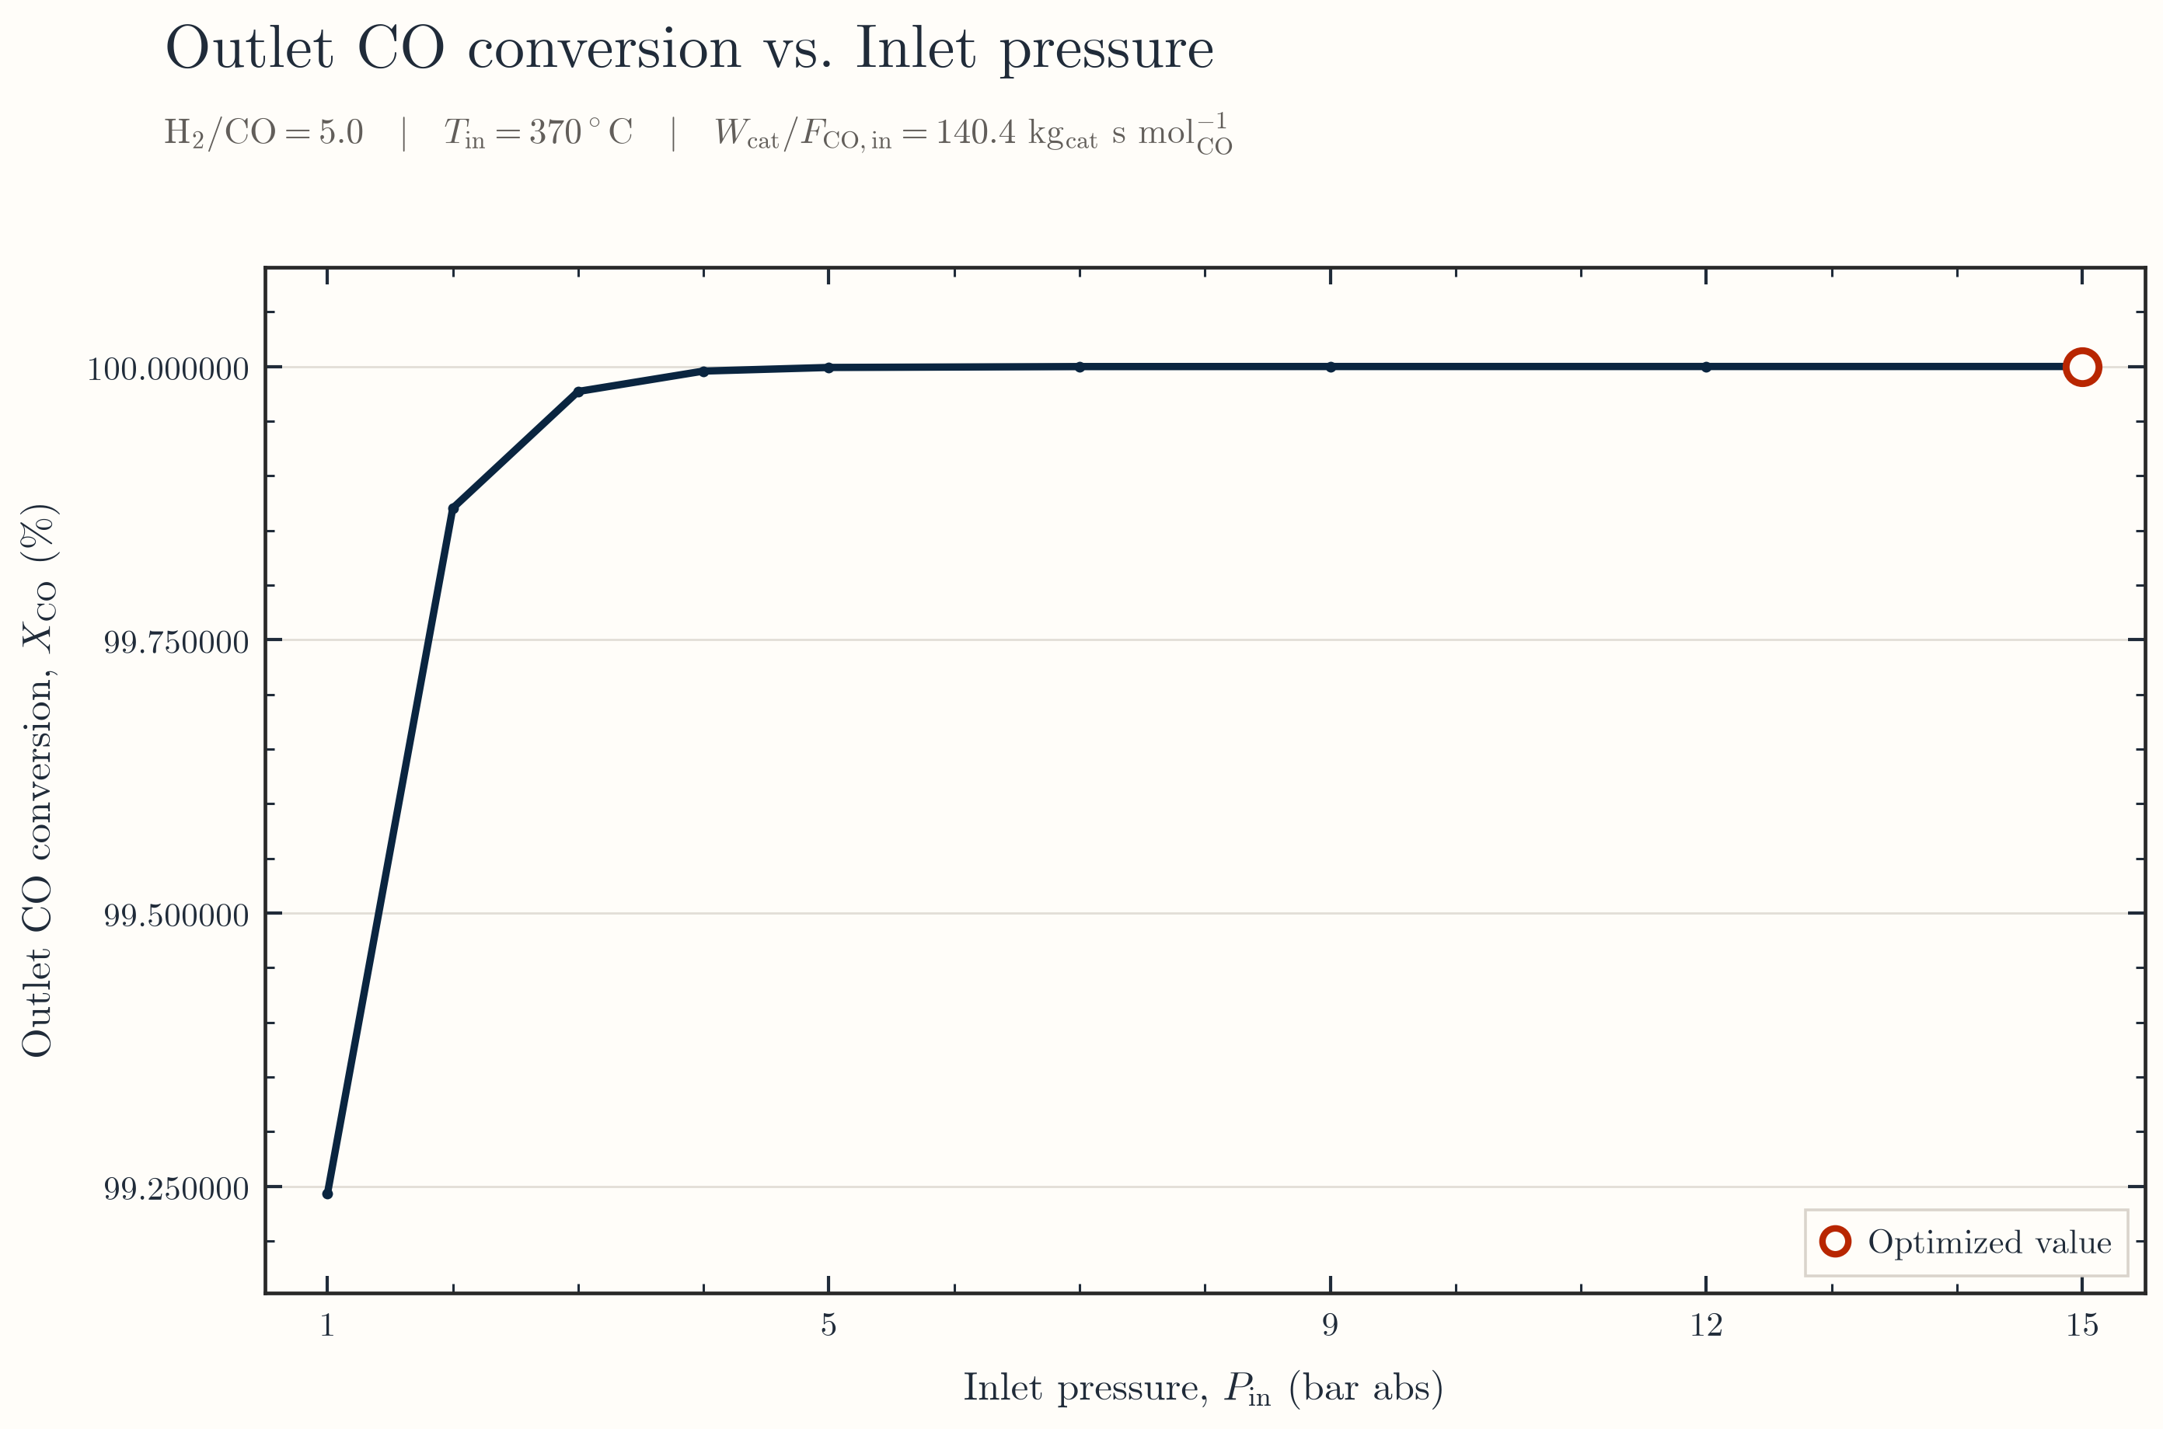
Figure 3. Outlet CO conversion across the sampled inlet pressures.
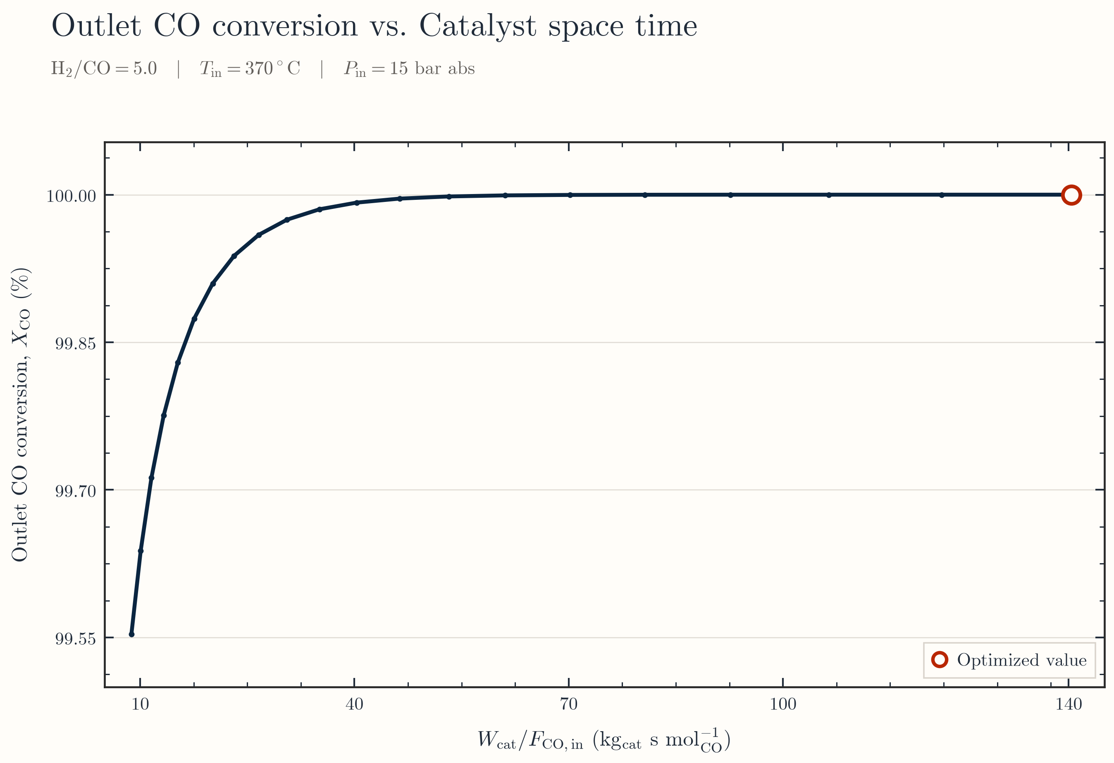
Figure 4. Outlet CO conversion across the sampled catalyst space times.

