Four Factor Optimization of CO Methanation in a Fixed Bed Reactor
A 20,412-case search of the Full M4 fixed bed model selected H₂/CO = 5.0, 370 °C, 15 bar absolute, and a catalyst space time of 140.4 kg catalyst·s/mol CO. Predicted outlet CO conversion was 99.999993%. The selected point lies on three grid boundaries and is a conditional model result, not a measured operating optimum.

Methodology

Reactor model and fixed basis
The Full M4 model follows CO, H₂, CH₄, H₂O, CO₂, and N₂ through a catalyst bed. It includes CO methanation, CO₂ methanation, and the water gas shift reaction. Species molar balances are integrated against catalyst mass. At each axial position, local mole fractions and pressure determine the species partial pressures used in the rate expressions. The original M4 kinetic constants were retained; no parameter was adjusted to reproduce Experiment 1.
Catalyst mass was held at 3.12 g. The assumed tube diameter and bed length were 25.4 mm and 304.8 mm; particle diameter was 3 mm. An assumed particle density of 1250 kg m⁻³ sets the bed voidage to 0.98384 for this catalyst charge and geometry. This unusually sparse bed is part of the numerical basis, not a measured packed bed property. Temperature was constant along the bed, while the Ergun relation supplied the axial pressure change. The inlet contained CO, H₂, and N₂, with N₂/CO fixed at 2.496875.

Factor grid and feed construction
The four inputs were inlet H₂/CO ratio, temperature, absolute pressure, and catalyst space time on an inlet CO basis. Ratio, temperature, and pressure levels came from the earlier three-factor map; the 21 space times came from the earlier ratio–space-time sweep. The ratio grid includes both the recorded Experiment 1 ratio of 2.996875 and the rounded value 3.0. Temperature was sampled at 250, 280, 300, 310, 340, 350, 370, 385, and 400 °C. Pressure was sampled at 1, 2, 3, 4, 5, 7, 9, 12, and 15 bar absolute. Space time ran from 8.775 to 140.4 kg catalyst·s/mol CO with geometric spacing.
Catalyst space time was defined as
$$τ_{CO} = \frac{W_{cat}}{F_{CO,in}}$$
where catalyst mass is in kilograms and inlet CO flow is in mol s⁻¹. At every grid point, the selected space time set the CO flow. H₂ flow equaled the selected H₂/CO ratio times CO flow; N₂ flow equaled 2.496875 times CO flow. Thus changing space time scaled all three feeds together, whereas changing H₂/CO changed the H₂ feed alone at a given space time. Neither CO throughput nor total inlet flow was fixed across the optimization.

Numerical search and figure construction
The Cartesian product contained 12 × 9 × 9 × 21 = 20,412 model cases. Each dry-feed case used the model's near-inlet start before integration with SciPy's BDF solver. Relative tolerance was 10⁻⁶, and the absolute molar-flow tolerance was 10⁻¹⁴ mol s⁻¹. A case counted as completed only if integration reached the full 3.12 g catalyst mass without a terminal pressure, temperature, or hydrogen event. All 20,412 cases completed. The saved grid records the inlet factors, outlet conversion and methane yield, feed flows, outlet pressure, and solver status for each case.
The objective was outlet CO conversion on the inlet CO basis:
$$X_{CO,out} = 100(1 − \frac{F_{CO,out}}{F_{CO,in}}) \%$$
Methane yield was calculated as net outlet CH₄ production divided by inlet CO flow and reported separately. The case with the largest computed conversion was selected; the objective contains no charge for hydrogen, pressure, or loss of throughput. The four figures vary one factor at a time around the selected case and use separate enlarged vertical scales. The pressure slice includes 1–4 bar points, which extrapolate the 5–15 bar kinetic fit interval.

Results and discussion
Table 1. Search ranges and best sampled model result.
Quantity | Grid or role | Best sampled value
Inlet H₂/CO ratio | 1.0–5.0 (12 levels) | 5.0
Inlet temperature | 250–400 °C (9 levels) | 370 °C
Inlet pressure | 1–15 bar abs (9 levels) | 15 bar abs
Catalyst space time | 8.775–140.4 (21 levels) | 140.4 kg catalyst·s/mol CO
CO / H₂ / N₂ inlet flow | Derived from inputs | 0.080 / 0.400 / 0.19975 mol h⁻¹
Outlet CO conversion | Objective | 99.999993%
Outlet CH₄ yield | Predicted output | 99.999932%

Best sampled case
The highest completed-bed conversion was 99.99999281%, with a predicted methane yield of 99.99993177%. Total inlet flow was 0.67975 mol h⁻¹. Temperature was an interior grid value, while ratio, pressure, and space time reached their upper sampled bounds. The grid therefore does not locate interior maxima for those three inputs. Methane yield was recorded, not optimized as a second objective.

Hydrogen ratio and temperature
With temperature, pressure, and space time fixed at the selected setting, conversion rose from 89.2678% at H₂/CO = 1.0 to 99.1364% at 1.4 (Figure 1). At a ratio of 3.0 it was 99.9099%, and at 5.0 it was 99.999993%. Most of the change occurred at the low end of the ratio range. Further hydrogen addition had little effect after outlet CO was nearly depleted.
Along the temperature slice, conversion was 99.857060% at 250 °C and 99.999923% at 350 °C (Figure 2). It reached 99.999993% at the sampled 370 °C point, then fell to 99.999960% at 400 °C. The difference between 370 and 400 °C is about 0.000032 percentage points. Thus 370 °C is the sampled maximum, but the high-temperature peak is shallow on an absolute conversion scale.

Pressure and catalyst space time
At the selected ratio, temperature, and space time, the pressure slice gave 99.2432% conversion at 1 bar, 99.999112% at 5 bar, and 99.999993% at 15 bar (Figure 3). The 1–4 bar portion is outside the fitted pressure interval. Within 5–15 bar, the gain is about 0.000880 percentage points at this already high conversion. Pressure has no cost in the objective, and its selected value is the upper grid bound.
The space time slice shows the associated throughput change. Conversion increased from 99.5533% at 8.775 kg catalyst·s/mol CO to 99.98516% at 35.1 and 99.999745% at 70.2 (Figure 4). The 140.4 setting gave the largest conversion, but it lowered the CO inlet flow from 1.28 mol h⁻¹ at the 8.775 setting to 0.080 mol h⁻¹, a sixteenfold reduction. With H₂/CO = 5.0 and the fixed N₂/CO ratio, total inlet flow likewise fell from 10.876 to 0.67975 mol h⁻¹. The conversion-only objective favors the longer space time despite the much smaller feed rate.

Limits of interpretation
The saved optimization summary compares its 2 bar reference case with a source-reported CO conversion of 40.63%; the model gives 96.94% at that saved point. The Experiment 1 abstract and results describe atmospheric operation, whereas an appendix states 2 bar. The saved comparison uses the appendix pressure and does not validate the model at the atmospheric-pressure reading. The reported conversion was not a kinetic fitting target.
The assumed bed voidage and isothermal operation also constrain the physical meaning of the near-complete predicted conversion. The result is the best sampled case, not a continuous optimum. Boundary values for ratio, pressure, and space time, together with unpenalized hydrogen use and throughput, preclude an operating recommendation without additional constraints and experimental checks.
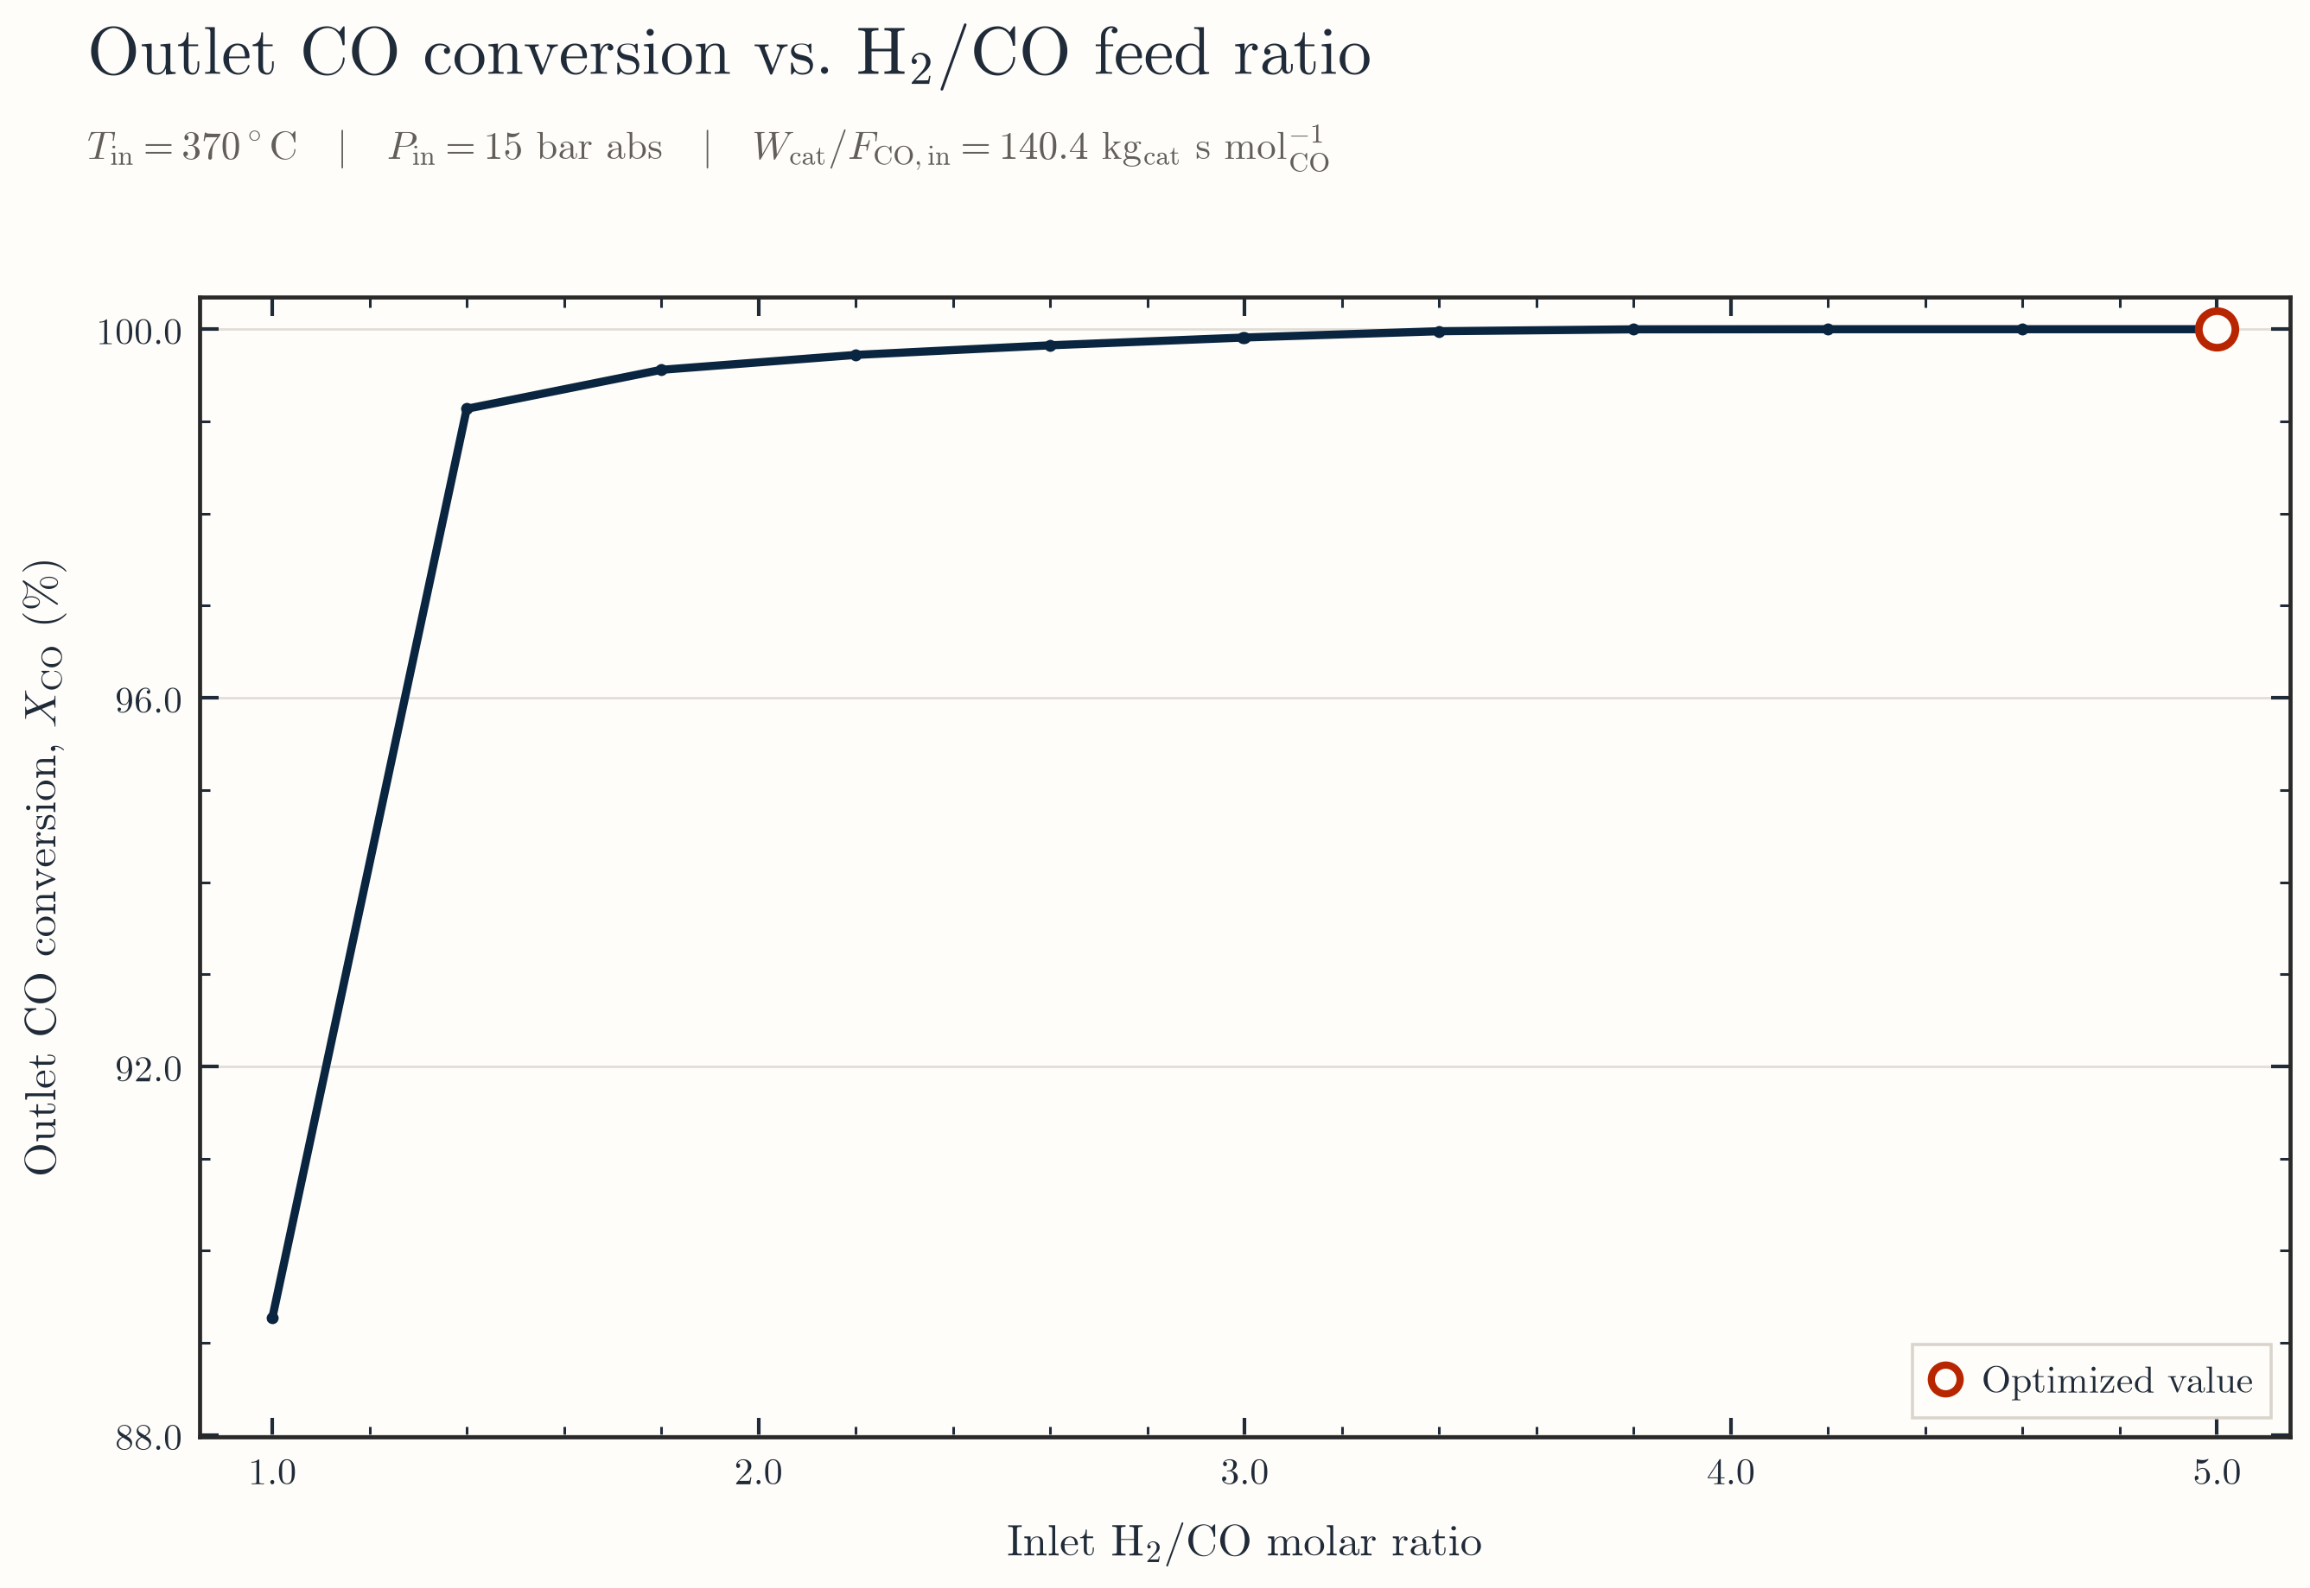
Figure 1. Outlet CO conversion across the sampled H₂/CO ratios.
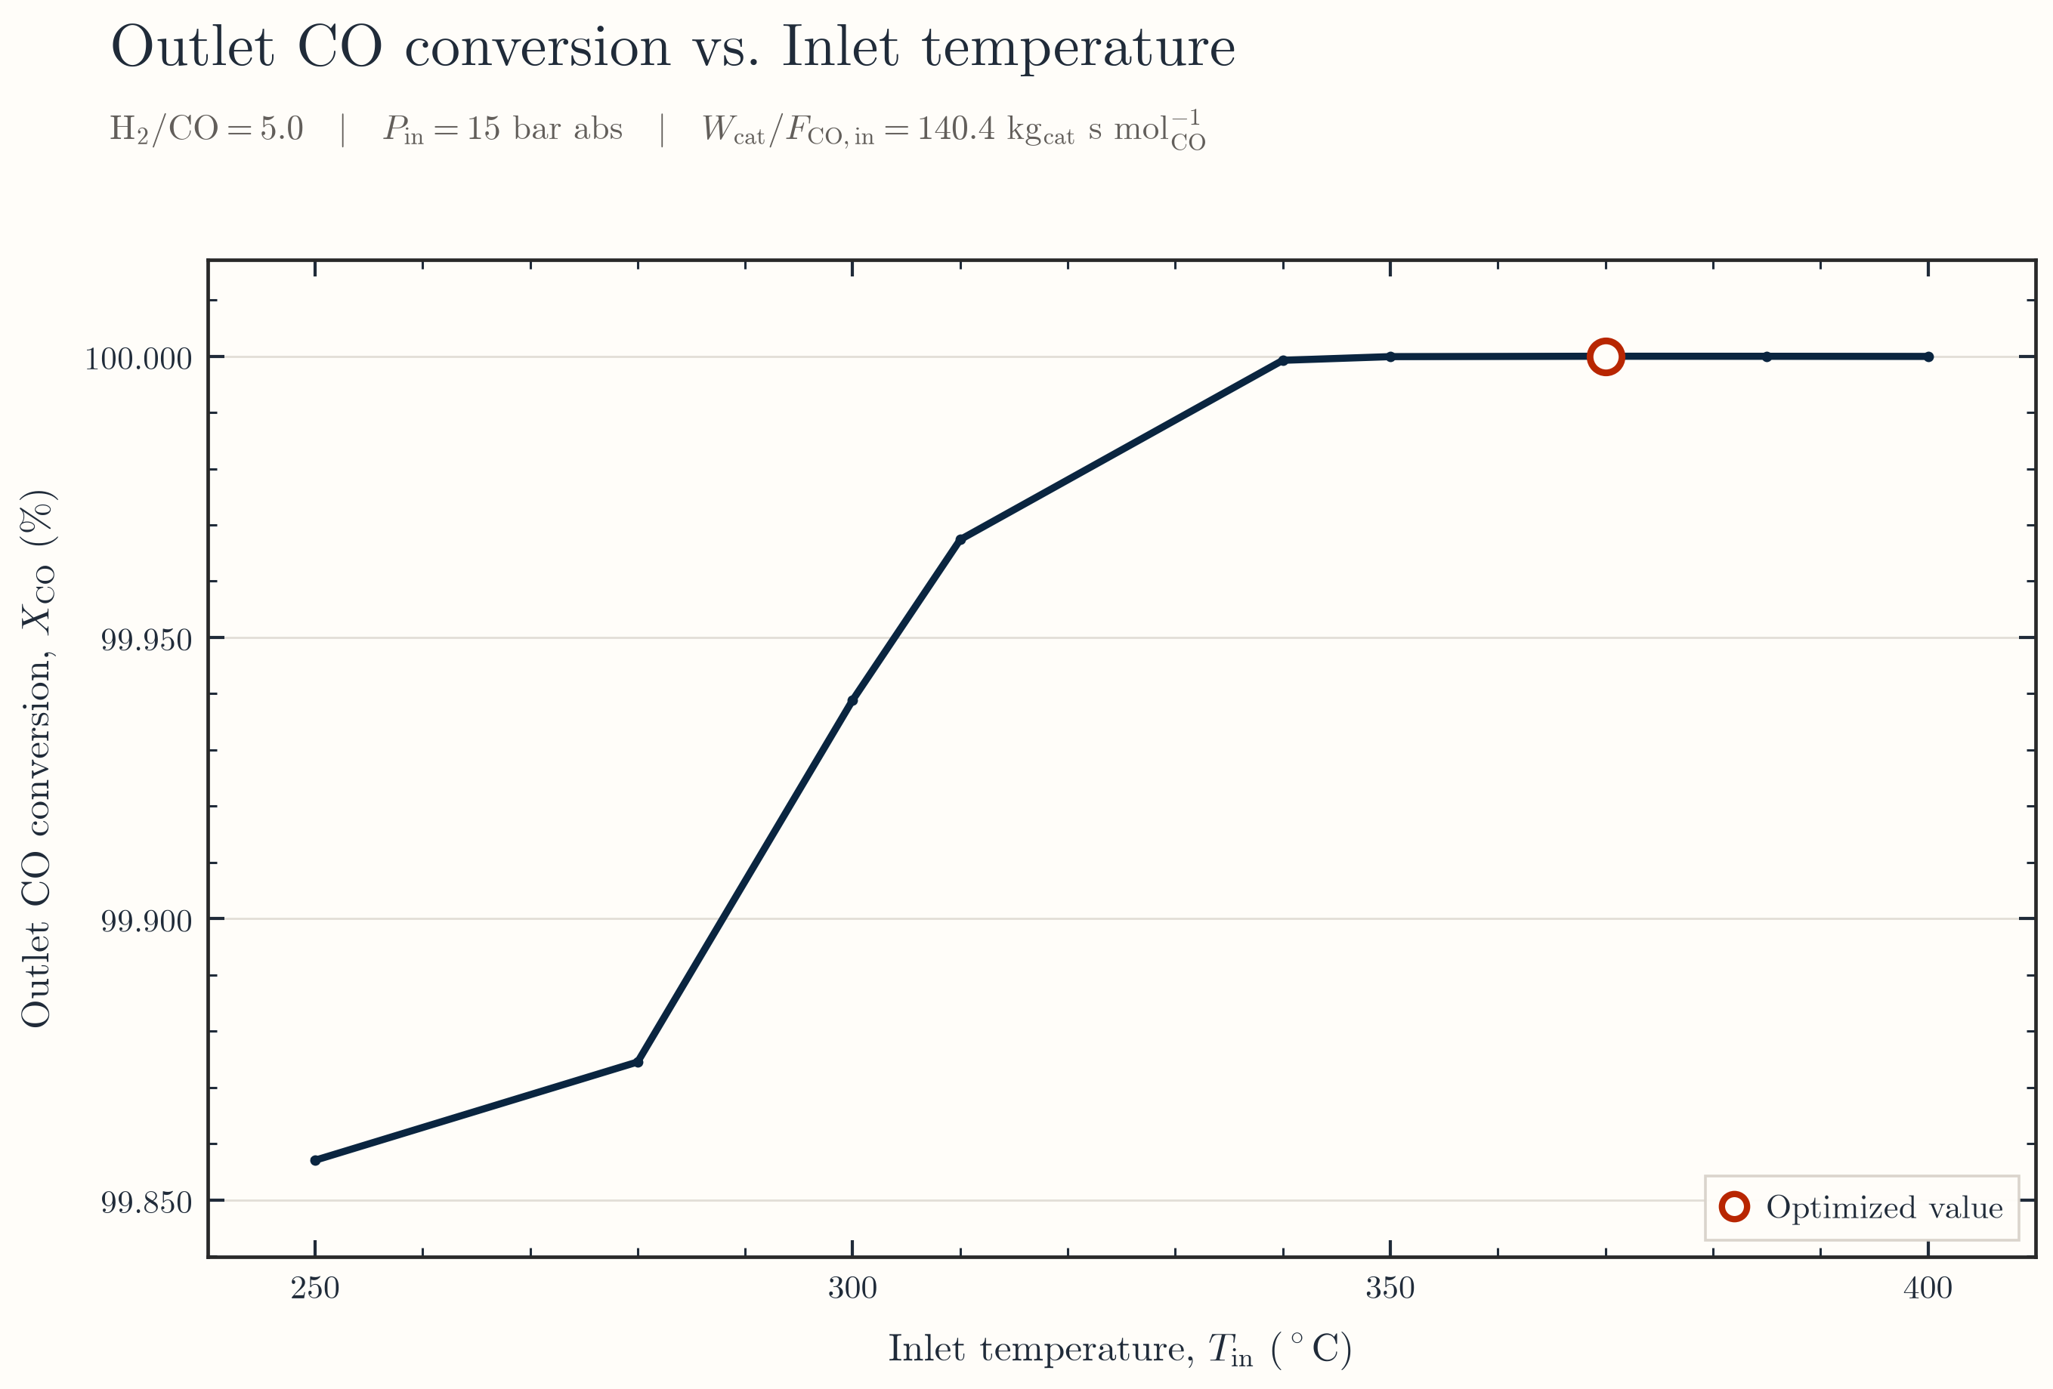
Figure 2. Outlet CO conversion across the sampled inlet temperatures.
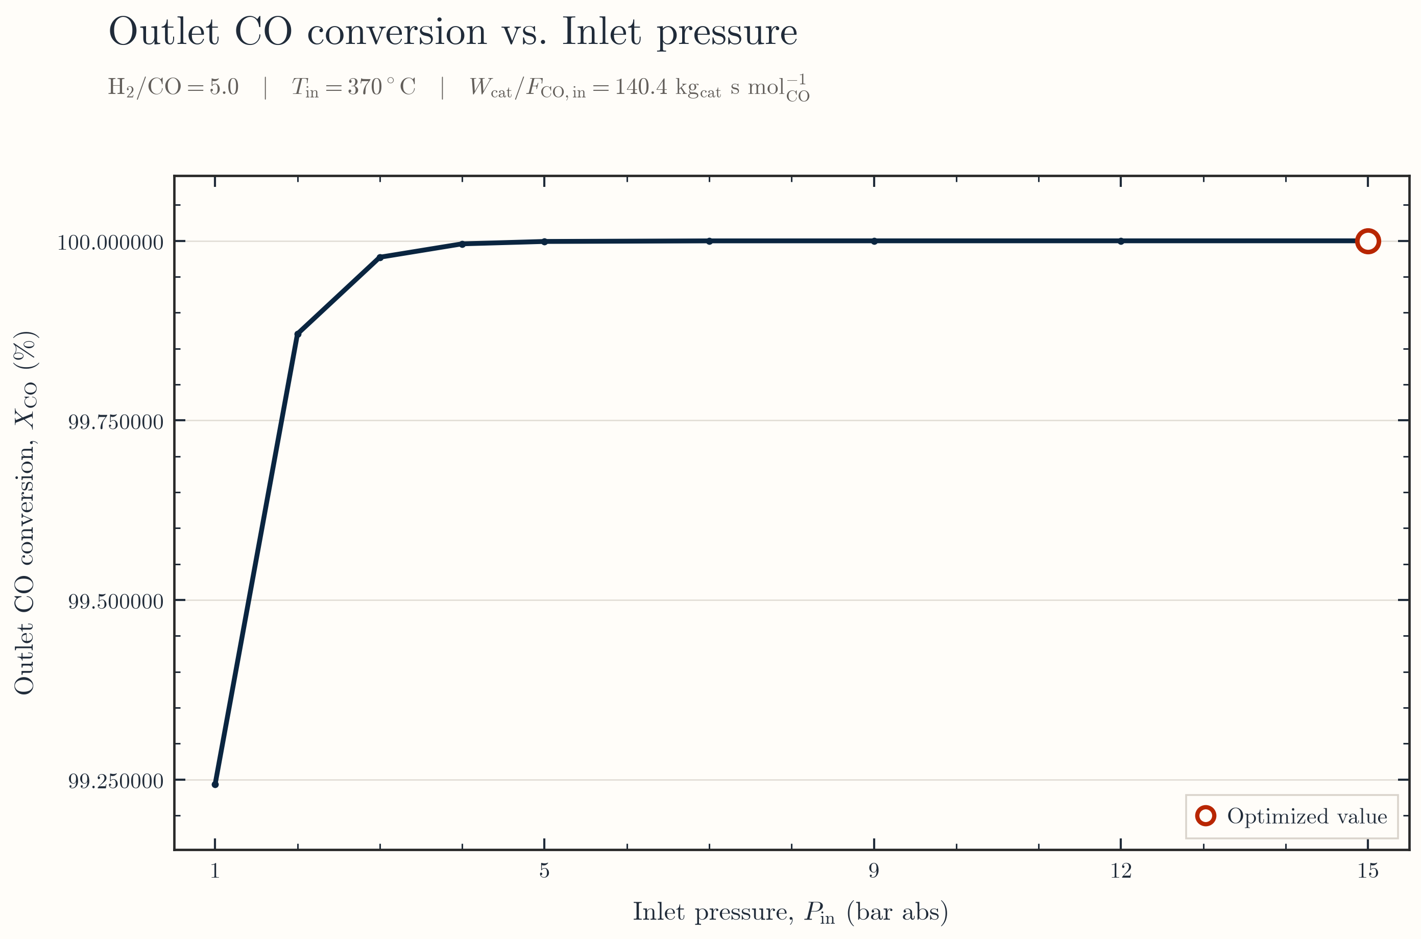
Figure 3. Outlet CO conversion across the sampled inlet pressures.
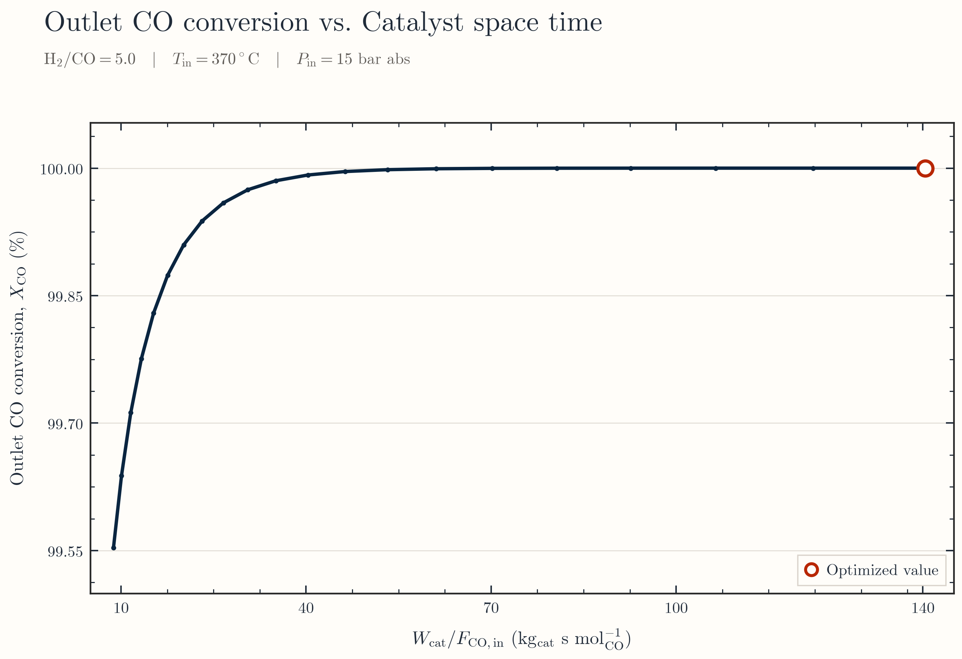
Figure 4. Outlet CO conversion across the sampled catalyst space times.

