Data Visualisation for business using Python and Bokeh.

Introduction
Data Visualisation describes the process of representing data in a graphical form, to communicate it more clearly and to help reveal any patterns within it. It has always played an important part in the fields of scientific research, or anywhere data must be studied, presented or used in decision making processes.
For a business, the power of data visualisation is in the ability to gain insights from all the data it has access to, whether this data is held in in-house databases, recorded by various sensor systems, or available through wider internet channels such as social media. Its day to day use in business ranges from creating simple charts in Excel, to using enterprise-level specialised packages like Tableau and QlikView.
In recent years, there has also been a trend for live graphics displayed on a dashboard-style screen, rather than, or in addition to, simply having periodic reports presented to management. These systems often take a browser-based approach, for example, using JavaScript libraries to build image files in the web page. Business dashboard systems may be different from analytical and presentation systems in that they typically allow users to monitor status and performance, such as business KPIs.

Objective
This project investigates the use of the Python programming language, coupled with the Bokeh Python/JavaScript libraries, for the purposes of processing business data, and turning that data into useful visuals for the purposes of data analysis, presentations, and business dashboards. The project will also look at some of the technical challenges in setting up a low-cost dashboard system, in terms of the hardware, software and networking challenges involved.
The project will research the sort of data sources data scientists and businesses have to work with, what the data can reveal through visualisation, and what hardware they could use to present and display the results. The concepts will be demonstrated using a variety of real-world public data, and some real business data will be used in building a business dashboard for a call centre.
Data visualisation
What is it and who uses it?
From maps to royal family trees, data visualisation has a long history in presenting, understanding and maximising value from data. Today, when the amount of data being generated is growing exponentially, there is a greater need than ever for people and tools to apply data visualisation skills to make sense of it. The range of types of data is also expanding with video, sound, sensor data, network data, web statistics and communications data.
Data visualisation techniques may differ greatly depending on the context and the intended audience. In data science, it may be used as part of data exploration, and as an aid in statistical analysis. In media, it is used to demonstrate concepts or figures such as weather data, or to help tell a story. In business it is used to do all of these.
Some common types of visual used include line and bar charts, scatter plots and histograms. Other more specialised charts and visuals include those used for networks, economic data like stock prices, Gantt charts for project planning and medical scans.

Technology

Python
Python is a popular programming language designed to be easy to use, easy to read and easy to extend. It ships with most Linux installs but can be used on most operating systems. It is often used as a scripting language for one-off jobs or quickly putting small applications together, and can be used as a ‘glue’ language for working with existing components written in faster performing languages like C.
Python has a large open-source community and thousands of pre-built packages are available for web frameworks, working with databases and with different data formats. There are tools for testing, automation and system administration.
Python is particularly popular in scientific computing, including the growing Data Science community, with libraries like NumPy, Pandas, SciPy and MatPlotLib. Many of these provide functionality similar to that of the specialised R language for statistical and analytical purposes.

Bokeh
Bokeh is a visualisation library with a Python component. In the creator’s words “Its goal is to provide elegant, concise construction of novel graphics in the style of D3.js, but also deliver this capability with high-performance interactivity over very large or streaming datasets”.
Using Bokeh can mean writing only Python code, but the output is an interactive HTML5 object for modern browsers, which uses Canvas to render the graphics. The output can be hooked up to a Bokeh server for real-time data updates, with any heavy computation being carried out on the server side.
Bokeh is a relatively new and still developing library so new functionality is being added quite quickly. It is being developed to tie in well with other Python data science tools such as Pandas, MatPlotLib and ggPlot. It has high level and low level interfaces, so you can create some standard charts easily without getting too involved in coding, or you can choose to have more control over all the inputs and configuration to produce highly customised visuals.
Bokeh Python works by basically translating Python objects into JSON. This is processed by the JavaScript library component of Bokeh into native Canvas and HTML (in addition to Python, the JSON can also be produced using NodeJS, R and Scala among others).
Some examples from the Bokeh gallery are shown below:
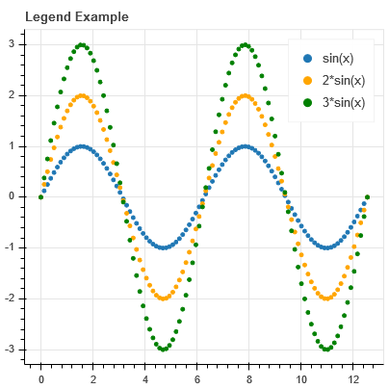
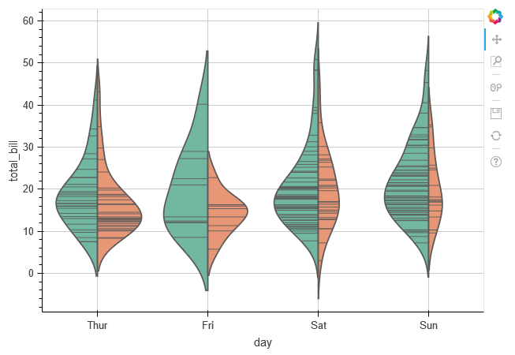
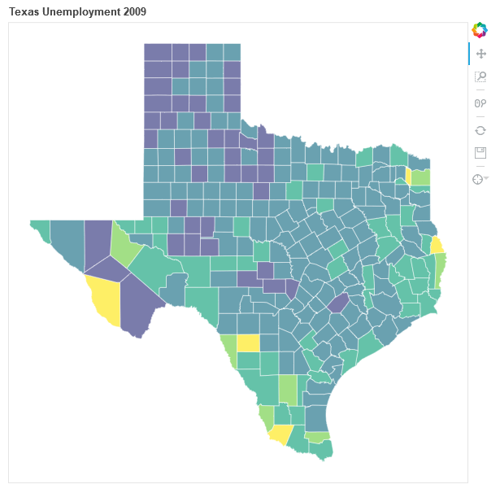
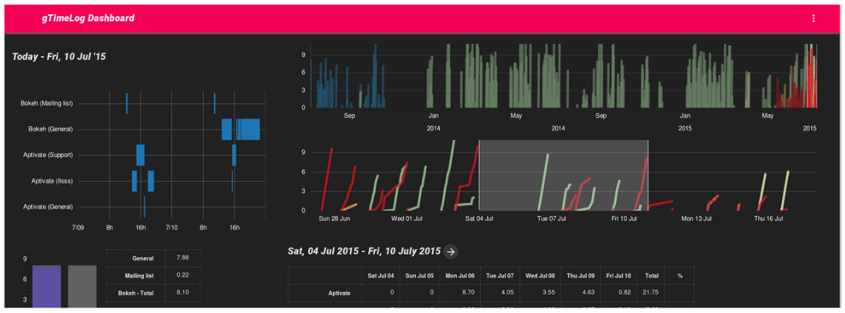

You can also see an example of a Bokeh version of a famous TED interactive presentation here.

Hardware
To demonstrate the low-cost dashboard concept, a standard TV with HDMI input will be used. The content will be served with an unobtrusive Raspberry Pi system mounted behind the screen. This will have to be set up to connect to the network through WiFi, be accessible remotely through SSH, and configured with custom start-up options to display the dashboard contents correctly without local user input.

Other considerations
- The coding for the project will be kept under version control using Git, and the Github service.
- Most of the work will be carried out on Linux Images on Oracle’s VirtualBox VM.
- A lot of the initial coding may be carried out and tested in an interactive Python browser environment, namely Jupyter (iPython) Notebook for instant feedback.
- If APIs have to be reproduced for serving data, these will use a Python REST Framework such as Django or Bottle.
- Raw data can come from a wide variety of sources in practice, so the project will attempt to replicate a good range of these.

Resources
- Intro to Python for Data Science https://www.datacamp.com/courses/intro-to-python-for-data-science
- Welcome to Bokeh http://bokeh.pydata.org/en/latest/
- One Chart, Twelve Charting Libraries http://lisacharlotterost.github.io/2016/05/17/one-chart-code/
- D3.js https://d3js.org/
- CSO Datasets http://data.cso.ie/datasets/index.html
- Reporting & Dashboard Software https://www.getapp.com/business-intelligence-analytics-software/reporting-dashboard/
- All-In-One Online Business Dashboard http://www.cyfe.com/
- Data Visualization Is The Future - Here's Why http://www.forbes.com/sites/dorieclark/2014/03/10/data-visualization-is-the-future-heres-why/
- PYTHON THE FASTEST GROWING OPEN DATA SCIENCE PLATFORM https://www.continuum.io/why-anaconda
- Raspberry Pi https://www.raspberrypi.org/
- Jupyter Notebook http://jupyter.org/

