Mod5-gradedmemo-KBaron.pdf

***Prepare a memo with the following information:***

***At least one screenshot of your AR effect in action***

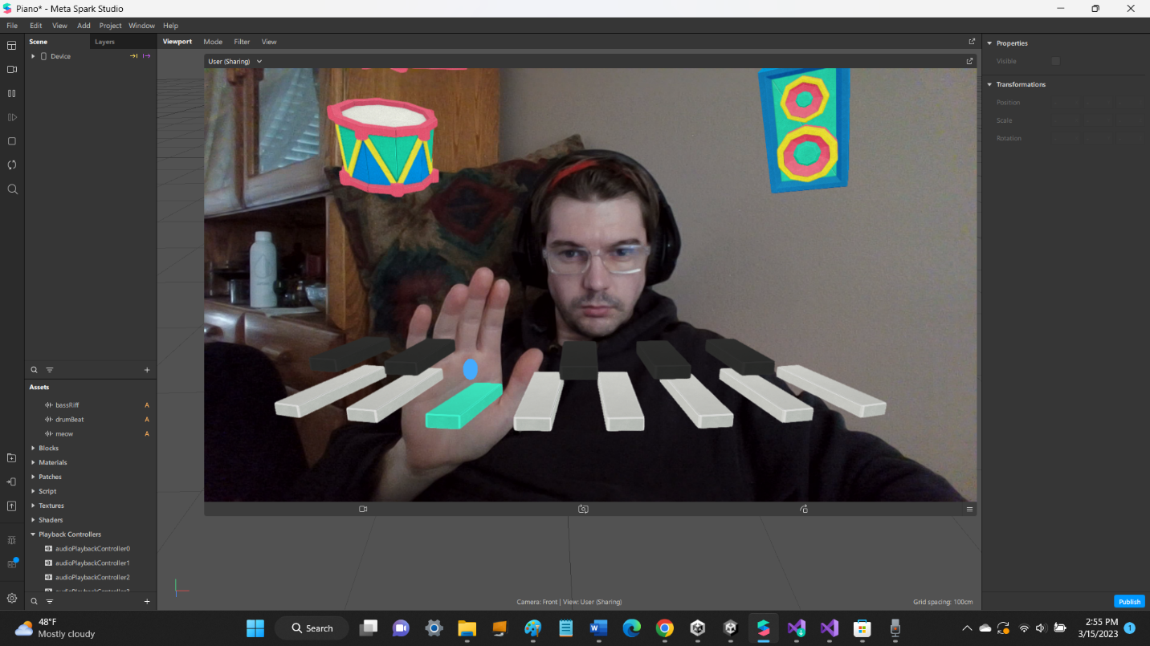

***A description of your AR effect’s functionality***

This AR experience allows the user to play music by putting either one or both of the hand cursors on piano keys, play a premade drum sequence by hovering a hand cursor over the drum object, or playing an entire premade drum and bass sequence by hovering a hand over the speaker object.

***The features of SparkAR that you used to create it***

This experience uses a VirtualPiano Block, preselected Audio (an “mmm” sound I recorded), and a landscape orientation to view the piano more spaced out. When using the “Try it on a device” option on Instagram, this horizontal option doesn’t seem to be reflected. I’m not sure if that’s because Instagram systematically does not flip to horizontal or if there is something I’m supposed to select or save in the Spark Studio.

***In three or four sentences, briefly explain the player agency and system agency in your AR effect. Consider these questions:***

***Player agency: What are the choices or actions that the user can make? Which user choices can affect the virtual world?***

The user can select the note they want to play by “touching” a different key. They also have agency over the tempo by how fast they decide to play. The choice is reflected by the key moving, turning green, and the sound effect starting. This can require some fine motor control and coordination to not hit adjacent notes.

***System agency: How does the system determine the virtual world? Does it conflict with the player agency?***

One noticeable area of system determination of the experience is the delay from the start of the audio file to the beginning of the “mmm” sound. This delay causes there to be conflict between the player agency and the system output, and makes the user (even though I’m pretty sure I know what is causing the problem) unsure about whether their input has been registered, which is detrimental when creating music. Minimum latency would be optimal.

The spacing of the keys is another system-introduced constant. The player cannot move the keys around, for example, by grabbing them. Positioning them in a way that reduces the chance of unintentional multiple simultaneous key inputs would be a good way to set up the keys from the start.