Want to make your Varsity Soccer Team next year?
Join Gala FC
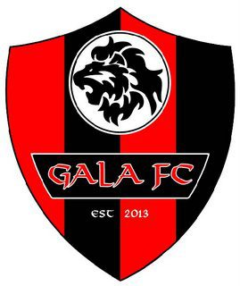
the club with the most college scholarships
and highest level training in the area

Day  Time | Location
Mondays  7:00 – 8:30 | Strawberry Fields Athletic Complex  6100 152nd St NE  Marysville, WA 98271
Tuesdays  7:15 – 8:45 | Tambark Creek Park  17217 35th Ave SE  Bothell, WA 98012
Wednesdays  7:00 – 8:30 | Kasch Park  8811 Airport Rd  Everett, WA 98204
Thursdays  6:00 – 7:30 | Martha Lake Airport Park  200 146th St SW  Lynnwood, WA 98087

Come to any practice to
try out and join Gala!

www.galafc.org (425) 346-0469
Want to make your Varsity Soccer Team next year?
Join Gala FC
the club with the most college scholarships
and highest level training in the area

Day  Time | Location
Mondays  7:00 – 8:30 | Strawberry Fields Athletic Complex  6100 152nd St NE  Marysville, WA 98271
Tuesdays  7:15 – 8:45 | Tambark Creek Park  17217 35th Ave SE  Bothell, WA 98012
Wednesdays  7:00 – 8:30 | Kasch Park  8811 Airport Rd  Everett, WA 98204
Thursdays  6:00 – 7:30 | Martha Lake Airport Park  200 146th St SW  Lynnwood, WA 98087

Come to any practice to
try out and join Gala!

www.galafc.org (425) 346-0469

