[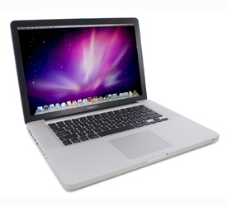](http://www.pcmag.com/slideshow_viewer/0,3253,l=250096&a=250056&po=0,00.asp)

**MSRP  
$1799.00**

* **PROS**

Superior design engineering. Seamless switching graphics technology. Fast Core i5 processor. Bigger battery. Illuminated keyboard. New motion scrolling multitouch gesture. Versatile touchpad. Higher resolutions with anti-glare available.

* **BOTTOM LINE**

At last, the MacBook Pro 15-inch gets the long awaited Intel Core processors and an unlikely graphics switching technology, but that's about it.

**SPEC DATA:**

**Apple MacBook Pro 15-inch (Core i5)**

|  |
| --- |
| **Type:** Gaming, General Purpose, Media |
| **Processor Name:** Intel Core i5-520M |
| **Processor Speed:** 2.4 GHz |
| **Operating System:** Mac OS X 10.6 |
| **RAM:** 4 GB |
| **Weight:** 5.5 lb |
| **Screen Size:** 15.4 inches |
| **Screen Type:** Widescreen |
| **Graphics Card:** Nvidia GeForce 330M |

|  |
| --- |
| **Graphics Memory:** 256 |
| **Storage Capacity (as Tested):** 320 GB |
| **Rotation Speed:** 5400 rpm |
| **Networking Options:** 802.11n |
| **Primary Optical Drive:** Dual-Layer DVD+/-RW |
| **Battery Type:** 77.5 Whr (Watt hours) |
| **Tech Support:** 1 year parts and labor |
| **MobileMark 2007 – Standard Battery Productivity Load (hrs:min):** 3:21 |
| **PCMark Vantage:** 5677 |
| **3-D BENCHMARK TESTS - 3DMark06 - Native – 0X/4X:** 5673 |