**Instruction**

1. Label the finger puppet in the column and at the back of the puppet.
2. Colour in your finger puppet.
3. Cut out a finger puppet along the dotted line and the strip.
4. 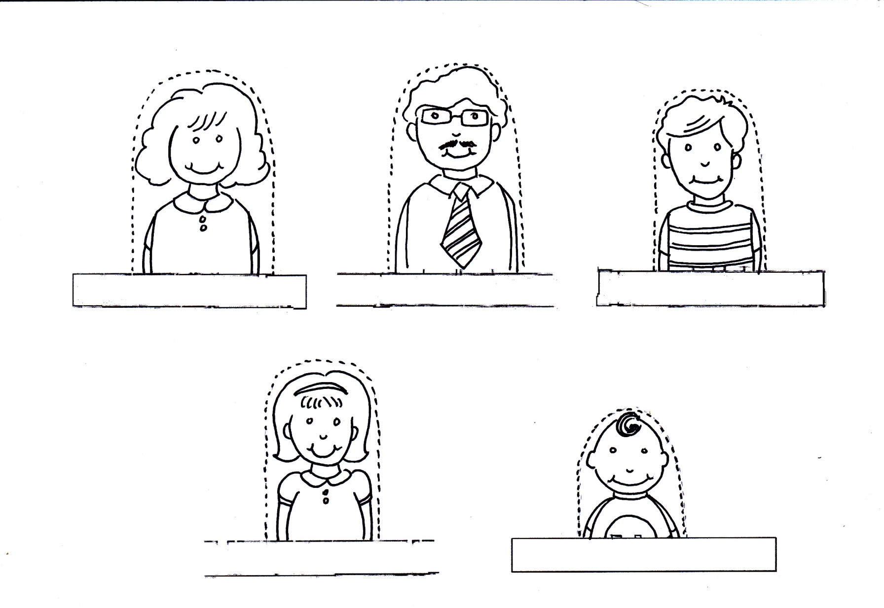Fold the puppet along the strip and use sticky tape to hold it together.