Finger Family Puppet
Norhasimah Mat Yasim, SK Sg Durin, Sibu.

Objective(s):
By the end of the activity pupils will be able to:
- Sing about members in the family and do actions.
- Make family finger puppets.
- Label the family finger.

Target Language:
- Family members (father, mother, brother, sister, baby)
- Greetings (“Where are you?” “Here I am”, “How do you do?”)

Time Needed:
Preparation: 5 Minutes
In class: 55 Minutes

Level:
Years 1 and 2

Language Focus:
Listening
Speaking
Language Arts
Choose an item.
Choose an item.

Activity Use:
Presentation
Practice
Production
Choose an item.

Pupil Task:
Whole Class
Individual
Choose an item.
Choose an item.

Materials:
- Finger puppet template.
- Colour pencil
- Scissors and tape.
Procedure:
Before class:
- Make a copy of finger puppet template for each pupil.
- Prepare a set of completed finger puppet as example for pupils.
In class:
- Review the family members (father, mother, brother, sister, baby).
- Teacher shows some pictures of family members and pupils identify the members.
- Teacher models a family finger song and finger play to silent the class (without the puppet). Pupils sing the family finger song 2-3x times.
- Teacher shows example of finger family puppets.
- Teacher explains and demonstrates correct ways of making finger puppets.
  - Label the puppets (i.e. father, mother, brother, sister, baby)
  - Colour them.
  - Cut according its shape.
  - Tape to fit the fingers.
- After pupils have finished their puppets, teacher checks pupils’ understanding by asking pupils to show a certain family finger.
(e.g. “Show me your Father Finger. “
“Show me your Mother Finger.”
- Pupils sing their finger family song using their finger puppets.

Follow Up:
- Pupils can take the puppets home to sing with parents
- Teacher helps pupils to keep the puppets to be used with other lessons/ class activities.
- Use the puppets for introduction of pupil’s family members.
(E.g. “This is my father. My father’s name is…”)

Variations:
- Pupils can label the puppets with the name of their family members.
- Use the puppets for introduction of family members.

Teaching Tips:
- Year 1 pupils might take longer time to complete their puppets.
- Use tape rather than glue.

Instruction
- Label the finger puppet in the column and at the back of the puppet.
- Colour in your finger puppet.
- Cut out a finger puppet along the dotted line and the strip.
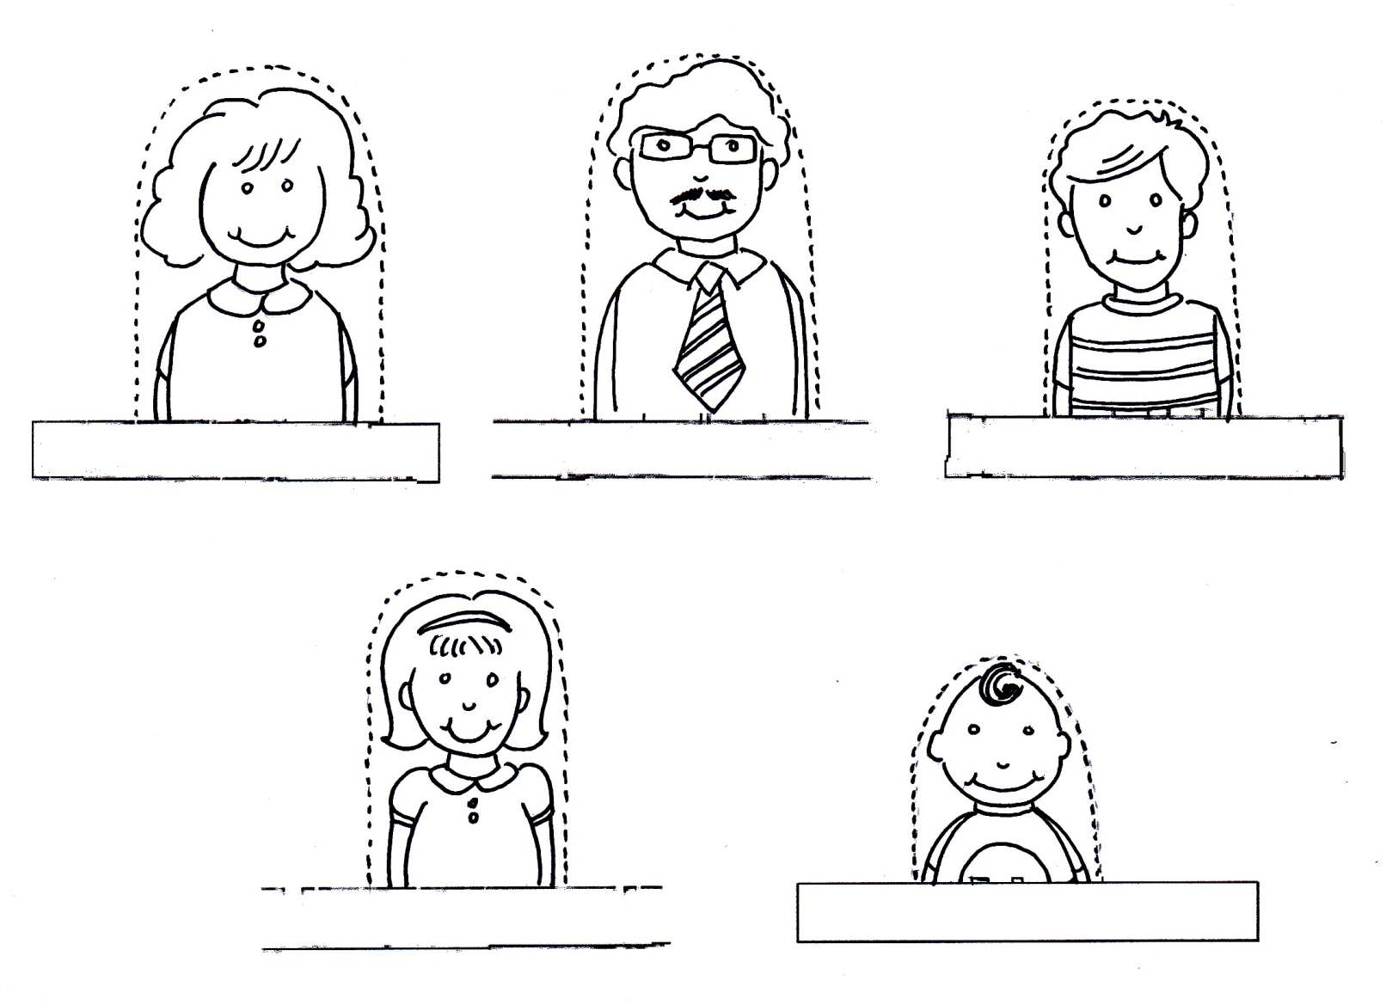
- Fold the puppet along the strip and use sticky tape to hold it together.

