**Attachment C**

**Write the words according to the same beginning sound**

|  |  |  |  |
| --- | --- | --- | --- |
| **“s”** | **“a”** | **“t”** | **“p”** |
|  |  |  |  |
|  |  |  |  |
|  |  |  |  |
|  |  |  |  |
|  |  |  |  |

|  |  |  |  |
| --- | --- | --- | --- |
| **“s”** | **“a”** | **“t”** | **“p”** |
|  |  |  |  |
|  |  |  |  |
|  |  |  |  |
|  |  |  |  |
|  |  |  |  |

|  |  |  |  |
| --- | --- | --- | --- |
| **“s”** | **“a”** | **“t”** | **“p”** |
|  |  |  |  |
|  |  |  |  |
|  |  |  |  |
|  |  |  |  |
|  |  |  |  |

**Attachment D**

**Match the pictures with the correct words**



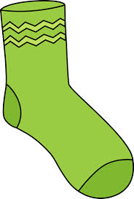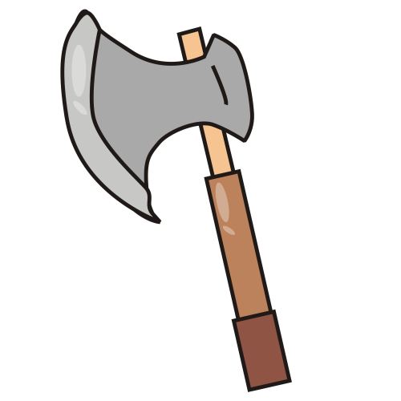

peg

top

tank



snake

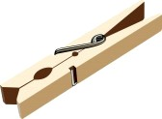

axe

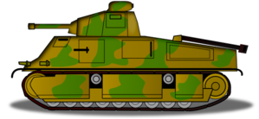

sock