|  |  |  |
| --- | --- | --- |
| snake | sun | http://www.illustrationinfo.com/tutorial_images/vector_step05ax.gif  snail |
| http://www.mpmaintenance.co.uk/images/photos/services_cartoon3.gif  saw | sock | ant |
| http://static.vecteezy.com/system/resources/previews/000/006/766/original/Apple-Cartoon.jpg  apple | axe | http://www.pd4pic.com/images/left-right-arrow-cartoon-double-pointing-arrows.png  arrow |

**Attachment A**

|  |  |  |
| --- | --- | --- |
| http://www.qacps.k12.md.us/ces/clipart/Carson%20Dellosa%20Clipart/Carson%20Dellosa%20Learning%20Themes/Images/Color%20Images/Transportation/AIRPLANE1.jpg  aeroplane | top | http://images.clipartpanda.com/tap-clipart-9555526-dripping-tap-light-blue-illustration-with-light-shadows-isolated-on-white-background.jpg  tap |
| tin | Military Tank Clip Art  tank | http://millersoap.com/soap/BearBath.GIF  tub |
| http://files.essenciadeluz.webnode.pt/200000203-551a756141/acc562ef4799aaa7069d2ade74bb3c97.png  pen | http://t0.gstatic.com/images?q=tbn:ANd9GcRTSKApnnqvNRCXR8Io3KGu-M6qVTT4srKrl5as9jksPyX3fLO_  pin | pot |

|  |  |  |
| --- | --- | --- |
| pond | peg |  |

**Dice template**

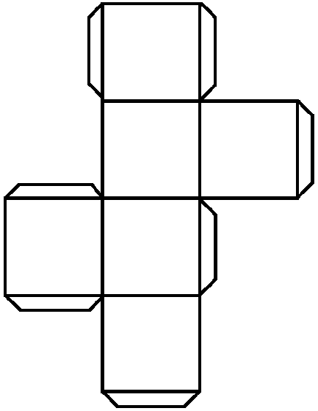

**Attachment B**

p

t

a

s