**Finger Family Puppet**

Norhasimah Mat Yasim, SK Sg Durin, Sibu.

**Objective(s):**

By the end of the activity pupils will be able to:

* Sing about members in the family and do actions.
* Make family finger puppets.
* Label the family finger.

**Target Language:**

Family members (father, mother, brother, sister, baby)

Greetings (“Where are you?” “Here I am”, “How do you do?”)

**Time Needed:**

**Preparation:** 5minutes

**In class:** 55minutes

**Level:**

Years 1 and 2

**Language Focus**:

Listening

Speaking

Language Arts

**Activity Use:**

Presentation

Practice

Production

**Pupil Task:**

Whole Class

Individual

**Materials:**

Finger puppet template, colour pencil, scissors and tape.

**Procedure:**

**Before class:**

1. Make a copy of finger puppet template for each pupil.
2. Prepare a set of completed finger puppet as example for pupils.

**In class:**

1. Review the family members (father, mother, brother, sister, baby).
2. Teacher shows some pictures of family members and pupils identify the members.
3. Teacher models a family finger song and finger play to silent the class (without the puppet). Pupils sing the family finger song 2-3x times.
4. Teacher shows example of finger family puppets.
5. Teacher explains and demonstrates correct ways of making finger puppets.
   1. Label the puppets (i.e. father, mother, brother, sister, baby)
   2. Colour them.
   3. Cut according its shape.
   4. Tape to fit the fingers.
6. After pupils have finished their puppets, teacher checks pupils’ understanding by asking pupils to show a certain family finger.

(e.g. “Show me your Father Finger. “

“Show me your Mother Finger.”

1. Pupils sing their finger family song using their finger puppets.

**Follow Up:**

Pupils can take the puppets home to sing with parents

Teacher helps pupils to keep the puppets to be used with other lessons/ class activities.

Use the puppets for introduction of pupil’s family members. (E.g. “This is my father. My father’s name is…”)

**Variations:**

Pupils can label the puppets with the name of their family members.

Use the puppets for introduction of family members.

**Teaching Tips:**

Year 1 pupils might take longer time to complete their puppets.

Use tape rather than glue.

**Instruction**

1. Label the finger puppet in the column and at the back of the puppet.
2. Colour in your finger puppet.
3. Cut out a finger puppet along the dotted line and the strip.
4. 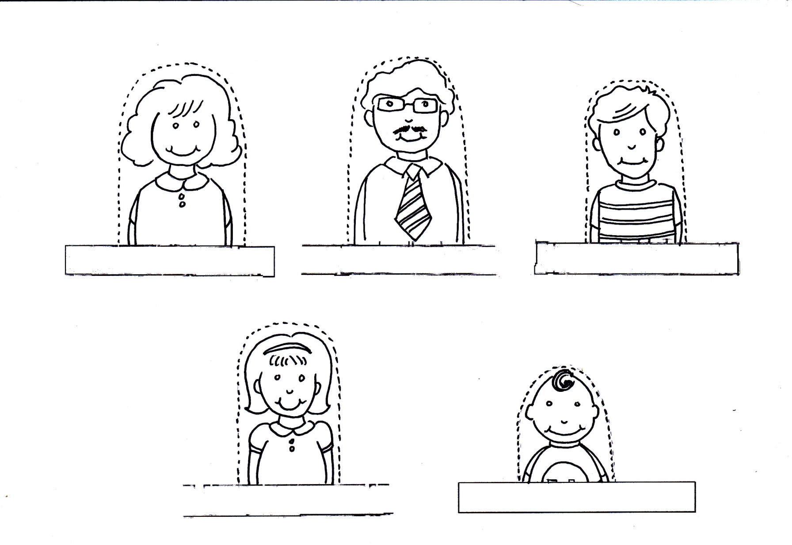Fold the puppet along the strip and use sticky tape to hold it together.