USER MANUAL

FOR igniCAD BRICK AND TILE STOVE DESIGN SOFTWARE

# INTRODUCTION

igniCAD is a valuable tool to design new brick/tile stoves or verify old ones to make sure they are compliant with the regulations of European Standard EN 15544 (inserted as BS EN 15544 in the British code of standards).

igniCAD offers some very unique advantages:

**igniCAD is based on the latest web technologies.** The software saves each and every step of your design procedure on a free and safe server. You will never lose data in igniCAD.

**igniCAD displays your data in a 3D space**, which brings the easiness of CAD to designing brick/tile stoves. You may rotate or zoom your design at will to make sure everything goes as you expect.

**igniCAD is safe.** We create a personal storage space for your data, which is accessible only by you.

**igniCAD is trustable.** We guarantee that we keep a finger on the pulse of market regulation and adjust the software in case of any change. Thus, you can rest assured your design complies the most up-to-date standard specifications.

**igniCAD is flexible where it is sexy.** The software is designed in co-operation with the best stove builders, so we believe it not merely complies the regulations; it helps to design stoves that are very practical to build.

Idea: why don’t you design the flue pipes of the stove at home and show it to your customers on spot?

# THE SCREEN

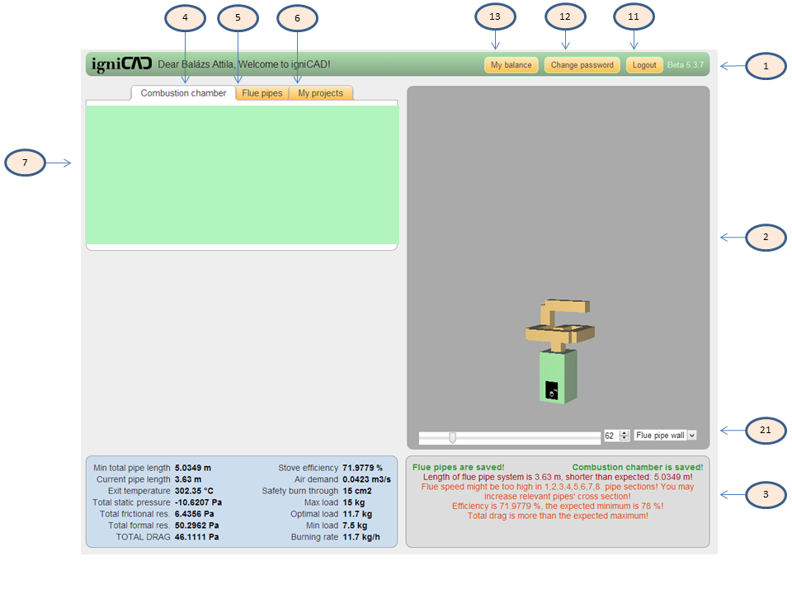

**1. Header** You may find your account related options here.

**11. Logout** Click this to log out from igniCAD. Or simply close your browser; igniCAD has already saved your work.

**12. Change password** Yes. Here you can change your password. Some say it is a good practice to change your password every once in a while as a habit to reduce the potential harm of account piracy.

**13. Balance** Click this option to check your igniCAD balance.

**2. Three-D space** You may follow your work in three dimensions in the this section of the screen. Hint on color coding: combustion chamber is green, flue pipes are yellow.

**21. Three-D space controls** To adjust the horizontal view, use the scroll bar. If you need more freedom, left-click and hold anywhere in the section for free rotation and mouse-wheel zoom.  
Choose ’wireframe’ in the drop-down menu to take a peek behind pipe walls or ’centerframe’ for direction only display.

**3. System messages** igniCAD displays messages here.  
Green text on the top left and right means your work is saved. In case you see gray text here, save is in progress. WARNING: if the text stays gray for more than a couple of seconds, there may be a problem with your internet connection. Please try to avoid work if your internet connection is not stable so as not to lose your data.  
Most of the system messages area is reserved for red and orange messages. These colours warns you if your design does not comply with the specifications of the standard. Please, pay attention to these messages and correct your design accordingly. Any deviance from the the standard will be indicated on the igniCAD document printout.

**4. Combustion chamber** Click on this tag to access combustion chamber design options. Please refer to section 5.2 of this user manual for details.

**5. Flue pipes** Click this tag if you wish to design the flue pipe system of the brick/tile stove. Please refer to section 5.2 of this user manual for details.

**6. My projects** Choose this tag to see the stove designs you created and saved. You can check, print and clone them here. (Cloning means creating an editable copy of a design)

**7. Edit option** igniCAD expects user input in this section of the screen. Please refer to section 5 of this user manual for details.

# ACCOUNT ADMINISTRATION

## REGISTRATION

Your first contact with igniCAD is registration. You may register to igniCAD by visiting [www.ignicad.com](http://www.ignicad.com). After registration, you are free to use the software and start designing your brick/tile stoves.

## LOG IN

As with most web services, you need to login first. Please take the usual care with handling your account name and password to avoid piracy issues.

## CHANGING PASSWORD

In case you are unsure the safety of your account, you may want to change your password. Some users find it useful to do it on a regular basis.  
If you have forgotten your password, you may indicate it on the login screen. This prompts us to initiate a password changing procedure which will require an exchange of very standard e-mails. Do not worry, it is easy.

## BALANCE

Designing a brick/tile stove with igniCAD and seeing if your design complies with the standard specifications are free. Completing a design project – and accessing a detailed certification – however does require you to have a positive igniCAD balance.

igniCAD balance is numeric information that tells you how many design projects are left for you to complete. Please select ’My balance’ in the header section of igniCAD to check or charge your balance.

There are two ways to charge your balance:

1. Via bank transfer. Please follow the instructions of My Balance.
2. Entering a coupon code. This is a very simple procedure that you can initiate in My Balance. Your only task is to enter the code of a coupon issued by igniCAD. To receive a coupon, please contact a sponsor of igniCAD by clicking on a banner on the igniCAD homepage.   
   Please note that igniCAD sponsors may require you to meet certain conditions to receive coupons. These conditions are usually simple and favourable to you. If you feel coupon conditions are unfair, please contact us.  
   FYI: a coupon permits closing of one project. Our company may check the validity of coupon usage. Malicious handling of coupons may be sanctioned as per General Terms and Conditions.

# PROJECTS

In igniCAD term, project is the complete procedure of designing a brick/tile stove. A project must consist of the following:

1. A designer (it is you)
2. A customer (your customer, who buys the stove)
3. A combustion chamber (please refer to 5.2 of this manual)
4. A flue pipe exit (which is the first section of the flue pipe system. Please refer to 5.3 for details)
5. Any number of (but at least one) flue pipe after the flue pipe exit. (please refer to 5.4. and sub sections of this manual)

## CREATING A PROJECT

Creating a project is simple. You always have one (exactly one) editable project. To create a new one, all you have to do is close your current one as detailed in 4.2. of this manual.

## CLOSING A PROJECT

To close a project, select ’My projects’ and click on ’Close project’. If the button is not available, please check if you have at least flue pipe added to the flue pipe exit. Once you clicked ’Close project’, you are prompted to do the following:

1. Check your balance. Closing a project will require a positive igniCAD balance. (Please refer to 3.4. of this manual for details)
2. Name your project. (It is a good idea to use a name that helps you recall the stove design. You do not need to use the name of the customer and the close date, as they are always visible in the project selection list)
3. Indicate what you used the design for. You have two option: ’design’ or ’checking’. Some users of igniCAD like to make a differentiation whether the project’s purpose is to create a new stove or check if an already build stove complies with regulations.
4. Enter the details of your company. This is strictly necessary only when you design your first stove in igniCAD, for the software uses the pieces of data you entered to your previous project as default values.
5. Enter the details of your customer. Since the igniCAD certificate will contain the details of your customer, all fields are required but the phone number.

A WORD OF ADVICE: Please take extra care when filling the fields needed for closing your project, for closed projects are not editable any longer. Some users find it useful to go through a checklist:

* Are there unanswered red / orange system messages? Do not forget that they will appear on the igniCAD certificate.
* Are pieces of builder information correct? The certificate will show exactly what you typed.
* Are pieces of customer information correct? The certificate will show exactly what you typed.

After completing the steps above, you should be able to close your project.

## PPRINTING A CERTIFICATE

You may find the list of your closed project in the ’My projects’ tag. The list is verbose about the name of the project, the customer and the date of project completion. Select the required project in the list:

* to see the flue pipe system in the 3D area
* to see the system messages relevant to the selected project
* to have the option to see the details of the combustion chamber and flue pipe system by selecting the respective tag
* to see the detailed customer information by clicking on the ’Info’ button
* to print the project in as many copies as you wish

A WORD OF ADVICE: printing relies on your printer. Please make sure your printer is connected and paper tray and the cartridge is not empty.

## CLONING A PROJECT

As we stated already, a closed project is not editable. If you wish to create an editable copy of an already closed project (for example to re-use the design for another customer), click on the ’Clone project’ button on’My projects’ tag after you have selected the project to clone.

A WORD OF WARNING: igniCAD always keeps exactly ONE project editable. Cloning a project clears your current work and loads the cloned project in its place. Please make double sure you will not lose valuable data when cloning.

# THE ROADMAP OF STOVE DESIGN

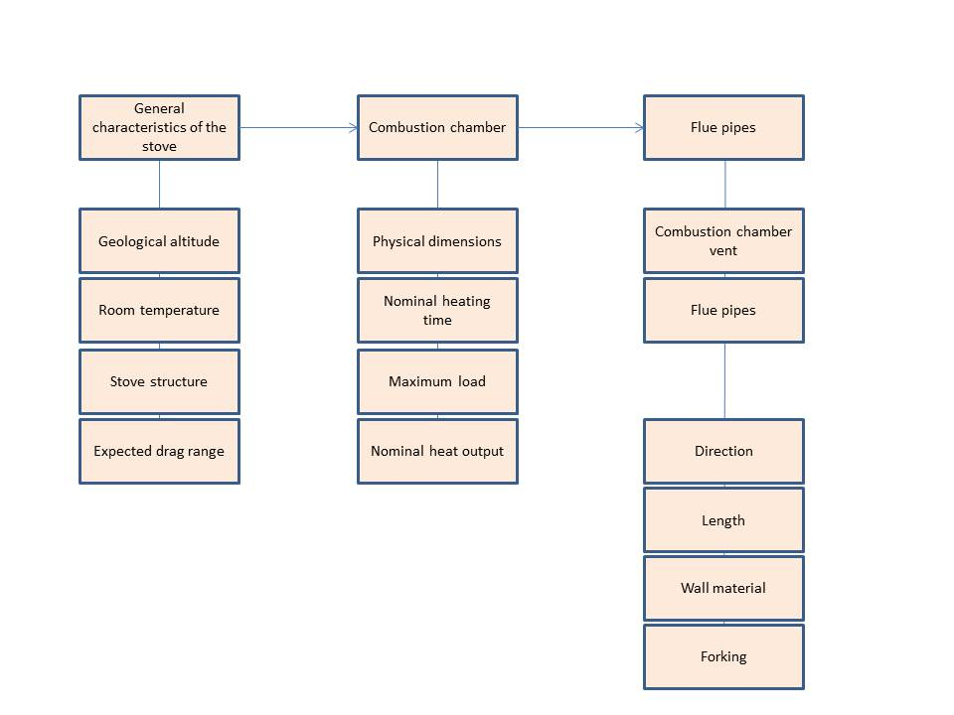

## GENERAL CHARACTERISTICS

The general characteristics fundamentally determine the output of your brick/tile stove. Data you enter here will affect the whole design, so we advise to take the necessary care. General data are:

* *Geological altitude* of the place you wish to build the stove
* *Air temperature* of the room you wish to build the stove
* *Stove structure* has two options: univalve or bivalve – which basically means if you plan to build a stove with or without and air gap.
* *Expected drag range* lets you enter your idea of the total drag of the system. We suggest to use the drag capacity of the chimney if you have this information. igniCAD will give you a warning if your design is out of the expected drag range.

## THE COMBUSTION CHAMBER

### PHYSICAL DIMENSIONS

Designing a combustion chamber starts with entering the physical dimensions:

* Side length (width and depth) in centimetres
* Height in centimetres

We designed igniCAD to help you with the details:

* Combustion chamber floor area is automatically calculated and re-calculated if you edit width or depth
* Once you are satisfied with the floor area, uncheck the control left of ’Floor area’. If this control is unchecked, changes made to width or depth will leave floor area unchanged, while the dimensions will be adjusted so as their product will result in the fixed floor area.
* The total inner surface is automatically calculated and re-calculated if you edit width, depth or height
* Once you are satisfied with the total inner surface, uncheck the control left of ’Inner surface’. If this control is unchecked, changes made to width, depth or height will leave inner surface unchanged, while the dimensions will be adjusted proportionally.
* You may choose to enter an exact value to inner surface or floor area. In this case, igniCAD will adjust the width, depth and height of the combustion chamber so that their proportion stays the same.

EN 15544 has very definite ideas about the dimensions of the combustion chamber:

* The combution chamber must have at least 100 cm2  for every kilogram of load.
* The combustion chamber must have at least 1 cm of height for every kilogram of load plus 25 cm.
* The combustion chamber must have at least 900 cm2 of total inner surface for every kilogram of load.

igniCAD keeps an eye on those prescriptions for you, but it does not bind your hands. You may design a combustion chamber that ignores the above rules, but it keeps you informed about the deviations with system messages on screen and on the printed the certification.

The reason for this relatively lenient approach is that beside designing a proper stove, you may also want to check the compliance of an already built stove.

FYI: While you might want to build a combustion chamber of any shape in practice, igniCAD always displays an ideal, block shaped combustion chamber for understandable reasons. This is by no way renders igniCAD short of use, since the standard prescribes only the relative sizes of the maximum load and the physical dimensions of the chamber. Therefore, in case of funny shaped combustion chambers, we advise you to enter the total surface and floor area by hand; from this on igniCAD makes all the calculations for you.

### OPERATIONAL PARAMETERS

The following parameters describe the operation of a brick/tile stove:

* Nominal heating time (in hours)
* Maximum load (in kilograms)
* Nominal heat output (in kilowatts)

These three parameters are strongly linked. igniCAD calls you to enter values to two of them and it calculates the third. You can indicate which of the three you wish igniCAD to calculate with the radio buttons on the right side of the input fields.

A WORD OF ADVICE: maximum load is strongly related to the physical dimensions described in 5.2.1.

## COMBUSTION CHAMBER VENT

To edit the combustion chamber vent, please select ’Flue pipes’ tag.

The combustion chamber vent is the first section of the flue pipe system. Despite, we need to handle it somewhat differently, for this section creates the link between the chamber and the pipe system. Thus, you have the option to set which face of the the chamber holds the vent:

* Top
* Left
* Right
* Back
* Sides: there are a vent on both (left and right) sides of the a combustion chamber. This is basically a forked pipe section, detailed in 5.4.4. of this user manual.

FYI: You can set the position of the vent only before adding further sections to your pipe system. If you want to change the position retrospectively, you need to delete all sections of the pipe system. To learn the details of deleting a pipe section, please read 5.4.3.

Once you have set the face, you have the option to fine-tune its position by adjusting its width and depth relative to the face of the combustion chamber. To restart fine tuning, you may click on ’Center’.

FYI: Positioning buttons ’Width’ and ’Depth’ are available only when they are logical to use. For example, if the vent sits on the right face of the chamber, you may adjust its depth but not its width, as it keeps sitting on the right side.

As part of the flue pipe system, the combustion chamber vent has the characteristics of the pipes as well (cross section, lentgh and wall material). Please refer to 5.4.1. of this manual for details.

## FLUE PIPE SYSTEM

The flue pipe system transmits the heat of the combustion chamber to the brick/tile stove wall. The standard is definite on the flue pipe system:

* It sets its minimum required total length
* It prescribes that the total drag of the system must harmonize with the drag of the chimney
* It sets the expected range of the flue speed in each flue pipe section
* It imposes a minimum efficiency of your stove

igniCAD warns you if your system does not comply with the prescriptions of the standard.

If you have many sections in the flue pipe system, it is easy to get lost. To ease the orientation, igniCAD highlights the current section with blue on the 3D space.

### CHARACTERISTICS OF THE FLUE PIPES

..are the following:

* The **direction** of the section. In igniCAD, it is pretty easy to set the desired direction. The simplest way is to use the scroll bars on the left of the screen and watch the result of your action in the 3D space. The scroll bars set the vertical and horizontal component of the desired direction in 450 steps, which is a shift generally fine enough. However, in certain cases you may want to exact degrees for setting the direction. In these rare instances, use the numeric input fields.
* The **cross section** of the pipe determines the flue speed: narrower cross section increases, broader cross section decreases it. You can set the exact cross section parameters of the pipe in centimeters.   
  FYI: three dimensional geometry can be tricky sometimes. Although it does not affect the hydrodynamics of the flue, you may need to swap the x and y parameters of the cross section in certain cases for a visually pleasant design.
* **Lentgh** of the pipe section in centimeters.
* **Wall material** of the pipe section. ingiCAD offers seven options all with different degree of roughness:
  + *Steel tube (T = 0.001)*
  + *Fireclay tube (T = 0.002)*
  + *Fireclay (T = 0.003)*
  + *Raw 1 (T = 0.005)*
  + *Raw 2 (T = 0.0066)*
  + *Raw 3 (T = 0.0088)*
  + *Raw 4 (T = 0.01)*
* For **Forking** a pipe section, please refer to 5.4.4. of this manual)

### ADDING A NEW PIPE SECTION

You may consider adding a new section to your pipe system, when *any* of the characteristics listed in 5.4.1. changes. The most common change of course is a change in direction or cross section, but it is adviseable to add a new section when you plan to use a different wall material. This way, igniCAD can calculate the hydrodynamics of your stove very exactly.

To add a new section after the current last one, click on ’+ADD NEW SECTION’.

The cross section and wall material of the new section will be inherited from the previous one. The default value is set to 50cm, the default direction is *horizontal back*.

A WORD OF ADVICE: if you cannot see the new new pipe section, it is possible that it overlaps the previous one.

### DELETING A PIPE SECTION

If, for some reason, you are not satisfied with your newly added section, you may delete it by clicking on ’delete’.

FYI: Only the last pipe section can be deleted. For deleting more pipe sections, repeat the delete procedure.

A WORD OF WARNING: Although it is visually a part of the pipe system, igniCAD does not allow to delete the combustion chamber vent.

### FORKED PIPES

Forked pipe sections are special, since the flue travels not one but two pipe section at the same time, which substantially alters flue dynamics. igniCAD is very much up to the challenge to handle this special case, but it requires you to obey the following criteria:

* The forked pipe sections need to be in perfect symmetry, so as neither of the branches is overloaded at the account of the other. An uneven load is extremely inefficient, so igniCAD is hard coded to not allow you to deviate from this rule.
* You can fork a pipe section exclusively in 900 in horizontal direction. The reason behind this rule is very similar to the previous one, since a vertical fork loads the downward pipe less than its upward counterpart.
* You are allowed to start a fork only if the current section is not forked already. That basically means that you cannot create simultaneously multiple forks in igniCAD.

To prompt a forked section, all you have to do is checking the ’Fork’ control. You can see on the 3D space that igniCAD erects a new forked pipe: one branch of the pipe stays in the direction you set, the other in the exact opposite horizontal direction.

Once you forked a pipe section, it stays forked until you have them meet. After they have met, adding a new section results in the addition of a singular (not forked) section.

FYI: igniCAD demands the forked branches to meet to end forking. As long as you use only 900 direction changes, it should not be a concern, but with more exotic angles, it can be quite tricky to determine the exact join spot.

### RETROSPECTIVE MODIFICATION OF PIPE PARAMETERS

igniCAD allows you to retrospectively modify most of the parameters of the pipe sections:

* Length
* Cross section
* Wall material
* Direction

There are a number of exceptions though. **You are not allowed** to modify retrospectively:

* The position of the combustion chamber vent
* Length of forked sections
* Direction of forked sections

# FREQUENTLY ASKED QUESTIONS

Question: *I don’t like the way the 3D space behaves. It is slow to react, it lags, it is ugly.*

Válasz: *igniCAD uses the latest technology to display 3D objects. Browser anufacturers are not always up to date with the application of new technologies, and this is beyond our control. To solve display issues, try to download the latest version of your favourite browser in the hope of they have already applied the technology igniCAD uses. If you are still not satisfied with the result, please consider downloading Google Chrome – it is free. We used this browser for development and we are pretty sure it can display igniCAD data.*

Question: *I cannot close my project, because ’close project’ button is unavailable.*

Answer: *A project needs at least one flue pipe section after the combustion chamber vent. Please add a new section in the ’Flue pipe’ tag as described in 5.4.2 of this manual.*

Question: *I can see data in the input fields, but I cannot modify them. Why?*

Answer: *Most probably, you are watching a closed project. Open an editable project as per 4.1. or 4.4. of this manual.*

Question: *I cloned a project. Now, I can’t seem to find the recent project I was working on.*

Answer: *Unfortunately, you are right. igniCAD allows you to have exactly* ***one*** *editable project. Cloning a project creates an editable copy of the this project, which triggers igniCAD overwrite your currently edited project.*

Question: *I want to build other than block shaped combustion chamber. What should I do?*

Answer: *While you might want to build a combustion chamber of any shape in practice, igniCAD always displays an ideal, block shaped combustion chamber for understandable reasons. This is by no way renders igniCAD short of use, since the standard prescribes only the relative sizes of the maximum load and the physical dimensions of the chamber. Therefore, in case of funny shaped combustion chambers, we advise you to enter the total surface and floor area by hand; from this on igniCAD makes all the calculations for you.*

Question: *I added a new pipe section, but I cannot see it on the 3D space.*

Answer: *The most possible answer is that your new section does appear on the 3D space, only you cannot see it because it overlaps your previous section. Please try to change the direction of your not appearing section.*

Question: *I cannot have the branches of the forked pipes meet.*

Answer: *Please make sure the branches are facing towards each other – as the forked branches are always symmetrical, it should not be hard. Next, check if their length are set right to meet – the 3D space does not always help to determine the needed length, because if they are too long, they can run over the meeting point overlapping each other. If the direction and length are set right and you still cannot have the branches meet, you probably used an exotic (330, 660, etc) angles somewhere. In these cases, defining the exact meeting point is a question of trigonometrical calculation. You may try to calculate it yourself, or you may call our customer service department on .........*