

Safety Plan Lane Assistance

**Document Version: [Version]**

**Template Version 1.0, Released on 2017-06-21**



# Document history

**[Instructions: Fill in the date, version and description fields. You can fill out the Editor field with your name if you want to do so. Keep track of your editing as if this were a real world project.**

**For example, if this were your first draft or first submission, you might say version 1.0. If this is a second submission attempt, then you'd add a second line with a new date and version 2.0]**

|  |  |  |  |
| --- | --- | --- | --- |
| Date | Version | Editor | Description |
| 14 jan 2018 | 1.0 | Vilas Chitrakaran | Initial version |
|  |  |  |  |
|  |  |  |  |
|  |  |  |  |
|  |  |  |  |

# Table of Contents

**[Instructions: We have provided a table of contents. If the table of contents is not showing up correctly in your word processor of choice, please update it. The table of contents should show each section of the document and page numbers or links. Most word processors can do this for you. In** [**Google Docs**](https://support.google.com/docs/answer/116338?co=GENIE.Platform%3DDesktop&hl=en)**, you can use headings for each section and then go to Insert > Table of Contents.** [**Microsoft Word**](https://support.microsoft.com/en-us/help/285059/how-to-create-a-table-of-contents-by-marking-text-in-word) **has similar capabilities]**

Document history

Table of Contents

Introduction

Purpose of the Safety Plan

Scope of the Project

Deliverables of the Project

Item Definition

Goals and Measures

Goals

Measures

Safety Culture

Safety Lifecycle Tailoring

Roles

Development Interface Agreement

Confirmation Measures

# Introduction

## Purpose of the Safety Plan

**[Instructions: Answer what is the purpose of a safety plan?]**

This document describes the overall framework within which functional safety is achieved for the Lane Assistance Item. Safety management roles and responsibilities are defined, along with associated confirmation measures taken to ensure that a functionally safe product is delivered by the project team.

## Scope of the Project

**[Instructions: Nothing to do here. This is for your information.]**

For the lane assistance project, the following safety lifecycle phases are in scope:

Concept phase

Product Development at the System Level

Product Development at the Software Level

The following phases are out of scope:

Product Development at the Hardware Level

Production and Operation

## Deliverables of the Project

**[Instructions: Nothing to do here. This is for your information.]**

The deliverables of the project are:

Safety Plan

Hazard Analysis and Risk Assessment

Functional Safety Concept

Technical Safety Concept

Software Safety Requirements and Architecture

# Item Definition

**[Instructions: REQUIRED**

**Discuss these key points about the system:**

**What is the item in question, and what does the item do?**

**What are its two main functions? How do they work?**

**Which subsystems are responsible for each function?**

**What are the boundaries of the item? What subsystems are inside the item? What elements or subsystems are outside of the item?**

**OPTIONAL**

**Optionally, include information about these points as well. These were not included in the lectures, but you might be able to find this information online:**

* **Operational and Environmental Constraints. This could especially be limited to camera performance; lane lines are difficult to detect in snow, fog, etc**
* **Legal requirements in your country for lane assistance technology**
* **National and International Standards Related to the Item**
* **Records of previously known safety-related incidents or behavioral shortfalls**

**]**

The lane assistance item shall alert the driver to impending and inadvertent departure of the vehicle from ego lane and shall assist the driver to steer and keep the vehicle within ego lane. The two main functions of the Item are

1. Lane departure warning
2. Lane keeping assistance

When the driver drifts towards the edge of the lane

1. The **lane departure warning** function shall apply an oscillating steering torque to provide the driver a haptic feedback
2. The lane keeping assistance function shall apply the steering torque when active in order to stay in ego lane

The following subsystems are part of the item:

1. Camera system
2. Car display system
3. Electronic power steering system

The lane departure warning funciton relies on camera system and the car display system, whereas all three systems listed above are responsible for lane keeping assistance function.

Illustration shows the high level system architecture and clarifies the item boundary. The camera system ECU detects lane departure and notifies the power steering ECU which generates corrective control action through a steering actuator. Simultaneously, the driver receives a lane departure warning from the display system and via vibrations from the steering wheel.

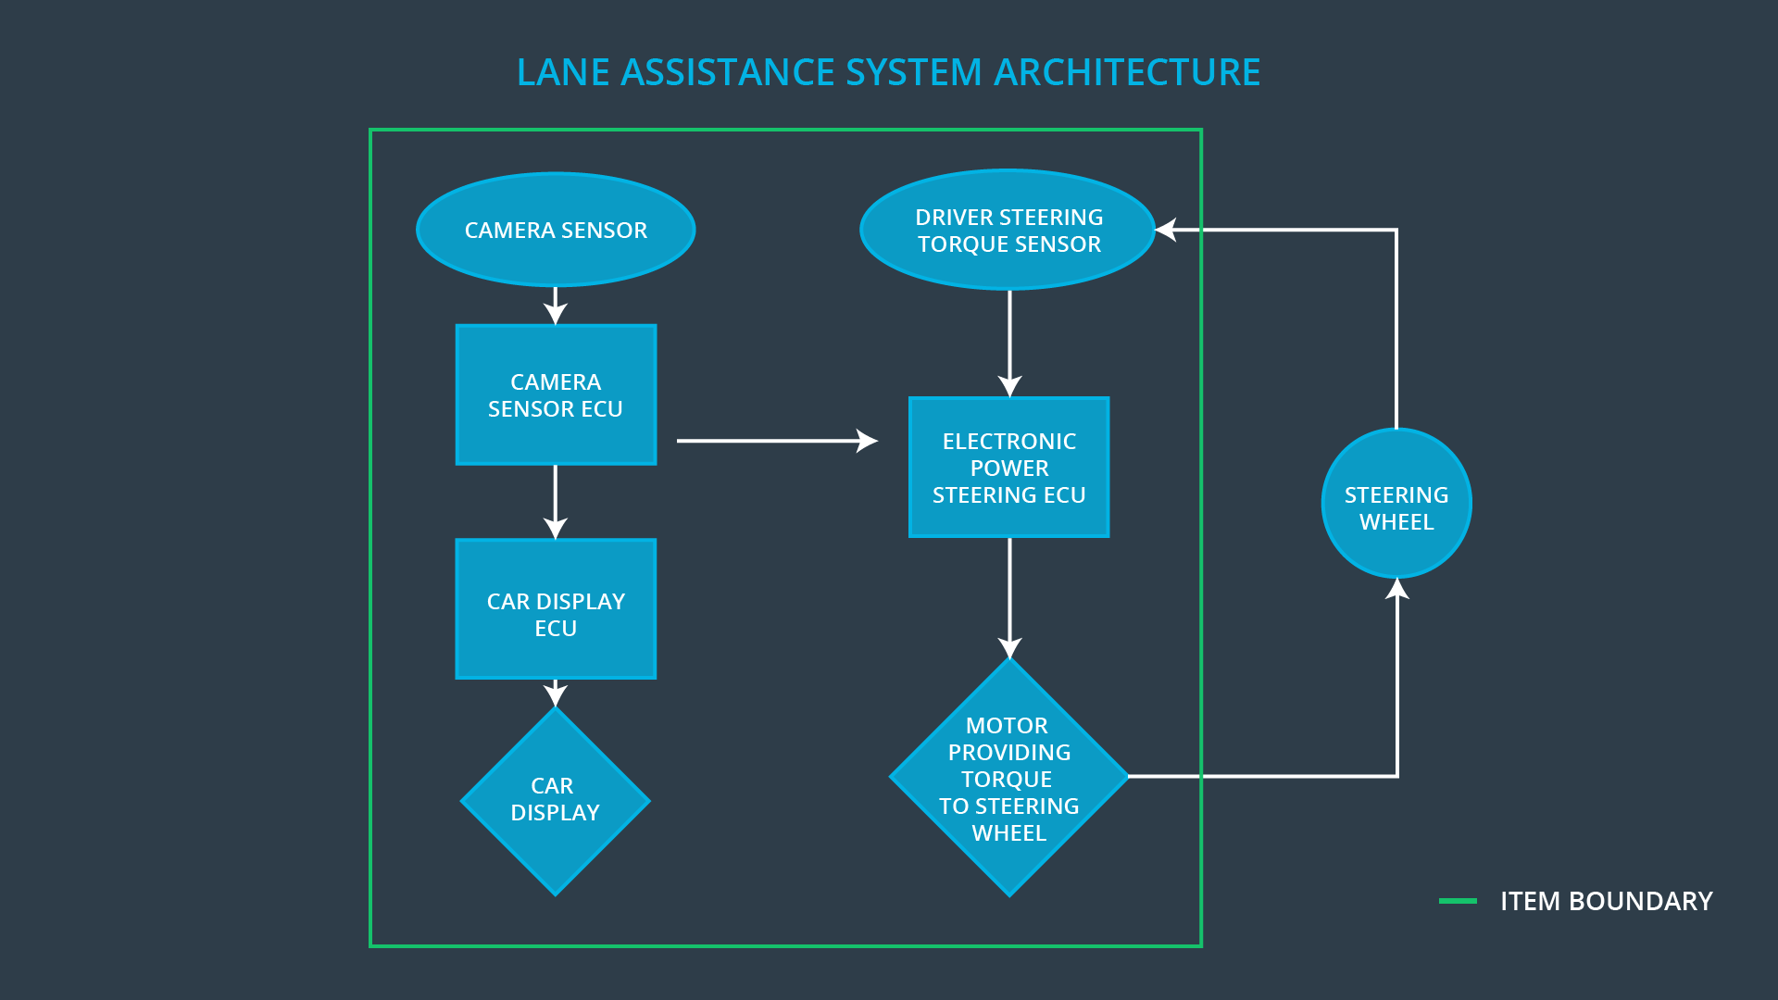  
Illustration 1: Lane Assistance System Architecture

# Goals and Measures

## Goals

**[Instructions:**

**Describe the major goal of this project; what are we trying to accomplish by analyzing the lane assistance functions with ISO 26262?]**

## Measures

**[Instructions:**

**Fill in who will be responsible for each measure or activity. Hint: The lesson on Safety Management Roles and Responsibilities.**

**The options are:**

**All Team Members**

**Safety Manager**

**Project Manager**

**Safety Auditor**

**Safety Assessor**

**]**

|  |  |  |
| --- | --- | --- |
| Measures and Activities | Responsibility | Timeline |
| Follow safety processes | All Team Members | Constantly |
| Create and sustain a safety culture | All Team Members | Constantly |
| Coordinate and document the planned safety activities | Safety Manager | Constantly |
| Allocate resources with adequate functional safety competency | Project Manager | Within 2 weeks of start of project |
| Tailor the safety lifecycle | Safety Manager | Within 4 weeks of start of project |
| Plan the safety activities of the safety lifecycle | Safety Manager | Within 4 weeks of start of project |
| Perform regular functional safety audits | Safety Auditor | Once every 2 months |
| Perform functional safety pre-assessment prior to audit by external functional safety assessor | Safety Manager | 3 months prior to main assessment |
| Perform functional safety assessment | Safety Assessor | Conclusion of functional safety activities |

# Safety Culture

**[Instructions:**

**Describe the characteristics of your company's safety culture. How do these characteristics help maintain your safety culture. Hint: See the lesson about Safety Culture**

The organisation promotes safety culture in the following ways:

* Safety has the **highest priority** amongst competing constraints, including costs and productivity.
* Roles and responsbilities are clearly defined to ensure **accountability**; design decisions are traceable back to individuals within the project team
* Achieving functional safety related milestones are a key target for the project team. Amongst various **incentives**, the organisation runs a performance related bonus scheme for its employees that is aligned with achieving functional safety targets.
* All Project Managers receive **training** to detect and stop activities that may encourage team members to overlook functional safety or quality.
* The organisation strives to maintain a sufficiently large pool of engineers who are skilled in functional safety. Such engineers work across projects as safety auditors, and to maintain **independence**, they do not contribute to design activities in those projects.
* Product development follows a **well defined process** to ensure timely delivery without compromising quality.
* Project managers are encouraged to establish **teams that are balanced and diverse** in terms of skills and experience.
* To encourage **teamwork and communication**, project teams are not hierarchical and all team members have an equal say in matters of safety.

# Safety Lifecycle Tailoring

**[Instructions:**

**Describe which phases of the safety lifecycle are in scope and which are out of scope for this particular project. Hint: See the** **Intro section** **of this document**

**]**

# Roles

**[Instructions:**

**This section is here for your reference. You do not need to do anything here. It is provided to help with filling out the development interface agreement section.**

**]**

|  |  |
| --- | --- |
| Role | Org |
| Functional Safety Manager- Item Level | OEM |
| Functional Safety Engineer- Item Level | OEM |
| Project Manager - Item Level | OEM |
| Functional Safety Manager- Component Level | Tier-1 |
| Functional Safety Engineer- Component Level | Tier-1 |
| Functional Safety Auditor | OEM or external |
| Functional Safety Assessor | OEM or external |

# Development Interface Agreement

**[Instructions:**

**Assume in this project that you work for the tier-1 organization as described in the above roles table. You are taking on the role of both the functional safety manager and functional safety engineer.**

**Please answer the following questions:**

1. **What is the purpose of a development interface agreement?**
2. **What will be the responsibilities of your company versus the responsibilities of the OEM? Hint: In this project, the OEM is supplying a functioning lane assistance system. Your company needs to analyze and modify the various sub-systems from a functional safety viewpoint.**

**]**

# Confirmation Measures

**[Instructions:**

**Please answer the following questions:**

1. **What is the main purpose of confirmation measures?**
2. **What is a confirmation review?**
3. **What is a functional safety audit?**
4. **What is a functional safety assessment?**

**]**

A safety plan could have other sections that we are not including here. For example, a safety plan would probably contain a complete project schedule.

There might also be a "Supporting Process Management" section that would cover "Part 8: Supporting Processes" of the ISO 26262 functional safety standard. This would include descriptions of how the company handles requirements management, change management, configuration management, documentation management, and software tool usage and confidence.

Similarly, a confirmation measures section would go into more detail about how each confirmation will be carried out.