Quick User Setup and Assignment Guide
HAZECO • Administrator guide • 31 October 2026
Website: https://hazeco.barqaab.pk • Mobile app: HAZECO Field Survey
1. Before you start
Have an active Super Admin login, an active project, Survey Team and feeder in that project. Mobile users need the approved HAZECO Field Survey Android app and internet for sign-in/sync. For PDF work, have the matching source PDF and GPX.
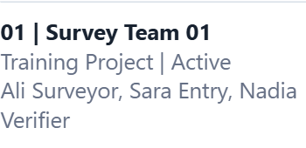
Check the project and Active Survey Team. Screens use training examples; use your approved records.
☐ Administrator access, project, team and feeder are ready.
2. Create and activate the three accounts
Menu: Administration → Users
1. In Add user, enter Name, unique Email, Role, Password and Confirm password. Use 10 or more password characters. Organization may remain None; phone and photo are optional.
Person | Exact Role to select
Mobile collector | Surveyor
PDF entry person | Data Entry Operator
Independent reviewer | Data Verifier
2. Click Create user. Repeat for all three people. New accounts are Active. In Existing users, check Role and Status: Active; click Save user if you change either.
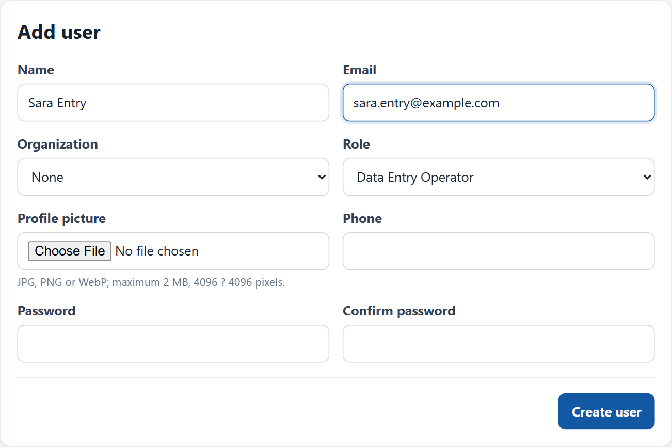
Add user: enter the person’s details, select the exact Role, then click Create user.
3. Give each person their own login securely. The app does not automatically send an account invitation. Keep entry and verification as different people/accounts.
☐ Surveyor, Data Entry Operator and Data Verifier accounts exist and are Active.

3. Add users to the correct Survey Team
Menu: Administration → Teams & Assignments
1. In Assign member, select Team type: Survey, the Team, and the User. Leave Survey team leader unchecked. Click Assign member. Repeat for all three people.
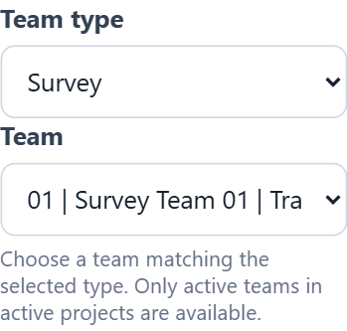  Choose Survey and the correct Survey Team. | 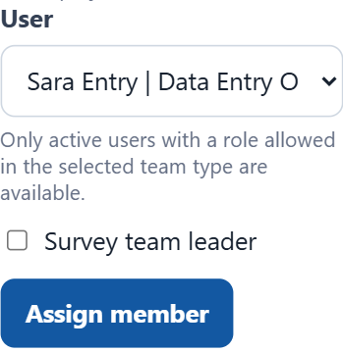  Choose the user, then click Assign member.

2. In Assign survey feeders, select the Survey team, Feeder selection: One feeder, Feeder and Start date → Assign feeders. Check Active feeder assignments. Dates must cover work and later sync.
Membership does not assign a personal mobile task or PDF batch. Mobile teams need a clear team number, for example code 01 and name Survey Team 01.
☐ All three users belong to the Survey Team; its feeder allocation is current.
4. Assign a personal Mobile App Survey task
Menu: Administration → User Assignments
1. Find/select the Surveyor and click View assignments. Check All assignments first to avoid giving duplicate work.
2. Choose Assignment type: Mobile App Survey → Choose type. Select Survey team and Project. Find tasks, then tick the intended feeder. Enter Start date, optional Deadline and Priority.
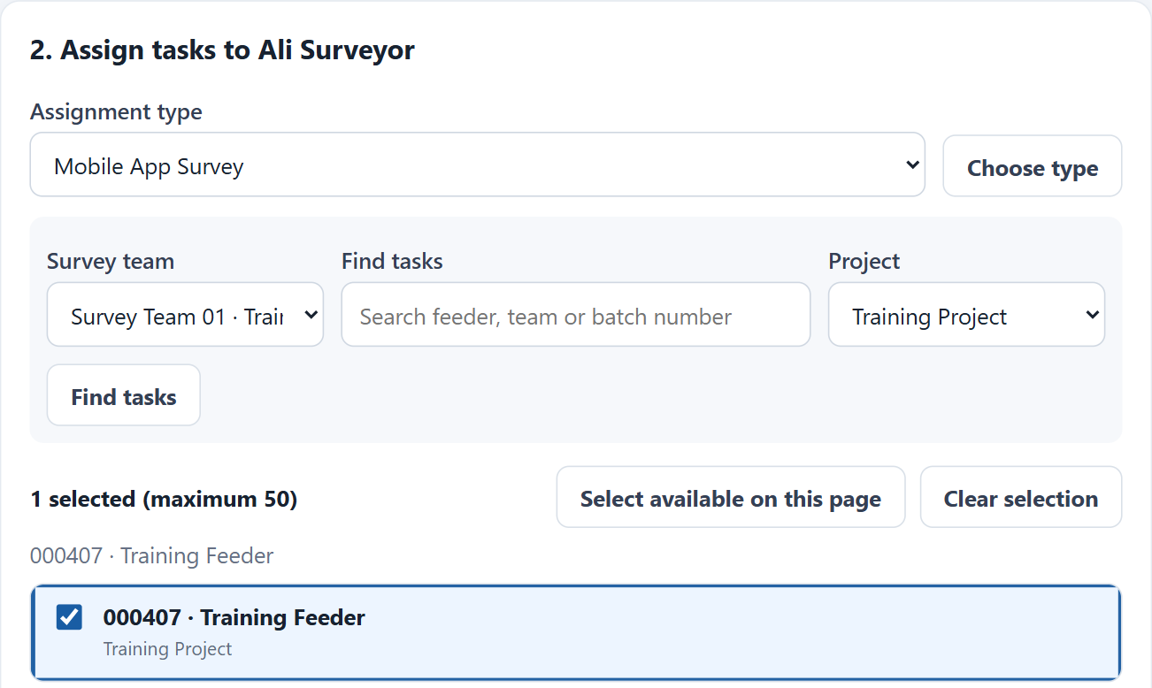
Mobile App Survey: select the team/project and tick the feeder for this surveyor.
3. Tick “I have checked the user, assignment type and selected tasks.” Click Review and assign, then Confirm and save. Check the success message and the new Direct task.
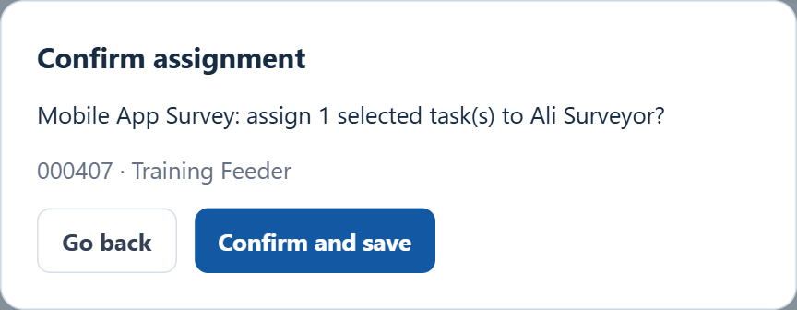
Check the person, type and selection before Confirm and save.
Leave overlapping work unchecked for ordinary allocation. Do not create another task merely because the first one is not yet downloaded.
☐ The surveyor has a personal Mobile App Survey task, not just team membership.

4. Mobile app: download, collect and sync
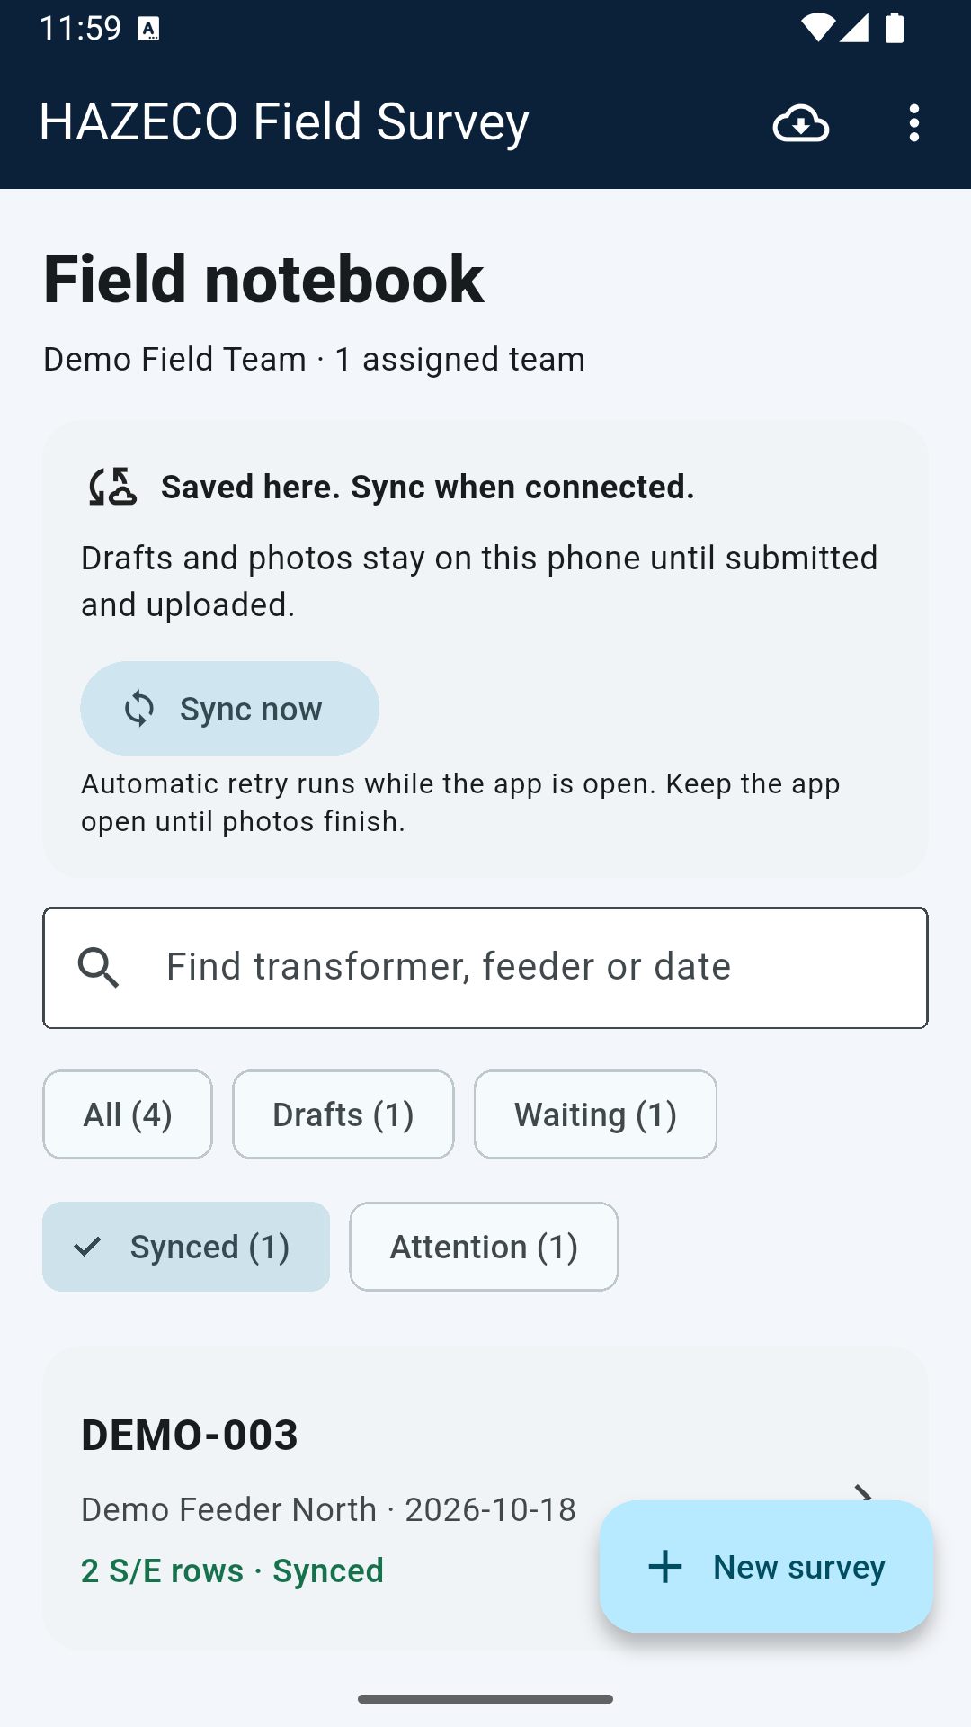  Existing Android training screen: Download assignments, Sync now and Synced. Example status only. | 1. While online, the Surveyor opens HAZECO Field Survey. Enter Email and Password, then tap Sign in and download assignments. Later, use the cloud Download assignments icon on Home.  2. Tap New survey. Choose the assigned Survey Team and feeder, then Create survey. Complete the actual transformer Details, S/E rows and required evidence.  3. Use Save draft when unfinished. When complete, tap Submit survey → Submit. On Home, tap Sync now and keep the app open until uploads finish.  4. Check that the form shows Synced and each photo shows Uploaded. The administrator checks receipt in Mobile Field Surveys.  A draft stays on the phone. Do not uninstall or clear app data before uploads finish. Synced is server receipt, not independent verification or proof that the entire feeder is complete.

☐ The surveyor can see the feeder, and the administrator can see the synced submission.
5. Start the separate PDF/GPX workflow
Mobile uploads do not automatically create a PDF/GPX batch. Obtain the matching source files separately.
Menu: MDB Creation & Validation → Create survey batch
1. Select Survey PDF and GPS GPX. Choose Project, Survey team, Feeder and Survey date. Click Create batch & start entry. Record the batch number and wait for both files to show Ready.
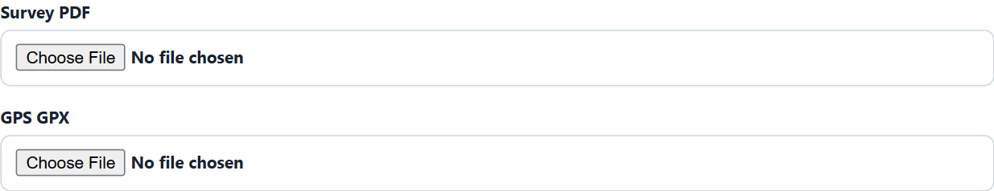  Choose the matching source PDF and GPX. | 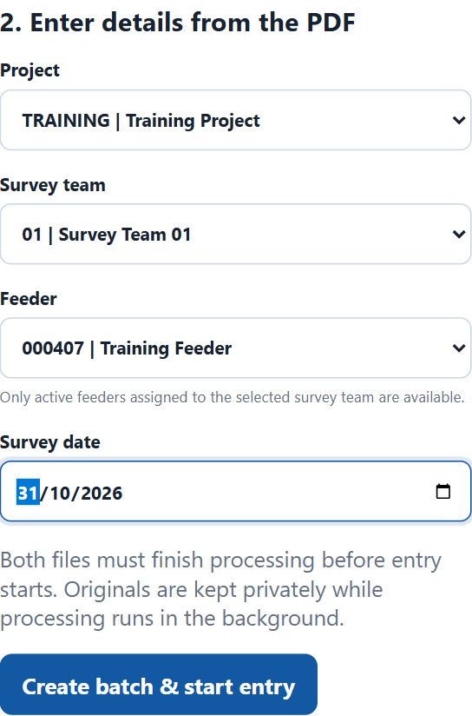  Check scope/date, then Create batch & start entry.

☐ A numbered PDF batch exists and both sources are Ready.

5. PDF: assign entry, submit, then assign verification
Admin menu: Workflow Task Assignments
2. Find the batch. Select Stage: Data entry and Assignee: the Data Entry Operator. Add a note if useful, then click Assign. Confirm Entry shows that person.
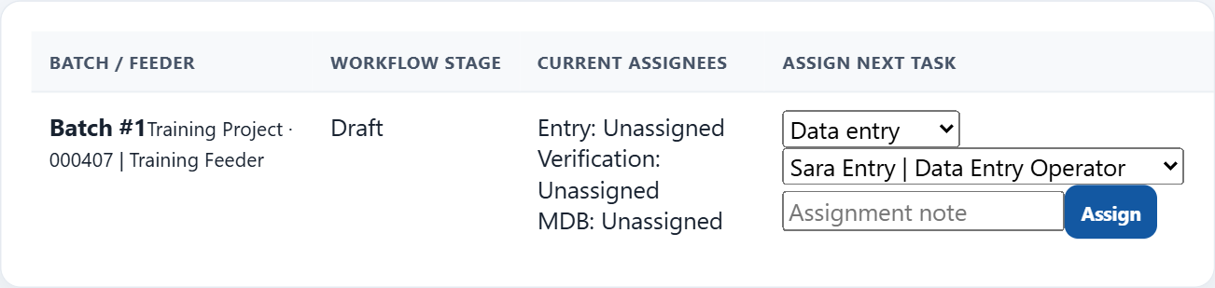
For the Draft batch, choose Data entry and Sara Entry, then Assign. Replace the example with your operator.
3. The operator signs in to the website: MDB Creation & Validation → PDF Data Entry → Open batch. Save each transformer header and its complete S/E pairs against the PDF and GPX. Fill required values such as Inspector, Location and Service category. Check that the saved records appear.
4. When all transformers are complete, open Review saved survey. In Survey workflow, click Submit for Verification. Resolve any validation errors. The whole batch becomes Pending Verification and entry is locked.
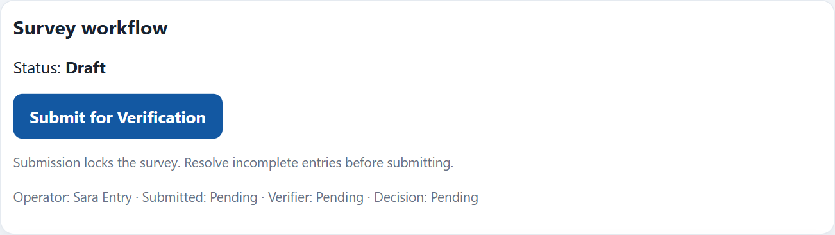
Operator review: Submit for Verification sends the whole batch for review. Saving rows alone does not submit it.
Alternative: Submit Transformer checks one transformer; continue if more remain. After the last one, “No, go to MDB Creation & Validation” submits the batch.
5. The administrator returns to Workflow Task Assignments. For that Pending Verification batch, select Stage: Verification and Assignee: a different Data Verifier. Click Assign.
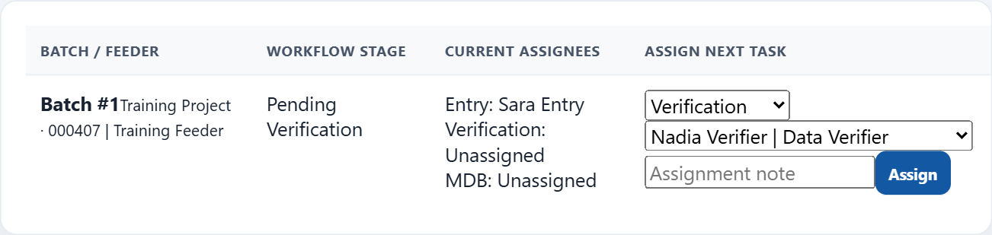
Once Pending Verification, choose Verification and Nadia Verifier, then Assign.
Anyone who entered the batch must not verify it. Changing the entry owner later does not remove this restriction. Assign existing batches; do not delete/recreate work to transfer it.
☐ Entry is submitted; a different person is the verification assignee.

5. PDF: approve or return for correction
Verifier menu: MDB Creation & Validation → Data Verification → Open batch
6. Check every transformer and its entered values against the source PDF/GPX. Review ticks are aids; they do not approve the batch. In Survey workflow, choose the correct decision below.
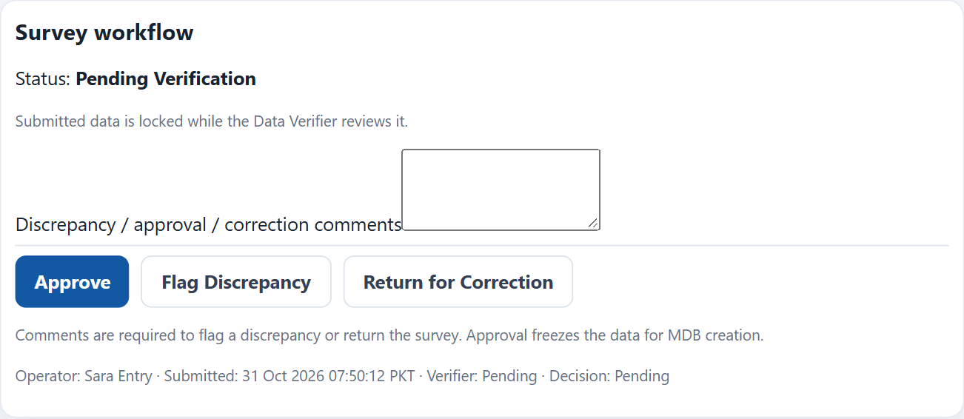
Approve accepts the batch. For entry changes, write clear comments and choose Return for Correction.
Approve → Verified. Return for Correction → operator edits the same batch, saves and resubmits; verifier reviews it again. Identify the transformer, PDF page and error in return comments. Flag Discrepancy keeps entry locked; it is not a return.
This decision applies to the whole PDF batch. Mobile uploads do not use this approval path; corrections to already synced mobile work need administrator/support assistance.
☐ The PDF batch is Verified, or returned with clear correction instructions.
6. Final sign-in and assignment checklist
☐ Surveyor signs in on Android, downloads and sees the intended feeder.
☐ Entry operator signs in on the website and sees the assigned Draft/Returned batch.
☐ Different verifier signs in and sees the submitted batch in Data Verification.
☐ Admin checks Workflow Task Assignments for both owners and the correct batch status.
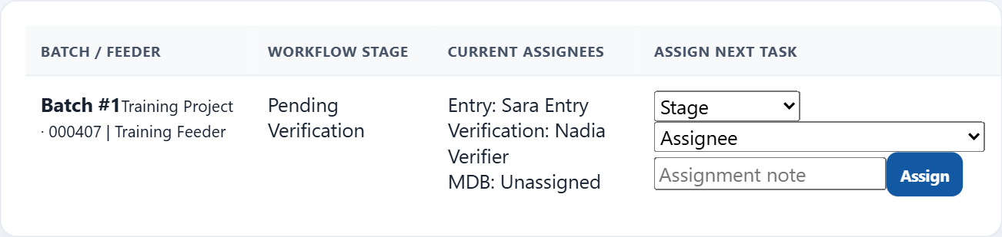
Current assignees confirms the two different owners on the same batch.
7. Common Problems
Problem | Quick fix
Cannot sign in | Check Email, Password and Active status. Admin can reset the password in Users.
Feeder/task missing | Check role, team, current dates and personal assignment. Download assignments on the phone; clear website filters.
PDF/GPX stays Queued | Ask hosting/support to check source processing. Avoid creating duplicate batches.
Verifier/batch unavailable | Submit first. Choose Data Verifier and a person who did not enter that batch.
Returned batch still locked | Use Return for Correction when entry changes are needed. Flag Discrepancy alone keeps it pending.
☐ Each person has tested their own login and can see the correct work.

