**اسئلة واجوبة الفصل الاول من نظم التشغيل**



**Q1/ What is an Operating System? What is the benefit of OS? Remember two examples of the most widely used types of Operating system.**

**الجواب في السلايد الاول والثاني**

**Q2/ Draw the Operating System Organization.**

**الجواب في السلايد الثالث**

**Q3/ What is the Kernel? define it and explain through drawing how the kernel can access many different types of hardware?**

**الجواب**

**The kernel is the operating system. the kernel communicates to hardware both directly and through drivers.**

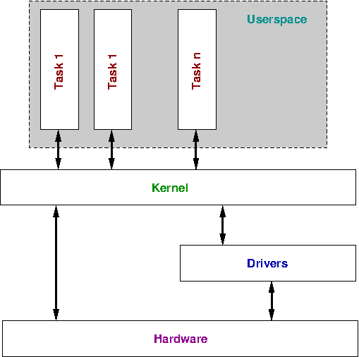

**Q4/ Numbering the four components of computer system. What is the job of each one?**

**الجواب في السلايد السابع**

**Q5/ Draw of the four components of a computer system.**

**الجواب في السلايد الثامن**

**Q9/ What is the meaning of Parallel Processing Systems. What are other its names?**

**الجواب**

Parallel Processing Systems are designed to speed up the execution of programs by dividing the program into multiple fragments and processing these fragments simultaneously.

Its two names are **multiprocessor systems** and **tightly coupled systems.**

**Q10/ Parallel systems deal with the simultaneous use, what are they?**

**الجواب**

Parallel systems deal with the simultaneous use of multiple computer resources that can include:

1. a single computer with multiple processors,
2. a number of computers connected by a network to form a parallel processing cluster
3. or a combination of both.

**Q11/ Define the Real Time operating System. What is the meaning of response time?**

**الجواب**

**A real-time system** is defined as a data processing system in which the time interval required to process and respond to inputs is so small that it controls the environment.

**Response time** is the time taken by the system to respond to an input and display of required updated information is termed as the.

**Q12/ Fill the following spaces:**

1. **Time-sharing or multitasking is a logical extension of multiprogramming.**
2. **Processor's time which is shared among multiple users simultaneously is termed as time-sharing.**

**Q13/ What is the meaning of time-sharing in OS, define it?**

**الجواب**

Time-sharing is a technique which enables many people, located at various terminals, to use a particular computer system at the same time.