Table 1. Summary of modeled selection patterns for cutthroat trout in Blue Ruin and Norwood alcoves during the DO-maxima and minima. Values indicate the available environmental ranges and the peak probabilities of selection for temperature and DO, derived from fitted models.
Variable | DO-maximum | DO-minimum
Blue Ruin
Available range temperature (°C) | 12.38 – 23.79 | 11.69 – 18.94
Available range DO (mg L⁻¹) | 3.50 – 9.52 | 1.97 – 5.35
Peak selection probability temperature (°C) | 15 | 13.78
Peak selection probability DO (mg L⁻¹) | 5.48 | 2.02
Norwood
Available range temperature (°C) | 12.25 – 25.71 | 11.81 – 20.70
Available range DO (mg L⁻¹) | 7.82 – 12.42 | 0.66 – 7.54
Peak selection probability temperature (°C) | 15.13 | 15.02
Peak selection probability DO (mg L⁻¹) | 9.17 | 2.52

Table 2. Model selection results comparing AIC scores from resource selection models for cutthroat trout in Blue Ruin and Norwood alcoves during periods DO-maxima and minima. Models included predictors for temperature only, DO only, and both temperature and DO. Lower AIC values indicate better model fit, and the best‐supported model for each period is denoted with an asterisk (*).
Window | Model | AIC
Blue Ruin
DO-maximum | Temperature & DO* | 1064.54
 | Temperature | 1202.18
 | DO | 1457.52
DO-minimum | Temperature & DO* | 1716.74
 | Temperature | 1778.46
 | DO | 1837.51
Norwood
DO-maximum | Temperature* | 337.14
 | Temperature & DO | 339.09
 | DO | 810.03
DO-minimum | Temperature & DO* | 658.39
 | Temperature | 670.39
 | DO | 736.88

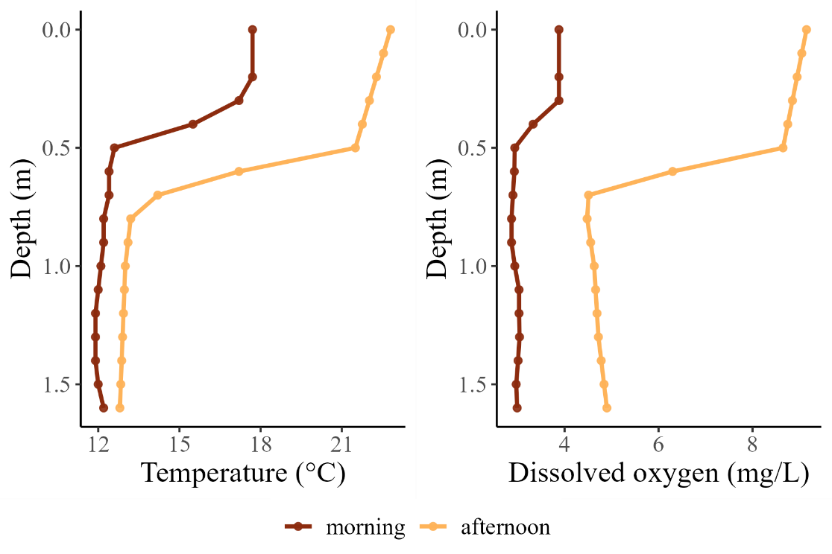

Figure 1. Diel contrasts in temperature and dissolved oxygen profiles for a floodplain alcove that provides thermal refuge for cold-water fishes. Profiles were recorded at dawn (06:00, near the DO-minimum) and in the afternoon (15:00, near the DO-maximum). During the dawn DO-minimum, the coolest depths in the water column became hypoxic. Data are from the Blue Ruin alcove.

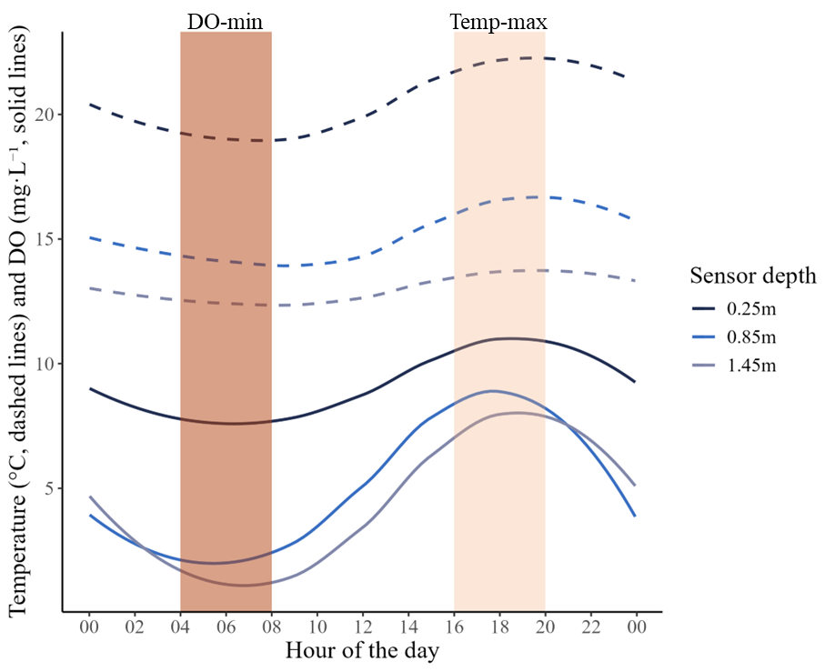
Figure 2. The diel cycle of water temperature (dashed lines) and dissolved oxygen (solid lines) at three depths of a stratified floodplain alcove. Shaded bars highlight the asynchrony between periods of peak hypoxia (dark pink) and peak thermal stress (light pink). Data shown here are for July 27th 2021 in Norwood alcove and have a 5-minute temporal resolution.

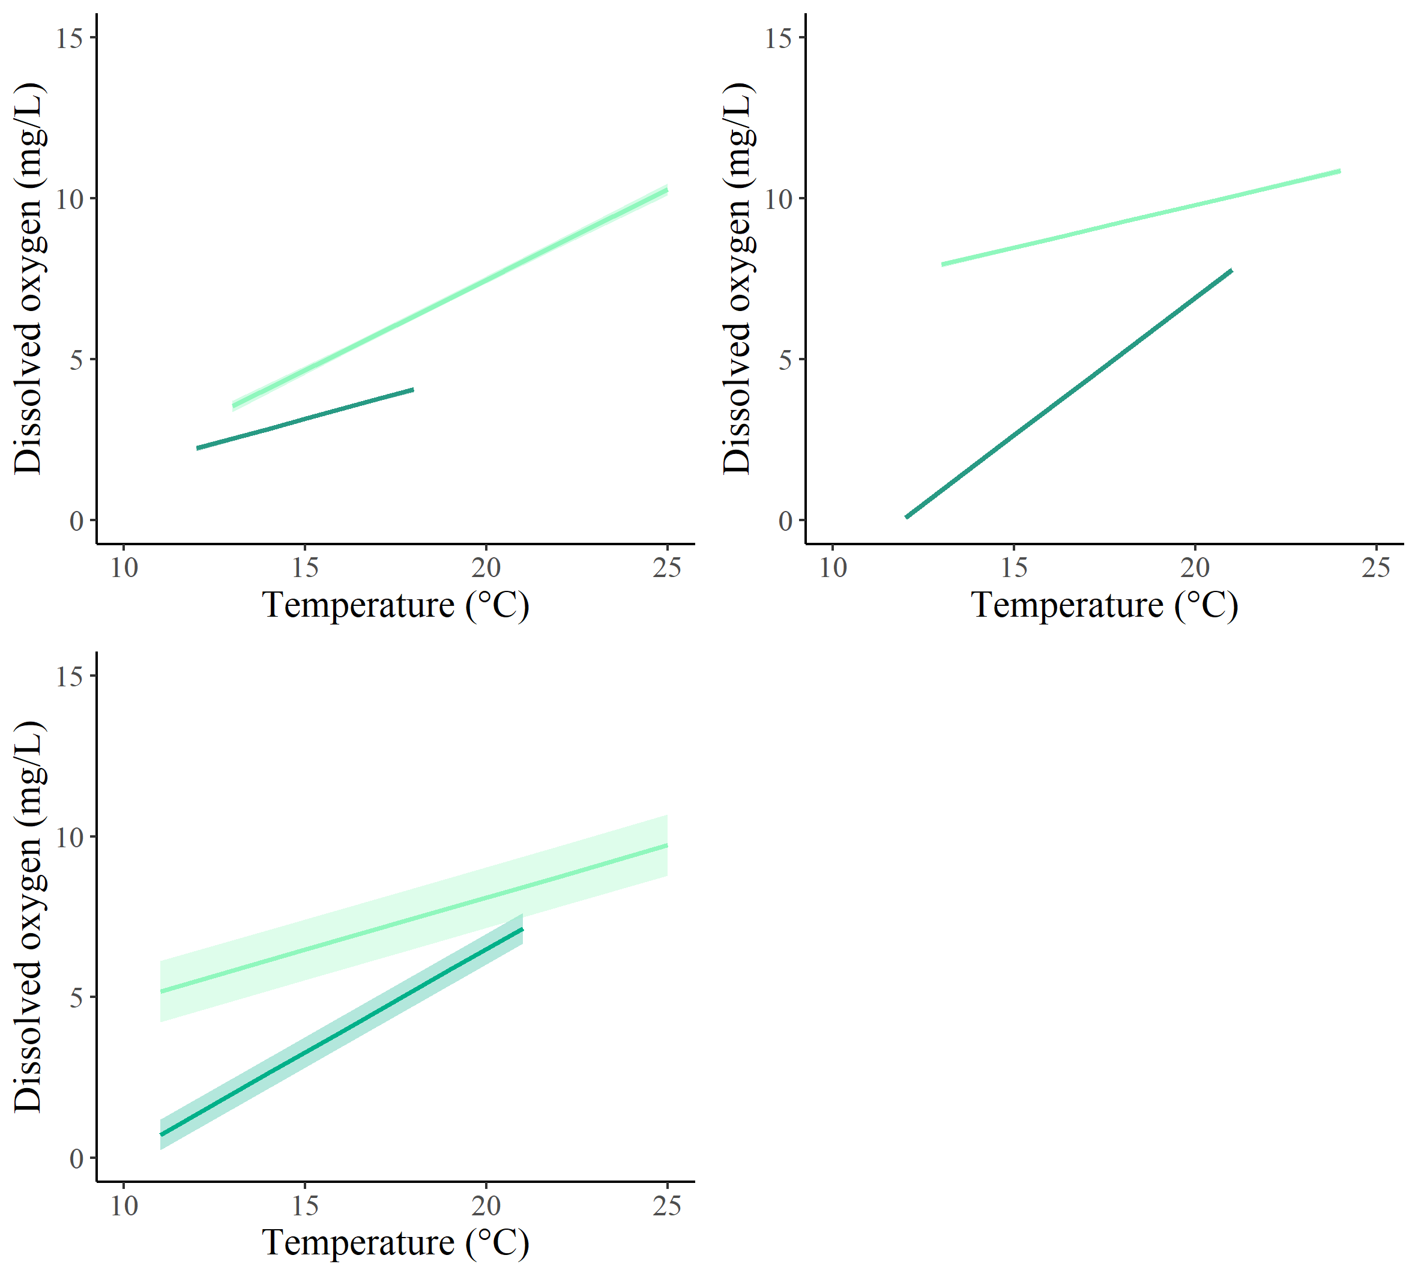
d
c
a
b
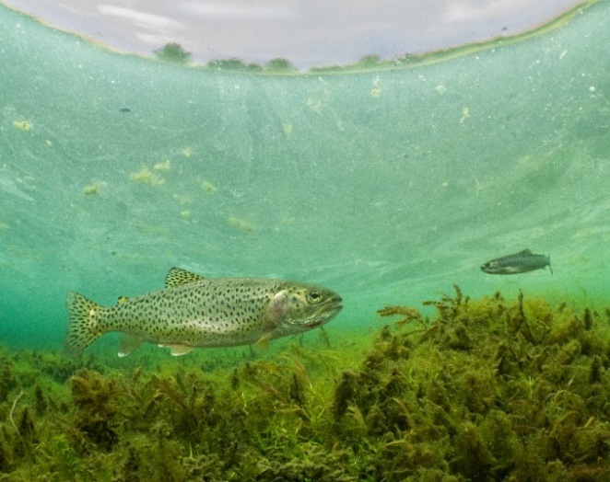
Figure 3. Diel variation in temperature-oxygen trade-offs as illustrated by linear mixed models evaluating the relationship between these variables across sites. Line colors indicate time of day, comparing the 2-hour window at dawn (DO-minimum; dark green) with the 2-hour window in the afternoon (DO-maximum; light green) in a. Blue Ruin cold-water alcove, b. Norwood cold-water alcove, and c. all six cold-water alcoves. All linear fits are plotted with their 95% confidence interval envelopes. d. Photo of a coastal cutthroat trout in Blue Ruin cold-water alcove (photo credit: Dave Herasimtschuk, Freshwaters Illustrated).
b

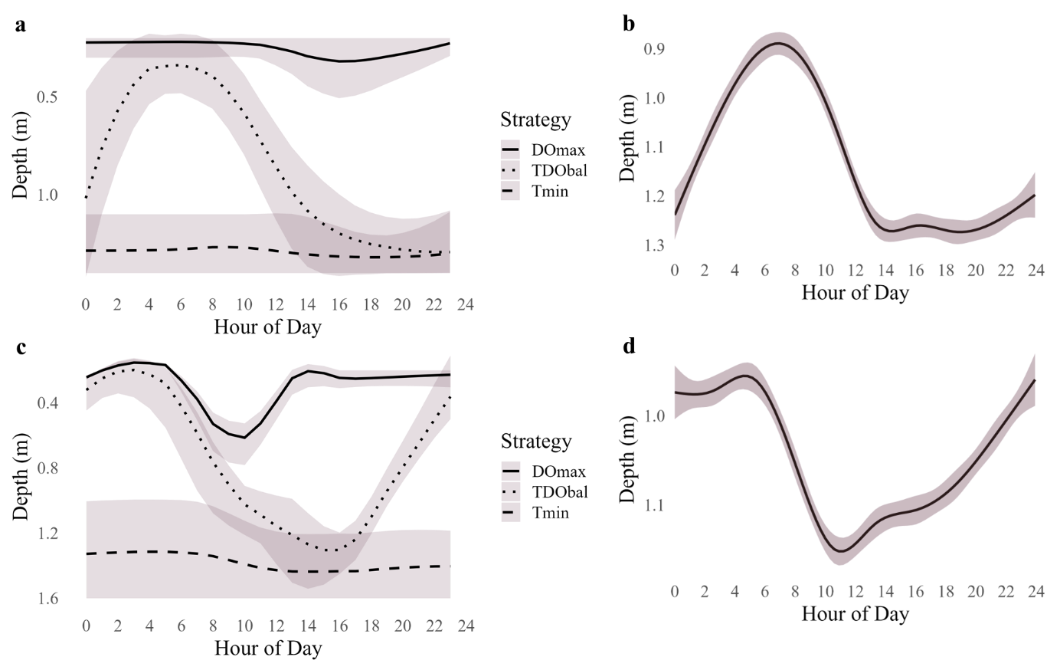

Figure 4. Predicted versus observed patterns of diel vertical habitat use in cold-water alcoves. Left panels (a, c): Numerical simulation of fish depth over a 24-hour period, based on three idealized behavioral strategies: maximizing dissolved oxygen (DO_{max}), minimizing water temperature (T_{min}), or optimizing both concurrently (TDO_{bal}). Each strategy was applied to empirical data on temperature and oxygen for two sites, Blue Ruin (a) and Norwood (c). Data were from Aug-1. Right panels (b, d): Smoothed depth profiles showing observed diel vertical migration of tagged individuals, pooled across fish from Blue Ruin (b) and Norwood (d) during August 1–7.
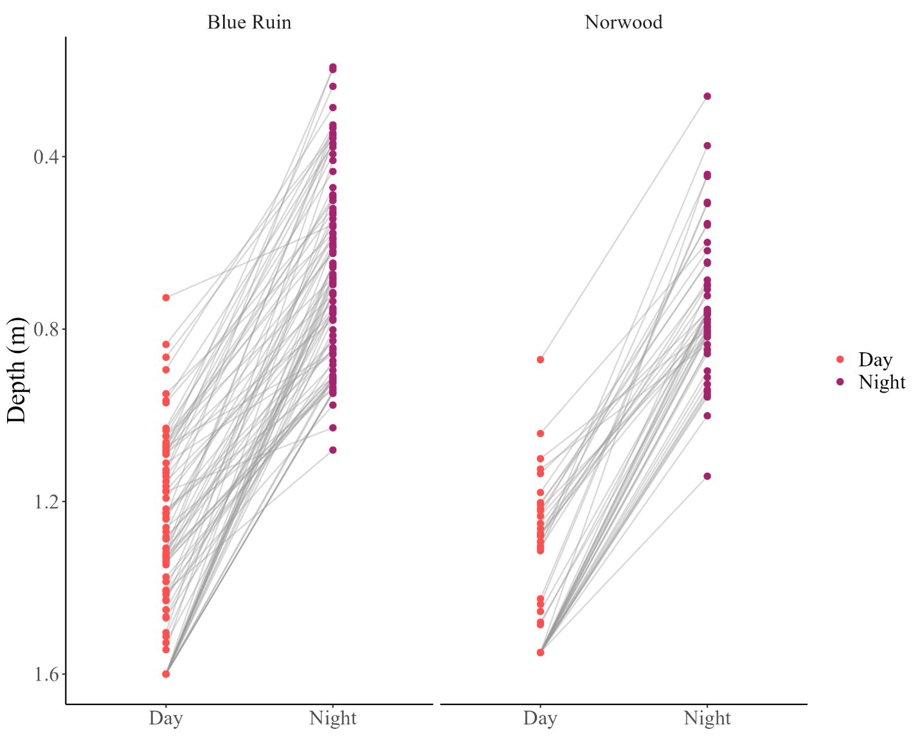
Figure 5. Diel changes in vertical position of tagged cutthroat trout for one week (July 30 – August 6). Each point represents the median depth of an individual fish during either day (red) or night (purple), and gray lines connect paired day-night values. Night-ascending diel vertical movement occurred in all individuals.

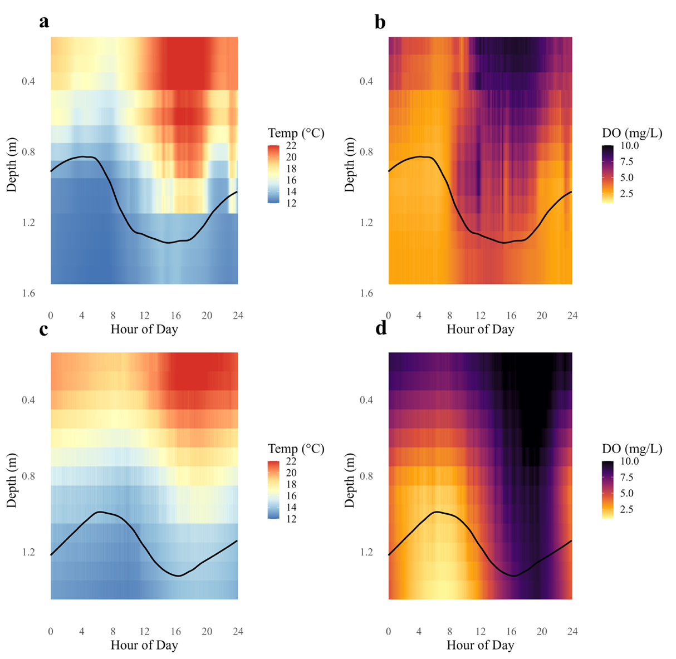

Figure 6. Diel variation in the vertical patterning of temperature (left panels) and dissolved oxygen (right panels) in relation to observed fish depth in Blue Ruin (top, a-b) and Norwood (bottom, c-d) alcoves. Color gradients represent hourly environmental conditions on August 1. Black lines indicate the smoothed depth of tagged cutthroat trout, pooled across individuals on August 1.

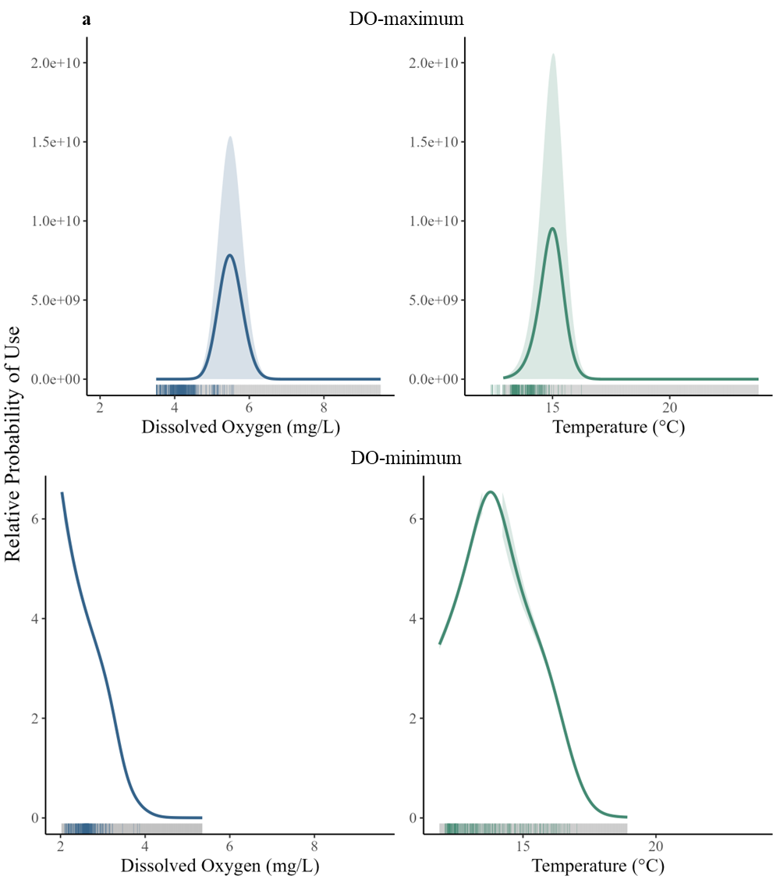

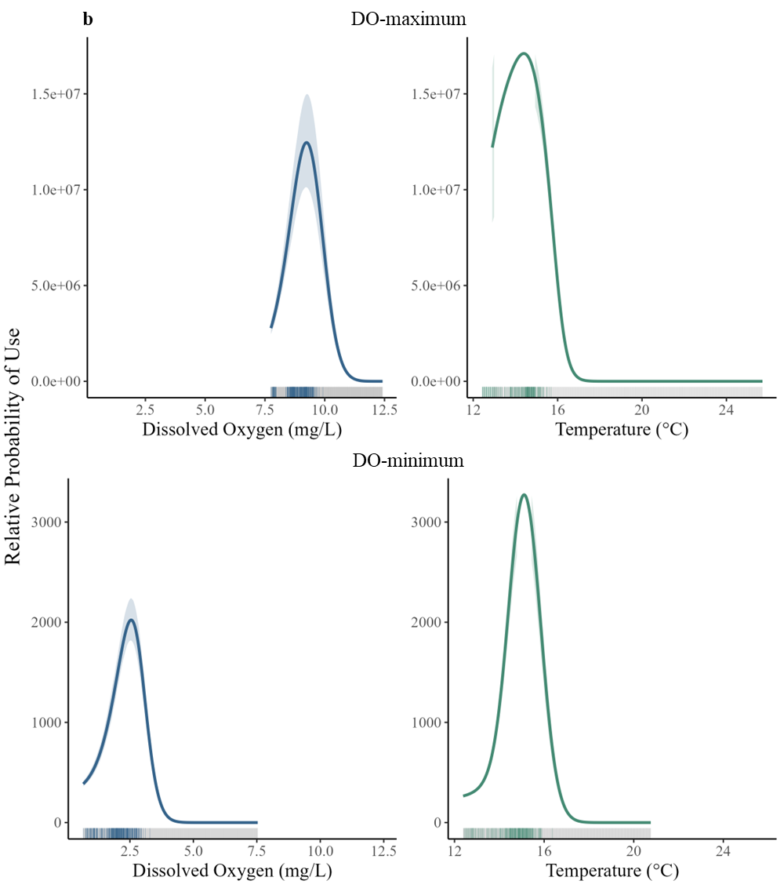
Figure 7. Predicted relative probability of habitat use by cutthroat trout, illustrating selection for temperature and dissolved oxygen values relative to their availability in cold-water alcoves. Results are shown for (a) Blue Ruin and (b) Norwood during the two-hour periods of DO-maximum (top panels) and DO-minimum (bottom panels). Panels show partial (average-effect) plots from resource selection functions (RSFs), illustrating how fish space use varied with dissolved oxygen (left) and temperature (right). Each curve represents fitted RSF values from conditional logistic GAMs, averaged across all possible values of the other covariate. Shaded ribbons denote 95% bootstrapped confidence intervals, and rug plots along the x-axes indicate used values (colored ticks) compared to available values (gray ticks). Fish selected a narrow range of intermediate temperature and dissolved oxygen conditions relative to what was available.

