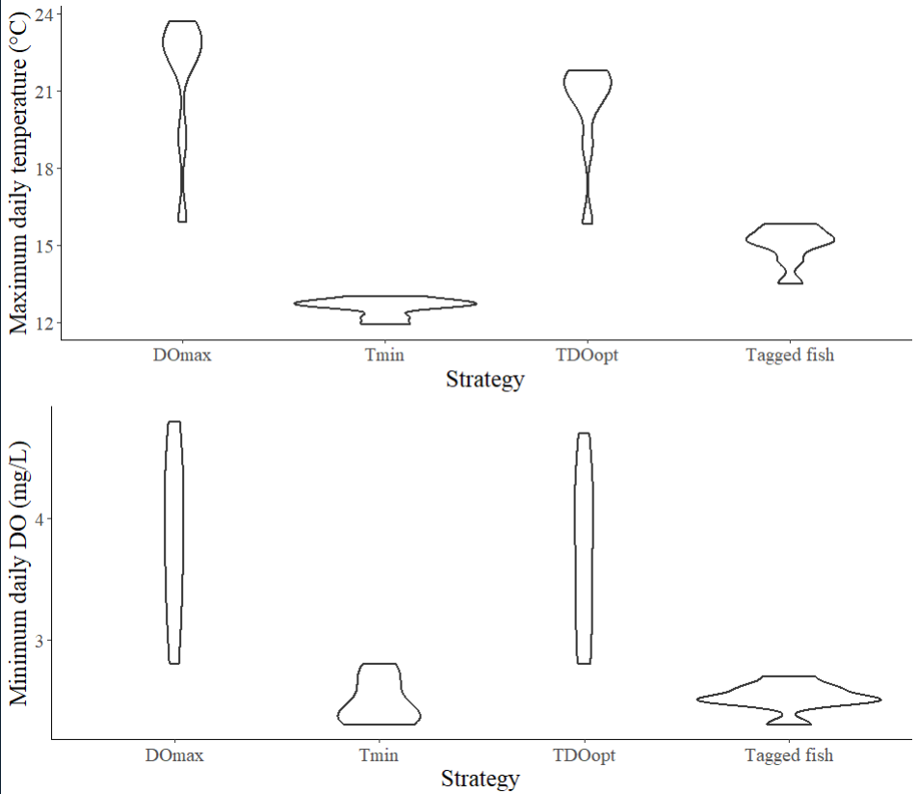
Blue Ruin don’t get gains in do we expected, slightly better in norwood, still in do lower than epa standard. In norwood, more hypoxic at depth, but fish can avoid by moving vertically to higher do, however BR less hypoxic at depth, but surface doesn’t have much DO either.
Don’t have scope for improvement even with increased temperature.

Stratification
Diel fluctuation
Asynchronous stressors
DVM potential to balance tradeoff, instead of static tradeoff
Surface layer in BR is fairly hypoxic at night – check out lmm results figure 3 – span of DO limited at night, potentially reflects lack of exchange with aerated ms water.
Physiological implications – if you’re starving temperature is the limiting aspect – has clear effects on energetic costs, if you select warmer tmps always increases cost, do demand depends on activity/digestion (multiplier factor of how high active resp above basal resp), if at basal resp, may not need too much do

Which begs the question, what is fish condition at the end of summer.
DVM softens tradeoff
Noteable – incur lower oxygen than we’d expect
What this comes down to is time – if they were to go to refuge for a day they would not select low DO habitats (maybe?) probably not optimal solution to their problem. They have to go potentially for a long time to weather high temperatures, in that case they are playing a game of trying to
Leave ms combination of thermal stress and food (not keeping up with energetic costs), habitat moving to is truly a refuge – different challenge on different timescale, not instantaneous conditions and whether it’s too hot/losing gains, more like how long can I starve
What are the long term effects of hypoxia, at end of day what is shaping behavior is nutritional stress and truly fucked DO –

Literature on cyclical low DO exposure – cumulative effects of low DO
It’s a game of time – just to avoid bad conditions for a day, wouldn’t make sense to go to coldest temps, not optimal. Only makes sens to minimize temps over long periods

If only trying to avoid high temp, and if ephemeral, would go to moderate temps
If temp is high and long term, there so long new stressor of energy.
Food stressor
Warming temps prolong summer temps, more fish will be doing this, time on refuge might get longer

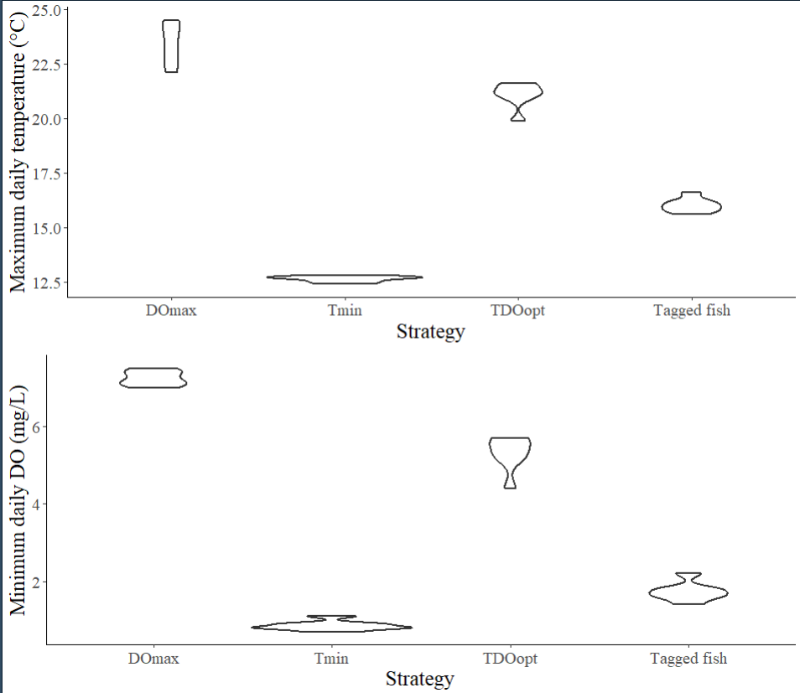
Norwood

Bivariate plot? Boxplots/stripchart

