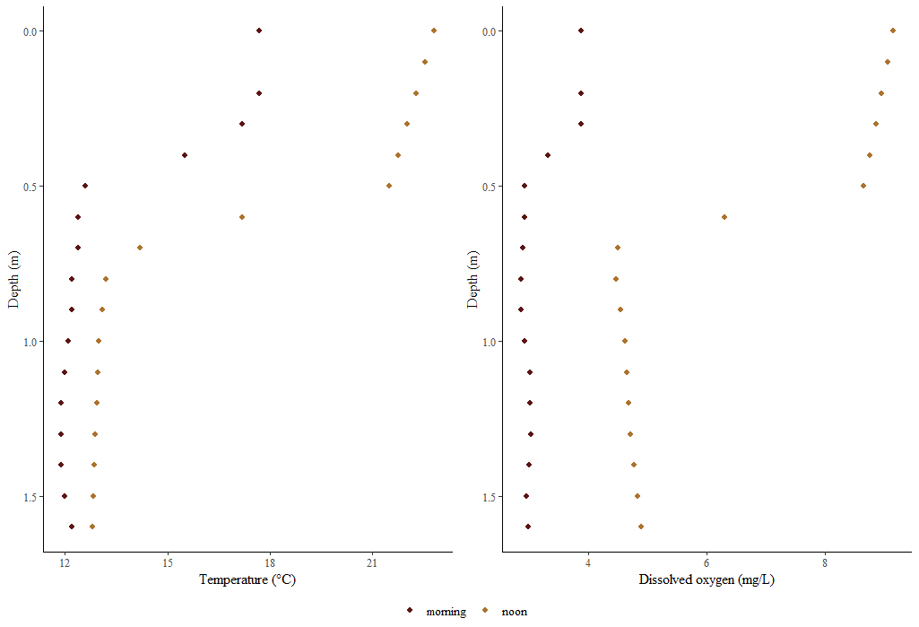
Figure 1 Temperature and dissolved oxygen profiles from terminus of Blue Ruin cold-water alcove, profiles from early morning (6:00, near dissolved oxygen minima), and late afternoon (15:00, near dissolved oxygen maxima).
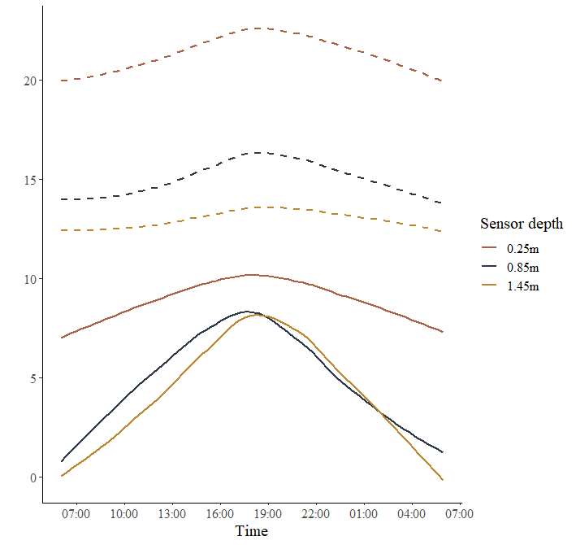

Figure 2 Temperature and dissolved oxygen recorded across 24-hours in the epilimnion, metalimnion, and hypolimnion of Norwood cold-water alcove. Time series begins on the morning of July 27th with a record interval of 5-minutes, dashed lines represent temperature, and solid lines represent dissolved oxygen
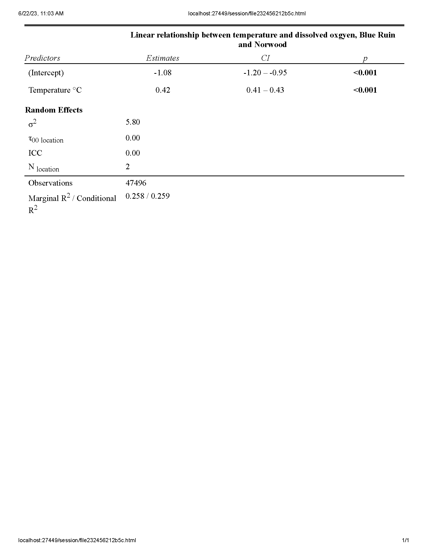
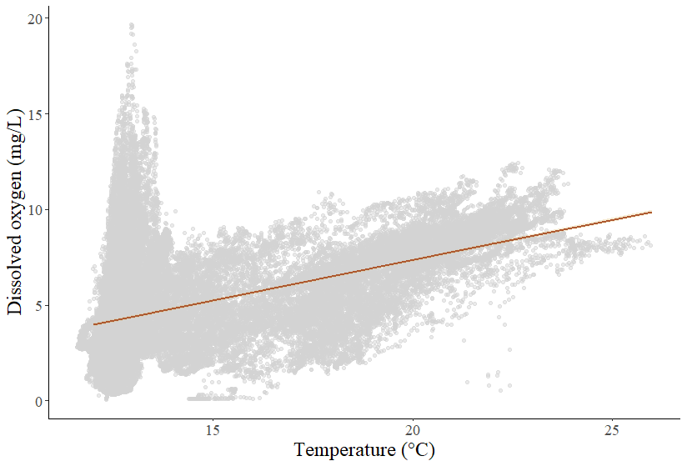
Figure 3(1) Marginal fit (solid orange line) from a mixed effects model evaluating the relationship between temperature and dissolved oxygen across Blue Ruin and Norwood cold-water alcoves plotted with raw data (grey points) and a 95% confidence interval envelope.

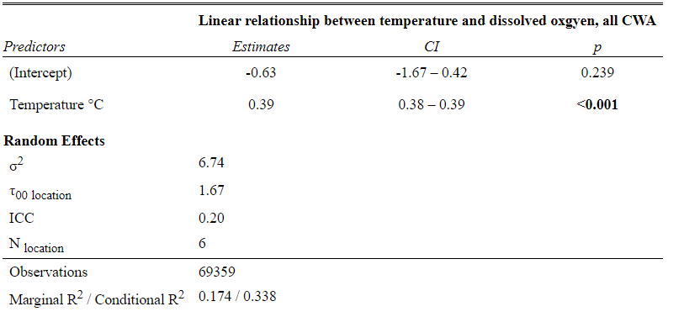
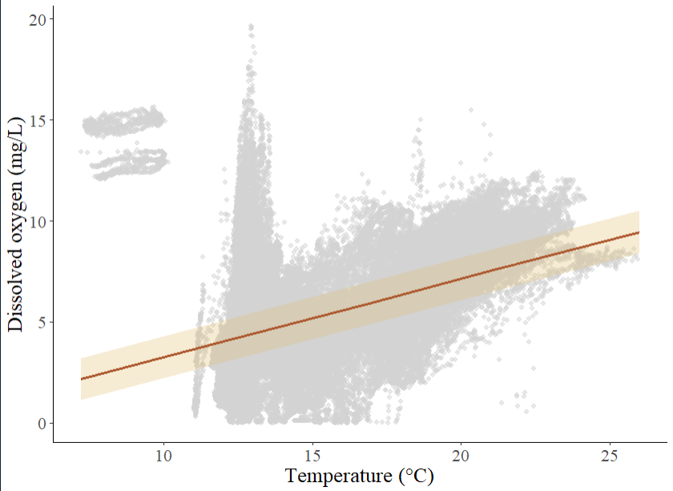
Figure 3(2) Marginal fit (solid orange line) from a mixed effects model evaluating the relationship between temperature and dissolved oxygen across six cold-water alcoves plotted with raw data (grey points) and a 95% confidence interval envelope (tan).
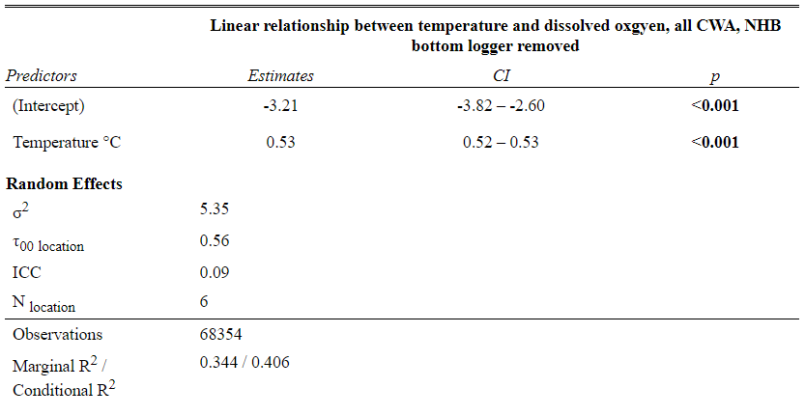
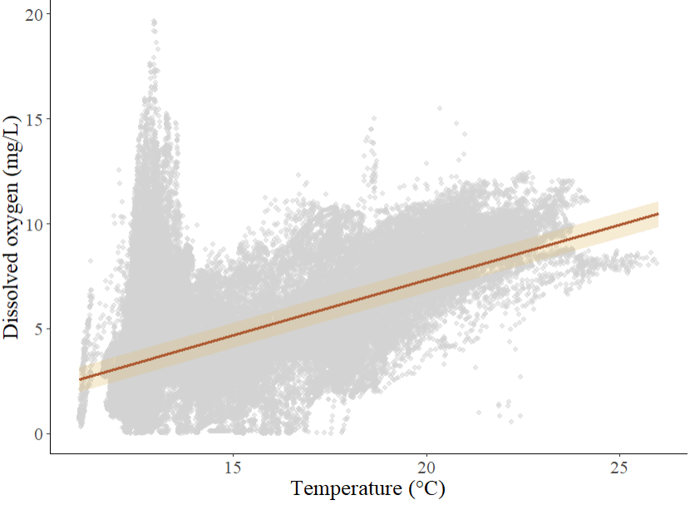
Figure 3(3) Marginal fit (solid orange line) from a mixed effects model evaluating the relationship between temperature and dissolved oxygen across six cold-water alcoves plotted with raw data (grey points) and a 95% confidence interval (bottom logger from N. Harrisburg removed).
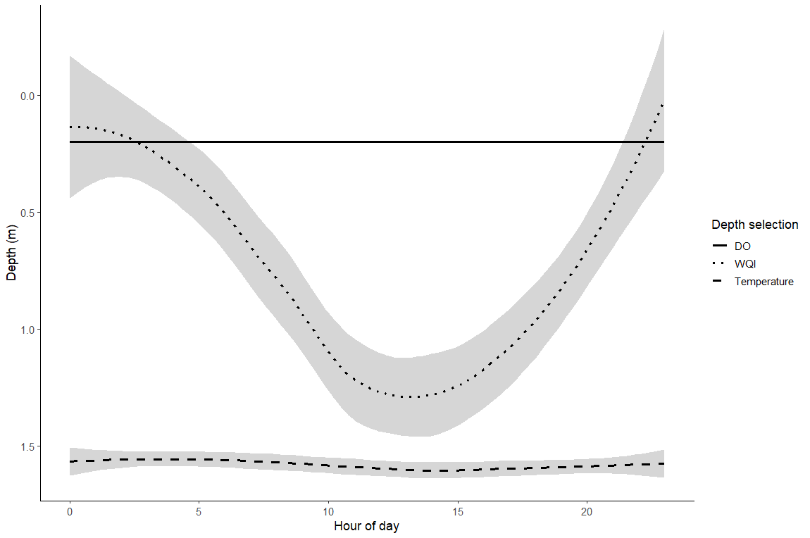
Figure 4 Simulation of depth selection based on three different strategies – fish that maximizes DO, fish that maximizes temp, fish that considers DO and temp concurrently

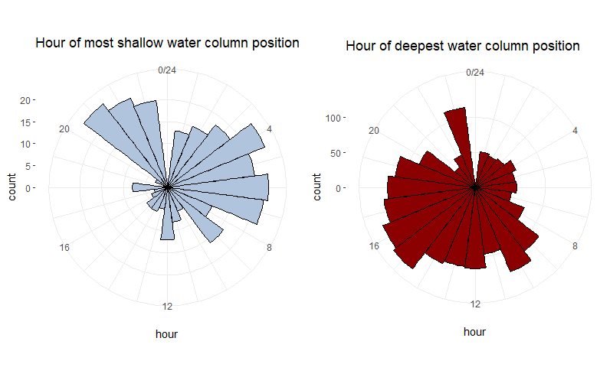
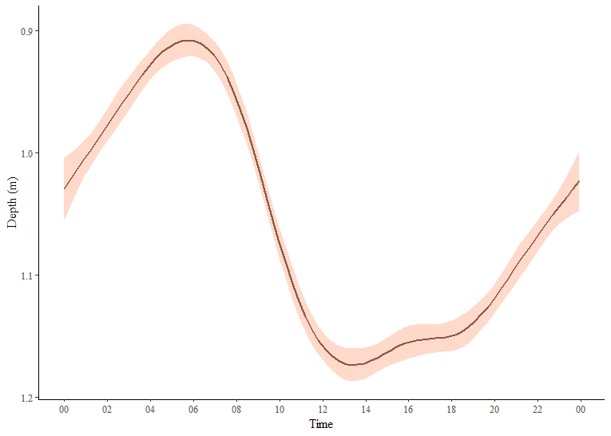
Figure 5 Smoothed plot of fish depth over 24-hour timeframe, pooled from both cold-water alcove locations, 07/30-08/06 (cut off first few days and end days, looking at 1-week)
