Norwood GAM individual tag id
Hannah Barrett
2023-10-29
##
## Attaching package: 'plotly'
## The following object is masked from 'package:ggplot2':
##
## last_plot
## The following object is masked from 'package:stats':
##
## filter
## The following object is masked from 'package:graphics':
##
## layout
## Loading required package: viridisLite
##
## Attaching package: 'dplyr'
## The following objects are masked from 'package:stats':
##
## filter, lag
## The following objects are masked from 'package:base':
##
## intersect, setdiff, setequal, union
##
## Attaching package: 'lubridate'
## The following objects are masked from 'package:base':
##
## date, intersect, setdiff, union
## Loading required package: nlme
##
## Attaching package: 'nlme'
## The following object is masked from 'package:dplyr':
##
## collapse
## This is mgcv 1.8-42. For overview type 'help("mgcv-package")'.
## ── Attaching core tidyverse packages ──────────────────────── tidyverse 2.0.0 ──
## ✔ forcats 1.0.0 ✔ stringr 1.5.0
## ✔ purrr 1.0.2 ✔ tibble 3.2.1
## ✔ readr 2.1.4 ✔ tidyr 1.3.0
## ── Conflicts ────────────────────────────────────────── tidyverse_conflicts() ──
## ✖ nlme::collapse() masks dplyr::collapse()
## ✖ dplyr::filter() masks plotly::filter(), stats::filter()
## ✖ dplyr::lag() masks stats::lag()
## ℹ Use the conflicted package (<http://conflicted.r-lib.org/>) to force all conflicts to become errors
GAM Norwood high DO tag 2
high.int.2 <-high.int[high.int$ibutton.id == 2,]
high.int.2$dumt <-rep(1,nrow(high.int.2))
gam.high.2<-gam(cbind(dumt,stratID) ~ s(standardized.do,standardized.temp), #how to add interaction for GAM
data = high.int.2,
family=cox.ph, weights = case)
summary(gam.high.2)
##
## Family: Cox PH
## Link function: identity
##
## Formula:
## cbind(dumt, stratID) ~ s(standardized.do, standardized.temp)
##
## Approximate significance of smooth terms:
## edf Ref.df Chi.sq p-value
## s(standardized.do,standardized.temp) 7.024 8.447 15.9 0.0645 .
## ---
## Signif. codes: 0 '***' 0.001 '**' 0.01 '*' 0.05 '.' 0.1 ' ' 1
##
## Deviance explained = -171%
## -REML = 27.515 Scale est. = 1 n = 770
pred.vals.high.2<- data.frame(standardized.do = -0.3603449, #setting DO to 4mg/l epa standard
standardized.temp = seq(min(high.int.2$standardized.temp, na.rm = T),
max(high.int.2$standardized.temp, na.rm = T),
0.1), stratID = 691)
preds.gam.high.2 <- predict.gam(gam.high.2, newdata = pred.vals.high.2, type = 'link', se.fit = T)
preds.gam.high.2<-cbind(pred.vals.high.2, preds.gam.high.2)
preds.gam.high.2$lcl<-preds.gam.high.2$fit - (1.96*preds.gam.high.2$se.fit)
preds.gam.high.2$ucl<-preds.gam.high.2$fit + (1.96*preds.gam.high.2$se.fit)
#back transformation from standardized scale
mean.t<-mean(nor.ib$temperature)
sd.t <-sd(nor.ib$temperature)
mean.do<-mean(nor.ib$dissolved.oxygen)
sd.do<-sd(nor.ib$dissolved.oxygen)
preds.gam.high.2$temperature <- preds.gam.high.2$standardized.temp*sd.t+mean.t
preds.gam.high.2$dissolved.oxygen<-preds.gam.high.2$standardized.do*sd.do+mean.do
#Plot
ggplot(preds.gam.high.2, aes(x=temperature, y=fit)) +
geom_line(aes(y = fit), linewidth = 1.25, color = "#01353D")+
geom_ribbon(aes(ymin=lcl, ymax=ucl), alpha=0.2, fill="#01353D")+
theme(panel.grid.major = element_blank(), panel.grid.minor = element_blank(),
panel.background = element_blank(), axis.line = element_line(colour = "black"),
text = element_text(size = 15, family = "serif"))+
xlab("Temperature (\u00B0C)") + ylab("Relative probability of selection")+
theme(legend.title = element_blank())
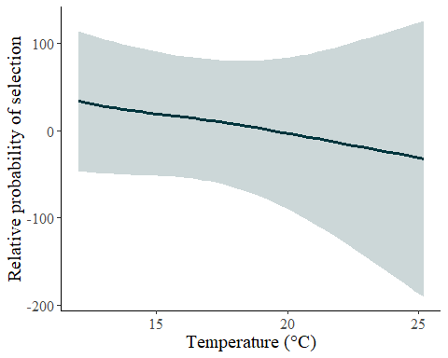
######Contour Plot#######
#Prep
df.pred.high.2 <-expand_grid(
standardized.do = seq(from = min(high.int.2$standardized.do, na.rm = T),
to = max(high.int.2$standardized.do, na.rm = T),
length.out = 100),
standardized.temp = seq(from = min(high.int.2$standardized.temp, na.rm = T),
to = max(high.int.2$standardized.temp, na.rm = T),
length.out = 100)
)
df.pred.high.2 <- predict(gam.high.2, newdata = df.pred.high.2,
se.fit = T)%>%
as_tibble()%>%
cbind(df.pred.high.2)
# Back transform temp and do for plot
df.pred.high.2$temperature <- df.pred.high.2$standardized.temp*sd.t+mean.t
df.pred.high.2$dissolved.oxygen <-df.pred.high.2$standardized.do*sd.do+mean.do
#Plot
ggplot()+
geom_tile(data = df.pred.high.2, aes(x = temperature, y = dissolved.oxygen, fill = fit))+
geom_point(data = high.int.2[high.int.2$case == 0,], aes(x = temperature, y = dissolved.oxygen), colour = "black", alpha = 0.5)+
geom_point(data = high.int.2[high.int.2$case == 1,], aes(x = temperature, y = dissolved.oxygen), colour = "white", alpha = 0.75)+
scale_fill_gradientn(colours = c("#D4D9DD", "#AEB2B7", "#878195", "#7C5467", "#532A34","#291919"))+
geom_contour(data = df.pred.high.2, aes(x = temperature, y = dissolved.oxygen, z= fit), colour = "white")+
theme(panel.grid.major = element_blank(), panel.grid.minor = element_blank(),
panel.background = element_blank(), axis.line = element_line(colour = "black"),
legend.key=element_rect(fill="white"), text = element_text(size = 15, family = "serif"))+
xlab(label = "Temperature (\u00B0C)") +
ylab(label = "Dissolved oxygen (mg/l)")+
labs(fill='')
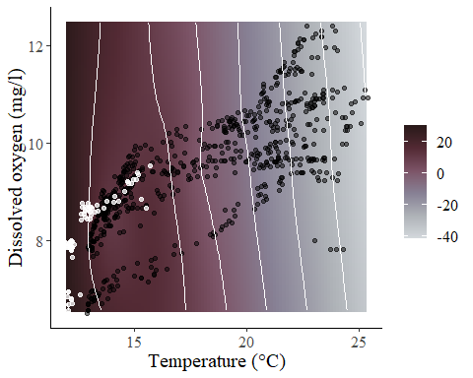
GAM Norwood low DO tag 2
low.int.2 <-low.int[low.int$ibutton.id == 2,]
low.int.2$dumt <-rep(1,nrow(low.int.2))
gam.low.2<-gam(cbind(dumt,stratID) ~ s(standardized.do,standardized.temp),
data = low.int.2,
family=cox.ph, weights = case)
summary(gam.low.2)
##
## Family: Cox PH
## Link function: identity
##
## Formula:
## cbind(dumt, stratID) ~ s(standardized.do, standardized.temp)
##
## Approximate significance of smooth terms:
## edf Ref.df Chi.sq p-value
## s(standardized.do,standardized.temp) 7.067 9.085 47.63 <2e-16 ***
## ---
## Signif. codes: 0 '***' 0.001 '**' 0.01 '*' 0.05 '.' 0.1 ' ' 1
##
## Deviance explained = -5.31%
## -REML = 61.714 Scale est. = 1 n = 770
pred.vals.low.2<- data.frame(standardized.do = -0.3603449, #setting DO to 4mg/l epa standard
standardized.temp = seq(min(low.int.2$standardized.temp, na.rm = T),
max(low.int.2$standardized.temp, na.rm = T),
0.1), stratID = 691)
preds.gam.low.2 <- predict.gam(gam.low.2, newdata = pred.vals.low.2, type = 'link', se.fit = T)
preds.gam.low.2<-cbind(pred.vals.low.2, preds.gam.low.2)
preds.gam.low.2$lcl<-preds.gam.low.2$fit - (1.96*preds.gam.low.2$se.fit)
preds.gam.low.2$ucl<-preds.gam.low.2$fit + (1.96*preds.gam.low.2$se.fit)
#back transformation from standardized scale
mean.t<-mean(nor.ib$temperature)
sd.t <-sd(nor.ib$temperature)
mean.do<-mean(nor.ib$dissolved.oxygen)
sd.do<-sd(nor.ib$dissolved.oxygen)
preds.gam.low.2$temperature <- preds.gam.low.2$standardized.temp*sd.t+mean.t
preds.gam.low.2$dissolved.oxygen<-preds.gam.low.2$standardized.do*sd.do+mean.do
#Plot
ggplot(preds.gam.low.2, aes(x=temperature, y=fit)) +
geom_line(aes(y = fit), linewidth = 1.25, color = "#01353D")+
geom_ribbon(aes(ymin=lcl, ymax=ucl), alpha=0.2, fill="#01353D")+
theme(panel.grid.major = element_blank(), panel.grid.minor = element_blank(),
panel.background = element_blank(), axis.line = element_line(colour = "black"),
text = element_text(size = 15, family = "serif"))+
xlab("Temperature (\u00B0C)") + ylab("Relative probability of selection")+
theme(legend.title = element_blank())
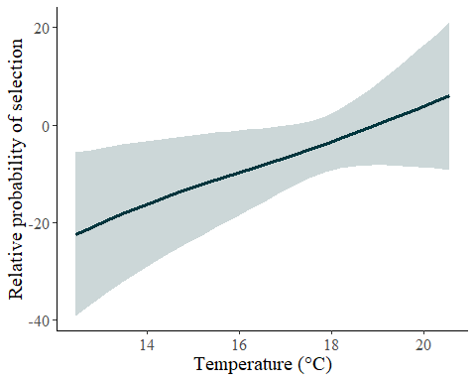
######Contour Plot#######
#Prep
df.pred.low.2 <-expand_grid(
standardized.do = seq(from = min(low.int.2$standardized.do, na.rm = T),
to = max(low.int.2$standardized.do, na.rm = T),
length.out = 100),
standardized.temp = seq(from = min(low.int.2$standardized.temp, na.rm = T),
to = max(low.int.2$standardized.temp, na.rm = T),
length.out = 100)
)
df.pred.low.2 <- predict(gam.low.2, newdata = df.pred.low.2,
se.fit = T)%>%
as_tibble()%>%
cbind(df.pred.low.2)
# Back transform temp and do for plot
df.pred.low.2$temperature <- df.pred.low.2$standardized.temp*sd.t+mean.t
df.pred.low.2$dissolved.oxygen <-df.pred.low.2$standardized.do*sd.do+mean.do
#Plot
ggplot()+
geom_tile(data = df.pred.low.2, aes(x = temperature, y = dissolved.oxygen, fill = fit))+
geom_point(data = low.int.2[low.int.2$case == 0,], aes(x = temperature, y = dissolved.oxygen), colour = "black", alpha = 0.5)+
geom_point(data = low.int.2[low.int.2$case == 1,], aes(x = temperature, y = dissolved.oxygen), colour = "white", alpha = 0.75)+
scale_fill_gradientn(colours = c("#D4D9DD", "#AEB2B7", "#878195", "#7C5467", "#532A34","#291919"))+
geom_contour(data = df.pred.low.2, aes(x = temperature, y = dissolved.oxygen, z= fit), colour = "white")+
theme(panel.grid.major = element_blank(), panel.grid.minor = element_blank(),
panel.background = element_blank(), axis.line = element_line(colour = "black"),
legend.key=element_rect(fill="white"), text = element_text(size = 15, family = "serif"))+
xlab(label = "Temperature (\u00B0C)") +
ylab(label = "Dissolved oxygen (mg/l)")+
labs(fill='')
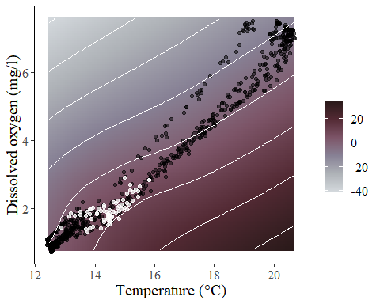
GAM Norwood high DO tag 6
high.int.6 <-high.int[high.int$ibutton.id == 6,]
high.int.6$dumt <-rep(1,nrow(high.int.6))
gam.high.6<-gam(cbind(dumt,stratID) ~ s(standardized.do,standardized.temp), #how to add interaction for GAM
data = high.int.6,
family=cox.ph, weights = case)
summary(gam.high.6)
##
## Family: Cox PH
## Link function: identity
##
## Formula:
## cbind(dumt, stratID) ~ s(standardized.do, standardized.temp)
##
## Approximate significance of smooth terms:
## edf Ref.df Chi.sq p-value
## s(standardized.do,standardized.temp) 4.231 5.162 9.006 0.118
##
## Deviance explained = -410%
## -REML = 0.071354 Scale est. = 1 n = 770
pred.vals.high.6<- data.frame(standardized.do = -0.3603449, #setting DO to 4mg/l epa standard
standardized.temp = seq(min(high.int.6$standardized.temp, na.rm = T),
max(high.int.6$standardized.temp, na.rm = T),
0.1), stratID = 3570)
preds.gam.high.6 <- predict.gam(gam.high.6, newdata = pred.vals.high.6, type = 'link', se.fit = T)
preds.gam.high.6<-cbind(pred.vals.high.6, preds.gam.high.6)
preds.gam.high.6$lcl<-preds.gam.high.6$fit - (1.96*preds.gam.high.6$se.fit)
preds.gam.high.6$ucl<-preds.gam.high.6$fit + (1.96*preds.gam.high.6$se.fit)
#back transformation from standardized scale
mean.t<-mean(nor.ib$temperature)
sd.t <-sd(nor.ib$temperature)
mean.do<-mean(nor.ib$dissolved.oxygen)
sd.do<-sd(nor.ib$dissolved.oxygen)
preds.gam.high.6$temperature <- preds.gam.high.6$standardized.temp*sd.t+mean.t
preds.gam.high.6$dissolved.oxygen<-preds.gam.high.6$standardized.do*sd.do+mean.do
#Plot
ggplot(preds.gam.high.6, aes(x=temperature, y=fit)) +
geom_line(aes(y = fit), linewidth = 1.45, color = "#01353D")+
geom_ribbon(aes(ymin=lcl, ymax=ucl), alpha=0.2, fill="#01353D")+
theme(panel.grid.major = element_blank(), panel.grid.minor = element_blank(),
panel.background = element_blank(), axis.line = element_line(colour = "black"),
text = element_text(size = 15, family = "serif"))+
xlab("Temperature (\u00B0C)") + ylab("Relative probability of selection")+
theme(legend.title = element_blank())
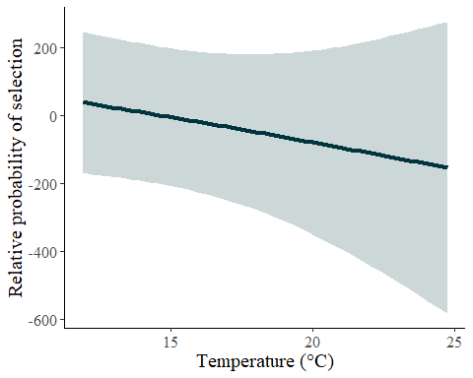
######Contour Plot#######
#Prep
df.pred.high.6 <-expand_grid(
standardized.do = seq(from = min(high.int.6$standardized.do, na.rm = T),
to = max(high.int.6$standardized.do, na.rm = T),
length.out = 100),
standardized.temp = seq(from = min(high.int.6$standardized.temp, na.rm = T),
to = max(high.int.6$standardized.temp, na.rm = T),
length.out = 100)
)
df.pred.high.6 <- predict(gam.high.6, newdata = df.pred.high.6,
se.fit = T)%>%
as_tibble()%>%
cbind(df.pred.high.6)
# Back transform temp and do for plot
df.pred.high.6$temperature <- df.pred.high.6$standardized.temp*sd.t+mean.t
df.pred.high.6$dissolved.oxygen <-df.pred.high.6$standardized.do*sd.do+mean.do
#Plot
ggplot()+
geom_tile(data = df.pred.high.6, aes(x = temperature, y = dissolved.oxygen, fill = fit))+
geom_point(data = high.int.6[high.int.6$case == 0,], aes(x = temperature, y = dissolved.oxygen), colour = "black", alpha = 0.5)+
geom_point(data = high.int.6[high.int.6$case == 1,], aes(x = temperature, y = dissolved.oxygen), colour = "white", alpha = 0.75)+
scale_fill_gradientn(colours = c("#D4D9DD", "#AEB2B7", "#878195", "#7C5467", "#532A34","#291919"))+
geom_contour(data = df.pred.high.6, aes(x = temperature, y = dissolved.oxygen, z= fit), colour = "white")+
theme(panel.grid.major = element_blank(), panel.grid.minor = element_blank(),
panel.background = element_blank(), axis.line = element_line(colour = "black"),
legend.key=element_rect(fill="white"), text = element_text(size = 15, family = "serif"))+
xlab(label = "Temperature (\u00B0C)") +
ylab(label = "Dissolved oxygen (mg/l)")+
labs(fill='')
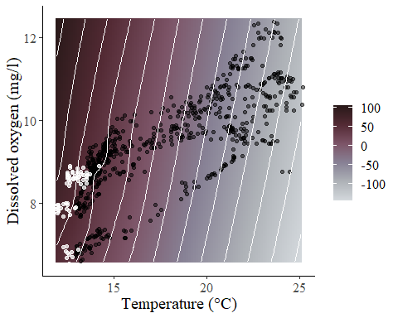
GAM Norwood low DO tag 6
low.int.6 <-low.int[low.int$ibutton.id == 6,]
low.int.6$dumt <-rep(1,nrow(low.int.6))
gam.low.6<-gam(cbind(dumt,stratID) ~ s(standardized.do,standardized.temp),
data = low.int.6,
family=cox.ph, weights = case)
summary(gam.low.6)
##
## Family: Cox PH
## Link function: identity
##
## Formula:
## cbind(dumt, stratID) ~ s(standardized.do, standardized.temp)
##
## Approximate significance of smooth terms:
## edf Ref.df Chi.sq p-value
## s(standardized.do,standardized.temp) 11.44 13.42 52.41 6.11e-06 ***
## ---
## Signif. codes: 0 '***' 0.001 '**' 0.01 '*' 0.05 '.' 0.1 ' ' 1
##
## Deviance explained = 40.2%
## -REML = 83.195 Scale est. = 1 n = 770
pred.vals.low.6<- data.frame(standardized.do = -0.3603449, #setting DO to 4mg/l epa standard
standardized.temp = seq(min(low.int.6$standardized.temp, na.rm = T),
max(low.int.6$standardized.temp, na.rm = T),
0.1), stratID = 3570)
preds.gam.low.6 <- predict.gam(gam.low.6, newdata = pred.vals.low.6, type = 'link', se.fit = T)
preds.gam.low.6<-cbind(pred.vals.low.6, preds.gam.low.6)
preds.gam.low.6$lcl<-preds.gam.low.6$fit - (1.96*preds.gam.low.6$se.fit)
preds.gam.low.6$ucl<-preds.gam.low.6$fit + (1.96*preds.gam.low.6$se.fit)
#back transformation from standardized scale
mean.t<-mean(nor.ib$temperature)
sd.t <-sd(nor.ib$temperature)
mean.do<-mean(nor.ib$dissolved.oxygen)
sd.do<-sd(nor.ib$dissolved.oxygen)
preds.gam.low.6$temperature <- preds.gam.low.6$standardized.temp*sd.t+mean.t
preds.gam.low.6$dissolved.oxygen<-preds.gam.low.6$standardized.do*sd.do+mean.do
#Plot
ggplot(preds.gam.low.6, aes(x=temperature, y=fit)) +
geom_line(aes(y = fit), linewidth = 1.65, color = "#01353D")+
geom_ribbon(aes(ymin=lcl, ymax=ucl), alpha=0.2, fill="#01353D")+
theme(panel.grid.major = element_blank(), panel.grid.minor = element_blank(),
panel.background = element_blank(), axis.line = element_line(colour = "black"),
text = element_text(size = 15, family = "serif"))+
xlab("Temperature (\u00B0C)") + ylab("Relative probability of selection")+
theme(legend.title = element_blank())
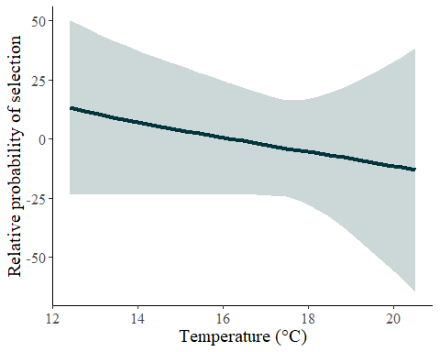
######Contour Plot#######
#Prep
df.pred.low.6 <-expand_grid(
standardized.do = seq(from = min(low.int.6$standardized.do, na.rm = T),
to = max(low.int.6$standardized.do, na.rm = T),
length.out = 100),
standardized.temp = seq(from = min(low.int.6$standardized.temp, na.rm = T),
to = max(low.int.6$standardized.temp, na.rm = T),
length.out = 100)
)
df.pred.low.6 <- predict(gam.low.6, newdata = df.pred.low.6,
se.fit = T)%>%
as_tibble()%>%
cbind(df.pred.low.6)
# Back transform temp and do for plot
df.pred.low.6$temperature <- df.pred.low.6$standardized.temp*sd.t+mean.t
df.pred.low.6$dissolved.oxygen <-df.pred.low.6$standardized.do*sd.do+mean.do
#Plot
ggplot()+
geom_tile(data = df.pred.low.6, aes(x = temperature, y = dissolved.oxygen, fill = fit))+
geom_point(data = low.int.6[low.int.6$case == 0,], aes(x = temperature, y = dissolved.oxygen), colour = "black", alpha = 0.5)+
geom_point(data = low.int.6[low.int.6$case == 1,], aes(x = temperature, y = dissolved.oxygen), colour = "white", alpha = 0.75)+
scale_fill_gradientn(colours = c("#D4D9DD", "#AEB2B7", "#878195", "#7C5467", "#532A34","#291919"))+
geom_contour(data = df.pred.low.6, aes(x = temperature, y = dissolved.oxygen, z= fit), colour = "white")+
theme(panel.grid.major = element_blank(), panel.grid.minor = element_blank(),
panel.background = element_blank(), axis.line = element_line(colour = "black"),
legend.key=element_rect(fill="white"), text = element_text(size = 15, family = "serif"))+
xlab(label = "Temperature (\u00B0C)") +
ylab(label = "Dissolved oxygen (mg/l)")+
labs(fill='')
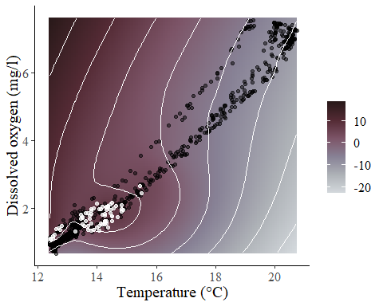
GAM Norwood high DO tag 13
high.int.13 <-high.int[high.int$ibutton.id == 13,]
high.int.13$dumt <-rep(1,nrow(high.int.13))
gam.high.13<-gam(cbind(dumt,stratID) ~ s(standardized.do,standardized.temp), #how to add interaction for GAM
data = high.int.13,
family=cox.ph, weights = case)
summary(gam.high.13)
##
## Family: Cox PH
## Link function: identity
##
## Formula:
## cbind(dumt, stratID) ~ s(standardized.do, standardized.temp)
##
## Approximate significance of smooth terms:
## edf Ref.df Chi.sq p-value
## s(standardized.do,standardized.temp) 8.474 9.96 33.76 0.000238 ***
## ---
## Signif. codes: 0 '***' 0.001 '**' 0.01 '*' 0.05 '.' 0.1 ' ' 1
##
## Deviance explained = 27.7%
## -REML = 62.213 Scale est. = 1 n = 770
pred.vals.high.13<- data.frame(standardized.do = -0.3603449, #setting DO to 4mg/l epa standard
standardized.temp = seq(min(high.int.13$standardized.temp, na.rm = T),
max(high.int.13$standardized.temp, na.rm = T),
0.1), stratID = 5010)
preds.gam.high.13 <- predict.gam(gam.high.13, newdata = pred.vals.high.13, type = 'link', se.fit = T)
preds.gam.high.13<-cbind(pred.vals.high.13, preds.gam.high.13)
preds.gam.high.13$lcl<-preds.gam.high.13$fit - (1.96*preds.gam.high.13$se.fit)
preds.gam.high.13$ucl<-preds.gam.high.13$fit + (1.96*preds.gam.high.13$se.fit)
#back transformation from standardized scale
mean.t<-mean(nor.ib$temperature)
sd.t <-sd(nor.ib$temperature)
mean.do<-mean(nor.ib$dissolved.oxygen)
sd.do<-sd(nor.ib$dissolved.oxygen)
preds.gam.high.13$temperature <- preds.gam.high.13$standardized.temp*sd.t+mean.t
preds.gam.high.13$dissolved.oxygen<-preds.gam.high.13$standardized.do*sd.do+mean.do
#Plot
ggplot(preds.gam.high.13, aes(x=temperature, y=fit)) +
geom_line(aes(y = fit), linewidth = 1.45, color = "#01353D")+
geom_ribbon(aes(ymin=lcl, ymax=ucl), alpha=0.2, fill="#01353D")+
theme(panel.grid.major = element_blank(), panel.grid.minor = element_blank(),
panel.background = element_blank(), axis.line = element_line(colour = "black"),
text = element_text(size = 15, family = "serif"))+
xlab("Temperature (\u00B0C)") + ylab("Relative probability of selection")+
theme(legend.title = element_blank())
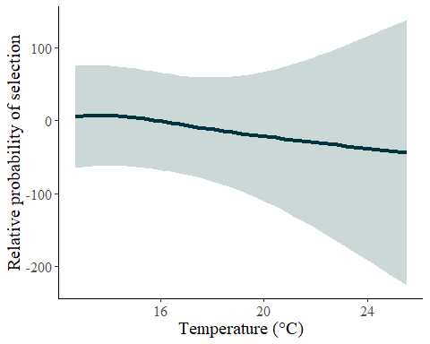
######Contour Plot#######
#Prep
df.pred.high.13 <-expand_grid(
standardized.do = seq(from = min(high.int.13$standardized.do, na.rm = T),
to = max(high.int.13$standardized.do, na.rm = T),
length.out = 100),
standardized.temp = seq(from = min(high.int.13$standardized.temp, na.rm = T),
to = max(high.int.13$standardized.temp, na.rm = T),
length.out = 100)
)
df.pred.high.13 <- predict(gam.high.13, newdata = df.pred.high.13,
se.fit = T)%>%
as_tibble()%>%
cbind(df.pred.high.13)
# Back transform temp and do for plot
df.pred.high.13$temperature <- df.pred.high.13$standardized.temp*sd.t+mean.t
df.pred.high.13$dissolved.oxygen <-df.pred.high.13$standardized.do*sd.do+mean.do
#Plot
ggplot()+
geom_tile(data = df.pred.high.13, aes(x = temperature, y = dissolved.oxygen, fill = fit))+
geom_point(data = high.int.13[high.int.13$case == 0,], aes(x = temperature, y = dissolved.oxygen), colour = "black", alpha = 0.5)+
geom_point(data = high.int.13[high.int.13$case == 1,], aes(x = temperature, y = dissolved.oxygen), colour = "white", alpha = 0.75)+
scale_fill_gradientn(colours = c("#D4D9DD", "#AEB2B7", "#878195", "#7C5467", "#532A34","#291919"))+
geom_contour(data = df.pred.high.13, aes(x = temperature, y = dissolved.oxygen, z= fit), colour = "white")+
theme(panel.grid.major = element_blank(), panel.grid.minor = element_blank(),
panel.background = element_blank(), axis.line = element_line(colour = "black"),
legend.key=element_rect(fill="white"), text = element_text(size = 15, family = "serif"))+
xlab(label = "Temperature (\u00B0C)") +
ylab(label = "Dissolved oxygen (mg/l)")+
labs(fill='')
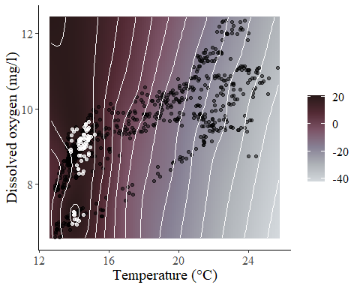
GAM Norwood low DO tag 13
low.int.13 <-low.int[low.int$ibutton.id == 13,]
low.int.13$dumt <-rep(1,nrow(low.int.13))
gam.low.13<-gam(cbind(dumt,stratID) ~ s(standardized.do,standardized.temp),
data = low.int.13,
family=cox.ph, weights = case)
summary(gam.low.13)
##
## Family: Cox PH
## Link function: identity
##
## Formula:
## cbind(dumt, stratID) ~ s(standardized.do, standardized.temp)
##
## Approximate significance of smooth terms:
## edf Ref.df Chi.sq p-value
## s(standardized.do,standardized.temp) 7.456 9.147 16.66 0.0543 .
## ---
## Signif. codes: 0 '***' 0.001 '**' 0.01 '*' 0.05 '.' 0.1 ' ' 1
##
## Deviance explained = -104%
## -REML = 35.582 Scale est. = 1 n = 770
pred.vals.low.13<- data.frame(standardized.do = -0.3603449, #setting DO to 4mg/l epa standard
standardized.temp = seq(min(low.int.13$standardized.temp, na.rm = T),
max(low.int.13$standardized.temp, na.rm = T),
0.1), stratID = 5010)
preds.gam.low.13 <- predict.gam(gam.low.13, newdata = pred.vals.low.13, type = 'link', se.fit = T)
preds.gam.low.13<-cbind(pred.vals.low.13, preds.gam.low.13)
preds.gam.low.13$lcl<-preds.gam.low.13$fit - (1.96*preds.gam.low.13$se.fit)
preds.gam.low.13$ucl<-preds.gam.low.13$fit + (1.96*preds.gam.low.13$se.fit)
#back transformation from standardized scale
mean.t<-mean(nor.ib$temperature)
sd.t <-sd(nor.ib$temperature)
mean.do<-mean(nor.ib$dissolved.oxygen)
sd.do<-sd(nor.ib$dissolved.oxygen)
preds.gam.low.13$temperature <- preds.gam.low.13$standardized.temp*sd.t+mean.t
preds.gam.low.13$dissolved.oxygen<-preds.gam.low.13$standardized.do*sd.do+mean.do
#Plot
ggplot(preds.gam.low.13, aes(x=temperature, y=fit)) +
geom_line(aes(y = fit), linewidth = 1.135, color = "#01353D")+
geom_ribbon(aes(ymin=lcl, ymax=ucl), alpha=0.2, fill="#01353D")+
theme(panel.grid.major = element_blank(), panel.grid.minor = element_blank(),
panel.background = element_blank(), axis.line = element_line(colour = "black"),
text = element_text(size = 15, family = "serif"))+
xlab("Temperature (\u00B0C)") + ylab("Relative probability of selection")+
theme(legend.title = element_blank())
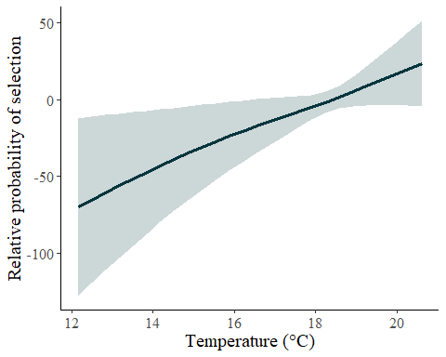
######Contour Plot#######
#Prep
df.pred.low.13 <-expand_grid(
standardized.do = seq(from = min(low.int.13$standardized.do, na.rm = T),
to = max(low.int.13$standardized.do, na.rm = T),
length.out = 100),
standardized.temp = seq(from = min(low.int.13$standardized.temp, na.rm = T),
to = max(low.int.13$standardized.temp, na.rm = T),
length.out = 100)
)
df.pred.low.13 <- predict(gam.low.13, newdata = df.pred.low.13,
se.fit = T)%>%
as_tibble()%>%
cbind(df.pred.low.13)
# Back transform temp and do for plot
df.pred.low.13$temperature <- df.pred.low.13$standardized.temp*sd.t+mean.t
df.pred.low.13$dissolved.oxygen <-df.pred.low.13$standardized.do*sd.do+mean.do
#Plot
ggplot()+
geom_tile(data = df.pred.low.13, aes(x = temperature, y = dissolved.oxygen, fill = fit))+
geom_point(data = low.int.13[low.int.13$case == 0,], aes(x = temperature, y = dissolved.oxygen), colour = "black", alpha = 0.5)+
geom_point(data = low.int.13[low.int.13$case == 1,], aes(x = temperature, y = dissolved.oxygen), colour = "white", alpha = 0.75)+
scale_fill_gradientn(colours = c("#D4D9DD", "#AEB2B7", "#878195", "#7C5467", "#532A34","#291919"))+
geom_contour(data = df.pred.low.13, aes(x = temperature, y = dissolved.oxygen, z= fit), colour = "white")+
theme(panel.grid.major = element_blank(), panel.grid.minor = element_blank(),
panel.background = element_blank(), axis.line = element_line(colour = "black"),
legend.key=element_rect(fill="white"), text = element_text(size = 15, family = "serif"))+
xlab(label = "Temperature (\u00B0C)") +
ylab(label = "Dissolved oxygen (mg/l)")+
labs(fill='')
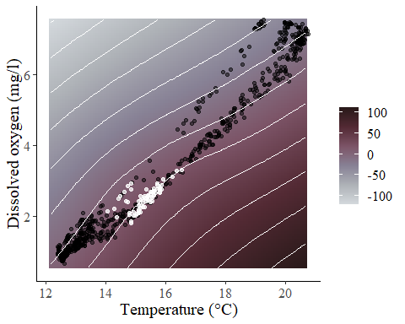
GAM Norwood high DO tag 14
high.int.14 <-high.int[high.int$ibutton.id == 14,]
high.int.14$dumt <-rep(1,nrow(high.int.14))
gam.high.14<-gam(cbind(dumt,stratID) ~ s(standardized.do,standardized.temp), #how to add interaction for GAM
data = high.int.14,
family=cox.ph, weights = case)
summary(gam.high.14)
##
## Family: Cox PH
## Link function: identity
##
## Formula:
## cbind(dumt, stratID) ~ s(standardized.do, standardized.temp)
##
## Approximate significance of smooth terms:
## edf Ref.df Chi.sq p-value
## s(standardized.do,standardized.temp) 7.772 9.295 32.88 0.000195 ***
## ---
## Signif. codes: 0 '***' 0.001 '**' 0.01 '*' 0.05 '.' 0.1 ' ' 1
##
## Deviance explained = -1.36e+03%
## -REML = 68.514 Scale est. = 1 n = 770
pred.vals.high.14<- data.frame(standardized.do = -0.3603449, #setting DO to 4mg/l epa standard
standardized.temp = seq(min(high.int.14$standardized.temp, na.rm = T),
max(high.int.14$standardized.temp, na.rm = T),
0.1), stratID = 6449)
preds.gam.high.14 <- predict.gam(gam.high.14, newdata = pred.vals.high.14, type = 'link', se.fit = T)
preds.gam.high.14<-cbind(pred.vals.high.14, preds.gam.high.14)
preds.gam.high.14$lcl<-preds.gam.high.14$fit - (1.96*preds.gam.high.14$se.fit)
preds.gam.high.14$ucl<-preds.gam.high.14$fit + (1.96*preds.gam.high.14$se.fit)
#back transformation from standardized scale
mean.t<-mean(nor.ib$temperature)
sd.t <-sd(nor.ib$temperature)
mean.do<-mean(nor.ib$dissolved.oxygen)
sd.do<-sd(nor.ib$dissolved.oxygen)
preds.gam.high.14$temperature <- preds.gam.high.14$standardized.temp*sd.t+mean.t
preds.gam.high.14$dissolved.oxygen<-preds.gam.high.14$standardized.do*sd.do+mean.do
#Plot
ggplot(preds.gam.high.14, aes(x=temperature, y=fit)) +
geom_line(aes(y = fit), linewidth = 1.45, color = "#01353D")+
geom_ribbon(aes(ymin=lcl, ymax=ucl), alpha=0.2, fill="#01353D")+
theme(panel.grid.major = element_blank(), panel.grid.minor = element_blank(),
panel.background = element_blank(), axis.line = element_line(colour = "black"),
text = element_text(size = 15, family = "serif"))+
xlab("Temperature (\u00B0C)") + ylab("Relative probability of selection")+
theme(legend.title = element_blank())
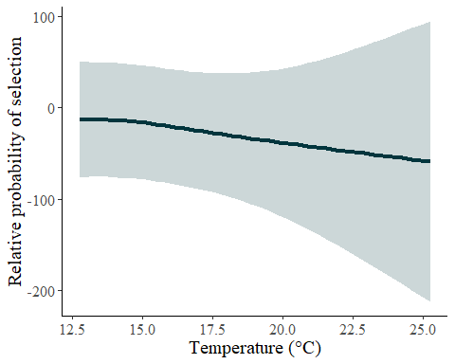
######Contour Plot#######
#Prep
df.pred.high.14 <-expand_grid(
standardized.do = seq(from = min(high.int.14$standardized.do, na.rm = T),
to = max(high.int.14$standardized.do, na.rm = T),
length.out = 100),
standardized.temp = seq(from = min(high.int.14$standardized.temp, na.rm = T),
to = max(high.int.14$standardized.temp, na.rm = T),
length.out = 100)
)
df.pred.high.14 <- predict(gam.high.14, newdata = df.pred.high.14,
se.fit = T)%>%
as_tibble()%>%
cbind(df.pred.high.14)
# Back transform temp and do for plot
df.pred.high.14$temperature <- df.pred.high.14$standardized.temp*sd.t+mean.t
df.pred.high.14$dissolved.oxygen <-df.pred.high.14$standardized.do*sd.do+mean.do
#Plot
ggplot()+
geom_tile(data = df.pred.high.14, aes(x = temperature, y = dissolved.oxygen, fill = fit))+
geom_point(data = high.int.14[high.int.14$case == 0,], aes(x = temperature, y = dissolved.oxygen), colour = "black", alpha = 0.5)+
geom_point(data = high.int.14[high.int.14$case == 1,], aes(x = temperature, y = dissolved.oxygen), colour = "white", alpha = 0.75)+
scale_fill_gradientn(colours = c("#D4D9DD", "#AEB2B7", "#878195", "#7C5467", "#532A34","#291919"))+
geom_contour(data = df.pred.high.14, aes(x = temperature, y = dissolved.oxygen, z= fit), colour = "white")+
theme(panel.grid.major = element_blank(), panel.grid.minor = element_blank(),
panel.background = element_blank(), axis.line = element_line(colour = "black"),
legend.key=element_rect(fill="white"), text = element_text(size = 15, family = "serif"))+
xlab(label = "Temperature (\u00B0C)") +
ylab(label = "Dissolved oxygen (mg/l)")+
labs(fill='')
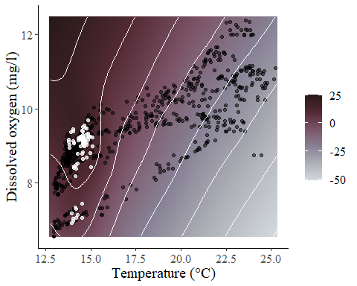
GAM Norwood low DO tag 14
low.int.14 <-low.int[low.int$ibutton.id == 14,]
low.int.14$dumt <-rep(1,nrow(low.int.14))
gam.low.14<-gam(cbind(dumt,stratID) ~ s(standardized.do,standardized.temp),
data = low.int.14,
family=cox.ph, weights = case)
summary(gam.low.14)
##
## Family: Cox PH
## Link function: identity
##
## Formula:
## cbind(dumt, stratID) ~ s(standardized.do, standardized.temp)
##
## Approximate significance of smooth terms:
## edf Ref.df Chi.sq p-value
## s(standardized.do,standardized.temp) 6.427 8.211 30.56 0.000204 ***
## ---
## Signif. codes: 0 '***' 0.001 '**' 0.01 '*' 0.05 '.' 0.1 ' ' 1
##
## Deviance explained = -168%
## -REML = 39.103 Scale est. = 1 n = 770
pred.vals.low.14<- data.frame(standardized.do = -0.3603449, #setting DO to 4mg/l epa standard
standardized.temp = seq(min(low.int.14$standardized.temp, na.rm = T),
max(low.int.14$standardized.temp, na.rm = T),
0.1), stratID = 6449)
preds.gam.low.14 <- predict.gam(gam.low.14, newdata = pred.vals.low.14, type = 'link', se.fit = T)
preds.gam.low.14<-cbind(pred.vals.low.14, preds.gam.low.14)
preds.gam.low.14$lcl<-preds.gam.low.14$fit - (1.96*preds.gam.low.14$se.fit)
preds.gam.low.14$ucl<-preds.gam.low.14$fit + (1.96*preds.gam.low.14$se.fit)
#back transformation from standardized scale
mean.t<-mean(nor.ib$temperature)
sd.t <-sd(nor.ib$temperature)
mean.do<-mean(nor.ib$dissolved.oxygen)
sd.do<-sd(nor.ib$dissolved.oxygen)
preds.gam.low.14$temperature <- preds.gam.low.14$standardized.temp*sd.t+mean.t
preds.gam.low.14$dissolved.oxygen<-preds.gam.low.14$standardized.do*sd.do+mean.do
#Plot
ggplot(preds.gam.low.14, aes(x=temperature, y=fit)) +
geom_line(aes(y = fit), linewidth = 1.145, color = "#01353D")+
geom_ribbon(aes(ymin=lcl, ymax=ucl), alpha=0.2, fill="#01353D")+
theme(panel.grid.major = element_blank(), panel.grid.minor = element_blank(),
panel.background = element_blank(), axis.line = element_line(colour = "black"),
text = element_text(size = 15, family = "serif"))+
xlab("Temperature (\u00B0C)") + ylab("Relative probability of selection")+
theme(legend.title = element_blank())
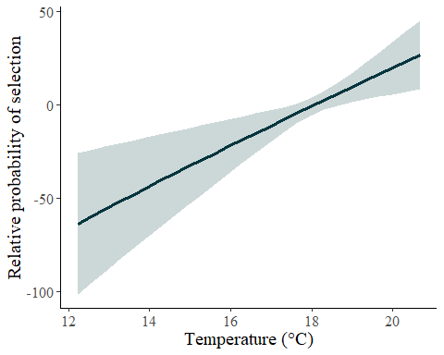
######Contour Plot#######
#Prep
df.pred.low.14 <-expand_grid(
standardized.do = seq(from = min(low.int.14$standardized.do, na.rm = T),
to = max(low.int.14$standardized.do, na.rm = T),
length.out = 100),
standardized.temp = seq(from = min(low.int.14$standardized.temp, na.rm = T),
to = max(low.int.14$standardized.temp, na.rm = T),
length.out = 100)
)
df.pred.low.14 <- predict(gam.low.14, newdata = df.pred.low.14,
se.fit = T)%>%
as_tibble()%>%
cbind(df.pred.low.14)
# Back transform temp and do for plot
df.pred.low.14$temperature <- df.pred.low.14$standardized.temp*sd.t+mean.t
df.pred.low.14$dissolved.oxygen <-df.pred.low.14$standardized.do*sd.do+mean.do
#Plot
ggplot()+
geom_tile(data = df.pred.low.14, aes(x = temperature, y = dissolved.oxygen, fill = fit))+
geom_point(data = low.int.14[low.int.14$case == 0,], aes(x = temperature, y = dissolved.oxygen), colour = "black", alpha = 0.5)+
geom_point(data = low.int.14[low.int.14$case == 1,], aes(x = temperature, y = dissolved.oxygen), colour = "white", alpha = 0.75)+
scale_fill_gradientn(colours = c("#D4D9DD", "#AEB2B7", "#878195", "#7C5467", "#532A34","#291919"))+
geom_contour(data = df.pred.low.14, aes(x = temperature, y = dissolved.oxygen, z= fit), colour = "white")+
theme(panel.grid.major = element_blank(), panel.grid.minor = element_blank(),
panel.background = element_blank(), axis.line = element_line(colour = "black"),
legend.key=element_rect(fill="white"), text = element_text(size = 15, family = "serif"))+
xlab(label = "Temperature (\u00B0C)") +
ylab(label = "Dissolved oxygen (mg/l)")+
labs(fill='')
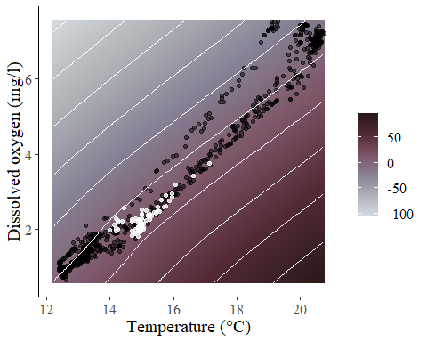
GAM Norwood high DO tag 16
high.int.16 <-high.int[high.int$ibutton.id == 16,]
high.int.16$dumt <-rep(1,nrow(high.int.16))
gam.high.16<-gam(cbind(dumt,stratID) ~ s(standardized.do,standardized.temp), #how to add interaction for GAM
data = high.int.16,
family=cox.ph, weights = case)
summary(gam.high.16)
##
## Family: Cox PH
## Link function: identity
##
## Formula:
## cbind(dumt, stratID) ~ s(standardized.do, standardized.temp)
##
## Approximate significance of smooth terms:
## edf Ref.df Chi.sq p-value
## s(standardized.do,standardized.temp) 8.412 9.999 30.23 0.000791 ***
## ---
## Signif. codes: 0 '***' 0.001 '**' 0.01 '*' 0.05 '.' 0.1 ' ' 1
##
## Deviance explained = -63.2%
## -REML = 68.259 Scale est. = 1 n = 770
pred.vals.high.16<- data.frame(standardized.do = -0.3603449, #setting DO to 4mg/l epa standard
standardized.temp = seq(min(high.int.16$standardized.temp, na.rm = T),
max(high.int.16$standardized.temp, na.rm = T),
0.1), stratID = 7889)
preds.gam.high.16 <- predict.gam(gam.high.16, newdata = pred.vals.high.16, type = 'link', se.fit = T)
preds.gam.high.16<-cbind(pred.vals.high.16, preds.gam.high.16)
preds.gam.high.16$lcl<-preds.gam.high.16$fit - (1.96*preds.gam.high.16$se.fit)
preds.gam.high.16$ucl<-preds.gam.high.16$fit + (1.96*preds.gam.high.16$se.fit)
#back transformation from standardized scale
mean.t<-mean(nor.ib$temperature)
sd.t <-sd(nor.ib$temperature)
mean.do<-mean(nor.ib$dissolved.oxygen)
sd.do<-sd(nor.ib$dissolved.oxygen)
preds.gam.high.16$temperature <- preds.gam.high.16$standardized.temp*sd.t+mean.t
preds.gam.high.16$dissolved.oxygen<-preds.gam.high.16$standardized.do*sd.do+mean.do
#Plot
ggplot(preds.gam.high.16, aes(x=temperature, y=fit)) +
geom_line(aes(y = fit), linewidth = 1.45, color = "#01353D")+
geom_ribbon(aes(ymin=lcl, ymax=ucl), alpha=0.2, fill="#01353D")+
theme(panel.grid.major = element_blank(), panel.grid.minor = element_blank(),
panel.background = element_blank(), axis.line = element_line(colour = "black"),
text = element_text(size = 15, family = "serif"))+
xlab("Temperature (\u00B0C)") + ylab("Relative probability of selection")+
theme(legend.title = element_blank())
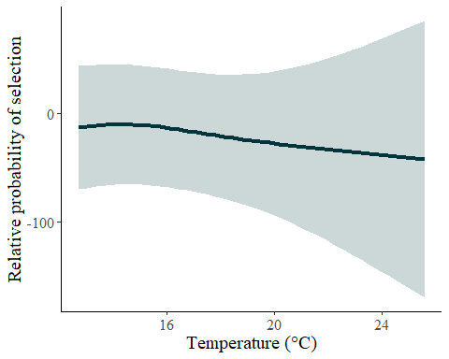
######Contour Plot#######
#Prep
df.pred.high.16 <-expand_grid(
standardized.do = seq(from = min(high.int.16$standardized.do, na.rm = T),
to = max(high.int.16$standardized.do, na.rm = T),
length.out = 100),
standardized.temp = seq(from = min(high.int.16$standardized.temp, na.rm = T),
to = max(high.int.16$standardized.temp, na.rm = T),
length.out = 100)
)
df.pred.high.16 <- predict(gam.high.16, newdata = df.pred.high.16,
se.fit = T)%>%
as_tibble()%>%
cbind(df.pred.high.16)
# Back transform temp and do for plot
df.pred.high.16$temperature <- df.pred.high.16$standardized.temp*sd.t+mean.t
df.pred.high.16$dissolved.oxygen <-df.pred.high.16$standardized.do*sd.do+mean.do
#Plot
ggplot()+
geom_tile(data = df.pred.high.16, aes(x = temperature, y = dissolved.oxygen, fill = fit))+
geom_point(data = high.int.16[high.int.16$case == 0,], aes(x = temperature, y = dissolved.oxygen), colour = "black", alpha = 0.5)+
geom_point(data = high.int.16[high.int.16$case == 1,], aes(x = temperature, y = dissolved.oxygen), colour = "white", alpha = 0.75)+
scale_fill_gradientn(colours = c("#D4D9DD", "#AEB2B7", "#878195", "#7C5467", "#532A34","#291919"))+
geom_contour(data = df.pred.high.16, aes(x = temperature, y = dissolved.oxygen, z= fit), colour = "white")+
theme(panel.grid.major = element_blank(), panel.grid.minor = element_blank(),
panel.background = element_blank(), axis.line = element_line(colour = "black"),
legend.key=element_rect(fill="white"), text = element_text(size = 15, family = "serif"))+
xlab(label = "Temperature (\u00B0C)") +
ylab(label = "Dissolved oxygen (mg/l)")+
labs(fill='')
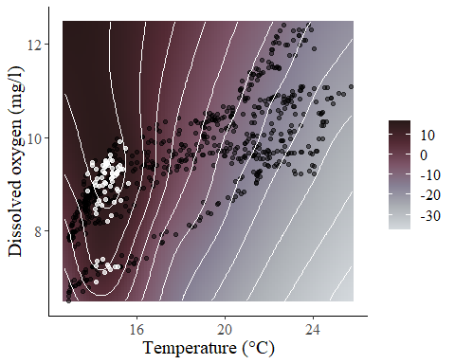
GAM Norwood low DO tag 16
low.int.16 <-low.int[low.int$ibutton.id == 16,]
low.int.16$dumt <-rep(1,nrow(low.int.16))
gam.low.16<-gam(cbind(dumt,stratID) ~ s(standardized.do,standardized.temp),
data = low.int.16,
family=cox.ph, weights = case)
summary(gam.low.16)
##
## Family: Cox PH
## Link function: identity
##
## Formula:
## cbind(dumt, stratID) ~ s(standardized.do, standardized.temp)
##
## Approximate significance of smooth terms:
## edf Ref.df Chi.sq p-value
## s(standardized.do,standardized.temp) 8.786 10.35 25.91 0.00514 **
## ---
## Signif. codes: 0 '***' 0.001 '**' 0.01 '*' 0.05 '.' 0.1 ' ' 1
##
## Deviance explained = -323%
## -REML = 35.818 Scale est. = 1 n = 770
pred.vals.low.16<- data.frame(standardized.do = -0.3603449, #setting DO to 4mg/l epa standard
standardized.temp = seq(min(low.int.16$standardized.temp, na.rm = T),
max(low.int.16$standardized.temp, na.rm = T),
0.1), stratID = 7889)
preds.gam.low.16 <- predict.gam(gam.low.16, newdata = pred.vals.low.16, type = 'link', se.fit = T)
preds.gam.low.16<-cbind(pred.vals.low.16, preds.gam.low.16)
preds.gam.low.16$lcl<-preds.gam.low.16$fit - (1.96*preds.gam.low.16$se.fit)
preds.gam.low.16$ucl<-preds.gam.low.16$fit + (1.96*preds.gam.low.16$se.fit)
#back transformation from standardized scale
mean.t<-mean(nor.ib$temperature)
sd.t <-sd(nor.ib$temperature)
mean.do<-mean(nor.ib$dissolved.oxygen)
sd.do<-sd(nor.ib$dissolved.oxygen)
preds.gam.low.16$temperature <- preds.gam.low.16$standardized.temp*sd.t+mean.t
preds.gam.low.16$dissolved.oxygen<-preds.gam.low.16$standardized.do*sd.do+mean.do
#Plot
ggplot(preds.gam.low.16, aes(x=temperature, y=fit)) +
geom_line(aes(y = fit), linewidth = 1.165, color = "#01353D")+
geom_ribbon(aes(ymin=lcl, ymax=ucl), alpha=0.2, fill="#01353D")+
theme(panel.grid.major = element_blank(), panel.grid.minor = element_blank(),
panel.background = element_blank(), axis.line = element_line(colour = "black"),
text = element_text(size = 15, family = "serif"))+
xlab("Temperature (\u00B0C)") + ylab("Relative probability of selection")+
theme(legend.title = element_blank())
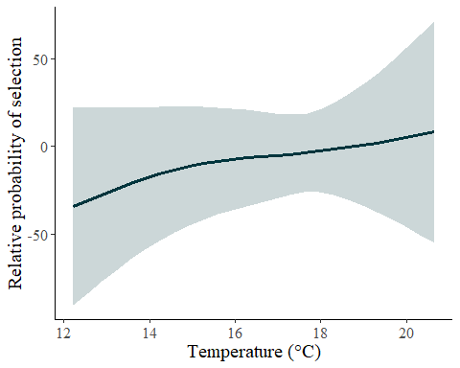
######Contour Plot#######
#Prep
df.pred.low.16 <-expand_grid(
standardized.do = seq(from = min(low.int.16$standardized.do, na.rm = T),
to = max(low.int.16$standardized.do, na.rm = T),
length.out = 100),
standardized.temp = seq(from = min(low.int.16$standardized.temp, na.rm = T),
to = max(low.int.16$standardized.temp, na.rm = T),
length.out = 100)
)
df.pred.low.16 <- predict(gam.low.16, newdata = df.pred.low.16,
se.fit = T)%>%
as_tibble()%>%
cbind(df.pred.low.16)
# Back transform temp and do for plot
df.pred.low.16$temperature <- df.pred.low.16$standardized.temp*sd.t+mean.t
df.pred.low.16$dissolved.oxygen <-df.pred.low.16$standardized.do*sd.do+mean.do
#Plot
ggplot()+
geom_tile(data = df.pred.low.16, aes(x = temperature, y = dissolved.oxygen, fill = fit))+
geom_point(data = low.int.16[low.int.16$case == 0,], aes(x = temperature, y = dissolved.oxygen), colour = "black", alpha = 0.5)+
geom_point(data = low.int.16[low.int.16$case == 1,], aes(x = temperature, y = dissolved.oxygen), colour = "white", alpha = 0.75)+
scale_fill_gradientn(colours = c("#D4D9DD", "#AEB2B7", "#878195", "#7C5467", "#532A34","#291919"))+
geom_contour(data = df.pred.low.16, aes(x = temperature, y = dissolved.oxygen, z= fit), colour = "white")+
theme(panel.grid.major = element_blank(), panel.grid.minor = element_blank(),
panel.background = element_blank(), axis.line = element_line(colour = "black"),
legend.key=element_rect(fill="white"), text = element_text(size = 15, family = "serif"))+
xlab(label = "Temperature (\u00B0C)") +
ylab(label = "Dissolved oxygen (mg/l)")+
labs(fill='')
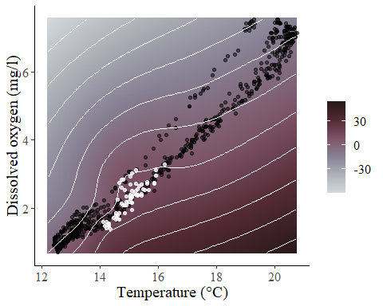
GAM Norwood high DO tag 18
high.int.18 <-high.int[high.int$ibutton.id == 18,]
high.int.18$dumt <-rep(1,nrow(high.int.18))
gam.high.18<-gam(cbind(dumt,stratID) ~ s(standardized.do,standardized.temp), #how to add interaction for GAM
data = high.int.18,
family=cox.ph, weights = case)
summary(gam.high.18)
##
## Family: Cox PH
## Link function: identity
##
## Formula:
## cbind(dumt, stratID) ~ s(standardized.do, standardized.temp)
##
## Approximate significance of smooth terms:
## edf Ref.df Chi.sq p-value
## s(standardized.do,standardized.temp) 15.51 18.18 44.31 0.000542 ***
## ---
## Signif. codes: 0 '***' 0.001 '**' 0.01 '*' 0.05 '.' 0.1 ' ' 1
##
## Deviance explained = NaN%
## -REML = 114 Scale est. = 1 n = 770
pred.vals.high.18<- data.frame(standardized.do = -0.3603449, #setting DO to 4mg/l epa standard
standardized.temp = seq(min(high.int.18$standardized.temp, na.rm = T),
max(high.int.18$standardized.temp, na.rm = T),
0.1), stratID = 9329)
preds.gam.high.18 <- predict.gam(gam.high.18, newdata = pred.vals.high.18, type = 'link', se.fit = T)
preds.gam.high.18<-cbind(pred.vals.high.18, preds.gam.high.18)
preds.gam.high.18$lcl<-preds.gam.high.18$fit - (1.96*preds.gam.high.18$se.fit)
preds.gam.high.18$ucl<-preds.gam.high.18$fit + (1.96*preds.gam.high.18$se.fit)
#back transformation from standardized scale
mean.t<-mean(nor.ib$temperature)
sd.t <-sd(nor.ib$temperature)
mean.do<-mean(nor.ib$dissolved.oxygen)
sd.do<-sd(nor.ib$dissolved.oxygen)
preds.gam.high.18$temperature <- preds.gam.high.18$standardized.temp*sd.t+mean.t
preds.gam.high.18$dissolved.oxygen<-preds.gam.high.18$standardized.do*sd.do+mean.do
#Plot
ggplot(preds.gam.high.18, aes(x=temperature, y=fit)) +
geom_line(aes(y = fit), linewidth = 1.45, color = "#01353D")+
geom_ribbon(aes(ymin=lcl, ymax=ucl), alpha=0.2, fill="#01353D")+
theme(panel.grid.major = element_blank(), panel.grid.minor = element_blank(),
panel.background = element_blank(), axis.line = element_line(colour = "black"),
text = element_text(size = 15, family = "serif"))+
xlab("Temperature (\u00B0C)") + ylab("Relative probability of selection")+
theme(legend.title = element_blank())
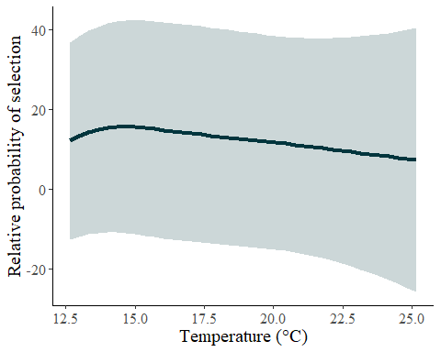
######Contour Plot#######
#Prep
df.pred.high.18 <-expand_grid(
standardized.do = seq(from = min(high.int.18$standardized.do, na.rm = T),
to = max(high.int.18$standardized.do, na.rm = T),
length.out = 100),
standardized.temp = seq(from = min(high.int.18$standardized.temp, na.rm = T),
to = max(high.int.18$standardized.temp, na.rm = T),
length.out = 100)
)
df.pred.high.18 <- predict(gam.high.18, newdata = df.pred.high.18,
se.fit = T)%>%
as_tibble()%>%
cbind(df.pred.high.18)
# Back transform temp and do for plot
df.pred.high.18$temperature <- df.pred.high.18$standardized.temp*sd.t+mean.t
df.pred.high.18$dissolved.oxygen <-df.pred.high.18$standardized.do*sd.do+mean.do
#Plot
ggplot()+
geom_tile(data = df.pred.high.18, aes(x = temperature, y = dissolved.oxygen, fill = fit))+
geom_point(data = high.int.18[high.int.18$case == 0,], aes(x = temperature, y = dissolved.oxygen), colour = "black", alpha = 0.5)+
geom_point(data = high.int.18[high.int.18$case == 1,], aes(x = temperature, y = dissolved.oxygen), colour = "white", alpha = 0.75)+
scale_fill_gradientn(colours = c("#D4D9DD", "#AEB2B7", "#878195", "#7C5467", "#532A34","#291919"))+
geom_contour(data = df.pred.high.18, aes(x = temperature, y = dissolved.oxygen, z= fit), colour = "white")+
theme(panel.grid.major = element_blank(), panel.grid.minor = element_blank(),
panel.background = element_blank(), axis.line = element_line(colour = "black"),
legend.key=element_rect(fill="white"), text = element_text(size = 15, family = "serif"))+
xlab(label = "Temperature (\u00B0C)") +
ylab(label = "Dissolved oxygen (mg/l)")+
labs(fill='')
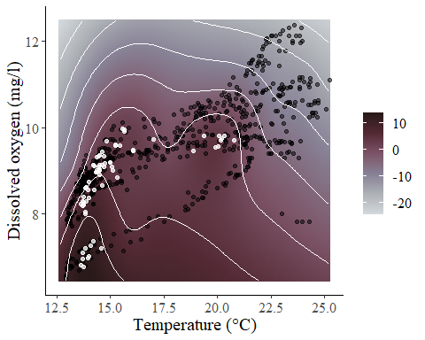
GAM Norwood low DO tag 18
low.int.18 <-low.int[low.int$ibutton.id == 18,]
low.int.18$dumt <-rep(1,nrow(low.int.18))
gam.low.18<-gam(cbind(dumt,stratID) ~ s(standardized.do,standardized.temp),
data = low.int.18,
family=cox.ph, weights = case)
summary(gam.low.18)
##
## Family: Cox PH
## Link function: identity
##
## Formula:
## cbind(dumt, stratID) ~ s(standardized.do, standardized.temp)
##
## Approximate significance of smooth terms:
## edf Ref.df Chi.sq p-value
## s(standardized.do,standardized.temp) 6.79 8.991 34.67 6.7e-05 ***
## ---
## Signif. codes: 0 '***' 0.001 '**' 0.01 '*' 0.05 '.' 0.1 ' ' 1
##
## Deviance explained = NaN%
## -REML = 101.8 Scale est. = 1 n = 770
pred.vals.low.18<- data.frame(standardized.do = -0.3603449, #setting DO to 4mg/l epa standard
standardized.temp = seq(min(low.int.18$standardized.temp, na.rm = T),
max(low.int.18$standardized.temp, na.rm = T),
0.1), stratID = 9329)
preds.gam.low.18 <- predict.gam(gam.low.18, newdata = pred.vals.low.18, type = 'link', se.fit = T)
preds.gam.low.18<-cbind(pred.vals.low.18, preds.gam.low.18)
preds.gam.low.18$lcl<-preds.gam.low.18$fit - (1.96*preds.gam.low.18$se.fit)
preds.gam.low.18$ucl<-preds.gam.low.18$fit + (1.96*preds.gam.low.18$se.fit)
#back transformation from standardized scale
mean.t<-mean(nor.ib$temperature)
sd.t <-sd(nor.ib$temperature)
mean.do<-mean(nor.ib$dissolved.oxygen)
sd.do<-sd(nor.ib$dissolved.oxygen)
preds.gam.low.18$temperature <- preds.gam.low.18$standardized.temp*sd.t+mean.t
preds.gam.low.18$dissolved.oxygen<-preds.gam.low.18$standardized.do*sd.do+mean.do
#Plot
ggplot(preds.gam.low.18, aes(x=temperature, y=fit)) +
geom_line(aes(y = fit), linewidth = 1.185, color = "#01353D")+
geom_ribbon(aes(ymin=lcl, ymax=ucl), alpha=0.2, fill="#01353D")+
theme(panel.grid.major = element_blank(), panel.grid.minor = element_blank(),
panel.background = element_blank(), axis.line = element_line(colour = "black"),
text = element_text(size = 15, family = "serif"))+
xlab("Temperature (\u00B0C)") + ylab("Relative probability of selection")+
theme(legend.title = element_blank())
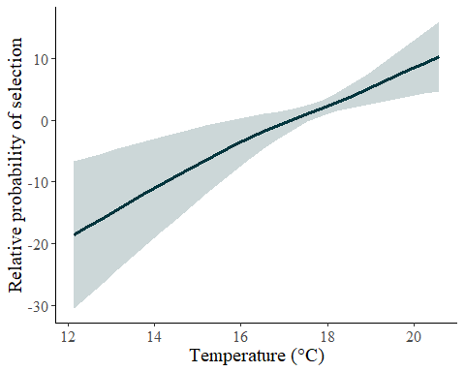
######Contour Plot#######
#Prep
df.pred.low.18 <-expand_grid(
standardized.do = seq(from = min(low.int.18$standardized.do, na.rm = T),
to = max(low.int.18$standardized.do, na.rm = T),
length.out = 100),
standardized.temp = seq(from = min(low.int.18$standardized.temp, na.rm = T),
to = max(low.int.18$standardized.temp, na.rm = T),
length.out = 100)
)
df.pred.low.18 <- predict(gam.low.18, newdata = df.pred.low.18,
se.fit = T)%>%
as_tibble()%>%
cbind(df.pred.low.18)
# Back transform temp and do for plot
df.pred.low.18$temperature <- df.pred.low.18$standardized.temp*sd.t+mean.t
df.pred.low.18$dissolved.oxygen <-df.pred.low.18$standardized.do*sd.do+mean.do
#Plot
ggplot()+
geom_tile(data = df.pred.low.18, aes(x = temperature, y = dissolved.oxygen, fill = fit))+
geom_point(data = low.int.18[low.int.18$case == 0,], aes(x = temperature, y = dissolved.oxygen), colour = "black", alpha = 0.5)+
geom_point(data = low.int.18[low.int.18$case == 1,], aes(x = temperature, y = dissolved.oxygen), colour = "white", alpha = 0.75)+
scale_fill_gradientn(colours = c("#D4D9DD", "#AEB2B7", "#878195", "#7C5467", "#532A34","#291919"))+
geom_contour(data = df.pred.low.18, aes(x = temperature, y = dissolved.oxygen, z= fit), colour = "white")+
theme(panel.grid.major = element_blank(), panel.grid.minor = element_blank(),
panel.background = element_blank(), axis.line = element_line(colour = "black"),
legend.key=element_rect(fill="white"), text = element_text(size = 15, family = "serif"))+
xlab(label = "Temperature (\u00B0C)") +
ylab(label = "Dissolved oxygen (mg/l)")+
labs(fill='')
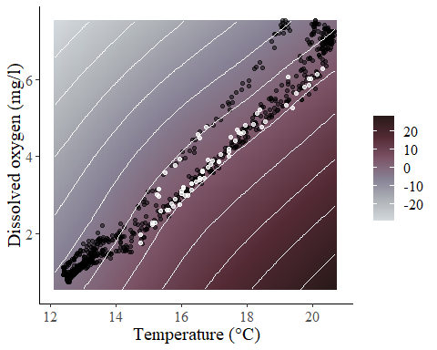
GAM Norwood low DO tag 4
low.int.4 <-low.int[low.int$ibutton.id == 4,]
low.int.4$dumt <-rep(1,nrow(low.int.4))
gam.low.4<-gam(cbind(dumt,stratID) ~ s(standardized.do,standardized.temp),
data = low.int.4,
family=cox.ph, weights = case)
summary(gam.low.4)
##
## Family: Cox PH
## Link function: identity
##
## Formula:
## cbind(dumt, stratID) ~ s(standardized.do, standardized.temp)
##
## Approximate significance of smooth terms:
## edf Ref.df Chi.sq p-value
## s(standardized.do,standardized.temp) 9.779 11 36.88 0.000125 ***
## ---
## Signif. codes: 0 '***' 0.001 '**' 0.01 '*' 0.05 '.' 0.1 ' ' 1
##
## Deviance explained = NaN%
## -REML = 84.566 Scale est. = 1 n = 770
pred.vals.low.4<- data.frame(standardized.do = -0.3603449, #setting DO to 4mg/l epa standard
standardized.temp = seq(min(low.int.4$standardized.temp, na.rm = T),
max(low.int.4$standardized.temp, na.rm = T),
0.1), stratID = 2070)
preds.gam.low.4 <- predict.gam(gam.low.4, newdata = pred.vals.low.4, type = 'link', se.fit = T)
preds.gam.low.4<-cbind(pred.vals.low.4, preds.gam.low.4)
preds.gam.low.4$lcl<-preds.gam.low.4$fit - (1.96*preds.gam.low.4$se.fit)
preds.gam.low.4$ucl<-preds.gam.low.4$fit + (1.96*preds.gam.low.4$se.fit)
#back transformation from standardized scale
mean.t<-mean(nor.ib$temperature)
sd.t <-sd(nor.ib$temperature)
mean.do<-mean(nor.ib$dissolved.oxygen)
sd.do<-sd(nor.ib$dissolved.oxygen)
preds.gam.low.4$temperature <- preds.gam.low.4$standardized.temp*sd.t+mean.t
preds.gam.low.4$dissolved.oxygen<-preds.gam.low.4$standardized.do*sd.do+mean.do
#Plot
ggplot(preds.gam.low.4, aes(x=temperature, y=fit)) +
geom_line(aes(y = fit), linewidth = 1.25, color = "#01353D")+
geom_ribbon(aes(ymin=lcl, ymax=ucl), alpha=0.2, fill="#01353D")+
theme(panel.grid.major = element_blank(), panel.grid.minor = element_blank(),
panel.background = element_blank(), axis.line = element_line(colour = "black"),
text = element_text(size = 15, family = "serif"))+
xlab("Temperature (\u00B0C)") + ylab("Relative probability of selection")+
theme(legend.title = element_blank())
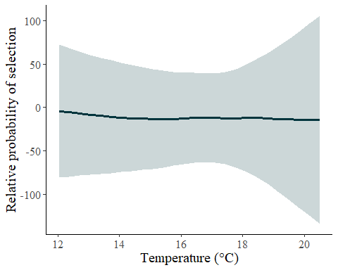
######Contour Plot#######
#Prep
df.pred.low.4 <-expand_grid(
standardized.do = seq(from = min(low.int.4$standardized.do, na.rm = T),
to = max(low.int.4$standardized.do, na.rm = T),
length.out = 100),
standardized.temp = seq(from = min(low.int.4$standardized.temp, na.rm = T),
to = max(low.int.4$standardized.temp, na.rm = T),
length.out = 100)
)
df.pred.low.4 <- predict(gam.low.4, newdata = df.pred.low.4,
se.fit = T)%>%
as_tibble()%>%
cbind(df.pred.low.4)
# Back transform temp and do for plot
df.pred.low.4$temperature <- df.pred.low.4$standardized.temp*sd.t+mean.t
df.pred.low.4$dissolved.oxygen <-df.pred.low.4$standardized.do*sd.do+mean.do
#Plot
ggplot()+
geom_tile(data = df.pred.low.4, aes(x = temperature, y = dissolved.oxygen, fill = fit))+
geom_point(data = low.int.4[low.int.4$case == 0,], aes(x = temperature, y = dissolved.oxygen), colour = "black", alpha = 0.5)+
geom_point(data = low.int.4[low.int.4$case == 1,], aes(x = temperature, y = dissolved.oxygen), colour = "white", alpha = 0.75)+
scale_fill_gradientn(colours = c("#D4D9DD", "#AEB2B7", "#878195", "#7C5467", "#532A34","#291919"))+
geom_contour(data = df.pred.low.4, aes(x = temperature, y = dissolved.oxygen, z= fit), colour = "white")+
theme(panel.grid.major = element_blank(), panel.grid.minor = element_blank(),
panel.background = element_blank(), axis.line = element_line(colour = "black"),
legend.key=element_rect(fill="white"), text = element_text(size = 15, family = "serif"))+
xlab(label = "Temperature (\u00B0C)") +
ylab(label = "Dissolved oxygen (mg/l)")+
labs(fill='')
