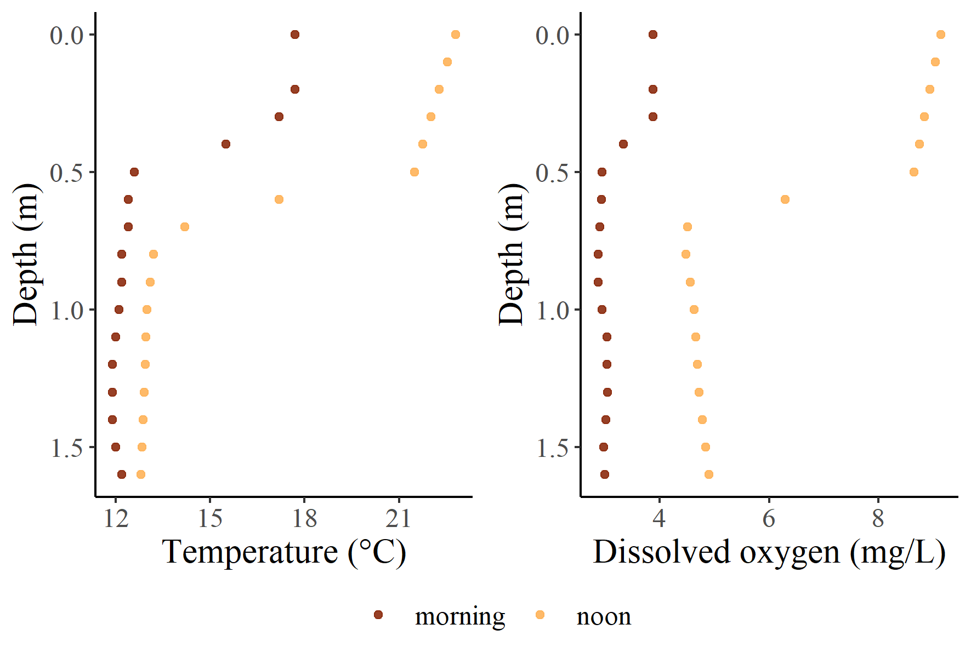
Figure 1 Temperature and dissolved oxygen profiles from terminus of Blue Ruin cold-water alcove, profiles from early morning (6:00, near dissolved oxygen minima), and late afternoon (15:00, near dissolved oxygen maxima).
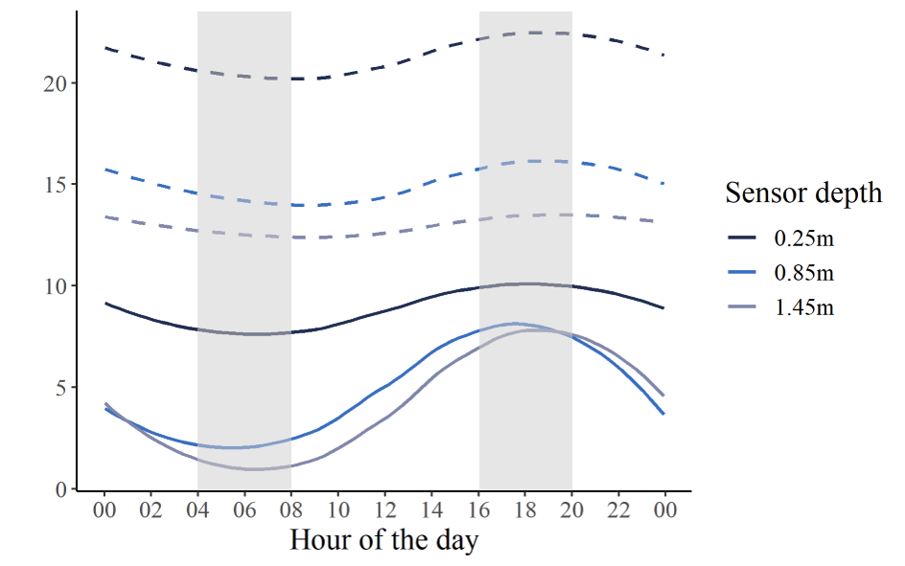
Figure 2 Temperature and dissolved oxygen recorded across 24-hours in the epilimnion, metalimnion, and hypolimnion of Norwood cold-water alcove. Time series begins on the morning of July 27th with a record interval of 5-minutes, dashed lines represent temperature, and solid lines represent dissolved oxygen. Grey bars highlight asynchronous periods of peak hypoxia and peak thermal stress.

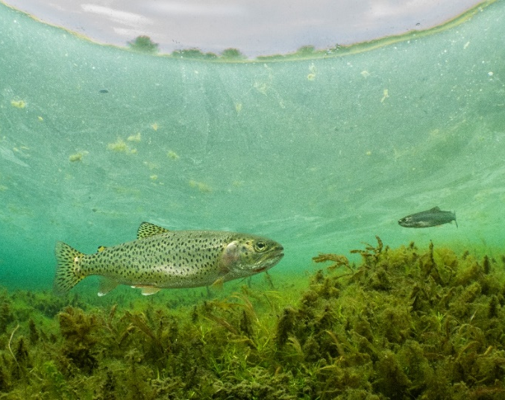
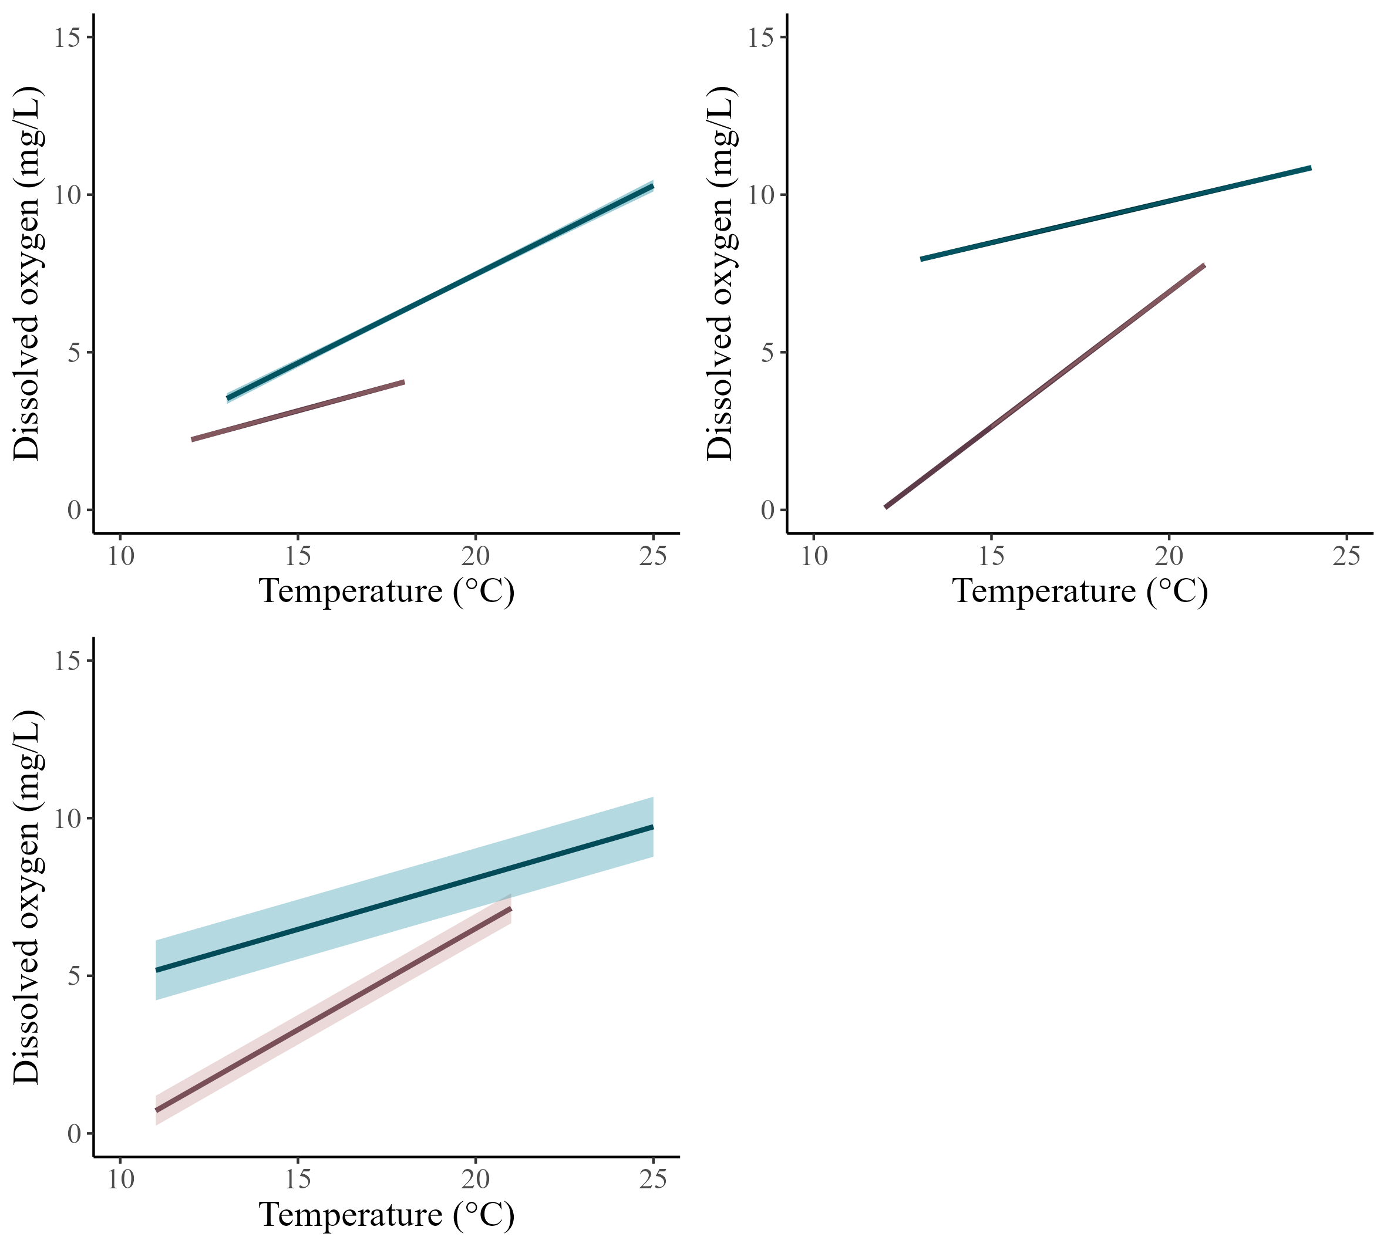
Figure 3 Results from linear mixed models evaluating the relationship between temperature and DO comparing the 2-hour window that approximates the DO-minima (pink) to the 2-hour window that approximates the DO-minima (teal) in a) Blue Ruin cold-water alcove, and b) Norwood cold-water alcove. c) Marginal fit from a mixed effects model evaluating the relationship between temperature and DO in all six cold-water alcoves. All linear fits are plotted with their 95% confidence interval envelopes. d) Photo of coastal cutthroat trout in Blue Ruin cold-water alcove (photo credit: Dave Herasimtschuk).
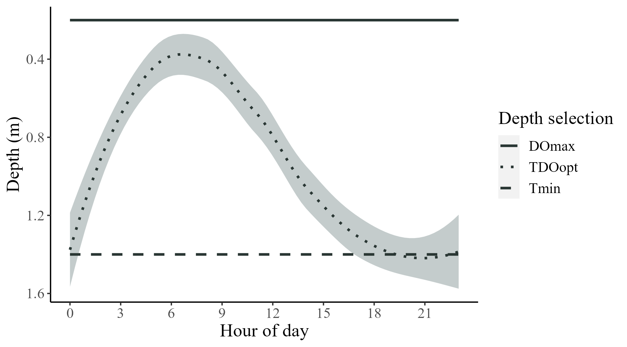
a
b
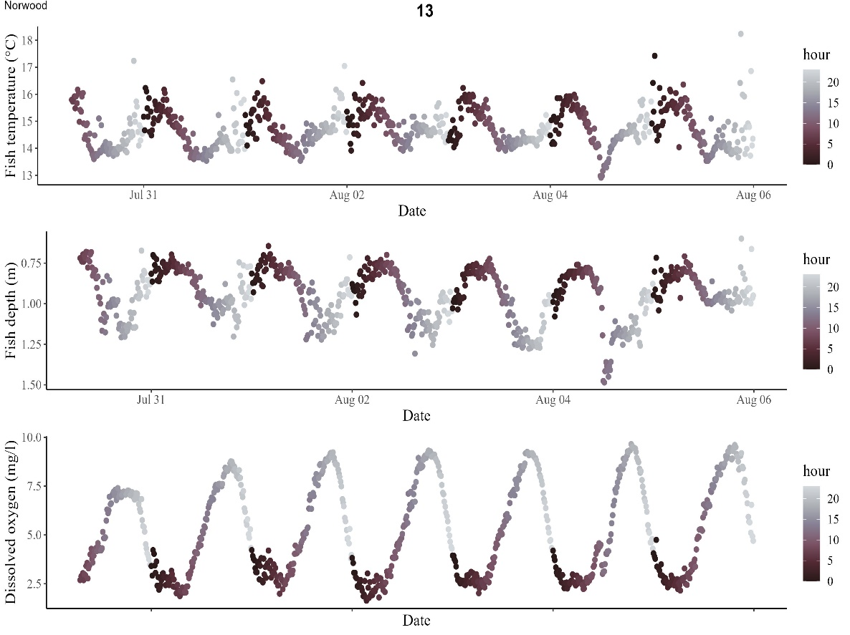
c
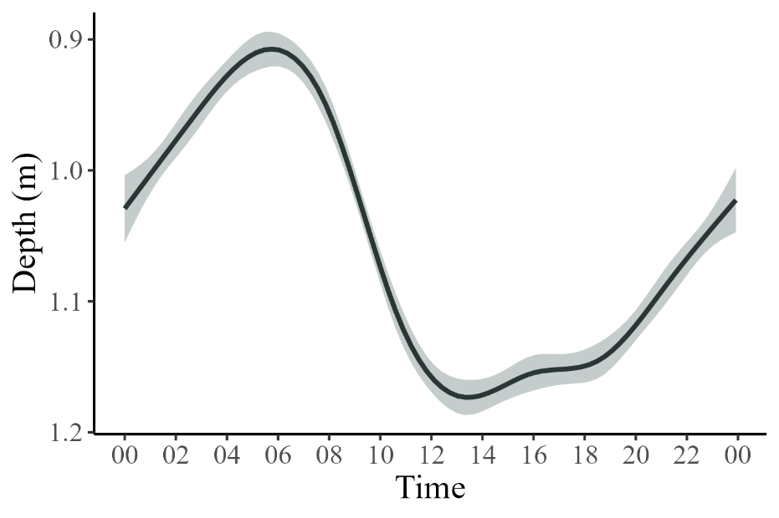
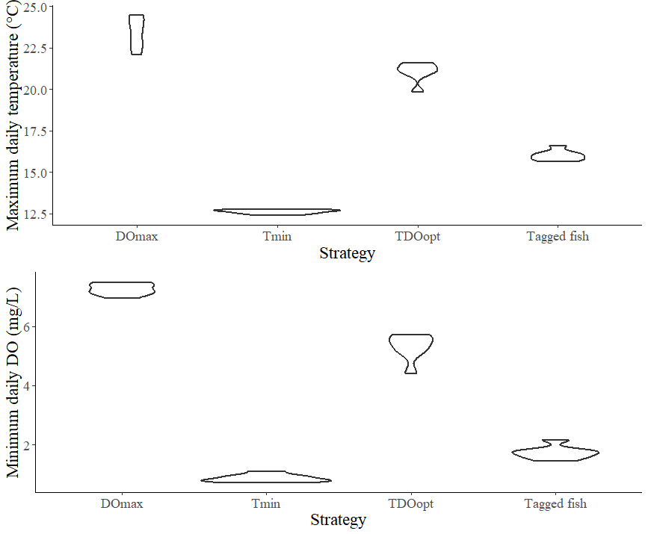
d

Figure 4a) Simulation of depth selection based on three different strategies; maximizing DO (DO_{max}), minimizing temperature (T_{min}), or considering both temperature and DO concurrently (TDO_{opt}). In the DO_{max} strategy, fish depth is based on maximizing DO, in the T_{min} strategy, fish depth is based on minimizing temperature, and in the TDO_{opt} strategy, fish depth is based on considering DO and temperature concurrently. 4b) Plot of individual tagged fish depth (calculated using linear interpolation) over 1-week, July 31 – August 6. 4c) Smoothed plot of fish depth over 24-hour timeframe, pooled from both cold-water alcove locations between July 31 and August 6. 4d) Maximum daily temperature and minimum daily DO encountered by simulated fish under three different strategies, data from 7-days of Norwood data, compared to as well as average maximum daily temperature and average minimum daily DO encountered by tagged fish in Norwood alcove.

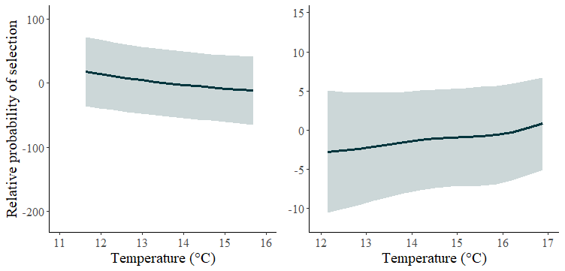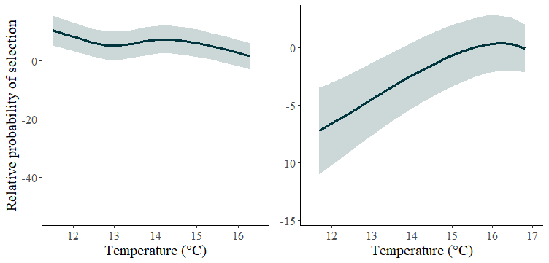
d
c
b
a

Figure 6 a) Norwood alcove early morning DO minima 2-hour window, b) Norwood alcove evening DO maxima 2-hour window c) Blue ruin alcove early morning DO minima 2-hour window, d) Blue ruin alcove evening DO maxima 2-hour window. In all plots, DO held constant at 4mg/L (EPA threshold for cold water fish).
In both alcoves, high probability of selecting coolest temperatures (at greatest depth) when DO is adequate, during the early morning DO minima, probability of selection switches to warm water (at surface) in Norwood, however in Blue Ruin there is no apparent selection strength.
Hypolimnion DO has way larger amplitude in Norwood than BR (look at average hypolimnion DO during min/max windows (Table 1) – influences probability of selecting shallower depths during night – DVM occurs but with less selection strength during low DO periods). High/low DO windows also vary by 1 hour between sites.

Table 1 Average minimum and maximum temperature and dissolved oxygen (DO) recorded at the hypolimnion and metalimnion in both Blue Ruin and Norwood alcoves at their net pen associated logger arrays.
Norwood 07-31 to 08-07 | Temp (℃) | DO (mg/L)
Average minimum hyporheic | 12.5 | 1.2
Average maximum hyporheic | 13.6 | 8.4
Average minimum epilimnetic | 20.0 | 6.9
Average maximum epilimnetic | 25.0 | 11.3
Blue Ruin 07-31 to 08-07 | Temp (℃) | DO (mg/L)
Average minimum hyporheic | 12.1 | 2.5
Average maximum hyporheic | 13.4 | 4.8
Average minimum epilimnetic | 16.2 | 3.4
Average maximum epilimnetic | 22.7 | 9.2

Table 2 Results from linear models (Norwood, Blue Ruin) and linear mixed models (all CWA) fit to data collected during the approximate 2-hour DO-maxima (6:00-8:00), and 2-hour DO-minima (18:00-20:00).
 |  | β | SE | p-value
Norwood | high DO | 0.264 | 0.007 | <0.001
 | low DO | 0.856 | 0.008 | <0.001
Blue Ruin | high DO | 0.563 | 0.013 | <0.001
 | low DO | 0.306 | 0.011 | <0.001
All CWA | high DO | 0.325 | 0.009 | <0.001
 | low DO | 0.642 | 0.008 | <0.001

Table 3 Results from conditional logistic regression models of resource selection by cutthroat trout.
Norwood
Low DO
Covariate | β | SE | p-value
Temperature | 5.999 | 1.103 | <0.001
DO | -11.760 | 7.841e-06 | <0.001
Temperature:DO | -2.603 | 0.321 | <0.001
High DO
Covariate | β | SE | p-value
Temperature | -6.000 | 0.578 | <0.001
DO | 7.799 | 0.825 | <0.001
Temperature:DO | 0.485 | 0.342 | 0.156
Blue Ruin
Low DO
Covariate | β | SE | p-value
Temperature | 0.595 | 0.716 | <0.001
DO | -8.260 | 0.562 | 0.406
Temperature:DO | -0.052 | 0.756 | 0.945
High DO
Covariate | β | SE | p-value
Temperature | 0.263 | 0.344 | <0.001
DO | -4.549 | 0.799 | 0.455
Temperature:DO | -10.394 | 1.109 | <0.001

Supplemental Figures

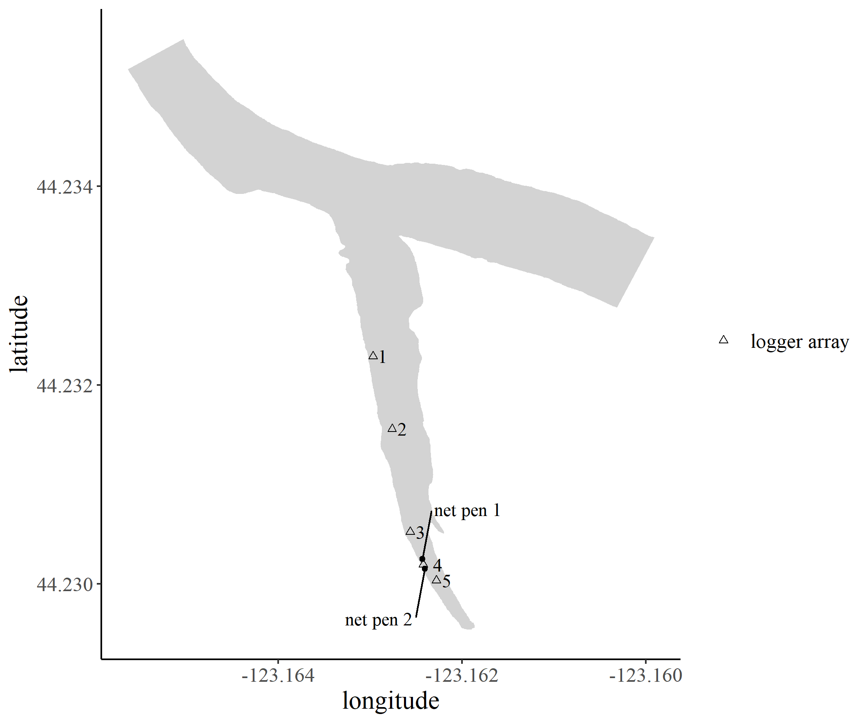
Mainstem Willamette River
Supplemental Figure 1 Map of Blue Ruin cold-water alcove with logger array (numbered triangles) and net pen (black points) locations.
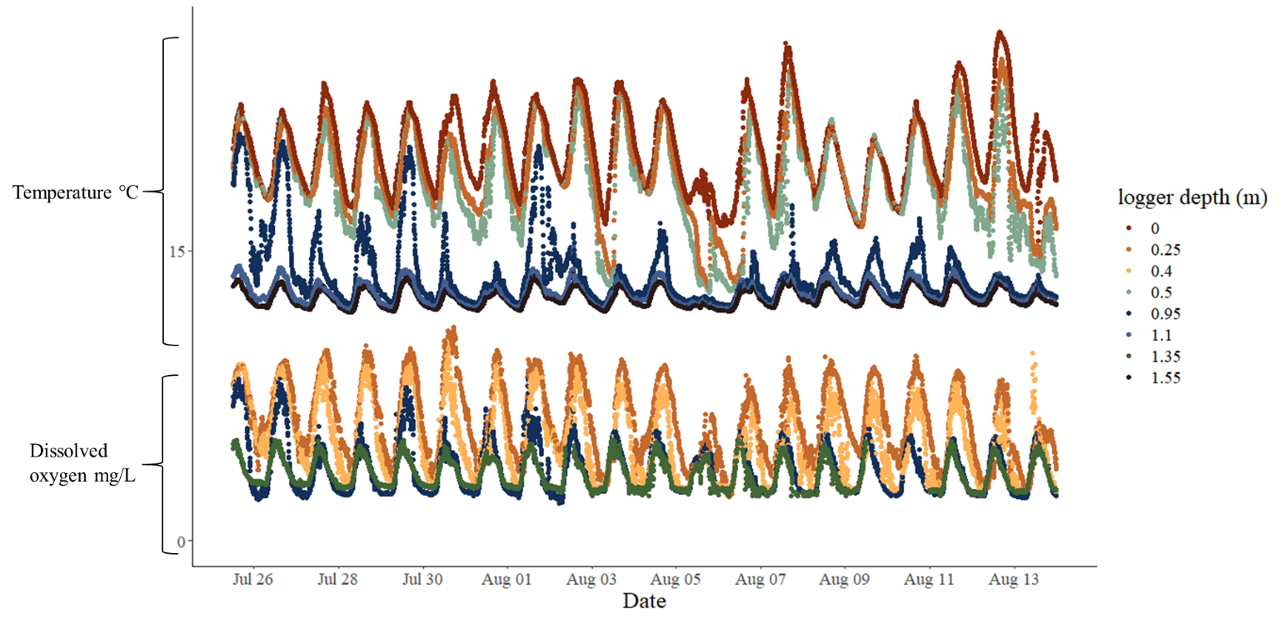

Supplemental Figure 2 Temperature and dissolved oxygen recorded at the Blue Ruin cold-water alcove site-4 net pen logger array.

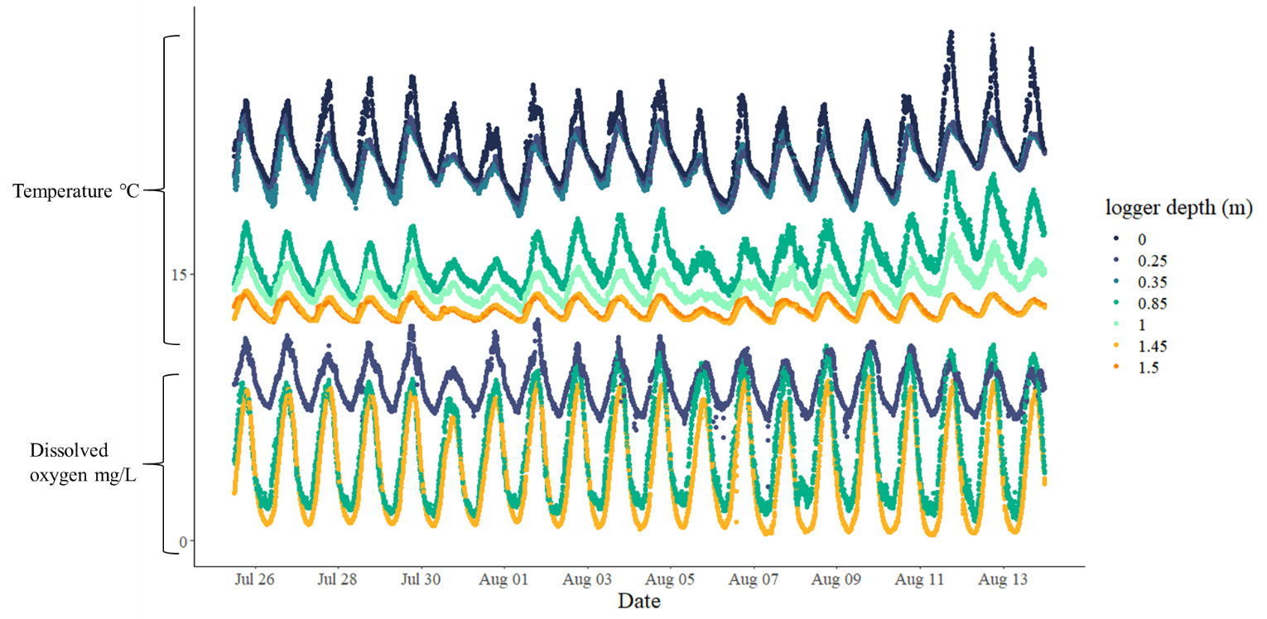
Supplemental Figure 3 Temperature and dissolved oxygen recorded at the Norwood cold-water alcove net pen logger array.

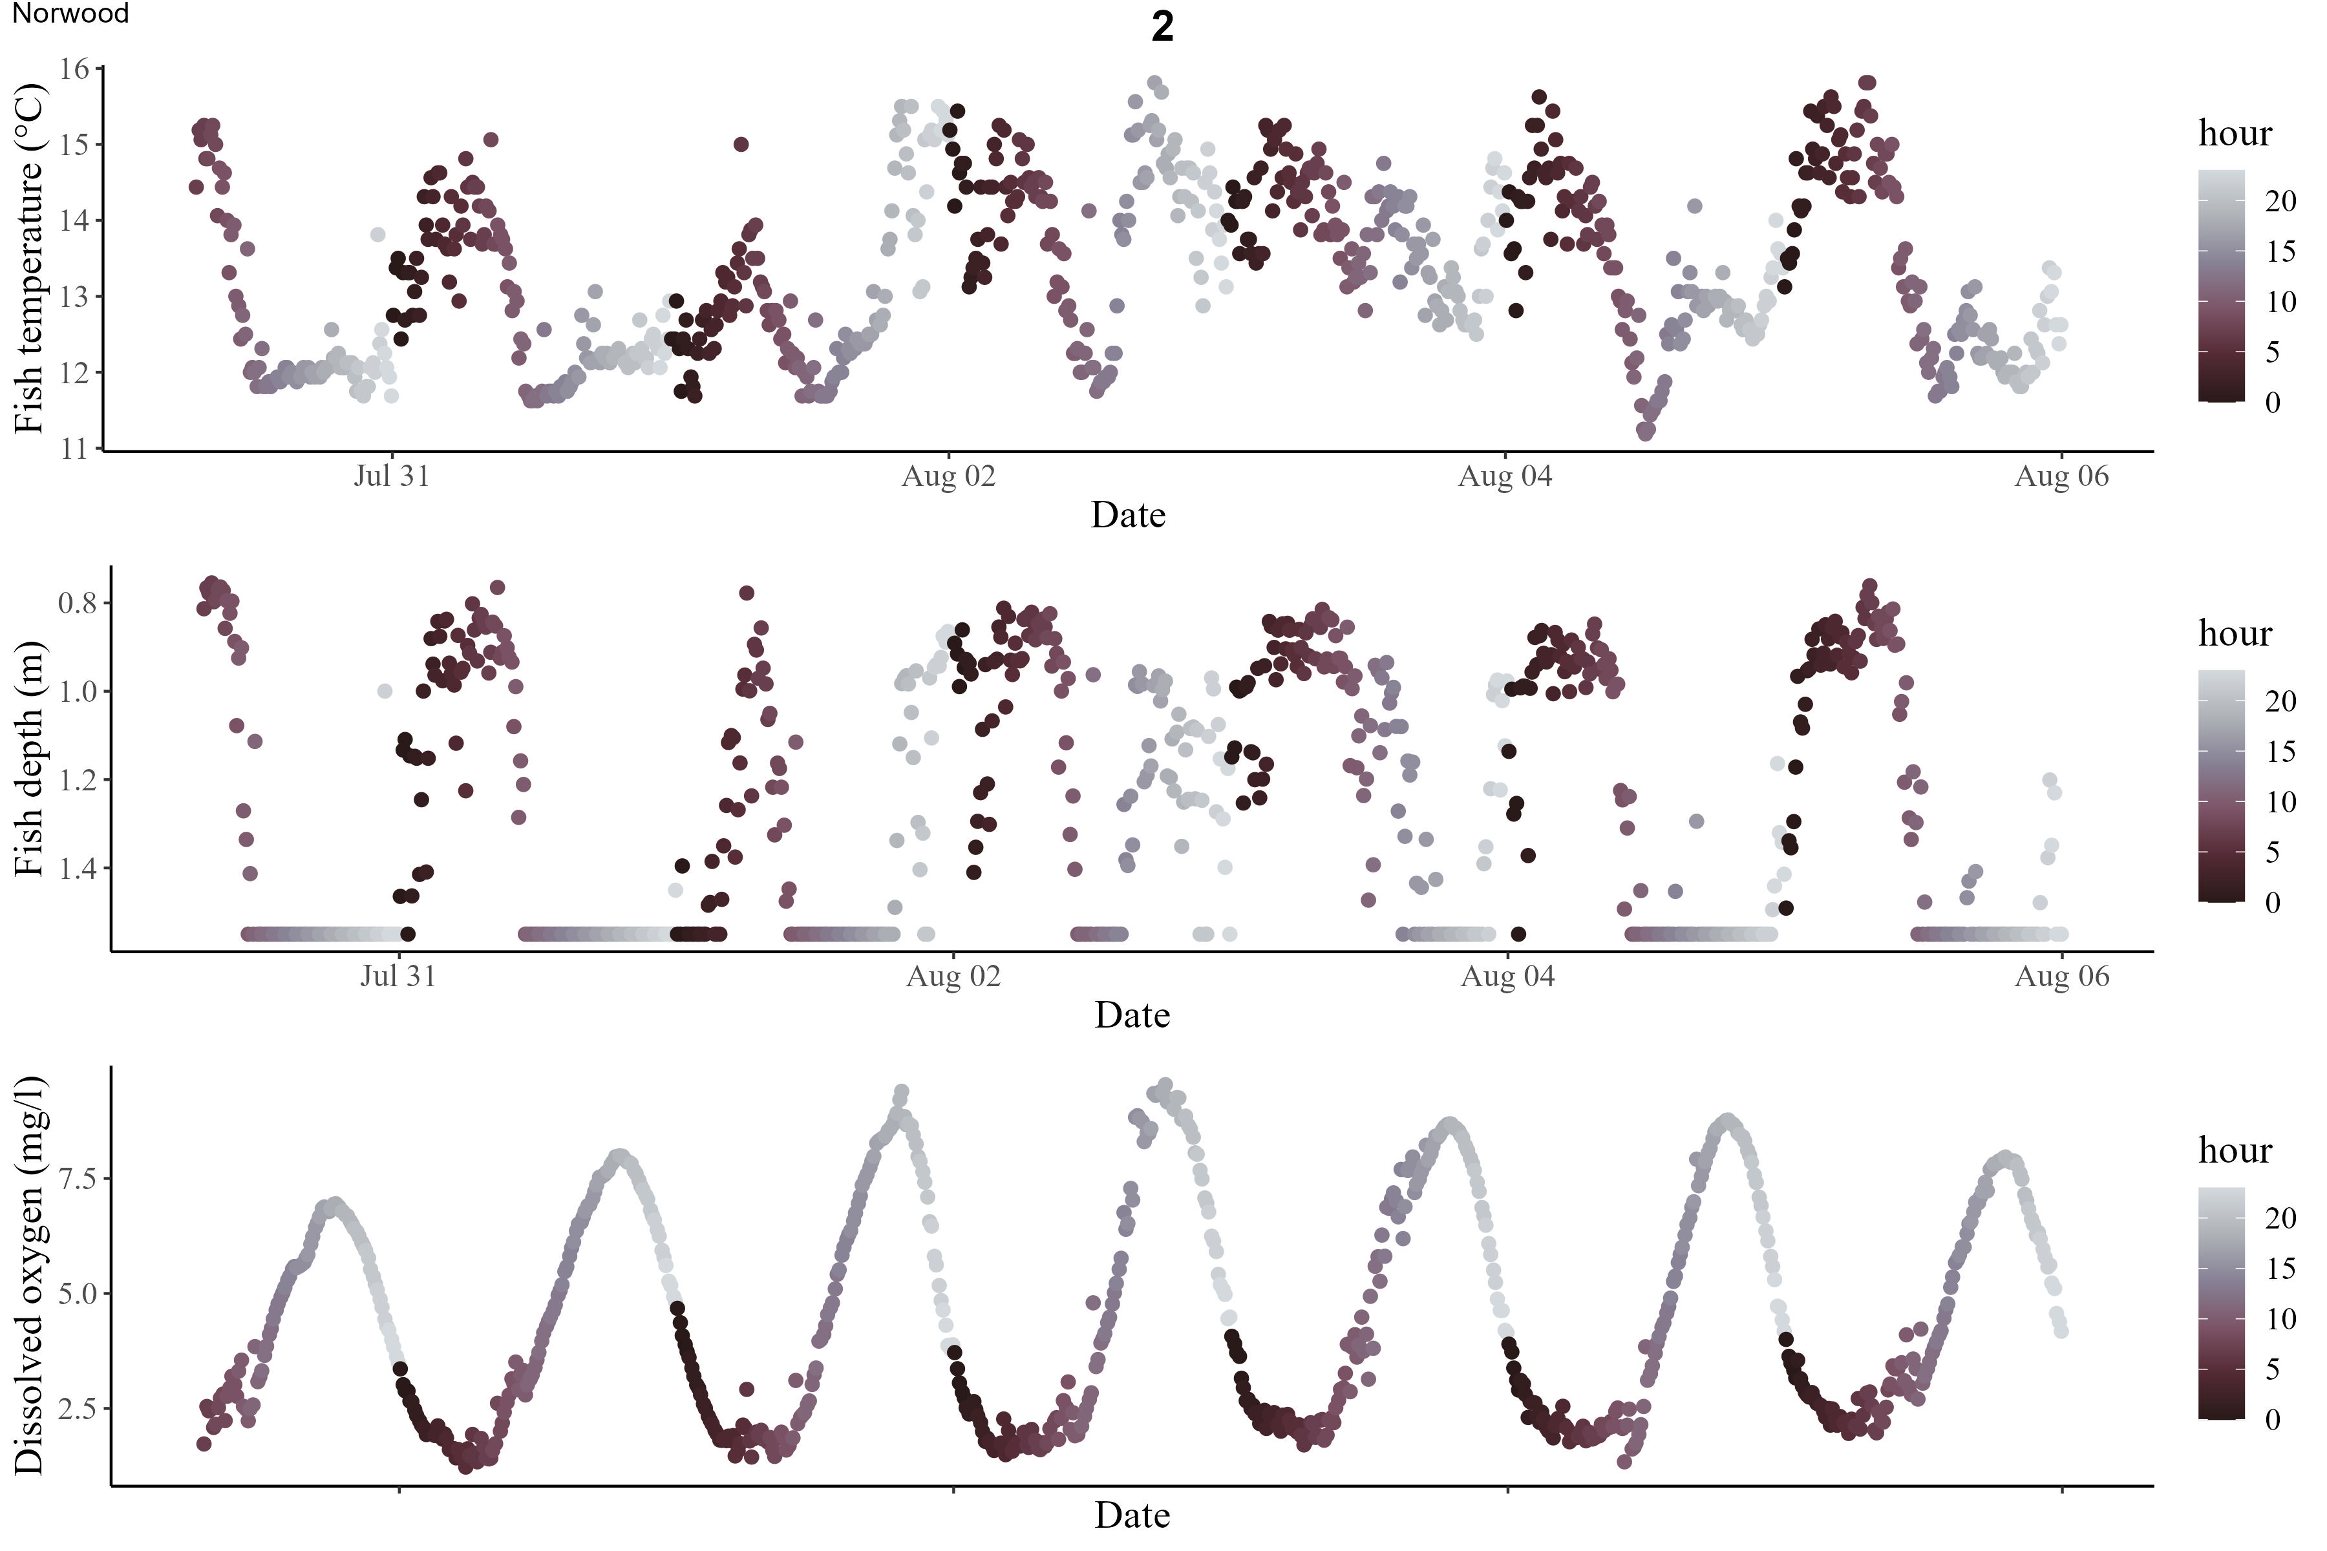
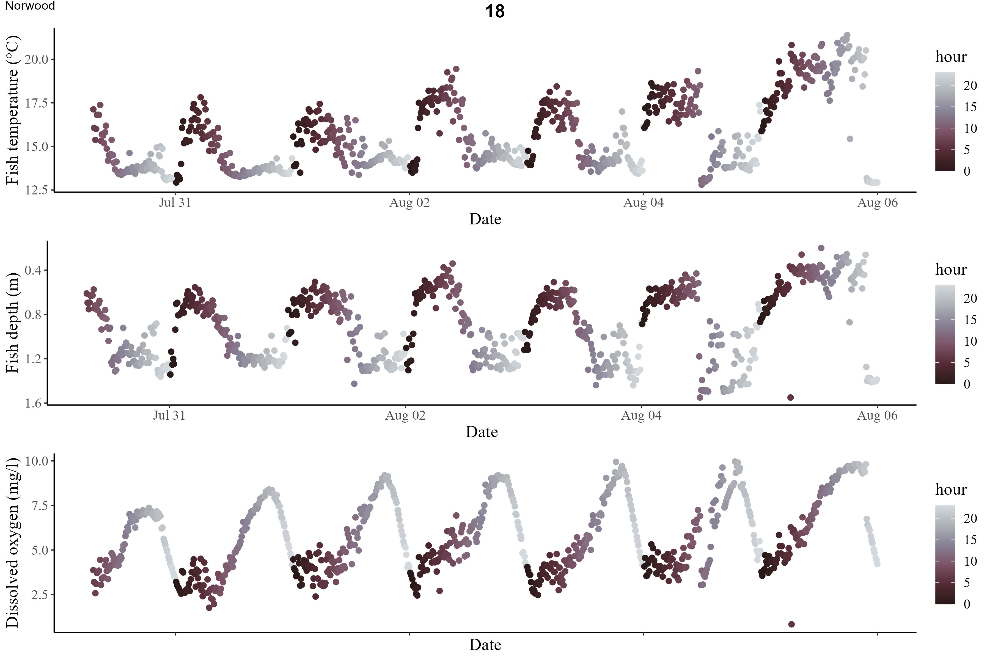
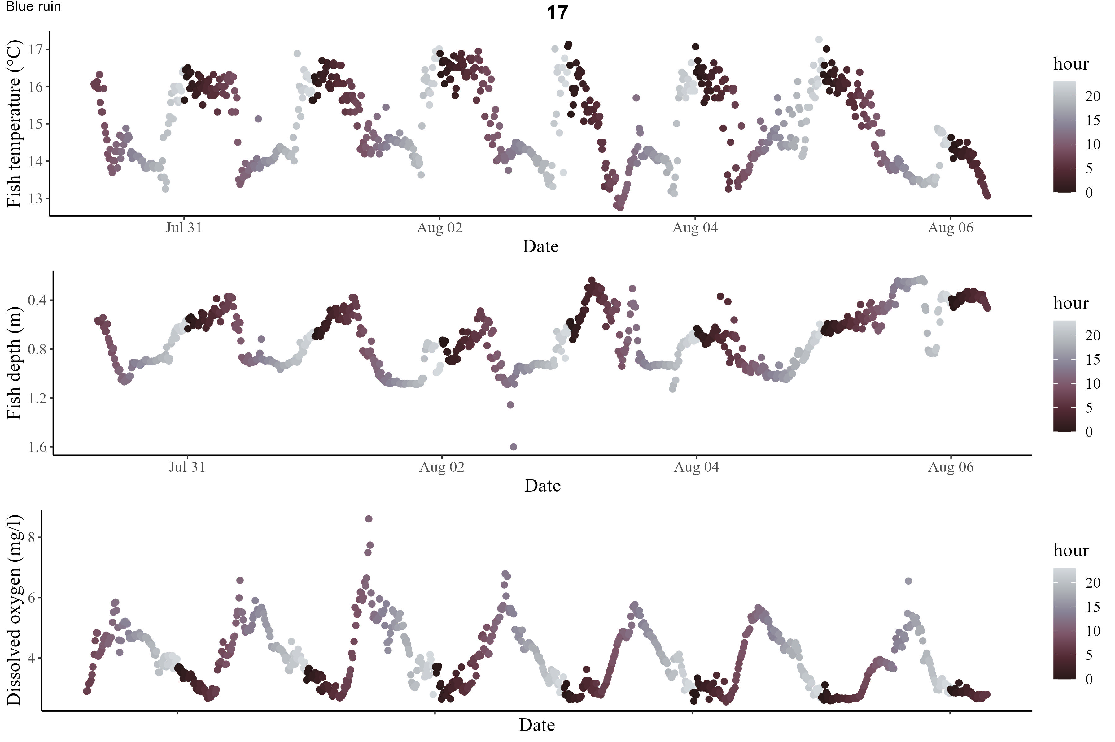
Supplemental Figure 4 Depth plots of 3-individual tagged fish from the iButton netpen study, fish display individual and intra-individual level variation in movement, however all display fine scale diel vertical movement patterns.

