Supporting Information

Table S1. Average minimum and maximum daily temperature (°C) and dissolved oxygen (DO; mg • L⁻¹) in epilimnetic and hypolimnetic layers at Norwood and Blue Ruin alcoves from July 31 to August 7.
Norwood | Temp (℃) | DO (mg • L⁻¹)
Average minimum hypolimnion | 12.5 | 1.2
Average maximum hypolimnion | 13.6 | 8.4
Average minimum epilimnetic | 20.0 | 6.9
Average maximum epilimnetic | 25.0 | 11.3
Blue Ruin | Temp (℃) | DO (mg • L⁻¹)
Average minimum hypolimnion | 12.1 | 2.5
Average maximum hypolimnion | 13.4 | 4.8
Average minimum epilimnetic | 16.2 | 3.4
Average maximum epilimnetic | 22.7 | 9.2

Table S2. Results from linear models (Norwood and Blue Ruin) and linear mixed-effects models (all cold-water alcove sites; CWA) fit to data collected during approximate 2-hour windows corresponding to daily DO-maxima (06:00–08:00) and DO-minima (18:00–20:00). Shown are estimated slope coefficients (β), standard errors (SE), and p-values for the relationship of interest.
 |  | β | SE | p-value
Norwood | DO-maxima | 0.264 | 0.007 | <0.001
 | DO-minima | 0.856 | 0.008 | <0.001
Blue Ruin | DO-maxima | 0.563 | 0.013 | <0.001
 | DO-minima | 0.306 | 0.011 | <0.001
All CWA | DO-maxima | 0.325 | 0.009 | <0.001
 | DO-minima | 0.642 | 0.008 | <0.001

a
b
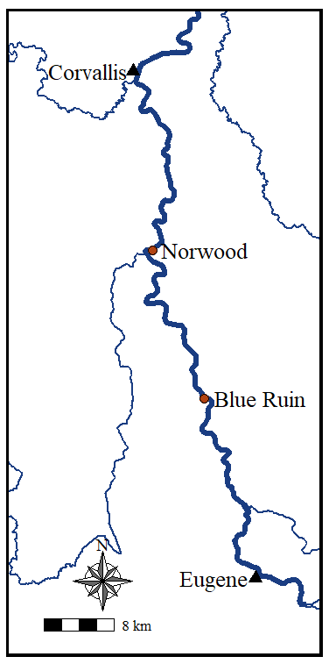
Figure S1a. Map of surveyed cold-water alcoves along the Upper Willamette River. Red points indicate cold-water alcove locations and triangles mark the location of major urban areas. b. Figure of Blue Ruin cold-water alcove with logger array (numbered triangles) and net pen (black points) locations.

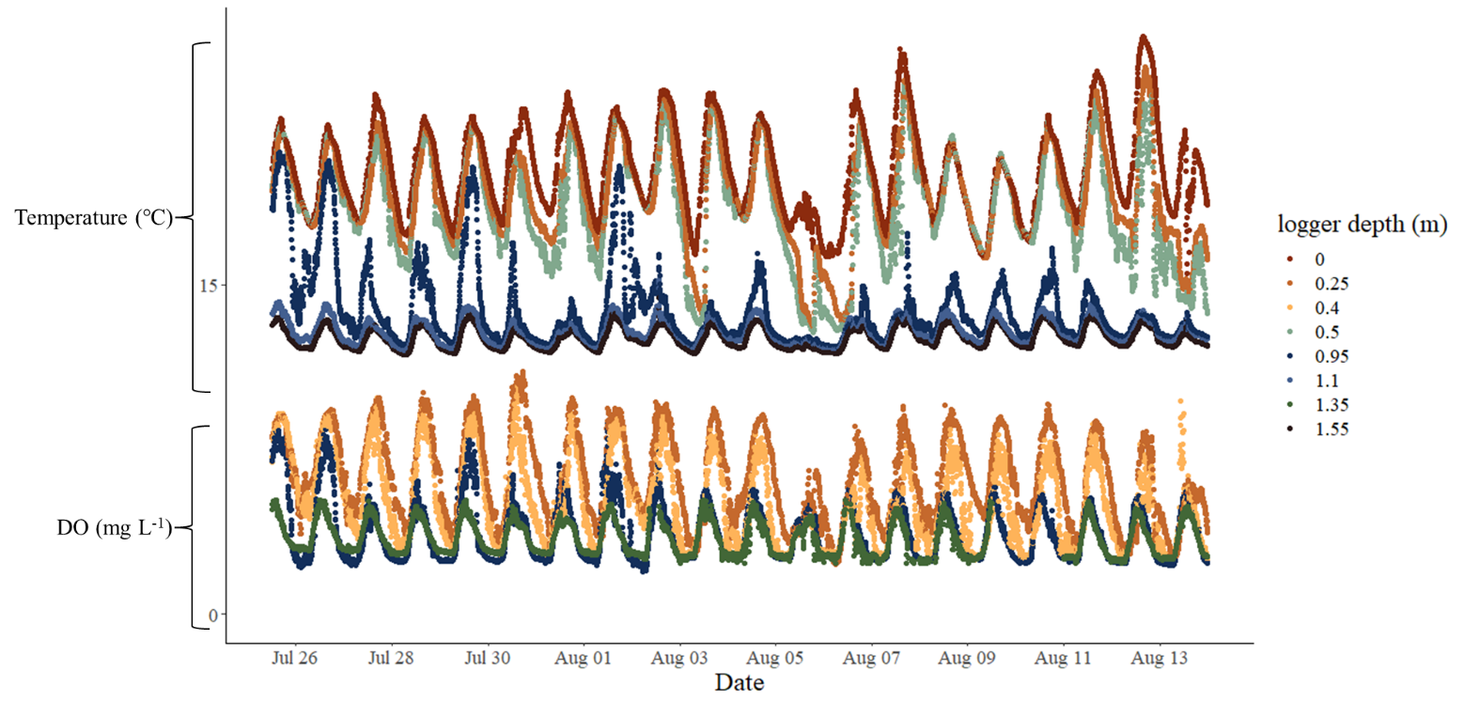
Figure S2. Temperature and dissolved oxygen recorded at the Blue Ruin cold-water alcove site-4 net pen logger array.

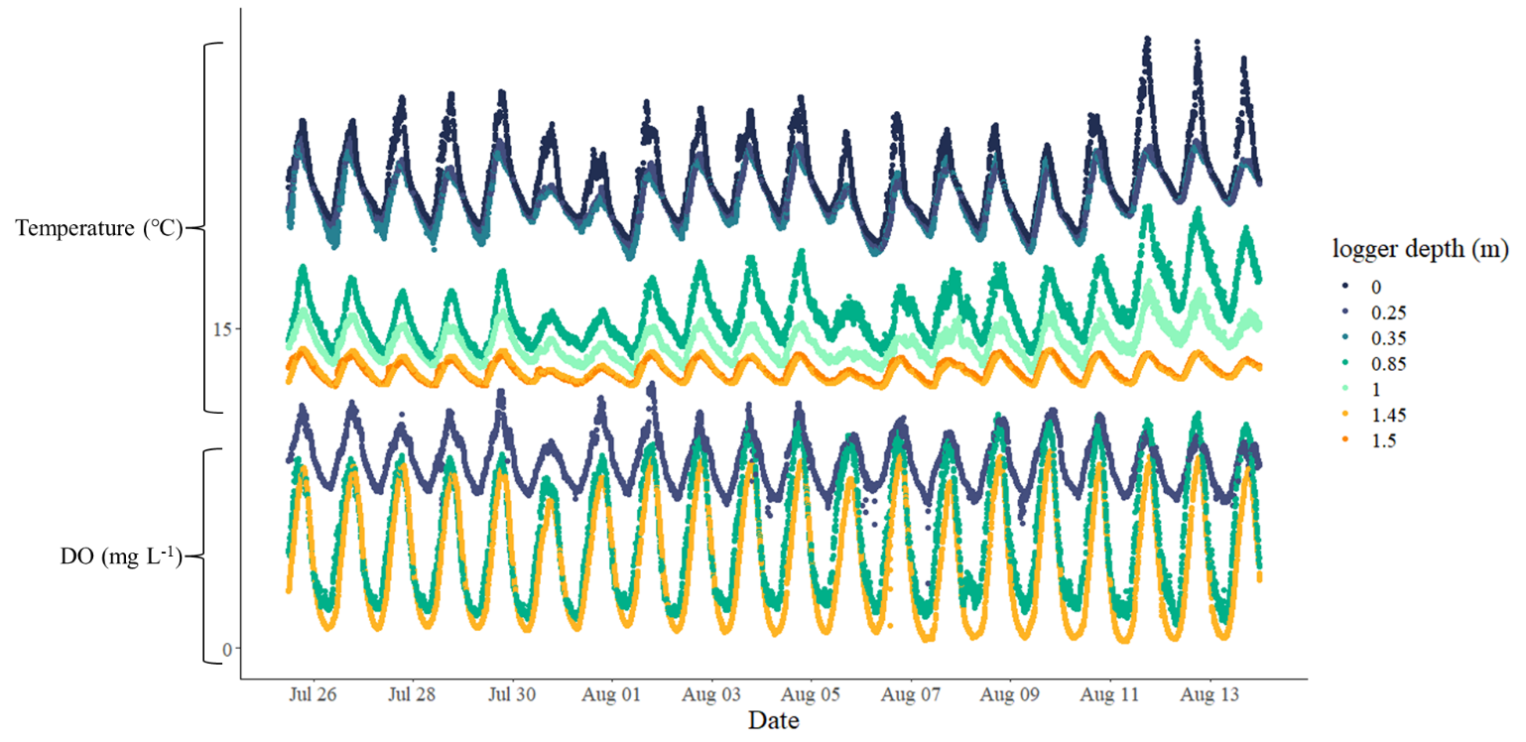

Figure S3. Temperature and dissolved oxygen recorded at the Norwood cold-water alcove net pen logger array.

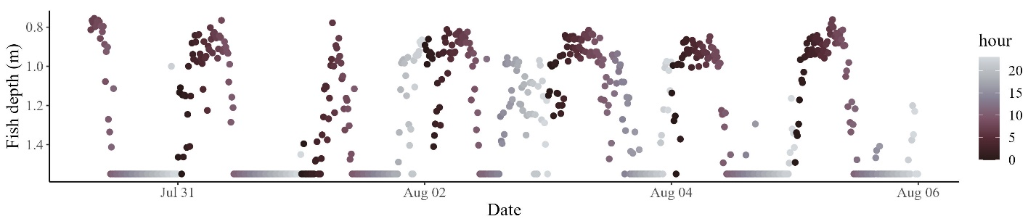
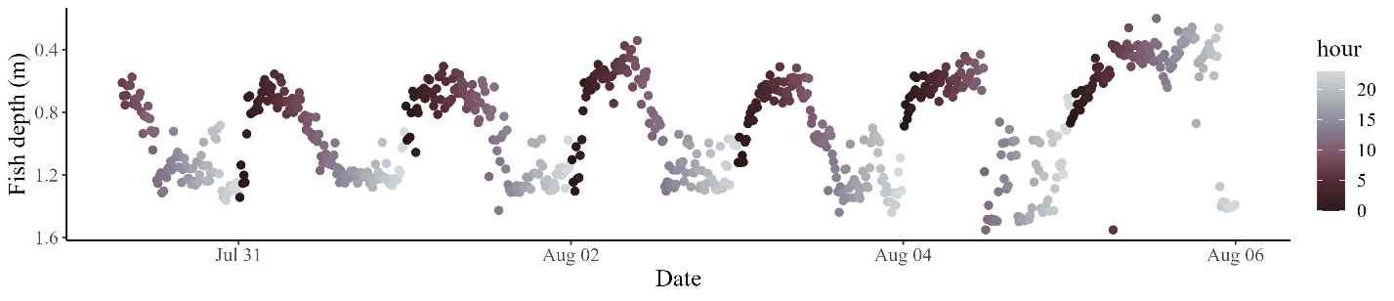
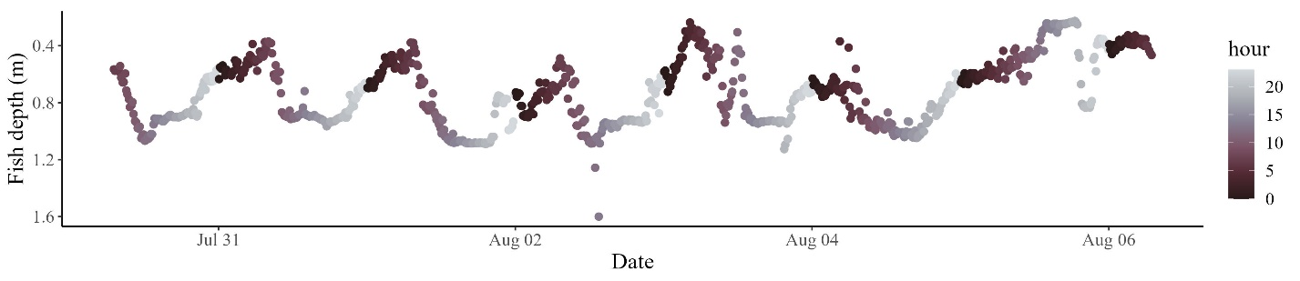
Figure S4. Depth plots of 3-individual tagged fish from the iButton netpen study, fish display individual and intra-individual level variation in movement, however all display fine scale diel vertical movement patterns.

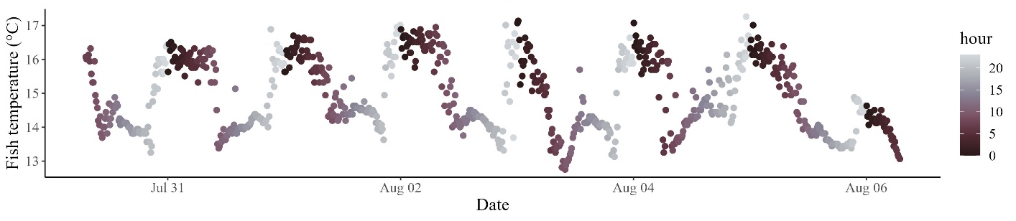

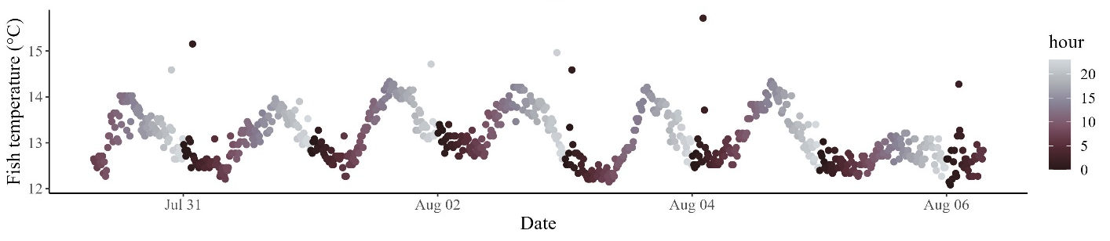
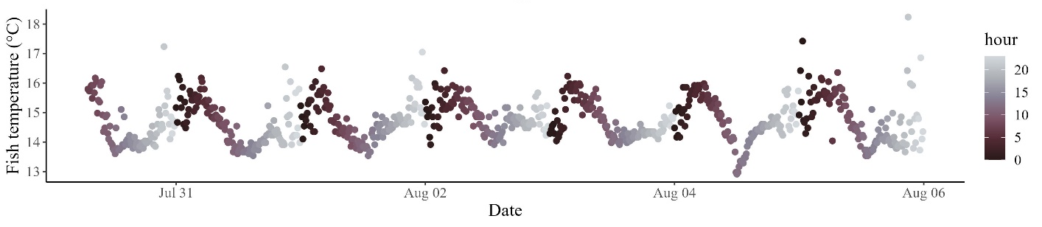
Figure S5. Temperature plots of 3-individual tagged fish from the iButton netpen study, fish display individual and intra-individual level variation in temperature selection.

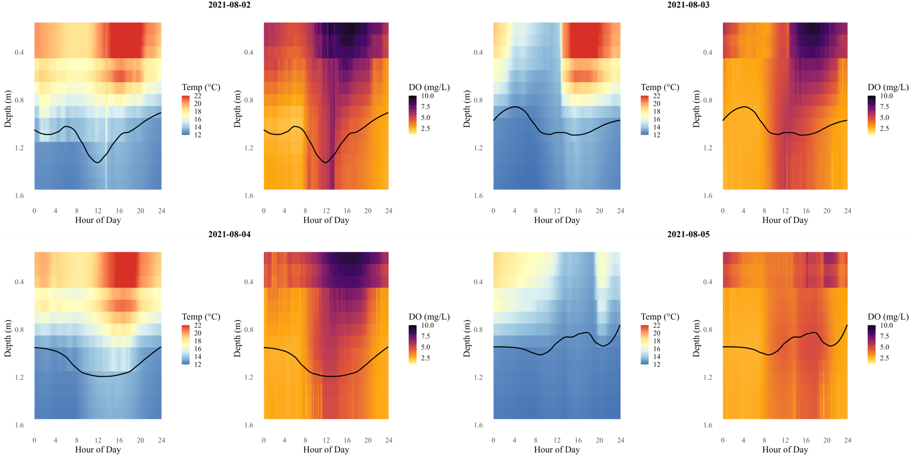
Figure S6. Temperature and DO profiles in relation to observed fish depth in Blue Ruin alcove across four consecutive days (August 2–5). Color gradients represent hourly environmental conditions, with temperature shown in the left panel and DO in the right panel for each day. Black lines indicate the smoothed mean depth of tagged cutthroat trout pooled across individuals for each day.

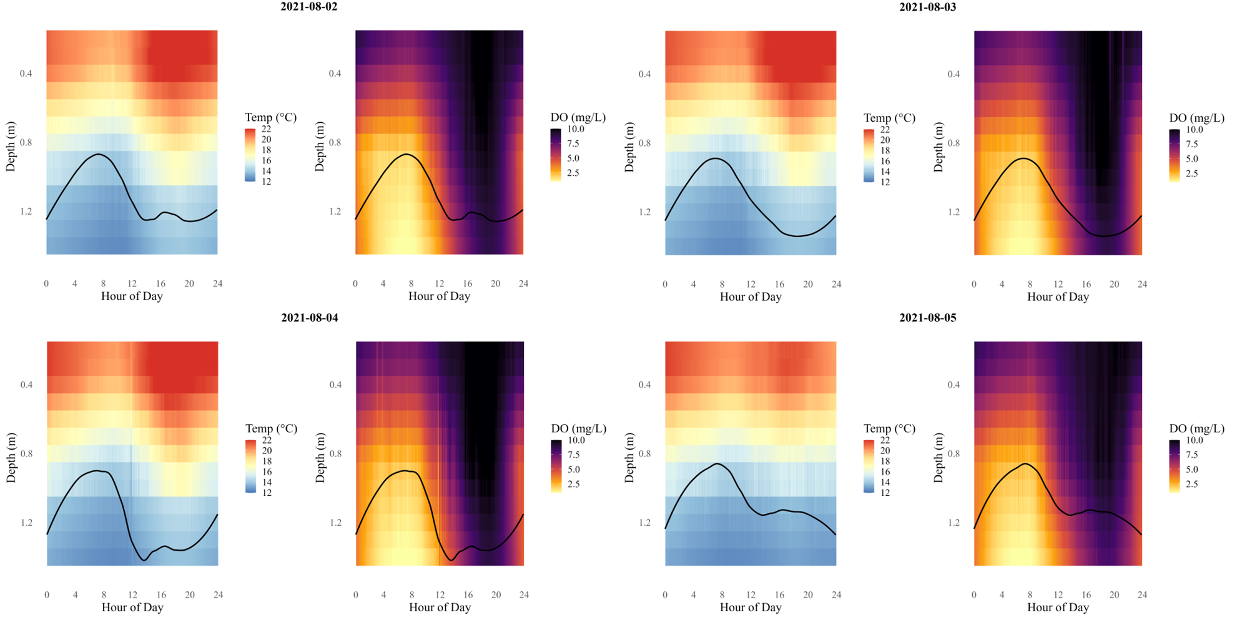
Figure S7. Temperature and DO profiles in relation to observed fish depth in Norwood alcove across four consecutive days (August 2–5). Color gradients represent hourly environmental conditions, with temperature shown in the left panel and DO in the right panel for each day. Black lines indicate the smoothed mean depth of tagged cutthroat trout pooled across individuals for each day.

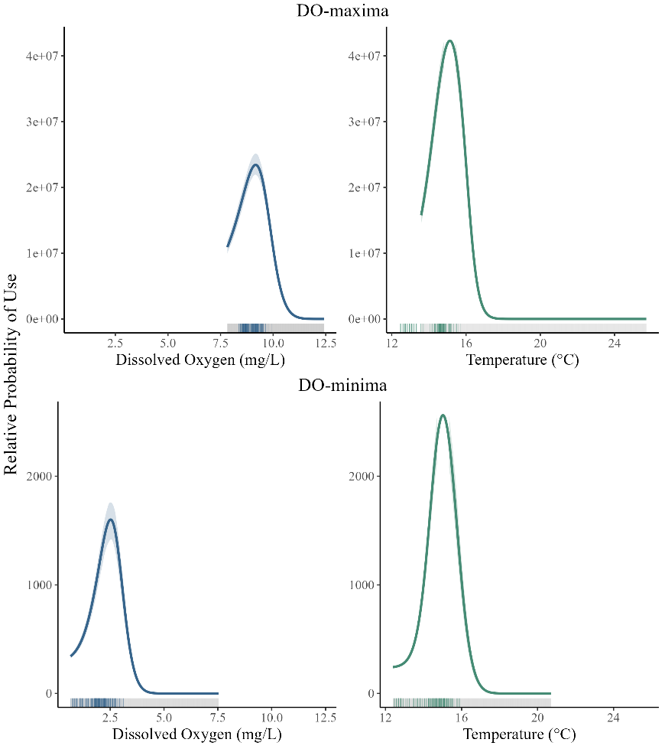
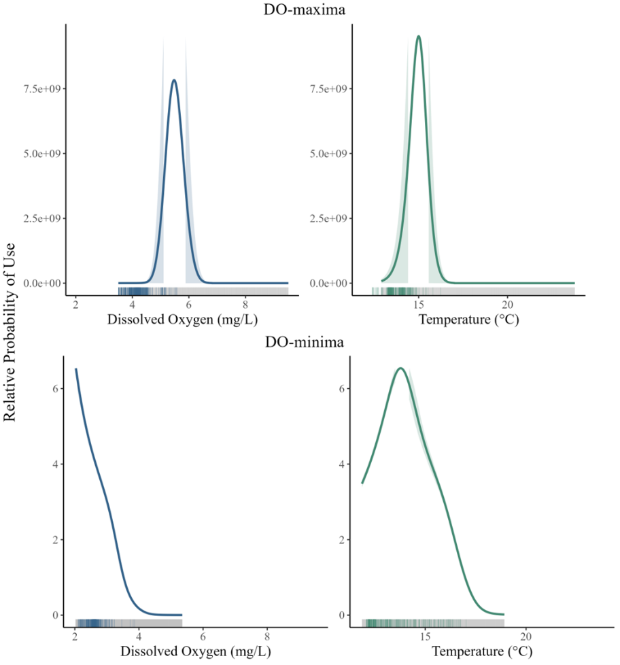
DO-maximum
DO-maximum
b
a

DO-minimum
DO-minimum

Figure S8. Predicted relative probability of habitat use by cutthroat trout, illustrating selection for temperature and dissolved oxygen values relative to their availability in cold-water alcoves. Results are shown for (a) Blue Ruin and (b) Norwood during the two-hour periods of DO-maximum (top panels) and DO-minimum (bottom panels). Panels show partial (average-effect) plots from resource selection functions (RSFs), illustrating how fish space use varied with dissolved oxygen (left) and temperature (right). Each curve represents fitted RSF values from conditional logistic GAMs, averaged across all possible values of the other covariate. Shaded ribbons denote 95% bootstrapped confidence intervals, and rug plots along the x-axes indicate used values. Fish selected a narrow range of intermediate temperature and dissolved oxygen conditions relative to what was available.

