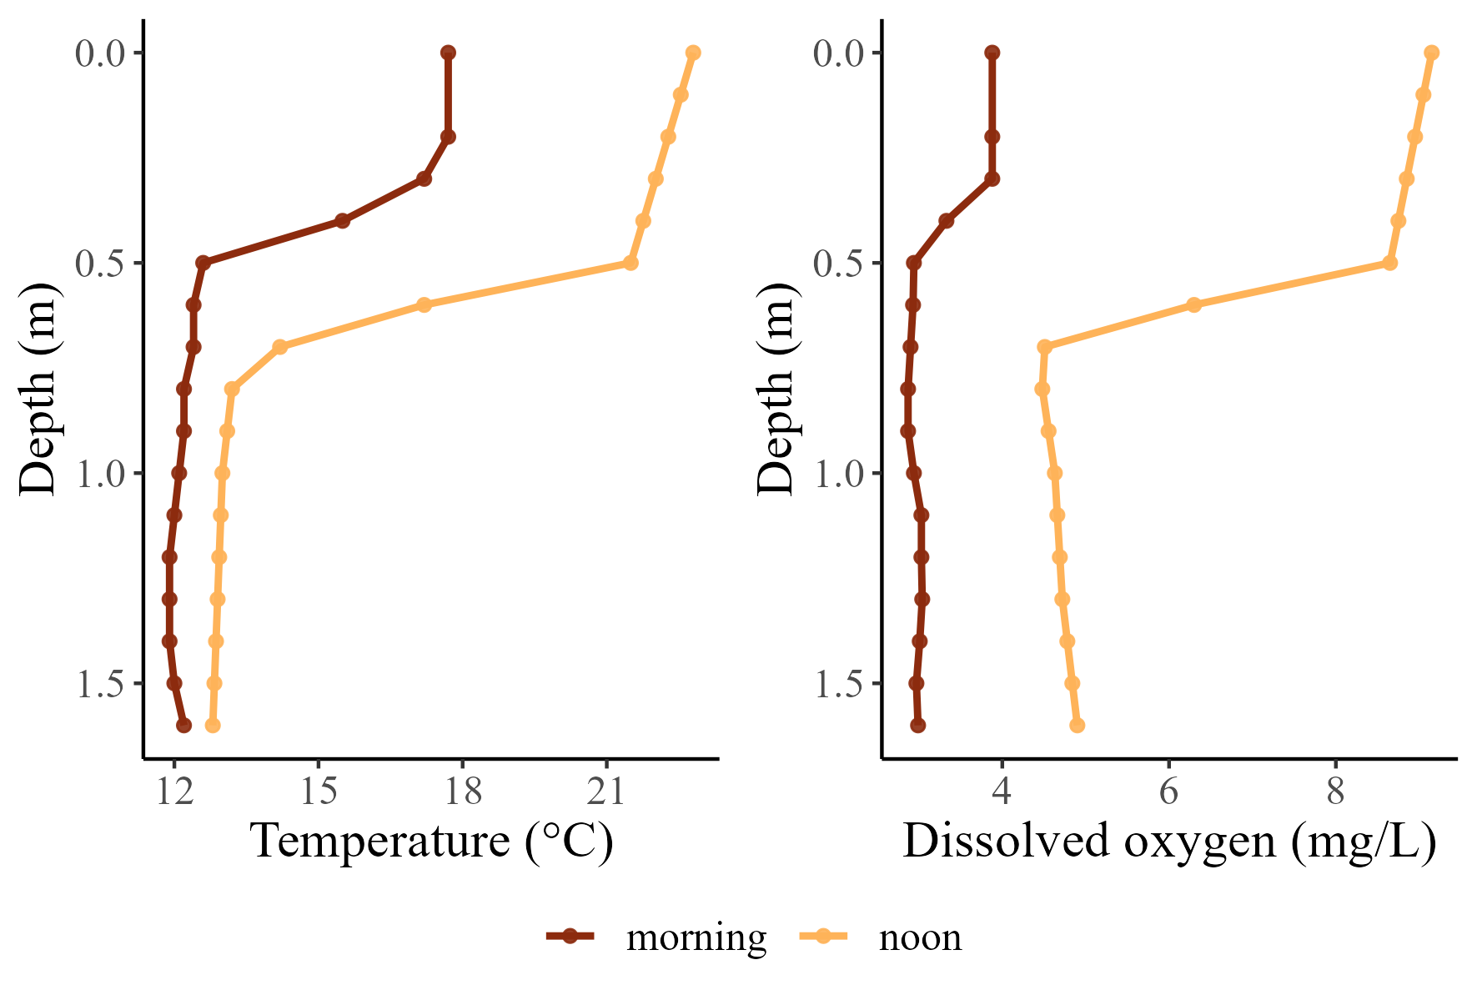
Figure 1 Diel contrasts in temperature and dissolved oxygen profiles for a floodplain alcove that provides thermal refuge for cold-water fishes of the Willamette River. Profiles were recorded at dawn (6:00, near DO-minima), and late afternoon (15:00, near the DO-maxima). Data are shown for the Blue Ruin alcove.

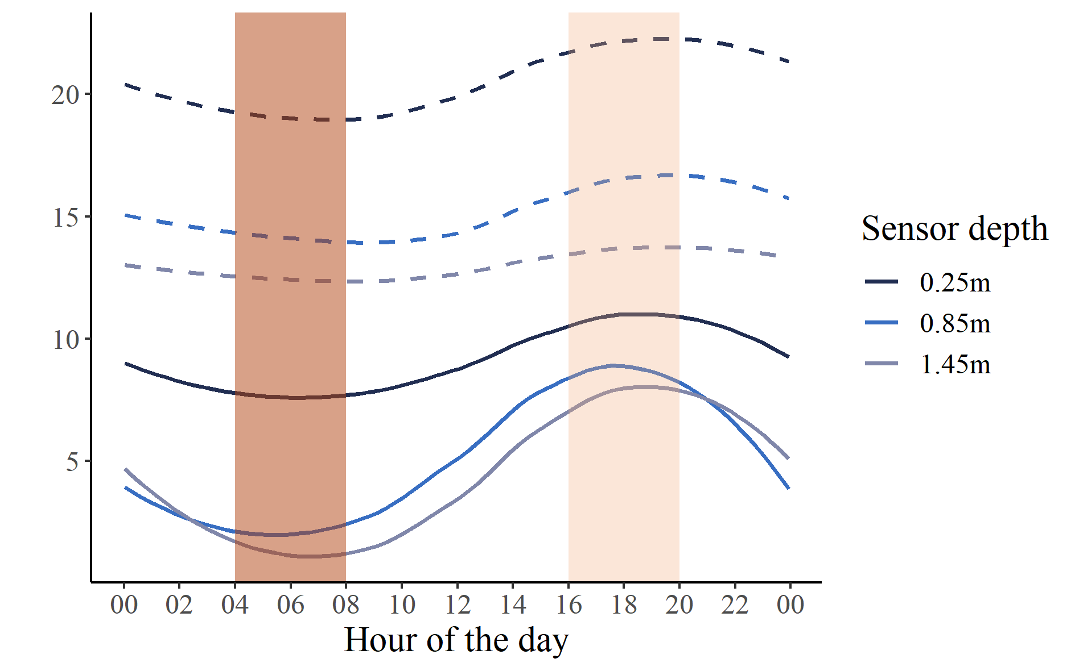
Min DO
Max Temp
Figure 2 The diel cycle of water temperature and dissolved oxygen at three depths of a stratified floodplain alcove. Shaded bars highlight the asynchrony between periods of peak hypoxia (dark pink) and peak thermal stress (light pink). Data shown here are for July 27th 2021 in Norwood alcove, and have a 5-minute temporal resolution. Dashed lines represent temperature (°C), and solid lines represent dissolved oxygen (mg/L).

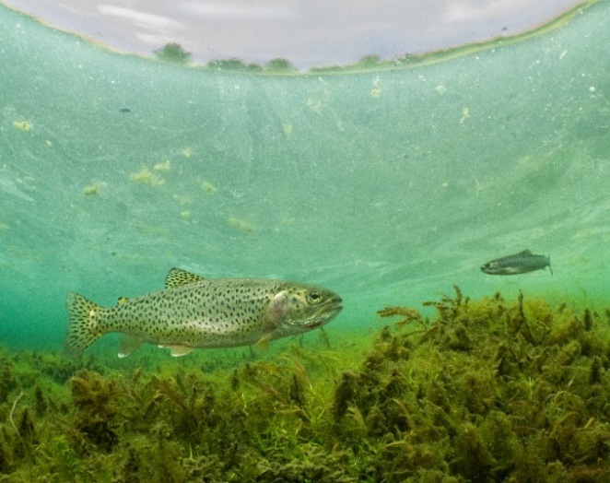
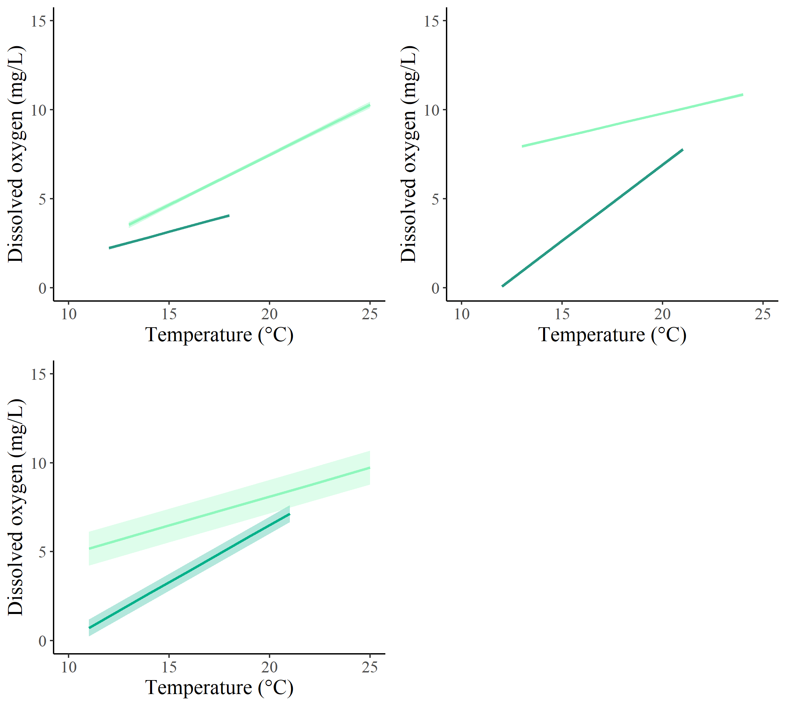
Figure 3 Results from linear mixed models evaluating the relationship between temperature and DO comparing the 2-hour window that approximates the DO-minima (dark green) to the 2-hour window that approximates the DO-minima (light green) in a) Blue Ruin cold-water alcove, b) Norwood cold-water alcove, and c) all six cold-water alcoves. All linear fits are plotted with their 95% confidence interval envelopes. d) Photo of a coastal cutthroat trout in Blue Ruin cold-water alcove (photo credit: Dave Herasimtschuk, Freshwaters Illustrated).
b

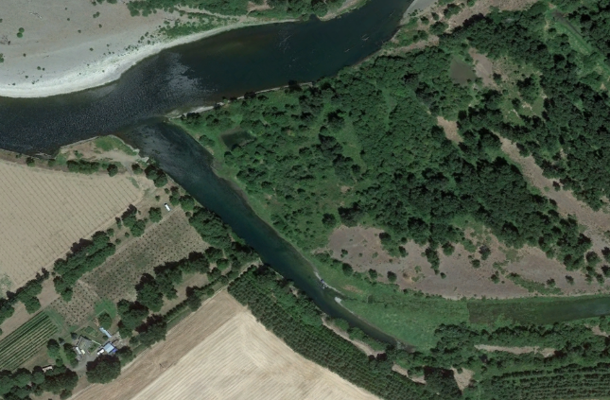
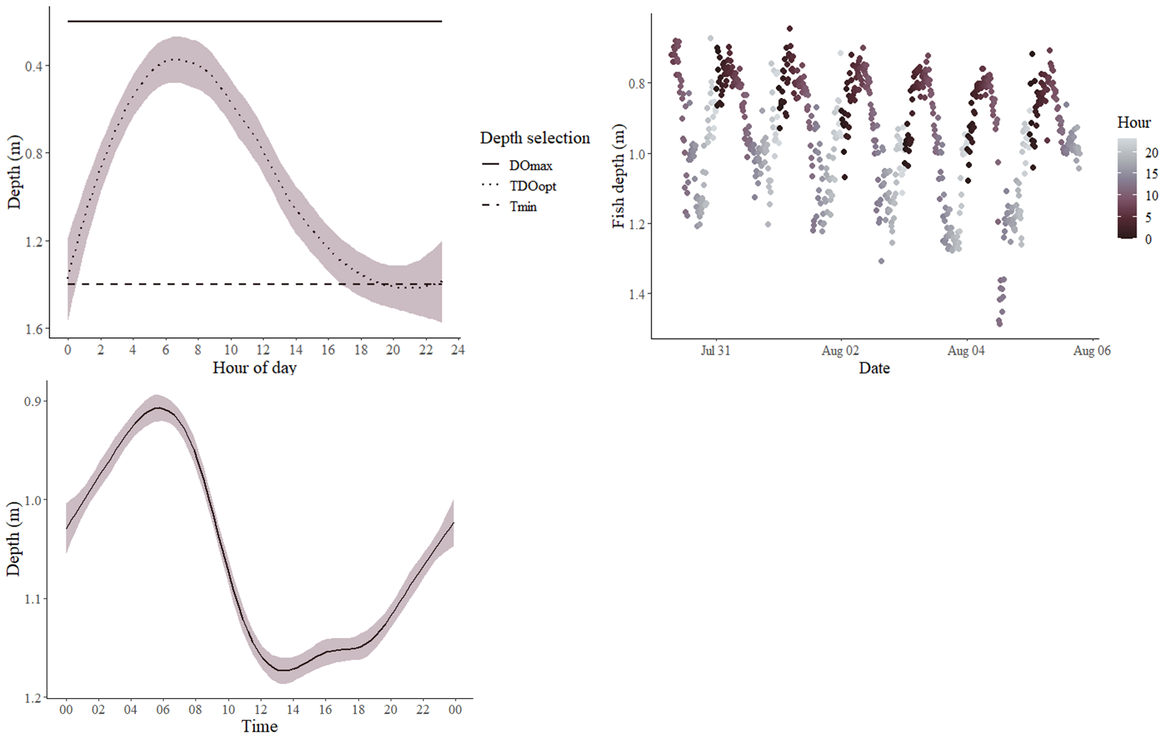

Figure 4a) Simulated predictions of fish depths throughout the diel cycle, based on three different strategies; maximizing dissolved oxygen (DO_{max}), minimizing water temperature (T_{min}), or considering both temperature and DO concurrently (TDO_{opt}). 4b) Example of observed diel vertical migration for a tagged individual cutthroat trout held in situ. See Methods for how depth was inferred from tag temperature). 4c) Smoothed plot of fish depth over 24-hour timeframe, pooled across all individuals in study. 4d) Satellite image of Blue Ruin alcove (placeholder).

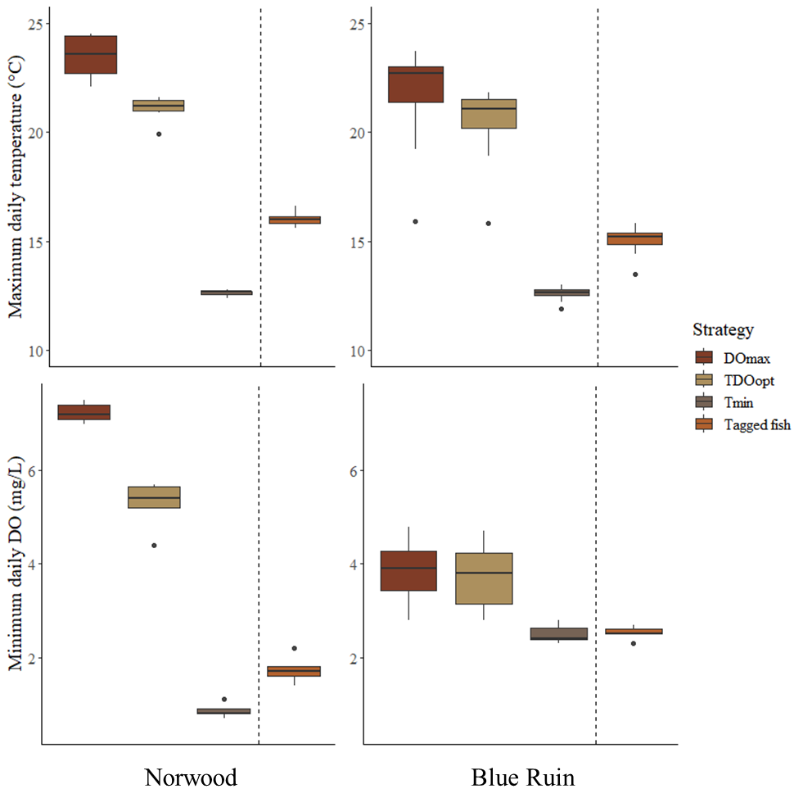
5) Maximum daily temperature and minimum daily DO encountered by simulated fish under three different strategies (n = 7 days), compared to corresponding average maximum and average minimum values for tagged fish held in enclosures (n = 19 individuals).

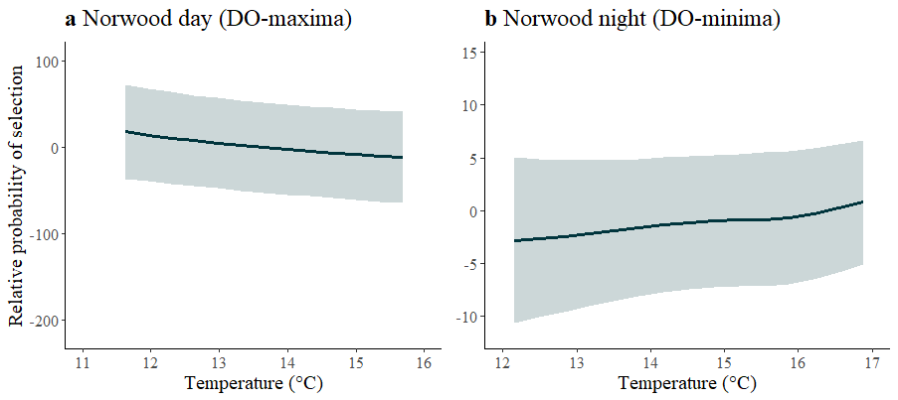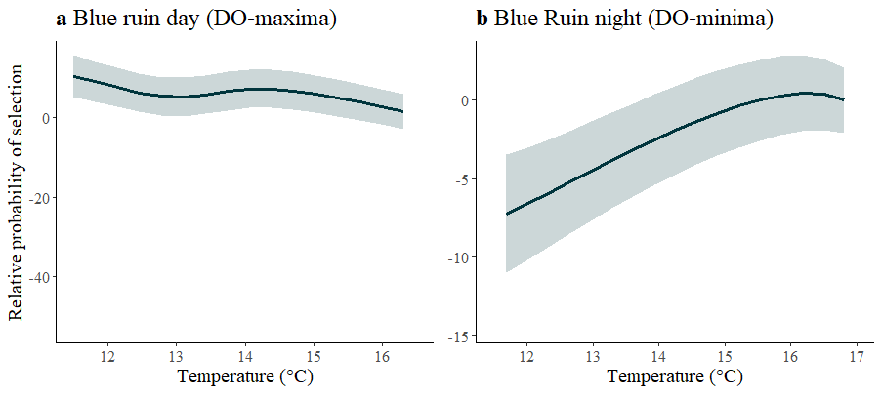
Figure 6 Predicted temperature selection for tagged coastal cutthroat trout held in enclosures during the 2-hour windows of DO-maxima and DO-minima. In all plots, DO was held constant at 4mg•L⁻¹ (EPA threshold for cold-water fish), and the x-axis was constrained to the range of temperatures selected by fish during the 2-hour window.

Supplemental Figures

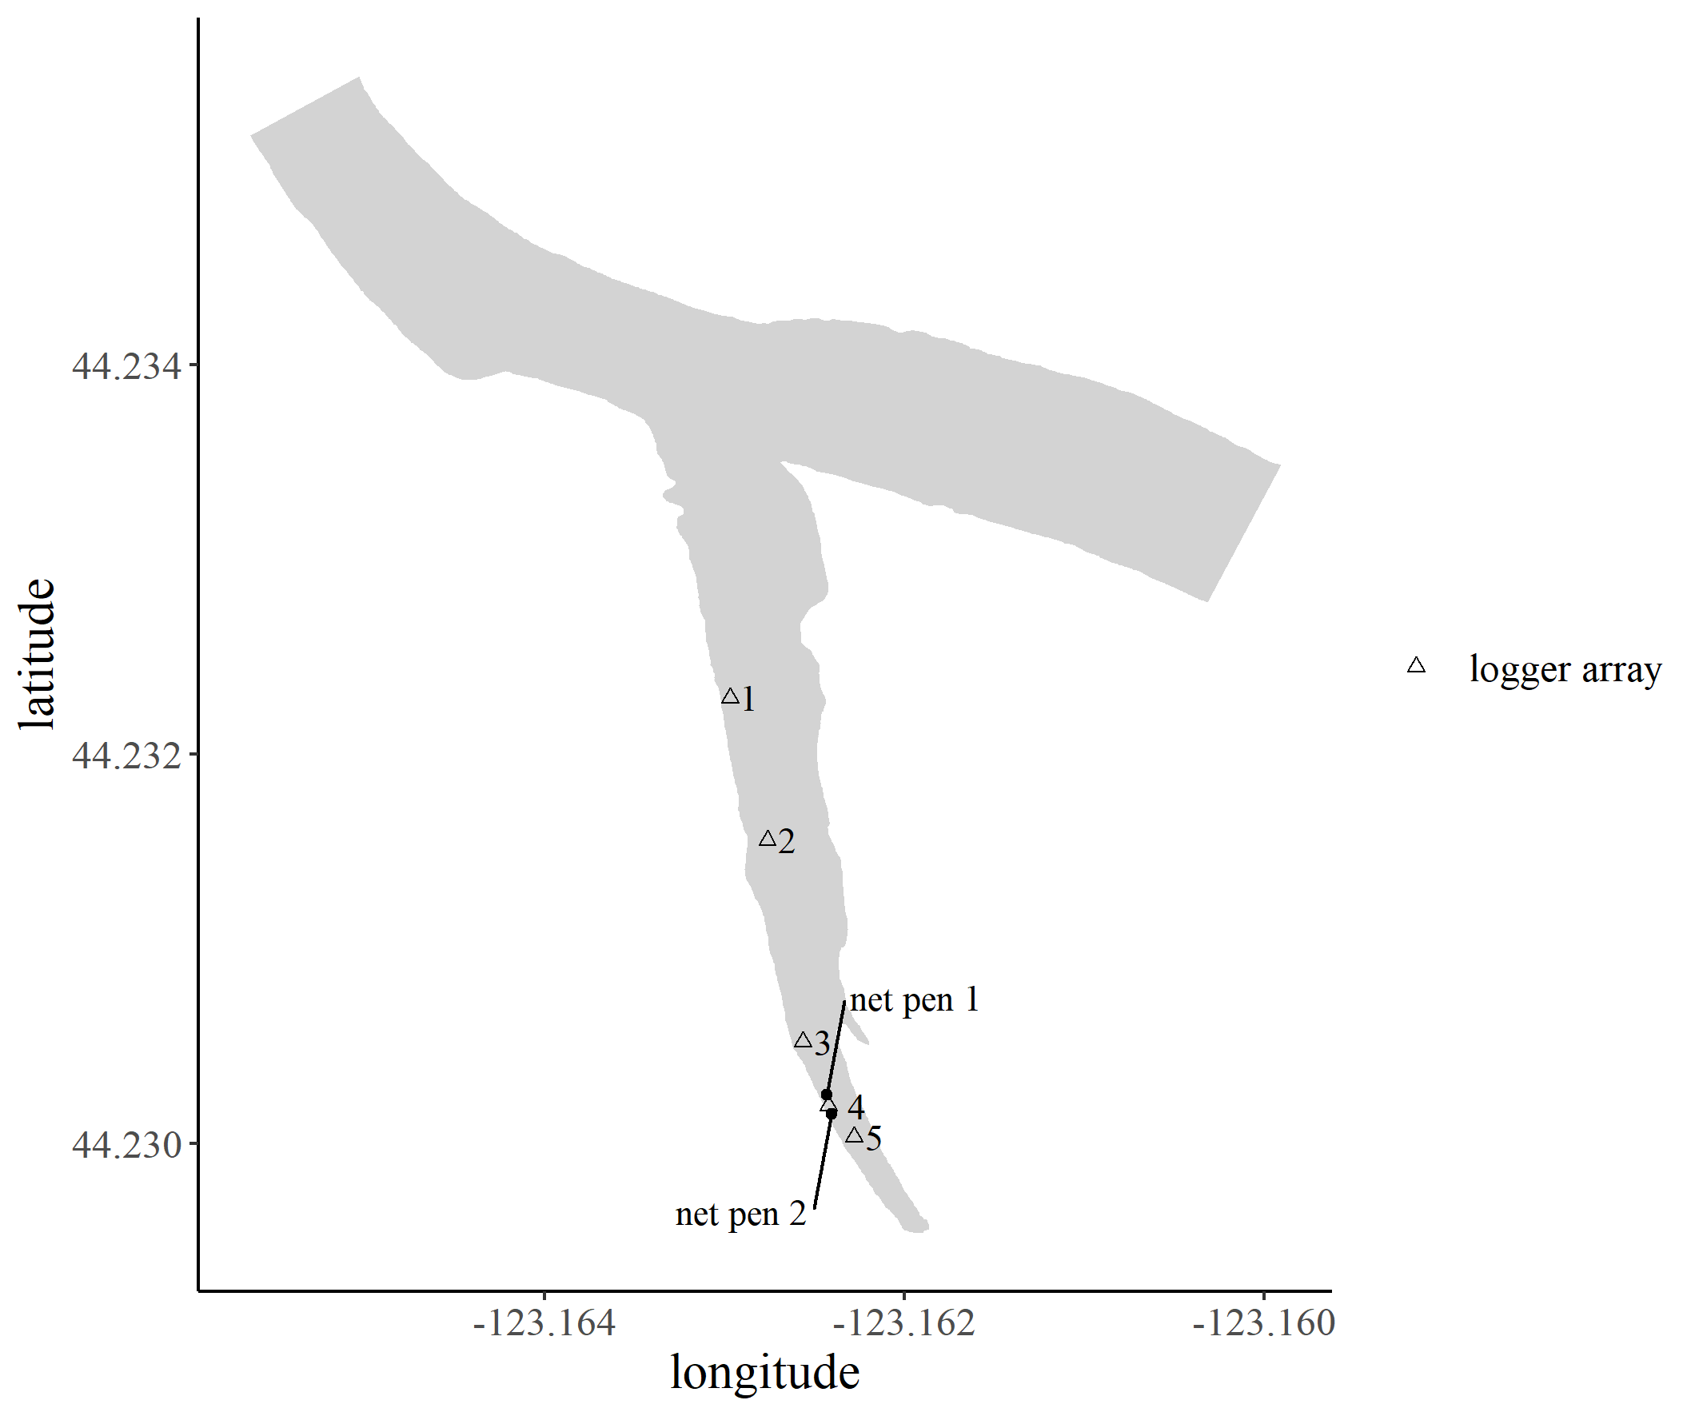
Mainstem Willamette River
Supplemental Figure 1 Map of Blue Ruin cold-water alcove with logger array (numbered triangles) and net pen (black points) locations.
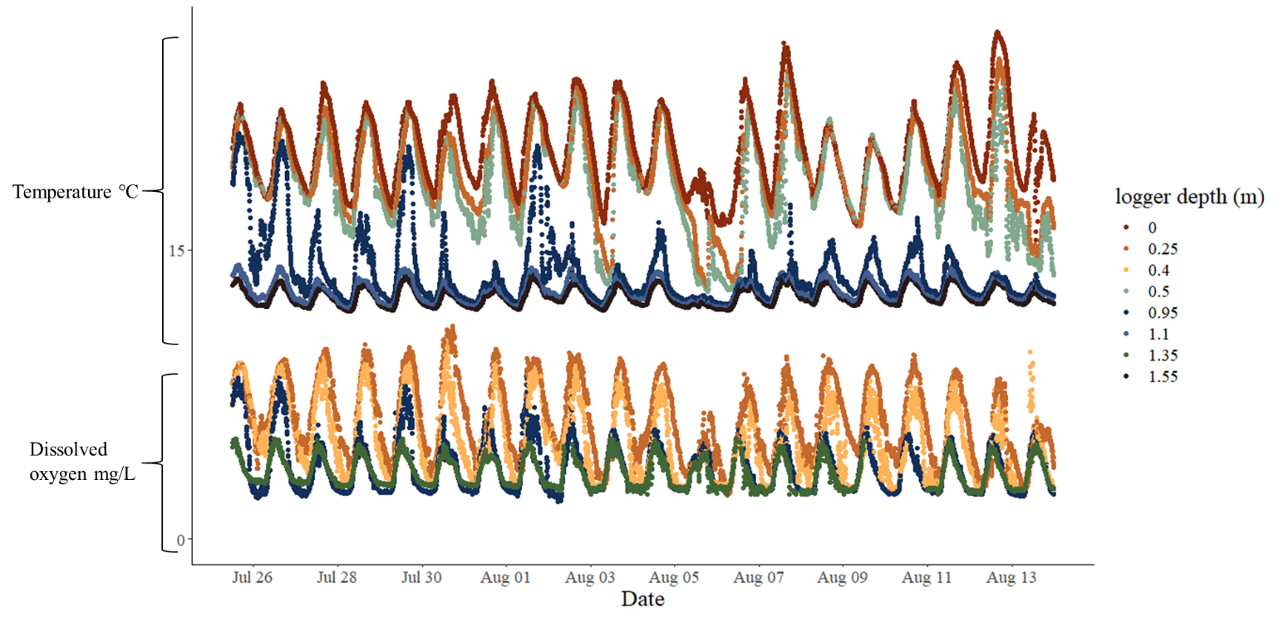

Supplemental Figure 2 Temperature and dissolved oxygen recorded at the Blue Ruin cold-water alcove site-4 net pen logger array.

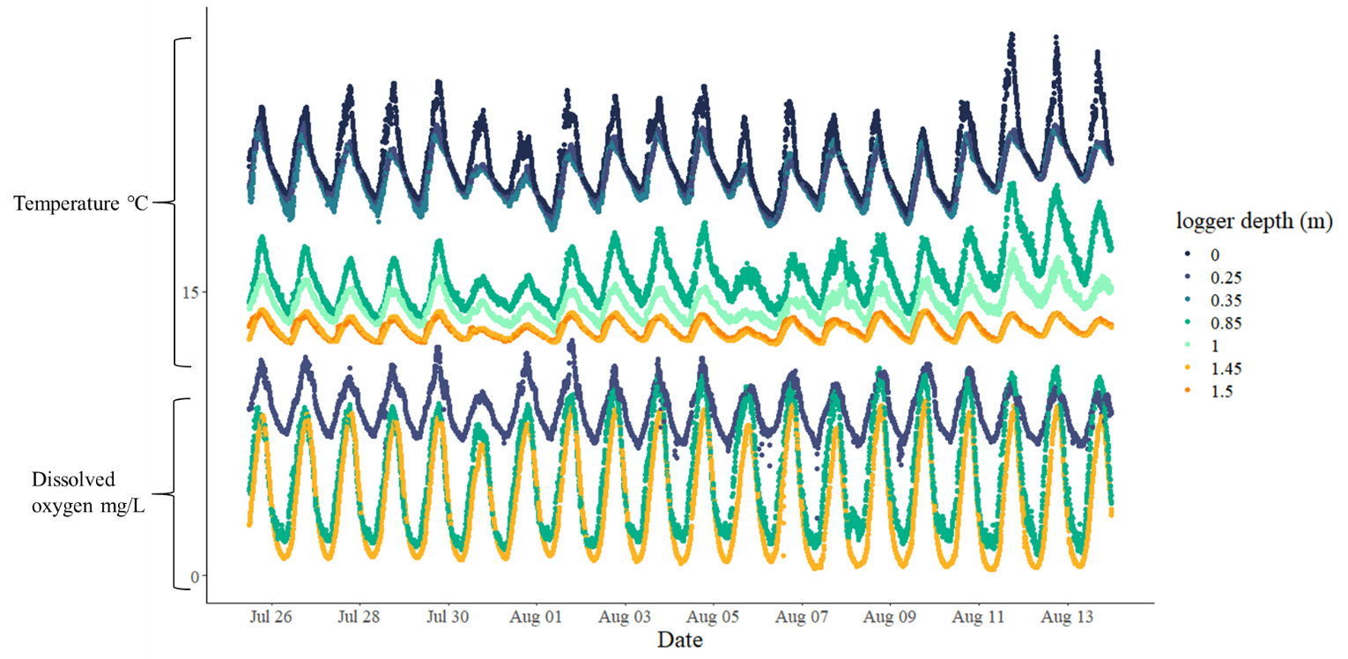
Supplemental Figure 3 Temperature and dissolved oxygen recorded at the Norwood cold-water alcove net pen logger array.

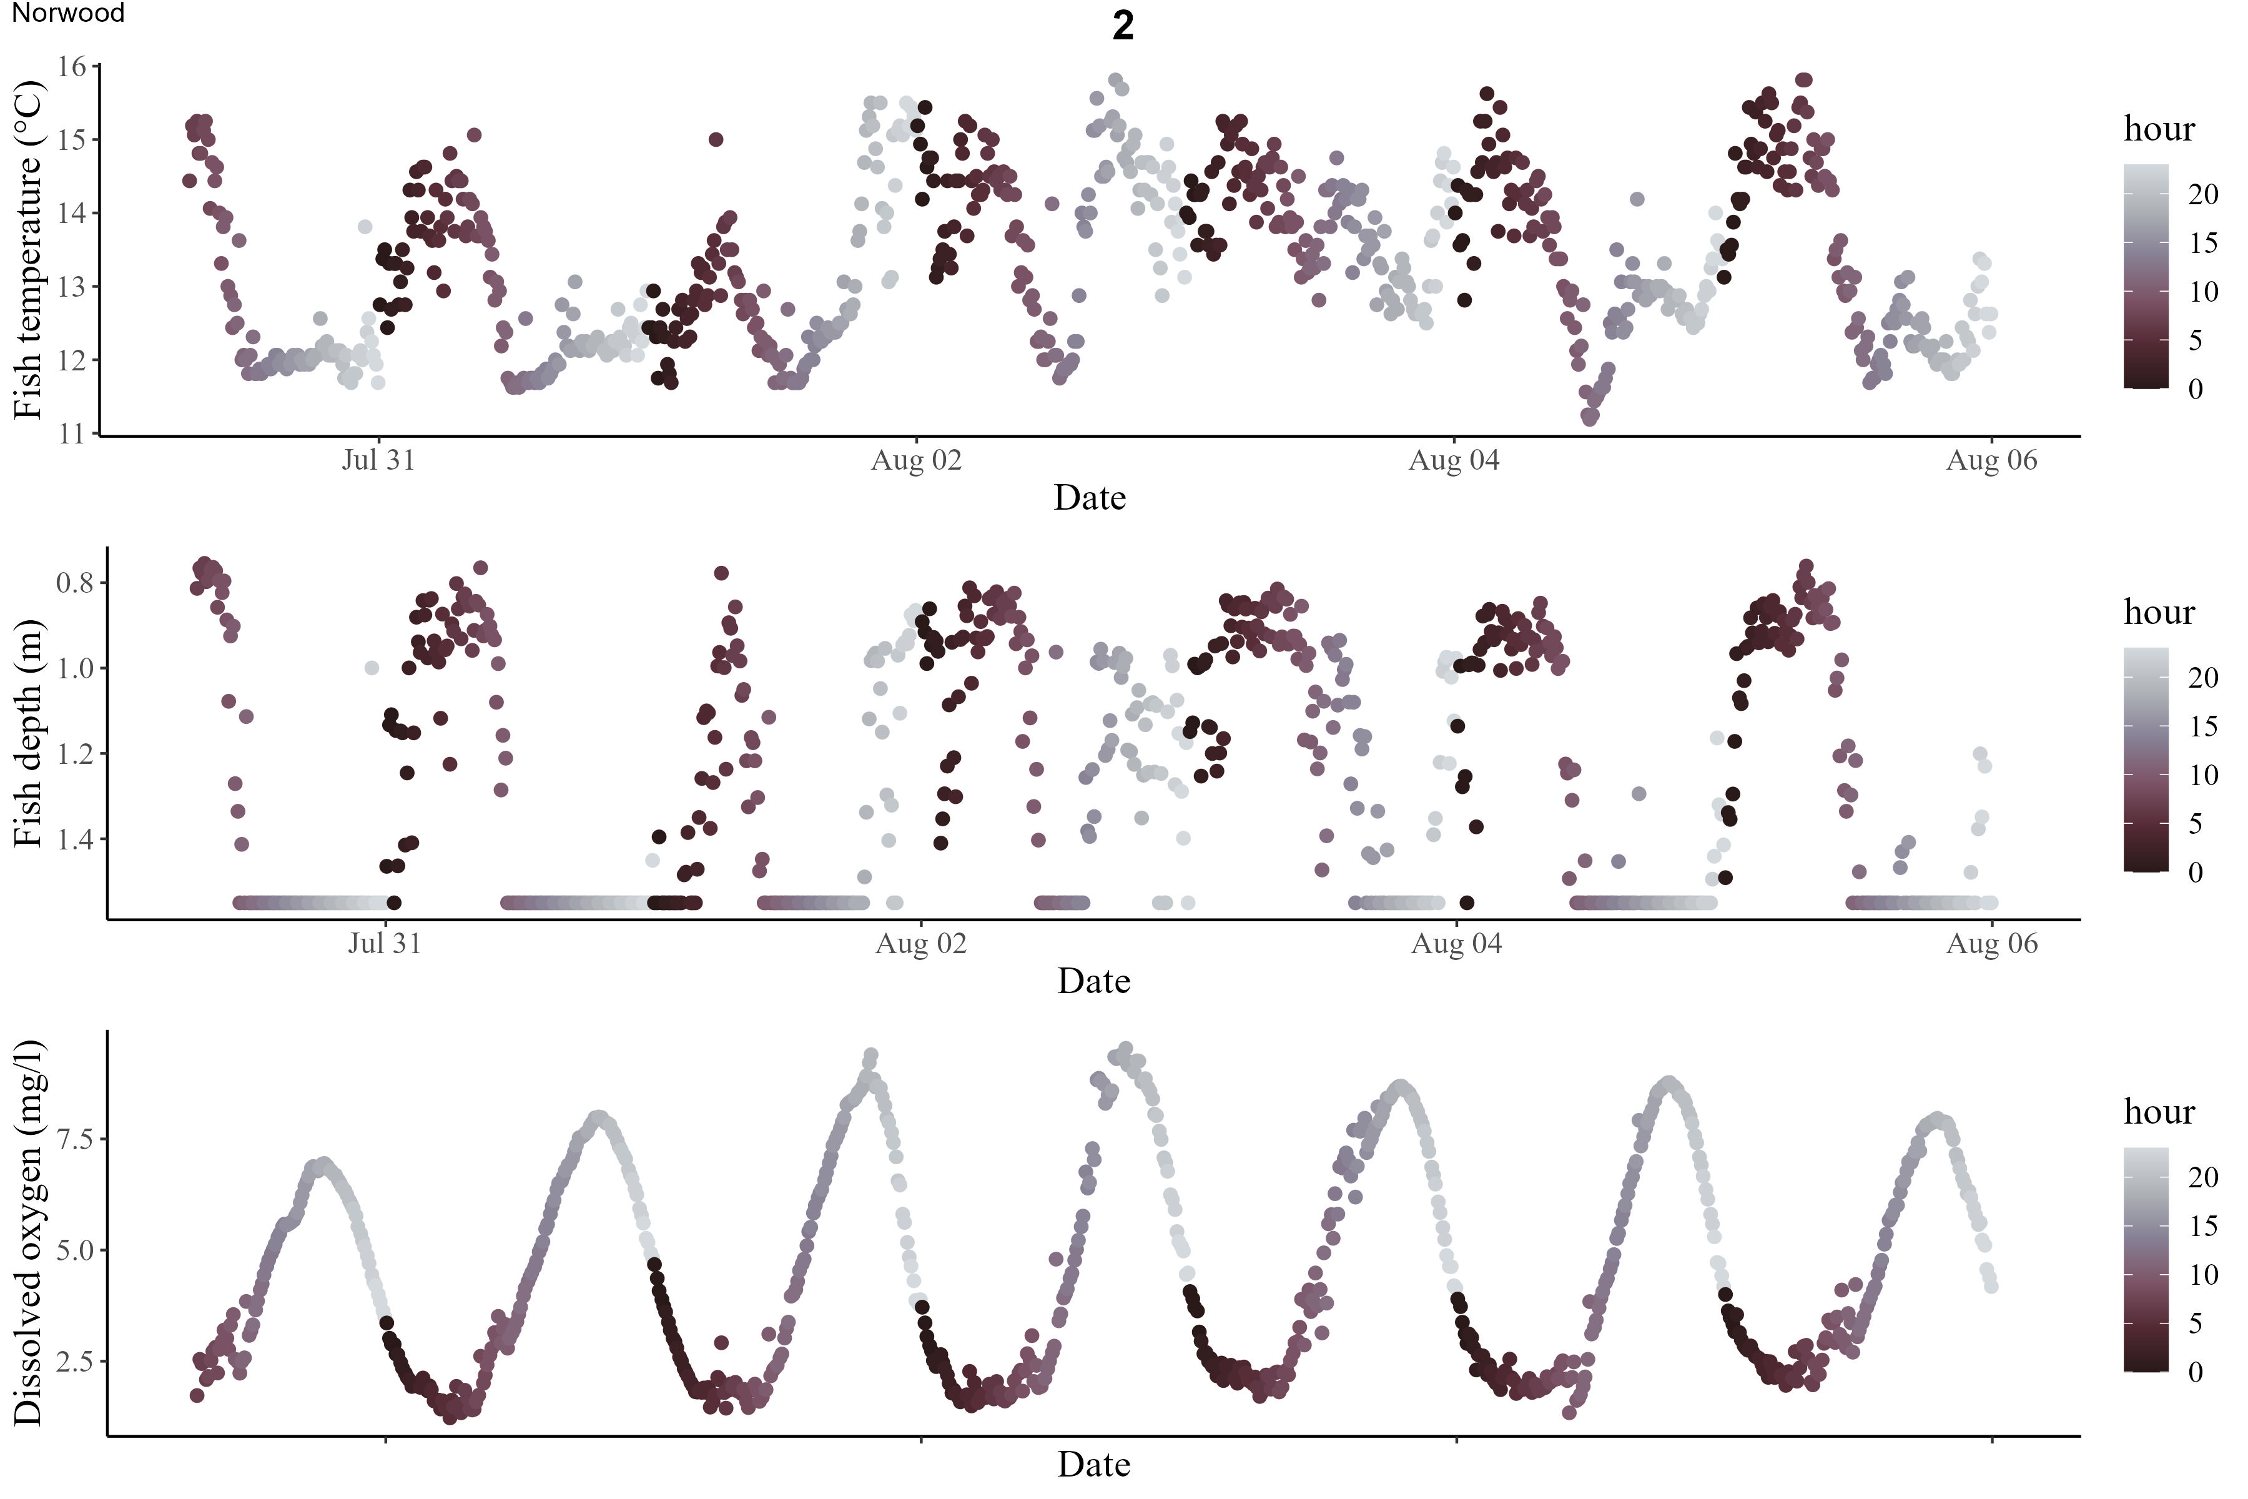
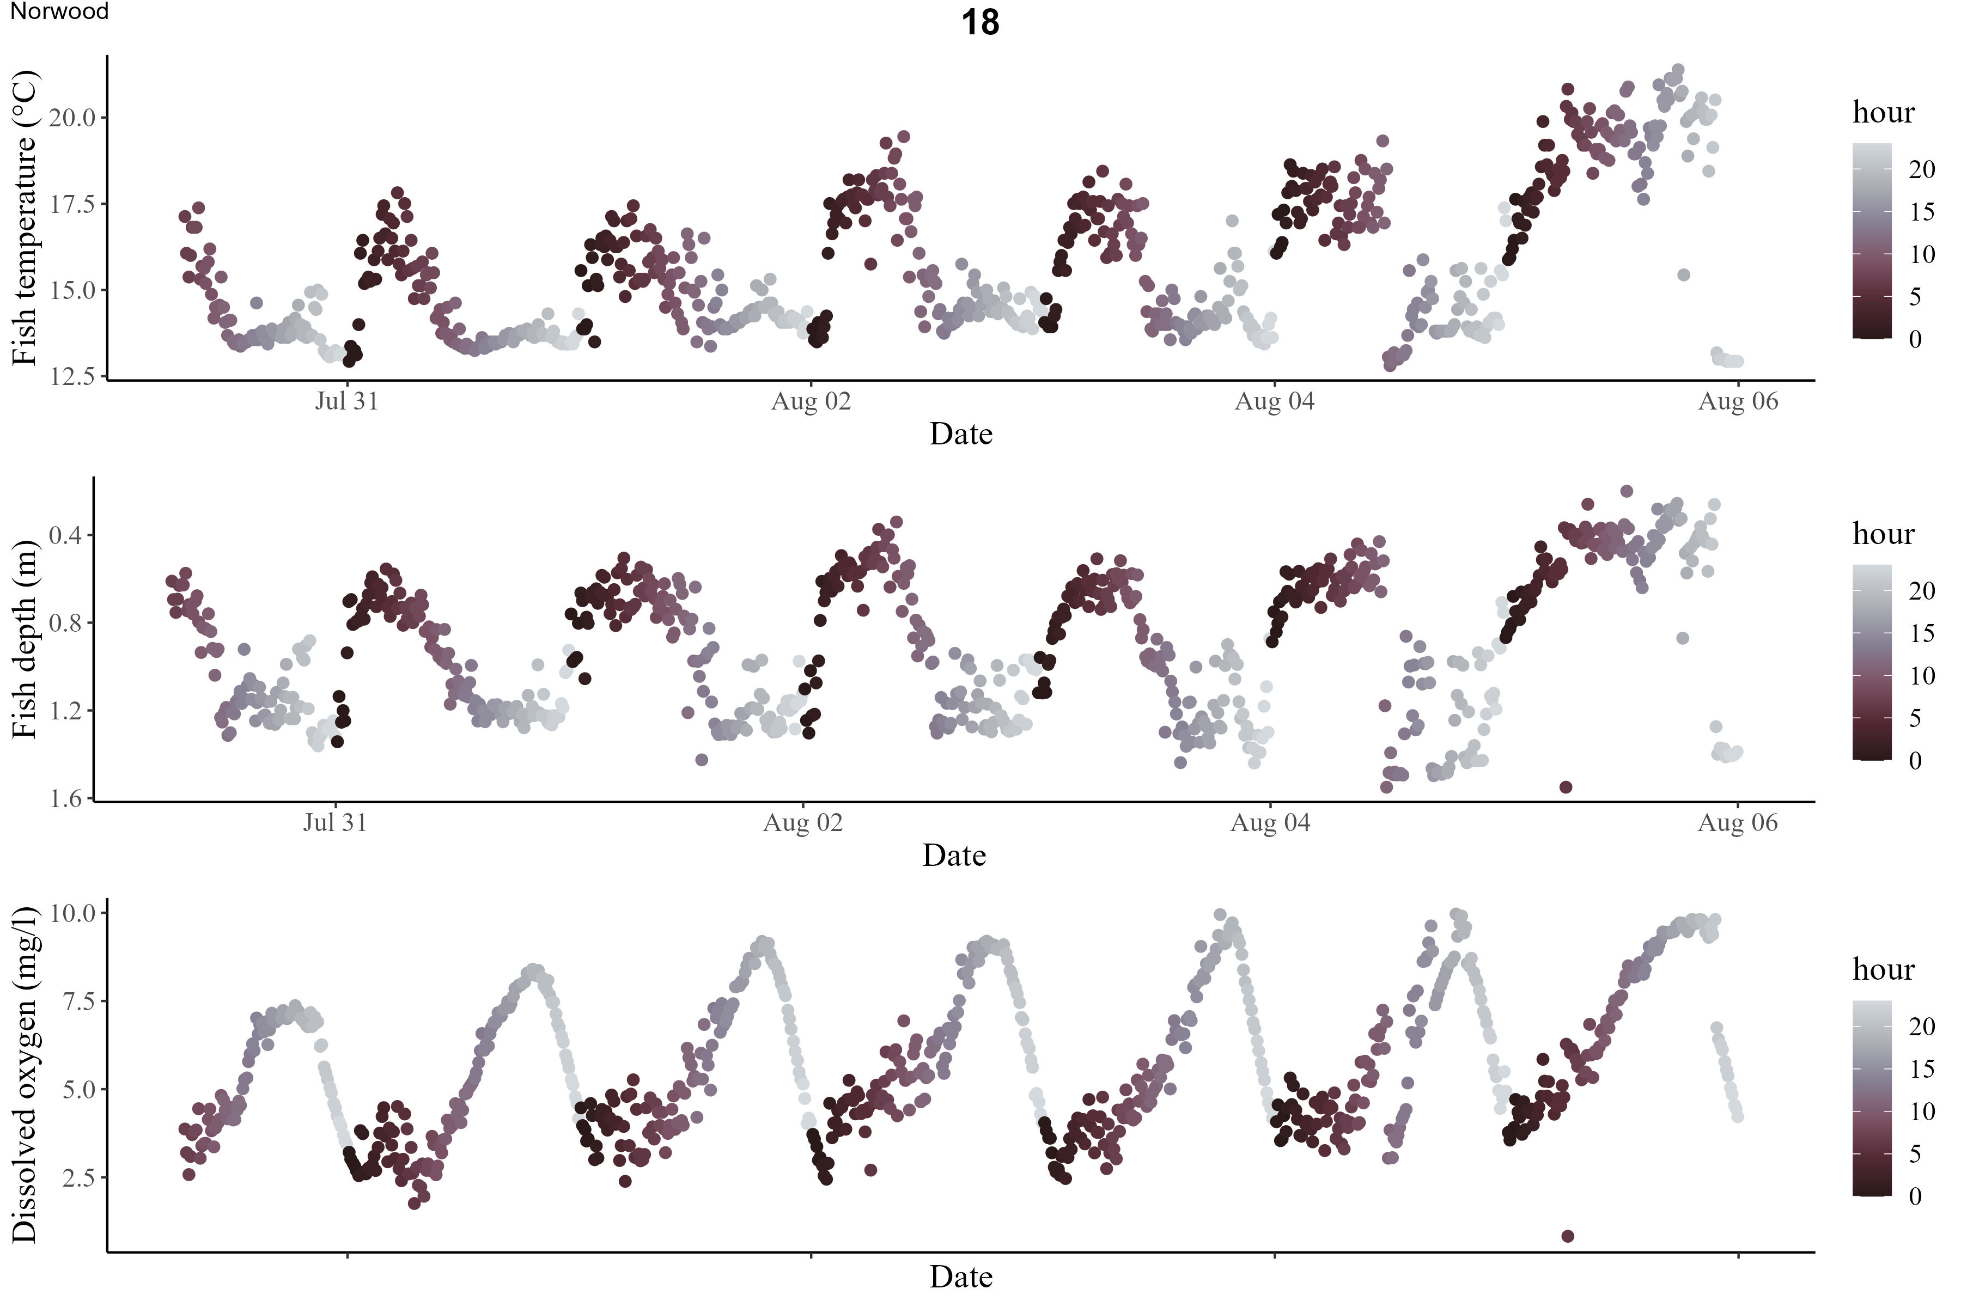
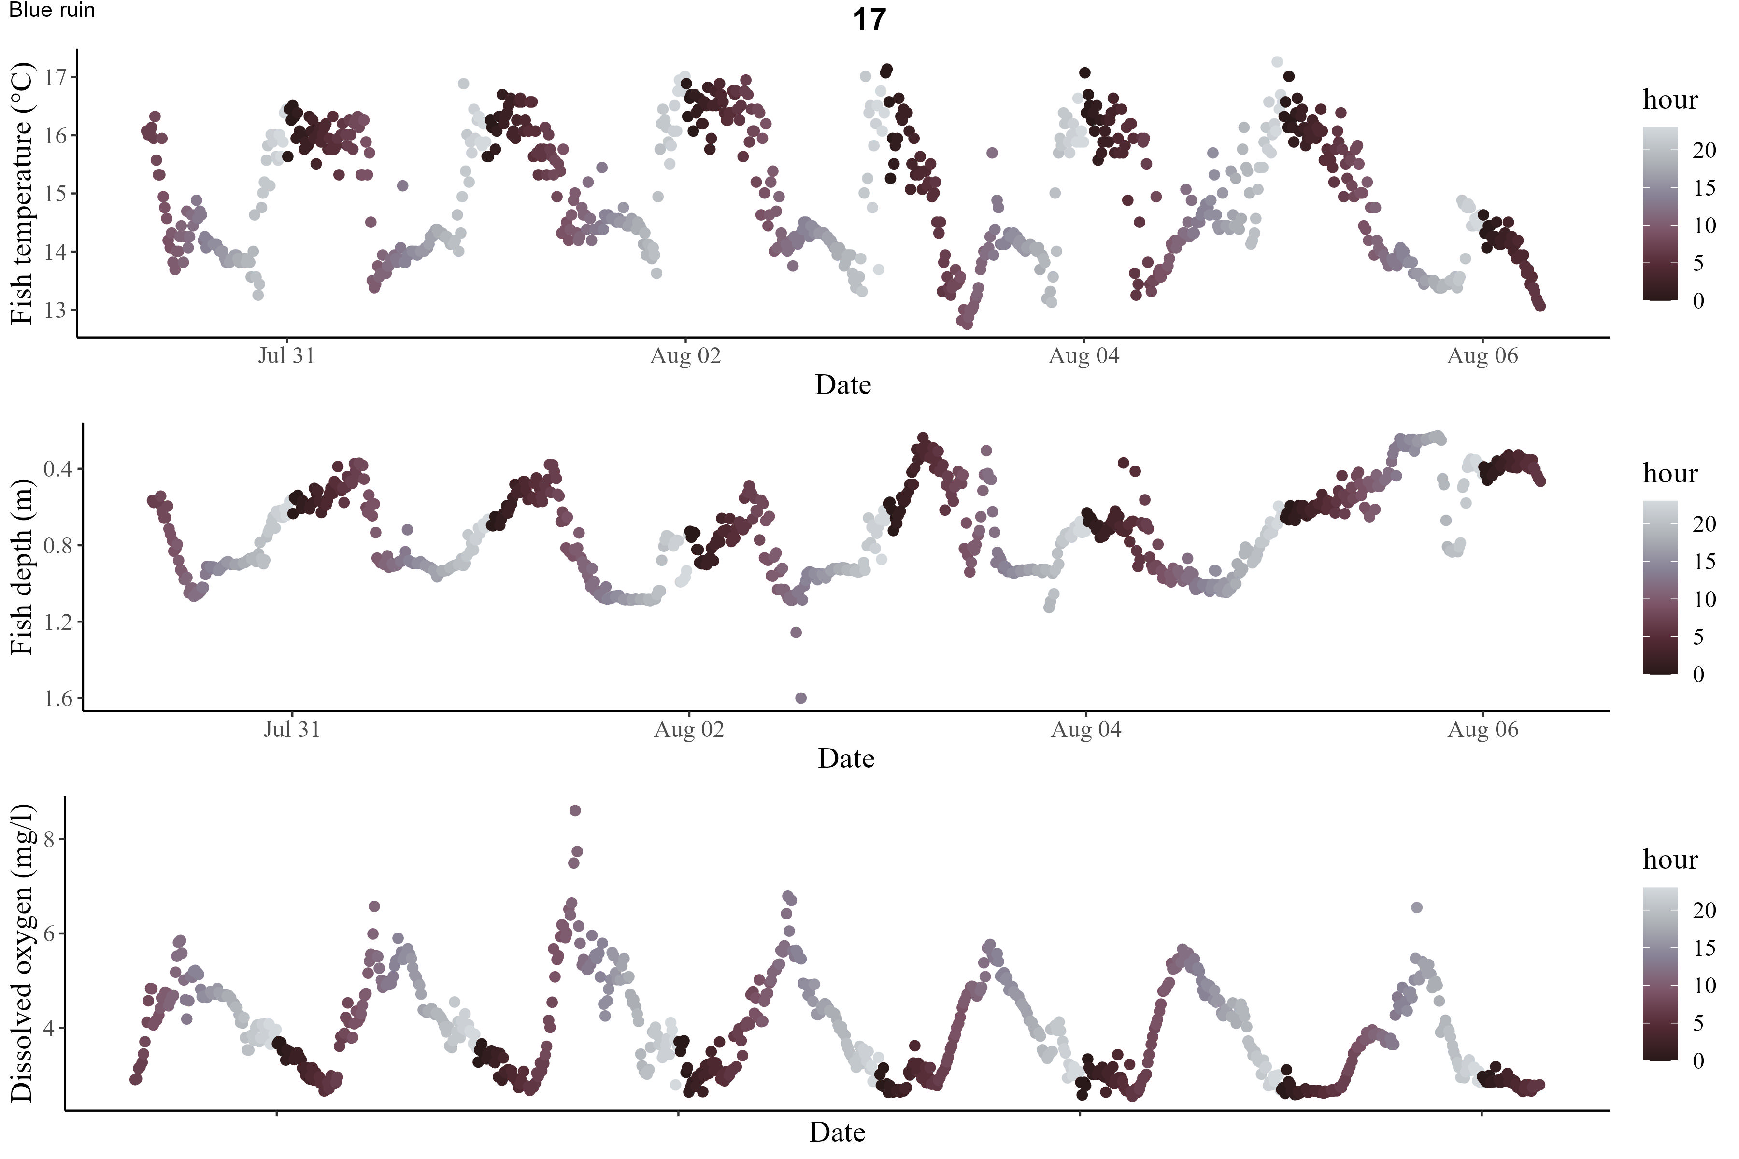
Supplemental Figure 4 Depth plots of 3-individual tagged fish from the iButton netpen study, fish display individual and intra-individual level variation in movement, however all display fine scale diel vertical movement patterns.

Supplemental Table 1 Average minimum and maximum temperature and dissolved oxygen (DO) recorded at the hypolimnion and epilimnion in both Blue Ruin and Norwood alcoves at their net pen associated logger arrays.
Norwood 07-31 to 08-07 | Temp (℃) | DO (mg/L)
Average minimum hypolimnion | 12.5 | 1.2
Average maximum hypolimnion | 13.6 | 8.4
Average minimum epilimnetic | 20.0 | 6.9
Average maximum epilimnetic | 25.0 | 11.3
Blue Ruin 07-31 to 08-07 | Temp (℃) | DO (mg/L)
Average minimum hypolimnion | 12.1 | 2.5
Average maximum hypolimnion | 13.4 | 4.8
Average minimum epilimnetic | 16.2 | 3.4
Average maximum epilimnetic | 22.7 | 9.2

Supplemental Table 2 Results from linear models (Norwood, Blue Ruin) and linear mixed models (all CWA) fit to data collected during the approximate 2-hour DO-maxima (6:00-8:00), and 2-hour DO-minima (18:00-20:00).
 |  | β | SE | p-value
Norwood | high DO | 0.264 | 0.007 | <0.001
 | low DO | 0.856 | 0.008 | <0.001
Blue Ruin | high DO | 0.563 | 0.013 | <0.001
 | low DO | 0.306 | 0.011 | <0.001
All CWA | high DO | 0.325 | 0.009 | <0.001
 | low DO | 0.642 | 0.008 | <0.001

