Lisp_lib.lsp
(30-day shareware)

Overview:
Lisp_lib.lsp is an easy to use dialogue based lisp library which acts as a powerful cataloging tool. This program was written to help the end user organize the potentially enormous amount of lisp programs that he/she collects and make it easy for them to find and load them. It operates

Installation:

To install Lisp_lib.lsp place all included files in any directory, it doesn’t need to lie within the Autocad search path. It is best to create a directory containing only these files (i.e. c:\library), the lisp library runs from its own path settings and doesn’t rely on Autocad to tell it where to search for files. I’ve created the library to work this way to make installation very simple without requiring the user to modify any Autocad settings. At the command prompt in Autocad type (load "drive:\\directory\\lisp_lib"). I.e. if you’ve copied the files to c:\library you would type:

command: (load “c:\\library\\lisp_lib”) Note: be sure to use the parentheses and double backslashes.

Then to run this program type 'Lib' at the command prompt. If you wish for this program to load at startup (recommended) open the acad.lsp file using any text editor (i.e. notepad.exe in windows or the dos editor in dos) and at the last line type:

(load "drive:\\directory\\lisp_lib") i.e. (load “c:\\library\\lisp_lib”)

Another option is to place the library location in apploads, at the command prompt in Autocad just type Appload, then point to the lisp_lib.lsp file, once its in the apploads directory just highlight the file and hit the load button.

To make your own macro (if you wish to use something other than 'Lib' to run the lisp_lib) open the file called acad.pgp (again using any text editor) and at the last line type whatever you want to use as your macro (say you wish to use LL instead of LIB) like this:

LL, *LIB

Interface:

The lisp library was written to make it extremely easy to use and to find routines no matter how many routines may be in the library. It does all its manipulation (i.e. alphabetizing, sorting, etc.) on the fly to be sure that all routines in the library are easily to find no matter what order they where entered in. When the user first loads the library he/she will see the interface in fig. 1 shown below.

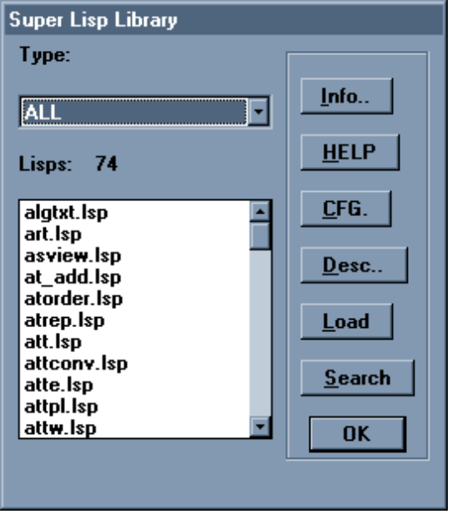
fig. 1

The default lisp type is ‘ALL’ this lists all lisp routines in the library. All lisp routines are organized in categories called ‘types’. Thus by clicking on the ‘Type:’ scroll bar (or hitting the first letter of the type of routine he/she is looking for while the ‘Type:’ scroll bar is highlighted) the user can select what type of routines to display in the ‘Lisps:’ scroll menu. For instance if the user chooses ‘TEXT’ from the ‘Type:’ scroll bar he/she will see the display as shown in fig. 2.

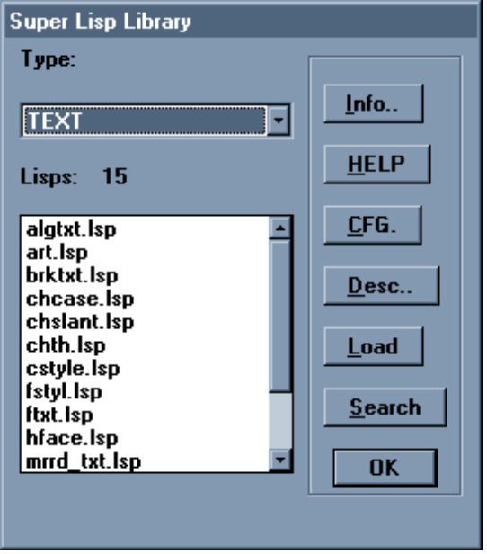
fig. 2

Now all of the routines displayed under the ‘Lisps:’ dialogue deal with text editing. Also notice that the number following ‘Lisps:’ has changed to 15. This number represents the number of routines that are in the library that deal with text editing.
Now turn your attention to the buttons to the right of the lisp scroll bars. The first button is labeled ‘Info:’. Pressing this button gives the general information about the lisp library including how to contact its author. Directly below the information button is the help button which contains complete on-line help to lead you through any problems or questions you may have. I would advise you to read through this entire help file because it contains some valuable tips on how to use this program.
Below the Help button is the ‘CFG’ button (configuration). Pressing this button brings up the library configuration settings and program registration area as shown below in fig. 3.

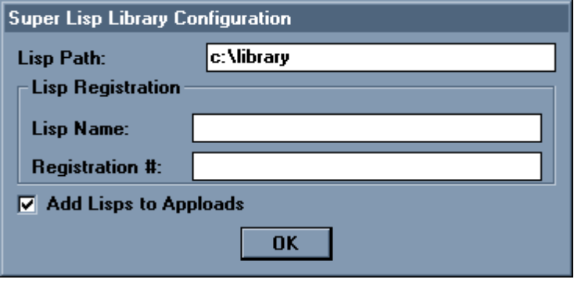

Fig. 3

The lisp path area lists the path you inputted the first time you installed the library in Autocad. You can change it here if you’ve moved or renamed the directory. The lisp name and registration # area is where you can input the lisp name you wish to register before the 30 day trial period is over and you can enter the registration number for the lisp your registering. Note: If you’ve added your own lisp routines to the library the library still generates a registration code for it. To let the Library know this is your own routine you enter the lisp name of your own routine and then enter in NEW for the registration number. BEWARE- you can enter NEW for my routines as well in this library and it will accept the code but the routine will still no longer run after 30 days, by entering in NEW for one of my routines you are just adding bad code to the routine. The library is still forced to search through this bad registration number to see if it is correct every time the library is loaded thus slowing down the library for no good reason.
Below the registration area is a radio button which gives you the option of adding the lisp routines you load to the apploads file as well. If you check this button every routine in the library that you load is also written to the apploads file.
Beneath the CFG button is the Description button. Highlighting any lisp routine in the library and then pressing the ‘Desc..’ button will bring up a complete description of the routine. For instance suppose you highlight the art.lsp routine shown in fig. 1 above. Fig. 4 shows the display you get after pressing the ‘Desc..’ button.

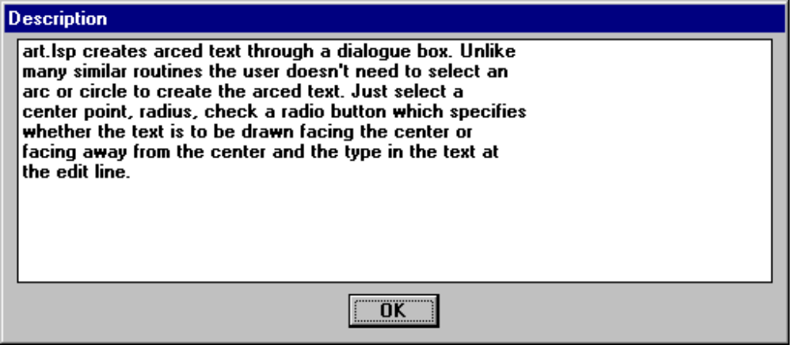
fig. 4

The user can then better decide whether to load this routine or not. Pressing ‘OK’ brings them back to the library dialogue box. If the user decides to load this routine he/she just highlights it and presses the ‘Load’ button.
The ‘Search’ button shown in fig. 2 is another powerful method of finding a routine the user is looking for. While the ‘Type’ scrollbar categorizes the lisp routines in a general fashion the search button can pinpoint a routines that deal with specific functions. For instance suppose the user needs to find a routine to move all entities to elevation zero. The user could go to the ‘Conversions’ category of routines under ‘Type:’ but there are still 12 routines to go through. By hitting the ‘Search’ button the user gets the dialogue as shown if fig. 5. By entering in the text “zero” in the text box the user is telling the search engine to find every occurrence of “zero” in the lisp descriptions (could have also used elevation as a search word ). The “match whole word” check box specifies whether the search engine should search for the word strictly or not (i.e. if the user wanted to search for elevation he/she could type “elev” and not check the check box thus every occurrence of elev, elevation, elevate, etc.. would be found, by checking the check box only “elev” would be found.).

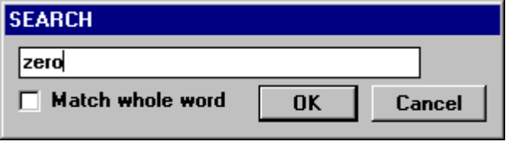
fig. 5

The search results for “zero” gives just one lisp routine as shown if fig. 6 (chel.lsp). By clicking the ‘Desc..’ button for chel.lsp the user can see that this routine indeed moves entities to elevation zero.

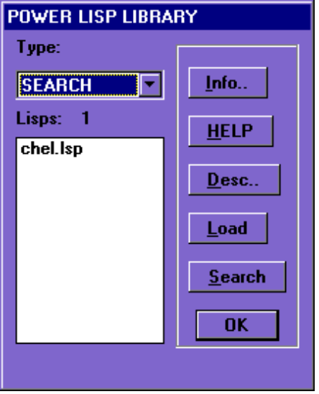
fig. 6

After highlighting chel.lsp and hitting the load button the user can then continue to load other routines or hit the ‘OK’ button which closes the library.

Adding your own lisp routines to the library:

Adding your own lisps to this library is very simple. Lisp_lib creates a list of lisp files and descriptions on the fly by reading a text file called lisp_lib.lst. This file just contains the names of the routines and a description of them. These lisps are not loaded until the user selects load from the lisp_lib dialog box. To edit the library list use any text editor (in windows-notepad.exe or in dos the dos editor) and open the file lisp_lib.lst. Then following the same format as the text already in this library the user can add more lisps into a category (TYPE) or add his/her own category (TYPE). After adding a new lisp routine to the library the user should then scroll down to the very bottom of the text file and add a description for the new lisp routine. Again following the same format as the other descriptions already in the file (be sure to use keywords to describe your lisp routine so the search engine can locate it if a search is made for a file of this type). NOTE: be sure to make a copy of the lisp_lib.lst file (Call it something like liblst.old) before you edit the file so if something goes wrong you can go back and rename the oldfile and try again.

Follow-up:

This program was written with the end user in mind to help him/her not only keep track of their routines but also to find the routine they need easily and quickly. I’ve made it extremely easy to load and configure requiring little to no manipulation of the Autocad environment settings. This shareware version of the lisp library contains all of the routines listed within it as shareware as well. The author of this library and all routines contained within it claims no responsibility for any problems or disasters that may arise from the use of these programs. The lisp library requires a donation of $30 for the registration or $150 for the library and all included routines. You may also register individual routines if you do not have a need for them all (see the individual descriptions in the library). All of the routines listed in the library are available in the lisp library package or individually, if you find these routines to be helpful to you please read the description for them in the library and send the requested donation to:

Ken Melvin
1351 Eureka St. #13
San Diego, CA 92110

You may also email me at: ken_and_tram@juno.com

