**HTML TEST EXAM**

**Section A**

**Q.1**

**Ans: HTML** stands for **Hypertext Markup Language**, it is used to structure web pages and construct in a way that is easily accessible by the web browser and the user.

Hypertext means the hyperlinks which is used to navigate to the different website, so with the help of this we can go to the other pages also

Markup Language means how the content should be shown to the user, the styling, font size, etc all those things which make it more easy to understand and make it more enhance the user experience.

**Q.2**

**Ans: HTML Elements** are the building blocks of the web pages which is used to structure the web page in an meaningful manner.

Element consists of <opening tag> content </closing tag>

<p>This is the 2nd Question</p>

This is known as an html elements

HTML Tags are the tags which is also used to design the web page and add content to the web page and with the use of the tags we can build the html elements

There are different types of tag:

<head>

<body>

<p>

<footer>

**Q.3**

**Ans:** <head> is used to contain the information of the web page, or if we want to link the CSS sheet or JS file.

It contains the information that is needed for the web browser.

Elements that can be placed in html tag are:  
 **<meta>** : this contains the info of the website, viewport which is used to see the content of the page to the user, scale 1.0 which is the normal or no zoom to the website.

**<link>:** link is used to link the CSS file to the HTML page so whenever anyone do the changes in the CSS file it should be visible to the html content.

**<script>:** It is used to the connect the script of the js file

For example: if we want to connect the bootstrap file to the

HTML file we add script tag inside the head tag.

**Q.4**

**Ans:** Semantic HTML elements means which is understandable to the coder/user or web browser. Semantic tags have meaning when we try to read the word

So it is easier to the user/coder to summarize the word and use it.

Exmaple of the semantic elements are:

**<head>**: Head tag is used to store the information about the web page

So while reading head tag anyone can guess that what head tag can do.

**<body>**: body tag is the tag in which we write the code which will be visible to the user on the screen, which is also understandable.

**<p>:** this is used to the write text body

**<footer>:** Footer tag is used to make footer content of the website where

everyone make copyrights or different details.

**<br>:** break line which is used to the break the content and the content which is written after br tag will be shifted to the next line.

**Q.5**

**Ans: alt** attribute is used in <img> tag which is used after the src attribute and very essential for the browser also

Alt attribute have two main functions which are:

1. Its is used by browser when any try to find image on google then the browser will search the alt attribute which is named as car or something about of something same
2. The second use of the alt attribute is if by any chance the image fails to load on the web page then the alt attribute shows the name of the image which is written inside of it

For example: alt=”car_image”.

**Q.6**

**Ans: Block level** elements are the elements those capture the whole width of the container and place vertically line by line manner.

**Inline Elements** are the elements which capture the required length and placed horizontally side by side of the other one

Example of the block level :

**<div> :** it creates a container which occupies the whole width of the page

**<p>:** it is used to display some text on the user screen and this also places vertically

Example of Inline elements are:

**<i>:** it is used to give italic font and it works as an inline

**<b>:** it is used to make the text strong and bold

**Q.7**

**Ans:** Meta tag are used in the head tag which holds the information about the web pages and which is essential to the web browser.

There are different types of the meta tags which is used to show different web info

Some meta tags are listed below:

1. <meta name=”description” content=”This is my seventh question”>

This meta tag includes the description of the page

1. <meta name=”viewport” content=”width:screen-width” >

This is used for the web pages which we are creating this mean the website should contains the full width

1. <meta name=”author” content=”your name”>

Using this your name will be displayed as the author.

**Section B**

**Q.1 My portfolio**

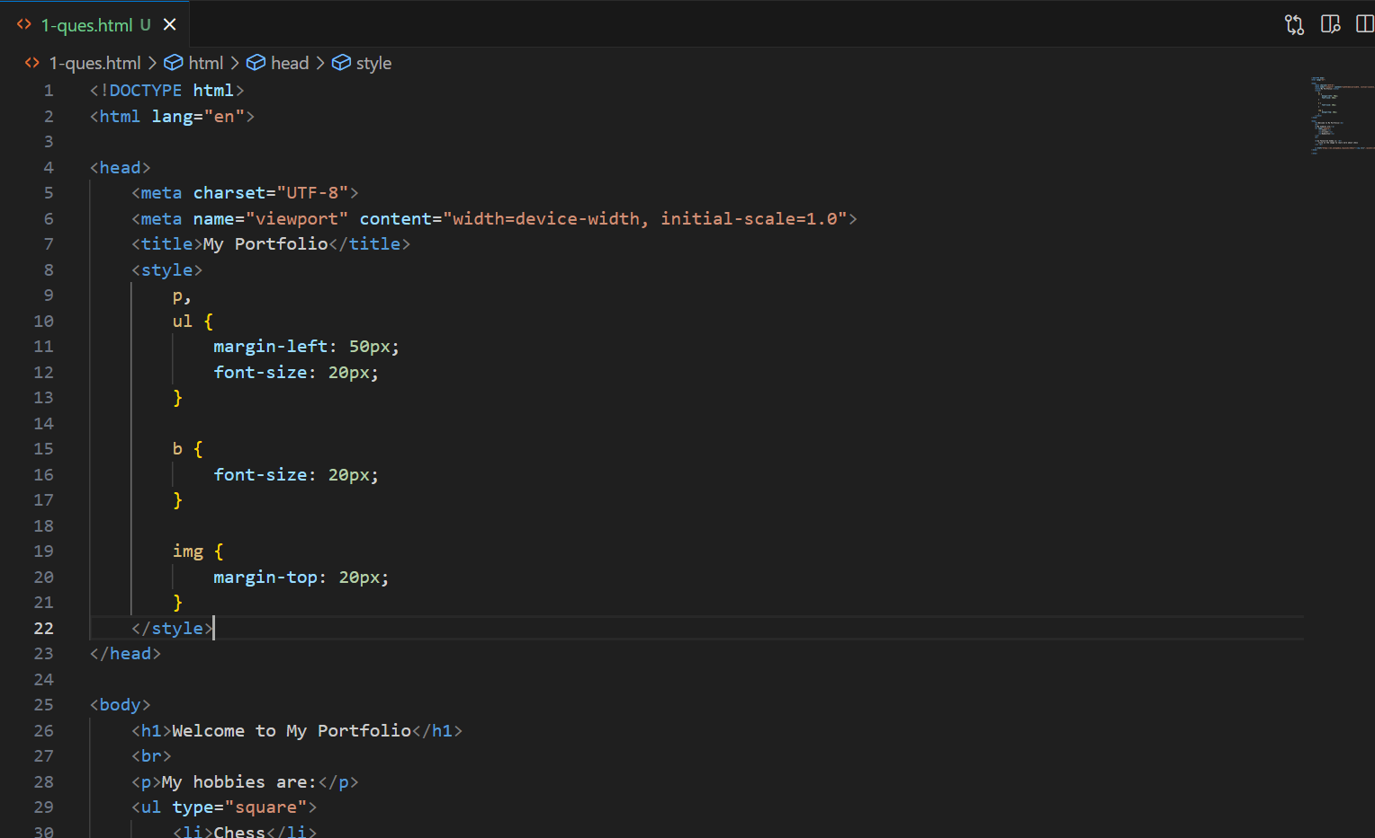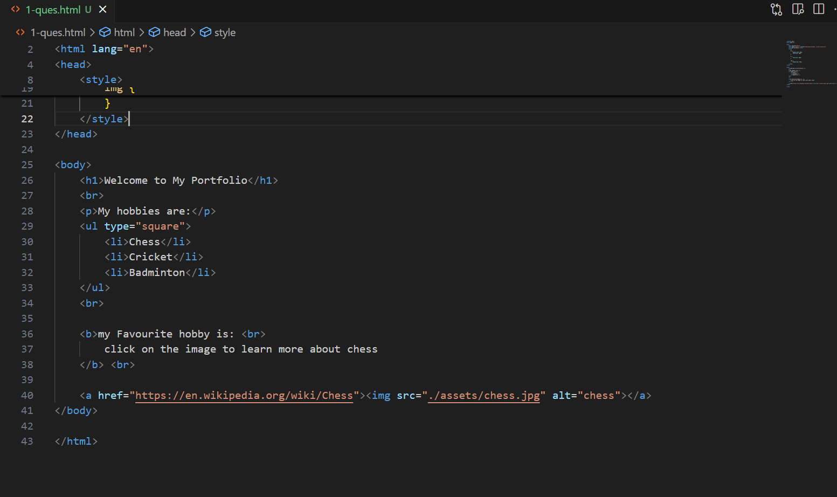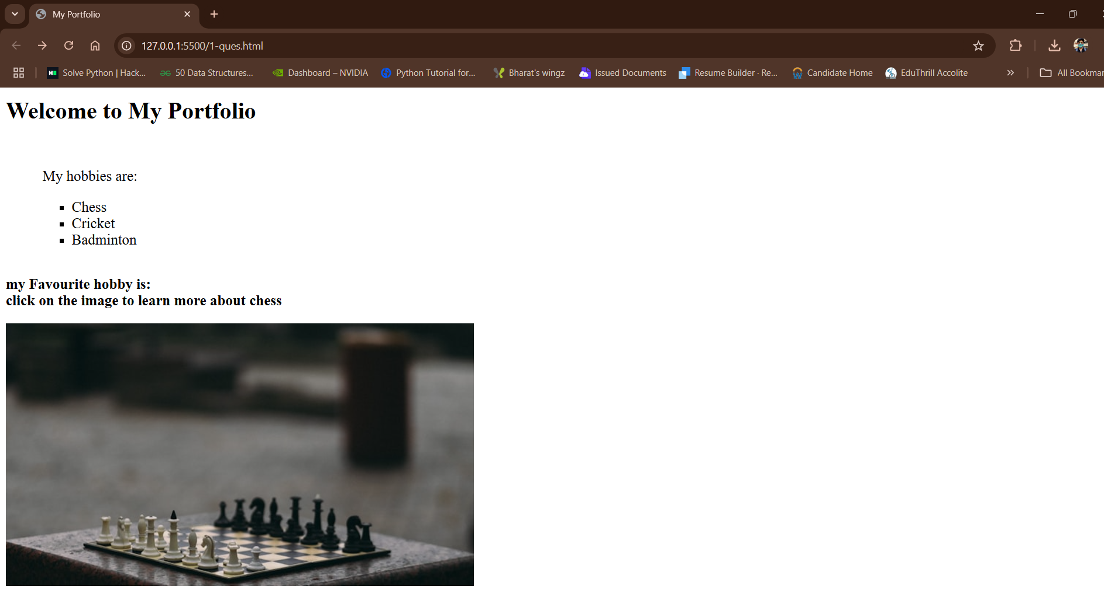

**Q.2 Registration**

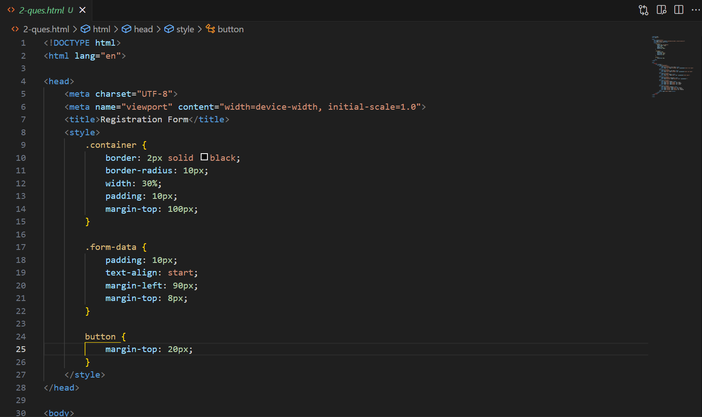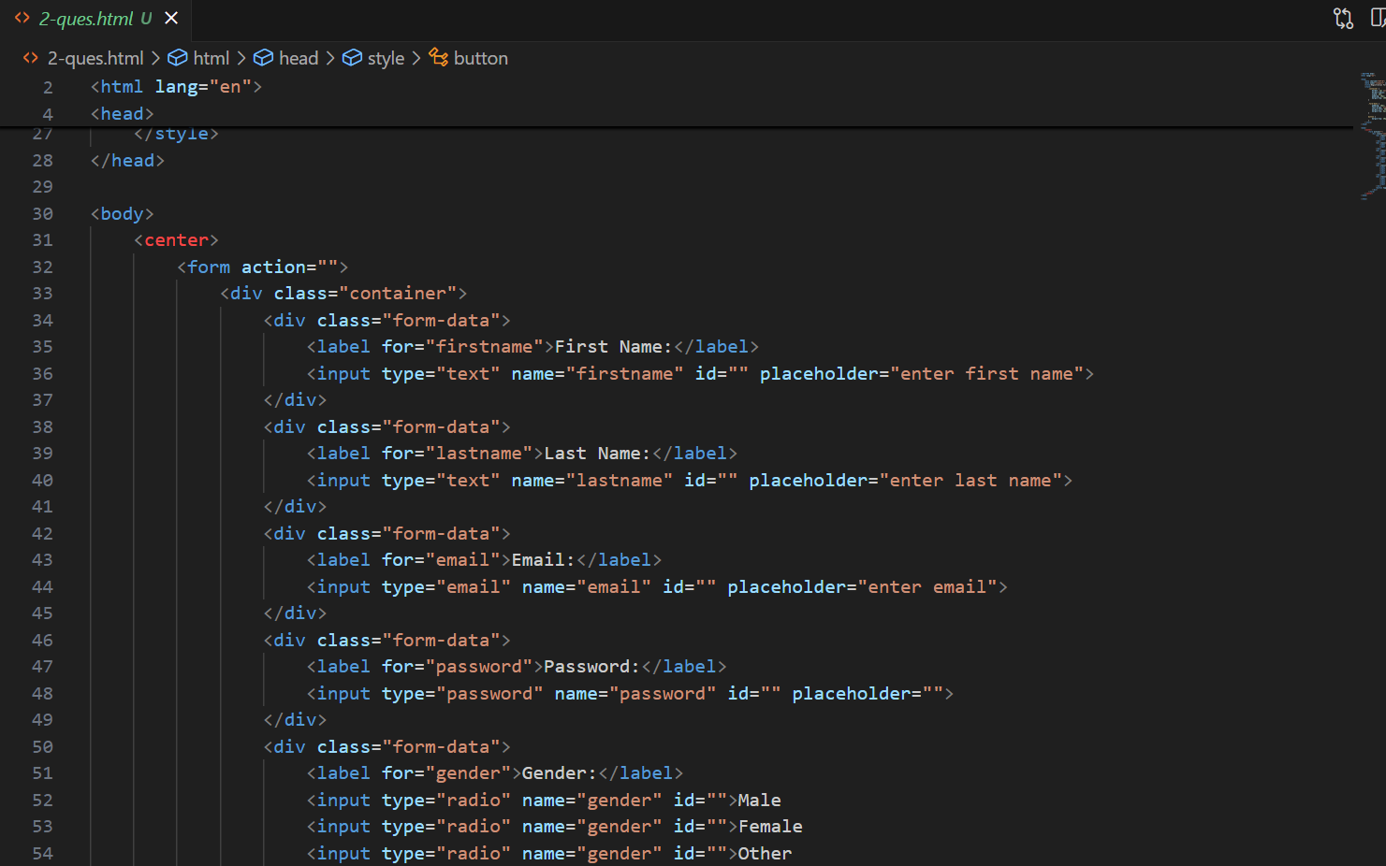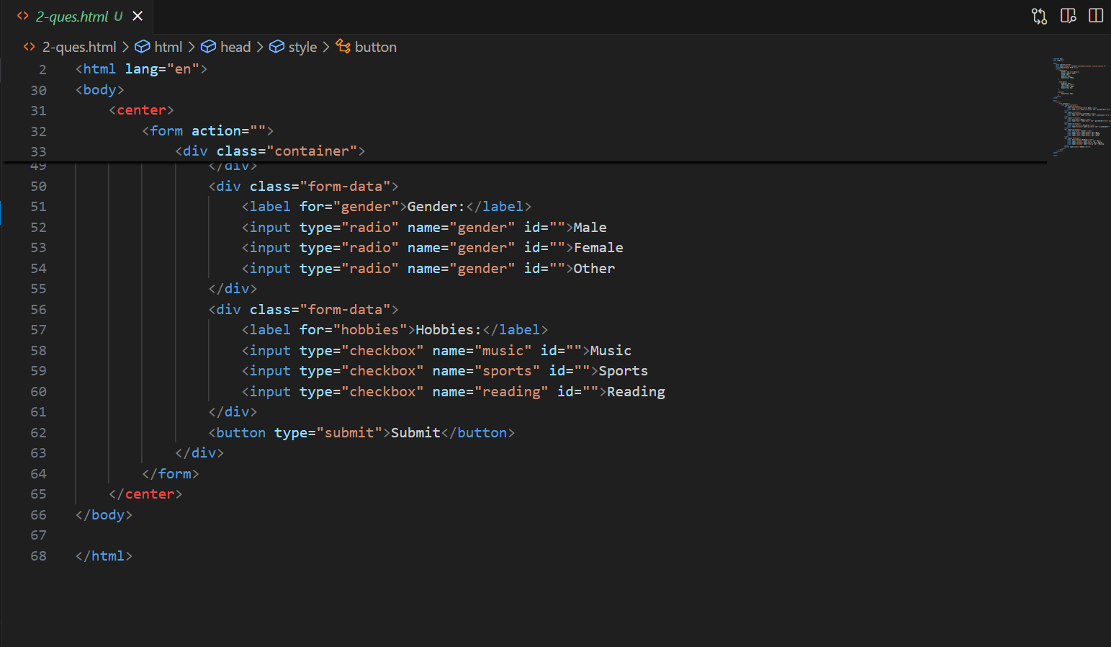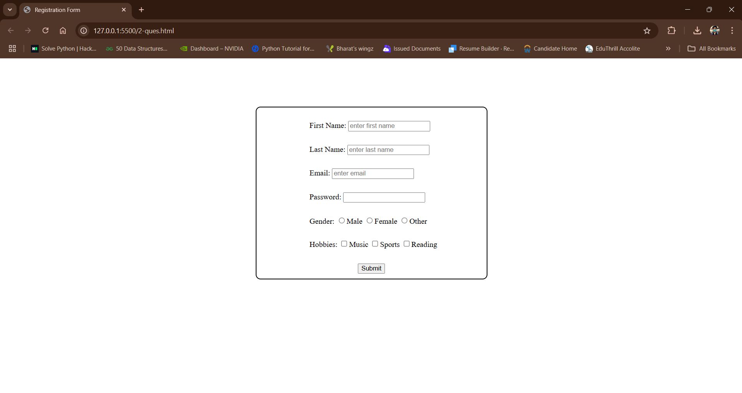

**Q.3 Table**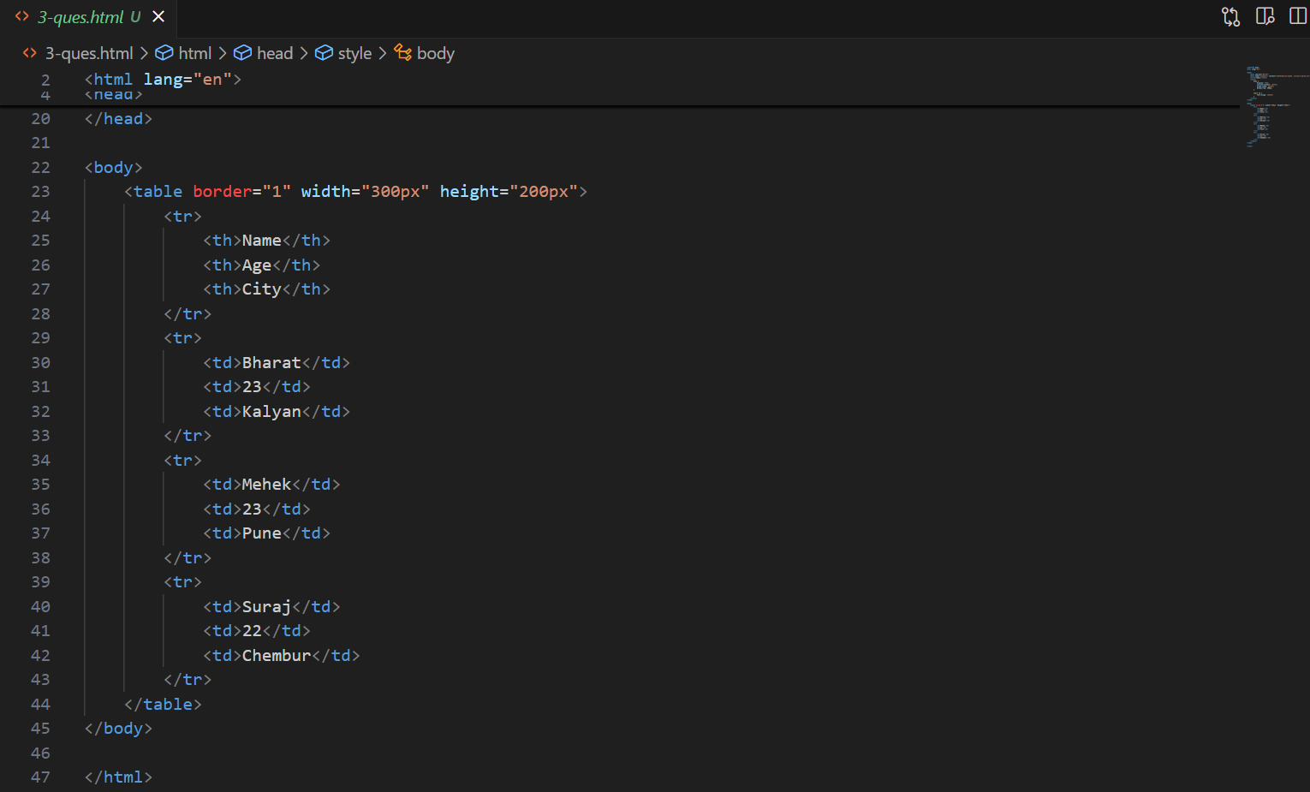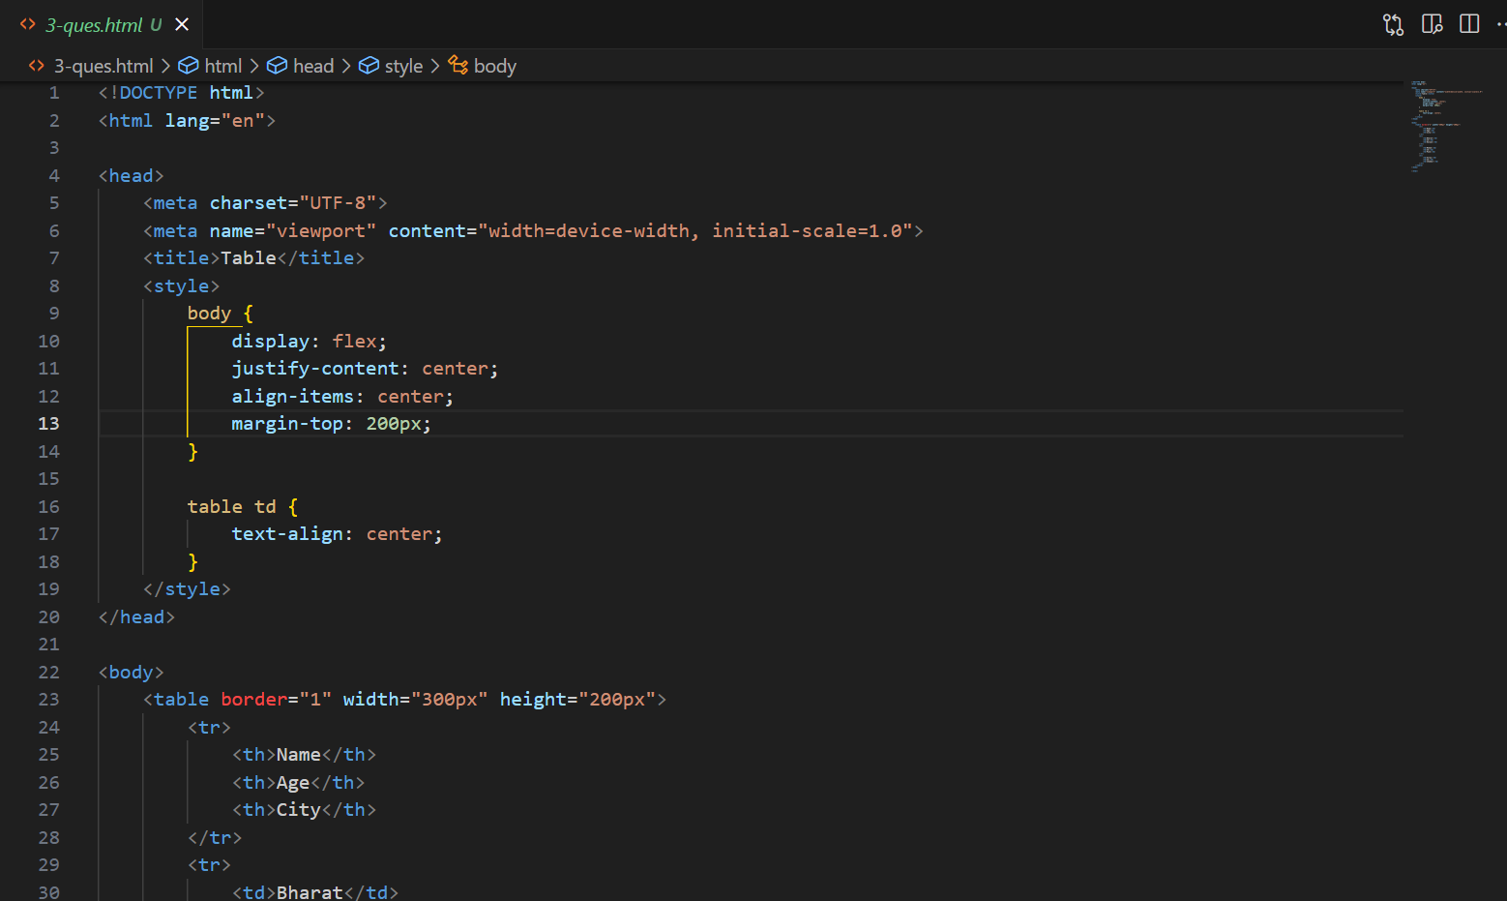

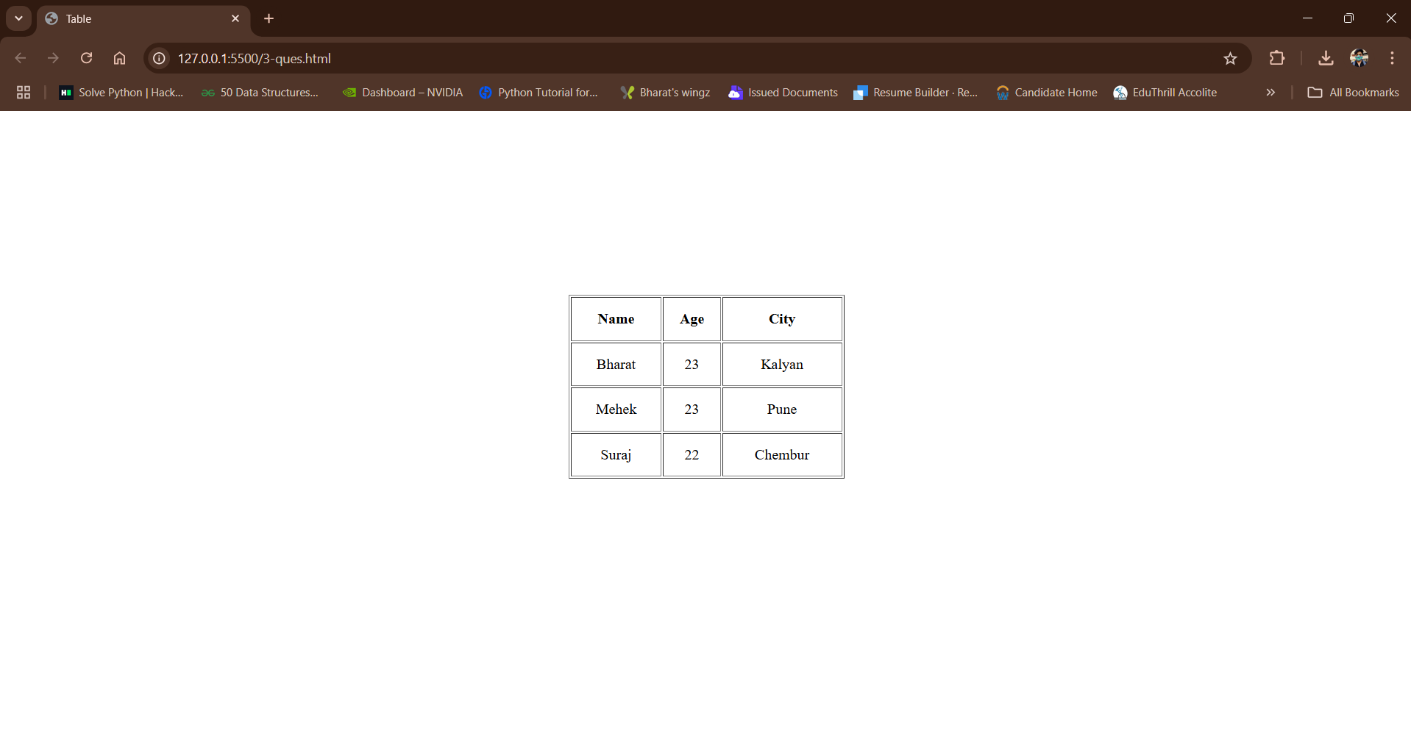

**Q.4 Navigation bar**

