# COMP7405A - Techniques in computational finance

# Assignment 2, Semester 2, 2016-17

# 3035348061

## Question 1

|  |  |  |  |  |  |  |  |
| --- | --- | --- | --- | --- | --- | --- | --- |
|  | **S** | **K** | **Tau** | **σ** | **r** | **Call** | **Put** |
| **3.1** | 100 | 100, | 0.5 | 20% | 1% | 5.876024 | 5.377272 |
| **3.2** | 100 | 120, | 0.5 | 20% | 1% | 0.774139 | 20.17564 |
| **3.3** | 100 | 100, | 1 | 20% | 1% | 8.433319 | 7.438302 |
| **3.4** | 100 | 100, | 0.5 | 30% | 1% | 8.677646 | 8.178893 |
| **3.5** | 100 | 100, | 0.5 | 20% | 2% | 6.120654 | 5.125637 |

See BlackScholes.ipynb for code (iPython notebook)

Change in Strike (K) affects Calls and Puts in opposite ways. An increase in Strike saw the value of calls decrease as they are less likely to expire in the money. However, an increase in Strike saw the value of puts increase as they are more likely to end in the money and with higher intrinsic value.

Increasing maturing increases the value of both Calls and Puts, as both have more time to move and expire in the money. Increasing volatility also affects the value of both calls and puts in the same way, and for the same reason as increasing maturing.

Increasing risk free rate will affect puts and calls in different ways. An increase in risk free rate is usually associated with an increase in calls because of the costs associated with borrowing and owning the underlying (or opportunity cost of investing in cash). In the same way, an increase in risk free rate is associated with a decrease in put value because puts have similar payoff profiles to stock short sales but you must pay the premium upfront (and borrow).

## Question 2

### 2.1

$Z=ρX+\sqrt{1-ρ^{2}}Y (1)$

µ is zero for standard normal distributions, Z is the sum of two normally distributed variables, and therefore is also normally distributed (http://mathworld.wolfram.com/NormalSumDistribution.html)

$µ_{Z}={ρµ}_{X}+{\sqrt{1-ρ^{2}}µ}_{Y}=0$

$ρ\left(X,Z\right)=\frac{Cov(X,Z)}{\sqrt{Var\left(X\right)Var(Z)}}$ From Correlation Definition

$ρ\left(X,Z\right)=\frac{Cov\left(X,ρX+\sqrt{1-ρ^{2}}Y\right)}{\sqrt{Var\left(X\right)Var\left(ρX+\sqrt{1-ρ^{2}}Y\right)}}$ Substitute for Z = (1)

$Cov\left(X,Z\right)=\frac{\left[\sum_{i=1}^{n}{{(x}_{i}-0)}\left(z_{i}-0\right)\right]}{n-1} \left(2\right), Var\left(X+Y\right)=Var\left(X\right)+Var\left(Y\right) \left(3\right)$

$Var\left(aX\right)=a^{2}Var\left(X\right) (4)$

$ρ\left(X,Z\right)=\frac{\left[\sum_{i=1}^{n}{x_{i}\left(ρx_{i}+\sqrt{1-ρ^{2}}y_{i}\right)}\right]1/{n-1}}{\sqrt{Var\left(X\right) \left[ρ^{2}Var\left(X\right)+\left(1-ρ^{2}\right)Var(Y)\right]}}$ Substitute (2), (3) and use (4)

$ρ\left(X,Z\right)=\frac{ρVar(X)+\left(1-ρ^{2}\right)Cov(X,Y)}{\sqrt{1 \left[{1ρ}^{2}+\left(1-ρ^{2}\right)1\right]}}$ $Var\left(X\right)=Var\left(Y\right)=1 , Cov\left(X,Y\right)=0$

$ρ\left(X,Z\right)=\frac{ρ1+\left(1-ρ^{2}\right).0}{1}=ρ$

### 2.2

See CorrNormRandVar.ipynb for code (iPython notebook)

See Q2-2_Results.txt for X, Y and Z data.

Sample Correlation Coefficient ρ(X,Z) = 0.51021864 which is reasonably close to ρ=0.5

## Question 3

### 3.1

### 3.2.1

See ImpliedVol.ipynb for code implementation (iPython notebook)

See data output in 31.csv, 32.csv and 33.csv

### 3.2.2

For all charts, x-axis is strike, y-axis is implied volatility

Minute 9:31am

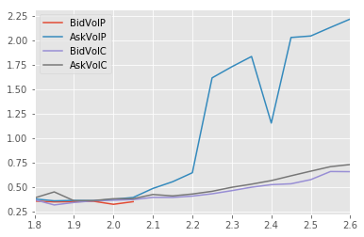

Minute 9:32am

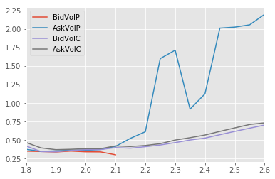

Minute 9:33am

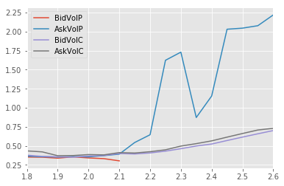

### 3.3

Create a synthetic option and go long the synthetic option, short actual. Payoff is synthetic – actual

Two different strategies:

1. Long Underlying (ask), buy put (ask), sell call (bid), borrow pv(Strike) at r
2. Short Underlying (bid), sell put (bid), buy call (ask), invest pv(Strike) at r

Each contract is for 10,000 of the underlying so the profit is 10,000 * (synthetic – actual) – Transaction The filtered results of checking the arbitrage at the end of each minute can be found at Arb_31.csv, Arb_32.csv, Arb_33.csv

In summary, there were no arbitrage opportunities at the 31st minute, there were 2 at the 32nd minute and there were 6 at the 33rd minute. All Arbitrage opportunities were gained by Selling the call, buying the put, and going long the underlying having borrowed the present value of the Strike. This can be double checked by looking for where this is no overlap in the implied volatility.



If we consider transaction costs of 3.3 per contract, and each arbitrage is made up of three instruments, the Net Profit is the Raw Profit – 3.3 * 3. After taking away transaction costs, only two trades have an arbitrage opportunity as can be seen in the table.