Lecture 1-1-3 Data Storage Intro to Arrays

Crayons

With five colors you could use Strings.

String redColor = “red”;

String yellowColor = “yellow”;

String purpleColor = “purple”;

String blueColor = “blue”;

String greenColor = “green”;

But if you had a lot of colors, this would be terrible.

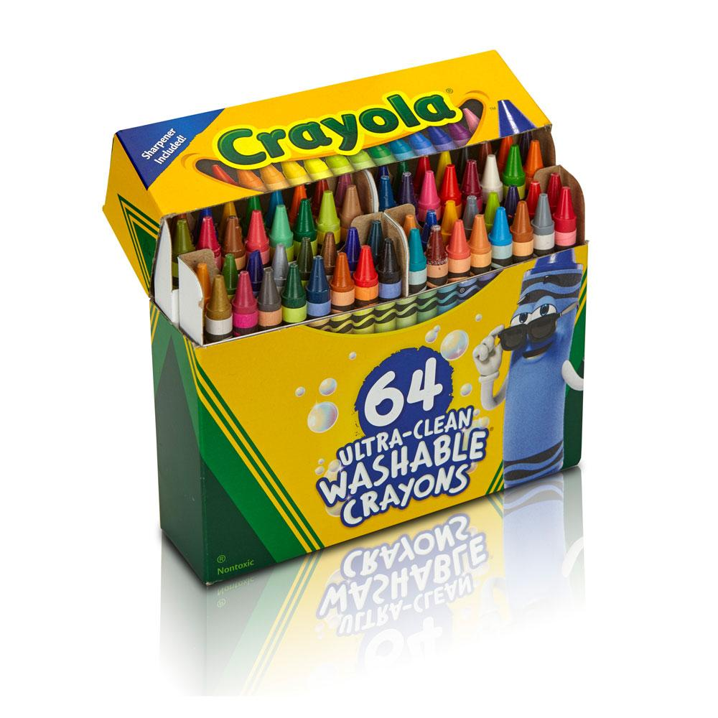

You do not want to write 64 Strings. Java has several data structures for medium amounts of data. The first one is called an array.

An array is a block of memory to hold items of ONE type. That means only int, or only double or only String. You cannot put a double and a String in an array. You cannot put a double and an int into an array.

You write it like this:

Declaration of array:

String [] thisIsAStringArray;

The pattern is Type-square brackets-nameOfArray-semicolon

Declare and instantiate the array which means declare the array with an initial size. :

String [] thisIsAnotherStringArray = new String[64];

(new is a special word. It is used when we create objects. Note its use here. Details in footnote).

The pattern is Type-square brackets-nameOfArray equals new and a size in square brackets.

String [] superArrayOfColors = new [64];

Declare, instantiate and initialize: declare the array with an initial size and a set of values:

Note: I am only going to include 10 colors.

String [] crayonColors = {“red”, “yellow”, “blue”, “green”, “orange”, “purple”, “brown”, “black”, “white”, “silver”};

Here are examples using the other primitive types.

Integer:

Declare:

int [] numberOfSeats;

Declare and instantiate:

int [] numberOfPeople = new int [10];

Declare, instantiate and initialize:

int howManyDoors = {1, 2, 3, 4};

The computer sees int and [] and thinks oh, make an int array!!

Hmm...how big? Look, I have 4 integers. I will make an array that is four integer memory units long.

int howManyDoors = {1, 2, 3, 4}; You don't have to use the word new if you initialize. The computer will automatically allocate the correct amount of memory.

Declare:

double [] priceOfFoodItems;

Declare and instantiate:

double [] moneyInThreeBanks = new double [2];

Declare, instantiate, and initialize:

double [] valueOfCoins = {0.01, 0.05, 0.1, 0.25, 0.5};

Declare:

boolean [] studentAnswers;

Declare and instantiate:

boolean [] codeForDoor = new boolean [8];

Declare, instantiate and initialize:

boolean answersToQuestions = {true, false, true, false, false};

**Elements in an array:**

We count elements in an array starting with zero.

Example:

0 1 2 3 4 5 6 7 8 9

“red”, “yellow”, “blue”, “green”, “orange”, “purple”, “brown”, “black”, “white”, “silver”

Because we start with zero, the last number is labeled as element 9. But there are 10 elements in the list!! In computer science, the last element in the array + one equals the number of elements in the array by normal counting in math.

So given this array:

String [] crayonColors = {“red”, “yellow”, “blue”, “green”, “orange”, “purple”, “brown”, “black”, “white”, “silver”};

If I want to isolate the color blue, I would write:

crayonColors[2]

What would you write to get the color red?

Orange?

Black?

Purple?

The number in the square brackets is called the index for that element of the array.

new: (Information from <https://www.javatpoint.com/new-keyword-in-java> )

# Java new Keyword

The Java new keyword is used to create an instance of the class. In other words, it instantiates a class by allocating memory for a new object and returning a reference to that memory. We can also use the new keyword to create an array object.

## Syntax

1. NewExample obj=**new** NewExample();

## Points to remember

* It is used to create an object.
* It allocates the memory at runtime.
* All objects occupy memory in the heap area.
* It invokes the object constructor.
* It requires a single, postfix argument to call the constructor

What does this mean?

Primitives like int, double and boolean are not objects. Objects start use capital letters for their type name:

String, Object. Strings and arrays have hybrid properties because they are older types of data structures. String has a capital letter. But array starts with a small letter.

The computer knows exactly what size memory to allocate for primitives. Objects can be many different sizes, so the programmer has to tell the computer how much memory. The computer will do the math, but it needs the keyword new to let it know it needs to figure out how much memory is needed for a new object.