Connect-4 Monte Carlo Tree Search (MCTS) Implementation Report
Project Overview
This project implements a Monte Carlo Tree Search (MCTS) algorithm and applies it to two different games: Tic-Tac-Toe and Connect-4. The focus of this report is on the Connect-4 implementation.
Game Description: Connect-4
Connect-4 is a two-player, turn-based game played on a 6-row by 7-column grid. Players take turns dropping colored discs into one of the columns. The disc falls to the lowest available space within the column. The objective is to be the first to form a horizontal, vertical, or diagonal line of four of one's own discs. The game ends when either a player wins or the board is completely filled with no winner (draw).
MCTS Overview
Monte Carlo Tree Search (MCTS) is an intelligent search algorithm used in decision-making processes, especially for games. MCTS consists of four phases:
- Selection: Starting from the root node, recursively select optimal child nodes based on the Upper Confidence Bound (UCT) until a leaf node is reached.
- Expansion: If the leaf node is not terminal, generate one or more child nodes by applying legal moves.
- Simulation (Playout): Simulate the game from the new child node using random moves until a terminal state is reached.
- Backpropagation: Propagate the simulation result back through the visited nodes to update statistics like win counts and playouts.
Implementation Details
- Connect4.java: Defines the game rules and manages the game loop.
- Connect4State.java: Represents a specific board state and implements game logic such as move generation, next state transition, terminal check, and winner detection.
- Connect4Move.java: Encapsulates a player’s move (i.e., dropping a disc in a column).
- Connect4Node.java: A node in the MCTS tree, storing state, children, and win/playout statistics.
- Connect4MCTS.java: Executes the full MCTS pipeline with UCT-based selection and randomized simulations.
Each simulation assigns a win score of 2 for a win, 1 for a draw, and 0 for a loss, enabling gradual learning over multiple iterations.

Output Demonstration
The program prints each step of the Connect-4 game as selected by MCTS. Below is a sample output:
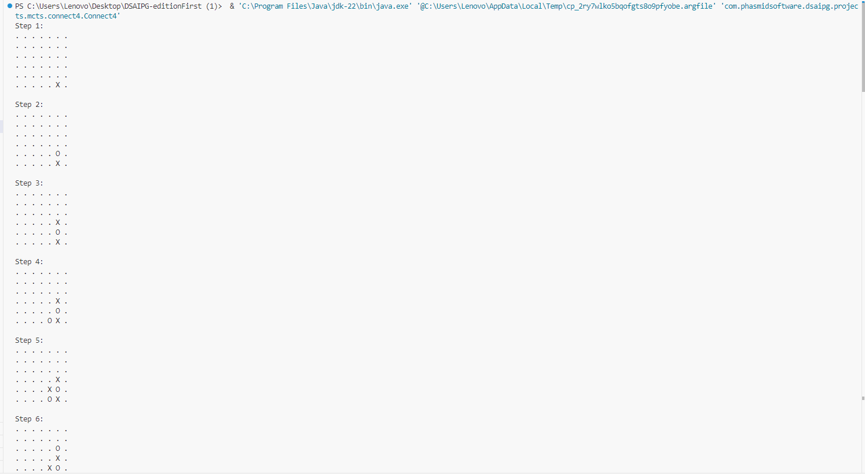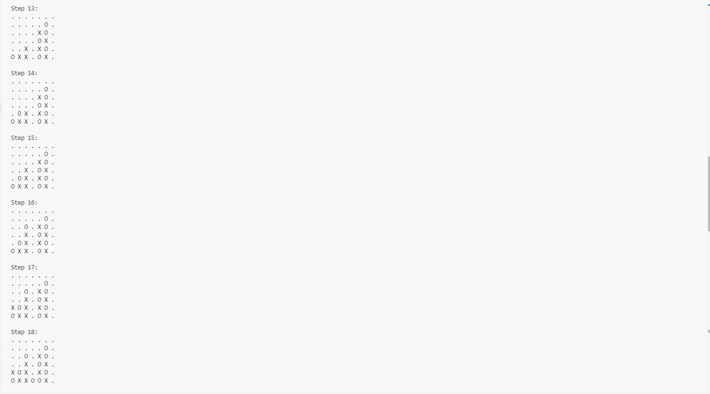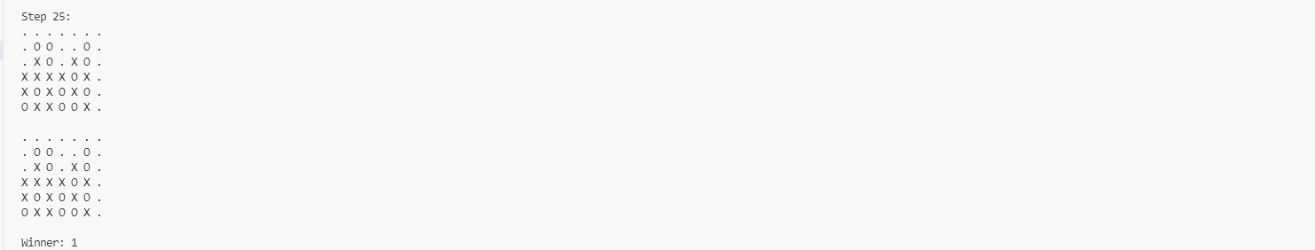This shows the AI’s decision-making at each turn, allowing users to observe how the board evolves.
Evaluation
The algorithm runs successfully, printing the final board and identifying the winner. Multiple runs have verified that MCTS selects reasonable moves and avoids illegal actions. Tests for game logic (horizontal/vertical/diagonal win conditions) passed successfully.
Conclusion
This implementation satisfies the core requirement of building a working Monte Carlo Tree Search for Connect-4. It correctly executes the MCTS phases, manages the game loop, and produces valid output. The modular structure allows easy reuse of MCTS for other games like Tic-Tac-Toe.
Optional extensions (such as human-AI play or GUI) can be integrated based on this functional foundation.

