Garden State JUG Brings Students into the Fold

The Garden State Java User Group (GSJUG) is the reshaping of a user group formed by Mike Redlich in 2001. Since the group's revamp in 2020, the JUG has held 40 meetings, including 22 meetings featuring Java Champions. We meet monthly in the Dorothy Young Center for the Arts at Drew University in Madison, New Jersey, US. The university provides this space free of charge.

With two Drew faculty members on the group's leadership team, GSJUG has strong ties with the university. Drew's liberal arts college has an enrollment of about 1700 undergraduate students, roughly 85 of them majoring in Computer Science or Cybersecurity. Since we meet on campus, Drew's students have easy access to each of our meetings. Professors in Computer Science and Cybersecurity courses encourage all students to attend.

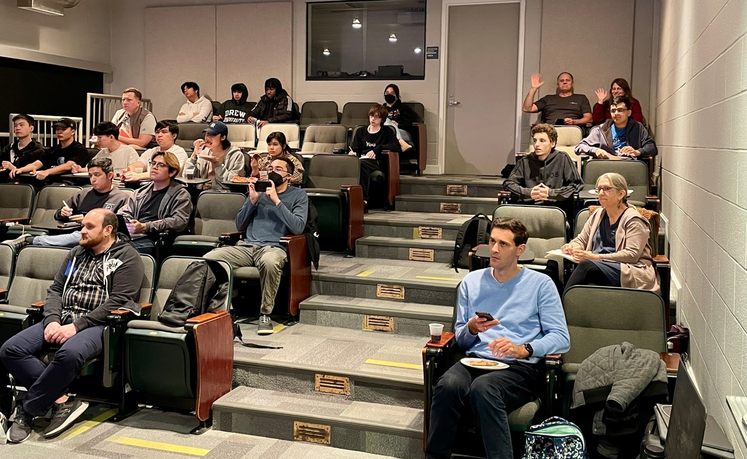

**Attendees at a recent GSJUG meeting.**

One problem we've had to address is the difference in background between the students and the professional developers who attend our meetings. Students typically have much less exposure to enterprise-level issues. Most of our speakers are ready to assume that attendees know the tricks and potential pitfalls of large-scale project deployment. Our juniors and seniors

may have some understanding of these issues through project-based courses and internships, but the beginning students have no prior knowledge. To achieve the right balance, we ask each of our speakers to begin with background material for undergraduates. For example, instead of leaping into the newest changes in Spring Boot, speakers start with a ten-minute introduction to the problems that Spring Boot solves, and the way Spring Boot solves these problems.

Every year, we set aside one monthly meeting to feature lightning talks by college students. The students show off their new-found technical skills and get practice speaking in public. These meetings are very well-attended because the students who speak invite their friends to come along. We don't pre-screen the talks. (Students who volunteer to speak are naturally good presenters.) Last year's lightning talks centered on the metaverse, edge computing, and jsoup for MongoDB. Like all of the JUG's events, these meetings are live-streamed.

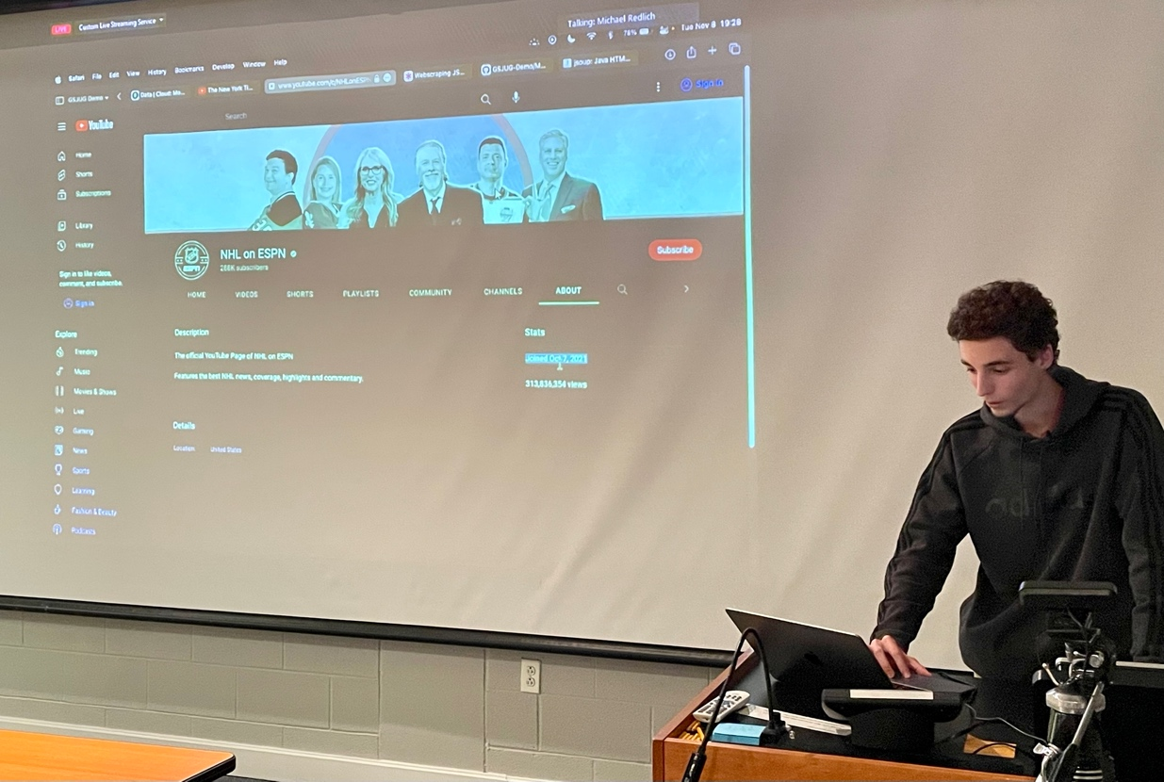

**Drew University student Ryan Kulyassa gives a lightning talk.**

Drew University has many alums who have found jobs doing Java development. For future meetings, we plan to invite some of these alums to give talks about their work.

The Garden State JUG also does outreach to local high school students. A computer science teacher at Madison High School is on the JUG's board of advisors. From time to time, members of GSJUG's leadership team visit the high school to give talks on Java and other topics of interest to students in the school's programming club and programming courses. We always keep these presentations lively and interactive. We come with a few slides, but we spend most of the time answering the students' questions. We actively seek feedback from the students at the meeting. What kinds of computing do they find most interesting? What has been their experience learning Java? What concerns do they have about careers in computing? We end each session with answers to some questions that the high school teacher prepared beforehand.

The next step for GSJUG is to expand the reach of its education programs. Two other universities — Fairleigh Dickinson and Saint Elizabeth's — are within two miles of Drew's campus, and another town's high school is only three miles away. We want to work with students from each of these institutions.

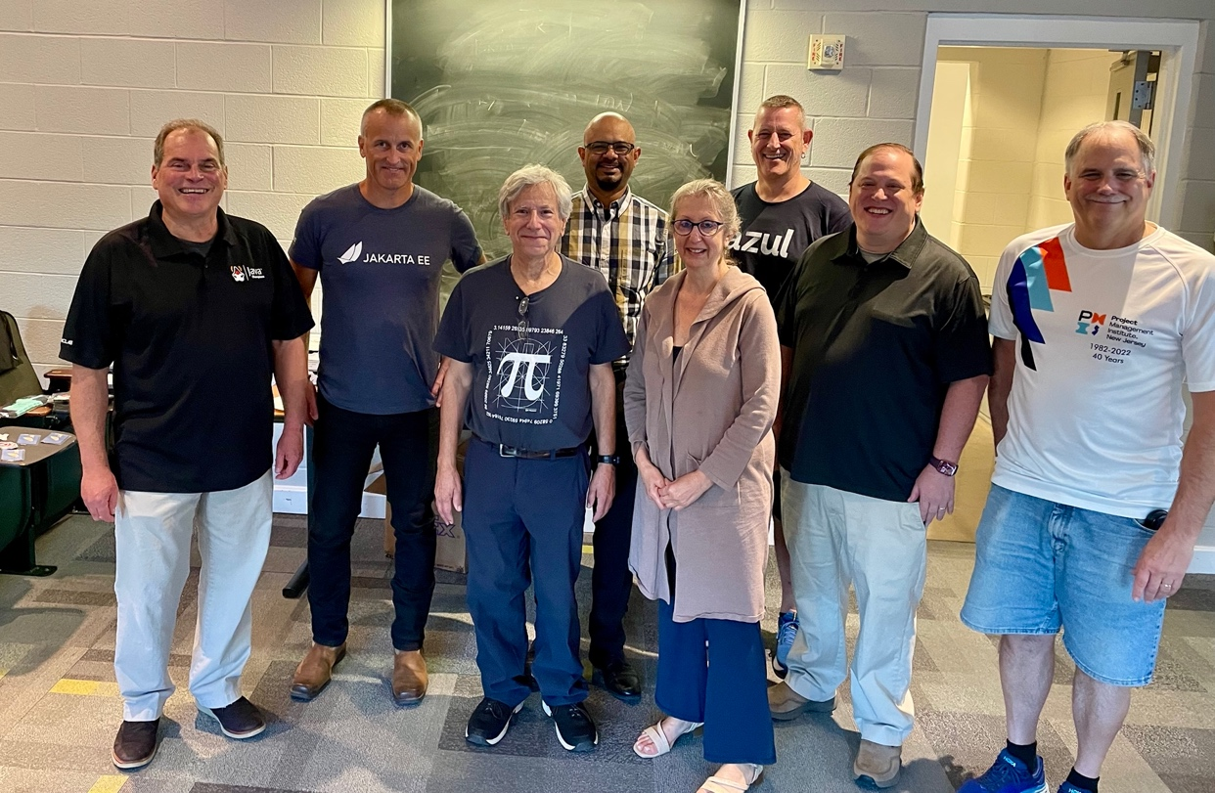

**Some GSJUG leaders with speakers Gerrit Grunwald and Ivar Grimstad.**