iD2 Cryptographic Library
Technical Description

Version 2.0

iD2 Technologies

© 1998 iD2 Technologies.
Copying of this documentation or accompanying software is forbidden, according to copyright laws, without the express written consent of iD2 Technologies.
Information in this document is subject to change without notice and does not represent a commitment on the part of iD2 Technologies.
Unless otherwise noted, all names of companies, products, street addresses and persons contained herein are part of a completely fictitious scenario and are designed solely to document the use of iD2 Cryptographic Library.
Windows NT is a trademark of Microsoft Corporation in the USA and other countries.



May 15th, 1998

Contents
Introduction 1
References 1
Environment 1
iD2 Cryptographic Library 2
Functions 2
User’s view 2
Administration Utility 2
Program folder 2
iD2 Smart Card Server 2
Programmer’s view 3
Functions and mechanisms 3
Interoperability 4
Supported Smart Cards and readers 6
Integration with Netscape Communicator 7
Installing 7
SSL client authentication 7
Sending signed e-mail with Netscape Messenger 8
Receiving signed e-mail with Netscape Messenger 8
Sending encrypted e-mail with Netscape Messenger 8
Receiving encrypted e-mail with Netscape Messenger 8
Installation 9
User’s view 9
Install Shield – Media 9
Installation – user options 9
Program folder 10
Files and file folders 10
Configuration file 10
Programmer’s view 11
Customization the "custom" folder 11
Uninstall 13
Documentation and help 15
User’s Guide 15
Contents 15
Program folder 15
Readme 15
System Developers Kit 15
Help 16

Introduction
iD2 Cryptographic Library is an application development tool, designed by iD2 Technologies, that integrates tokens into security-enabled applications. This document describes version 2.0 of iD2 Cryptographic Library. The following topics are covered:
- functional overview of the product
- the product from an end-user perspective (“User’s view”)
- how the product may be used and customized by an integrator, i.e., an OEM customer (“Programmer’s view”)
- how iD2 Cryptographic Library may be integrated with Netscape Communicator
- he installation procedure for iD2 Cryptographic Library
- available documentation and help functions.
To provide feedback about our products or to suggest product enhancements, please, send an email to feedback@iD2Tech.com.

References

Ref | Document | Date
[1] | PKCS #11: Cryptographic Token Interface Standard. An RSA Laboratories Technical Note, v2.01 | 1997-12-22

Environment
This version of iD2 Cryptographic Library works in Windows NT 4.0 and Windows 95.

iD2 Cryptographic Library

Functions
The product iD2 Cryptographic Library contains basic cryptographic algorithms and a Card Service Layer which supports different kinds tokens, i.e., various Smart Card readers and Virtual Smart Cards.
The interface to iD2 Cryptographic Library is compatible with Cryptoki (PKCS #11 version v2.01) and implements a subset of the API as defined in ref. [1]. It supports both hardware and software tokens.
iD2 Cryptographic Library is noticed by the end-user mainly through the Administration Utility.

User’s view

Administration Utility
The Administration Utility is used to configure Smart Card readers and Virtual Smart Cards. The Administration Utility is fully described in the “Guide to iD2 Cryptographic Library”.
In short the following functions are included:
- setting of Smart Card reader type
- COM port configuration
- setting of Virtual Smart Card file location, i.e. the file that contains the private keys and certificates.
- changing of PIN code

Program folder
The Administration Utility is started with the Administration Utility icon in the iD2 Cryptographic Library program folder.

iD2 Smart Card Server
The Smart Card support of iD2 Cryptographic Library is run as a service. The service is called ”iD2 Smart Card Server” in Windows NT and ‘iD2scaps’ in Windows 95. Being a service, it is found in Windows 95 by command CTRL + ALT + DEL and in Windows NT in the Control Panel/Services folder.

Programmer’s view
The architecture of iD2 Cryptographic Library:

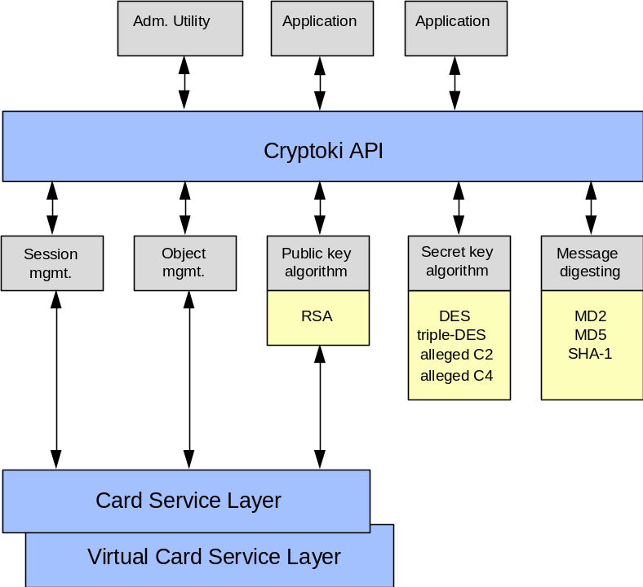

The Card Service Layer is an internal interface. Its purpose is to provide a general interface to Smart Cards and readers and thereby hiding the specific details of the Smart Card operating systems and reader devices.
The Virtual Card Service Layer uses a file to store the users' RSA key pairs. The private RSA key is encrypted before it is stored in the file. In the future, it will be possible to handle different key storage file formats, but currently, there is only one format defined. This format is called PSE, i.e., Private Security Environment file.

Functions and mechanisms
iD2 Cryptographic Library supports the functions specified in PKCS #11 version 2.01, ( see ref. [1]), with the exceptions stated in section "Interoperability" on page 4.
The mechanisms available for a Crypto token are:
CKM_RSA_PKCS_KEY_PAIR_GEN | PKCS #1 RSA key pair generation
CKM_RSA_PKCS | PKCS #1 RSA
CKM_RC2_KEY_GEN | RC2 key generation
CKM_RC2_CBC | RC2 CBC block encryption
CKM_RC4_KEY_GEN | RC4 key generation
CKM_RC4 | RC4 stream encryption
CKM_DES_KEY_GEN | DES key generation
CKM_DES_CBC | DES CBC block encryption
CKM_DES3_KEY_GEN | Triple-DES key generation
CKM_DES3_CBC | Triple-DES CBC block encryption
CKM_MD2 | MD2 message digest algorithm
CKM_MD5 | MD5 message digest algorithm
CKM_SHA_1 | SHA-1 message digest algorithm
For a Smart Card Token and a Virtual Smart Card Token the following mechanisms are available:
CKM_RSA_PKCS_KEY_PAIR_GEN | PKCS #1 RSA key pair generation
CKM_RSA_PKCS | PKCS #1 RSA

Interoperability
The PKCS #11 v2.01 specification is the complete documentation of the API implemented by iD2 Cryptographic Library. This document only describes exceptions from PKCS #11.

C_Initialize()
Supports pInitArgs == NULL_PTR or choice 2, all functions pointer have the value NULL_PTR. CryptoKi will always assume multithread access and will handle it.

C_GetSlotList()
Each physical Smart Card token will be shown as two virtual tokens to allow multiple PIN codes on a Smart Card. If only one PIN is available, then the second slot will be empty.

C_GetMechanismList()
The available mechanisms are stated in the previous section.

C_InitToken()
Not implemented.

C_InitPIN()
CKU_SO is not supported, so this function can not be accessed.

C_CloseSession()
The token is not automatically logged out if the last session is closed and the state is logged in.

C_CloseAllSessions()
The token is not automatically logged out if the state is logged in.

C_GetSessionInfo()
The ulDeviceError field is used for remaining PIN attempts.

C_GetOperationState()
Not implemented.

C_SetOperationState()
Not implemented.

C_Login()
Only CKU_USER is supported.

C_CreateObject()
According to specification, but it's only possible to create the following objects:
- Data objects
- X.509 Certificate objects
- RSA public key objects
- RSA private key objects
- RC2 secret key objects
- RC4 secret key objects
- DES secret key objects
- DES3 secret key objects

C_DestroyObject()
It is not possible to destroy the objects of other sessions. Destroying an object on a Virtual Smart Card will destroy all the other corresponding objects. E.g., if you destroy a public key then the private key and the certificate will also be destroyed. Destroying of Smart Card objects is not implemented.

C_GetObjectSize()
Not implemented.

C_SetAttributeValue()
If an attempt is made ot change multiple attributes at the same time and one (or more) of these attributes cannot be changed, then the operation will be aborted as soon as the first attribute fails. As a result, some attributes may be changed even if the function fails.

C_FindObjectsInit()
A return value is added: CKR_TEMPLATE_INCONSISTENT

C_SignUpdate()
Not implemented.

C_SignFinal()
Not implemented.

C_VerifyUpdate()
Not implemented.

C_VerifyFinal()
Not implemented.

C_DigestEncryptUpdate()
Not implemented.

C_DecryptDigestUpdate()
Not implemented.

C_SignEncryptUpdate()
Not implemented.

C_DecryptVerifyUpdate()
Not implemented.

C_DeriveKey()
Not implemented.

C_GenerateKeyPair()
Calling CKM_RSA_PKCS_KEY_PAIR_GEN for a Smart Card token will ONLY get handle to the public and private key on the Smart Card. As a result, you are able to create new certificates for a Smart Card from Netscape Communicator.
CKM_RSA_PKCS_KEY_PAIR_GEN for a Virtual Smart Card token works as expected.

C_UnblockPIN()
This function is not member of the PKCS #11 v2.01 specification. It can be used to unblock a locked PIN.
CK_RV C_UnblockPIN(
CK_SESSION_HANDLE hSession,
CK_CHAR_PTR pPin,
CK_ULONG ulPinLen,
CK_CHAR_PTR pPuk,
CK_ULONG ulPukLen );
hSession is an ordinary session handle. pPIN should point to a buffer containing the PIN. It's depending on the token whether this should be the old PIN or a new PIN. pPUK is a pointer to the unblocking code.

Supported Smart Cards and readers
The supported Smart Cards and Smart Card Readers are found in the README file. Note that iD2 Cryptographic Library has support for PC/SC, and thus will support most future Smart Card readers.

Integration with Netscape Communicator

Installing
iD2 Cryptographic Library is added to Netscape Communicator version 4.03 or later in the same way as any PKCS #11 version 2.01 module.
- Start Communicator.
- Select Communicator | Security info.
- Click "Cryptographic Modules".
- Click the Add button.
- Type Security Module Name, e.g., “iD2 Cryptographic Library”.
- Specify the location of file “%system%\id2cbox.dll”, e.g., “c:\winnt\system32\id2cbox.dll”.
- Click the Cancel button in the Password Entry Dialog. (You will get this dialog once for each token that is present.)
- Select “iD2 Cryptographic Library” or the name you have chosen.
- Click the View/Edit button.
- Select “Crypto Token” and click Config.
- Turn on all functions for the enabled token and click OK.
- Select next item in the list box and click Config.
- Mark only “Publicly-readable certs” and click OK.
- Repeat steps 12-13 until all items are configured.
- Click OK to exit “Edit Security Module”.
- Click OK to exit "Cryptographic Modules".
- Select Communicator | Security info again and click "Certificates" and you will see the certificates of your tokens.

SSL client authentication
When you communicate with a server that requests client authentication during the SSL negotiation, you will be able to select which certificate to use. For client authentication you should select a certificate with the name xxx:Authentication.
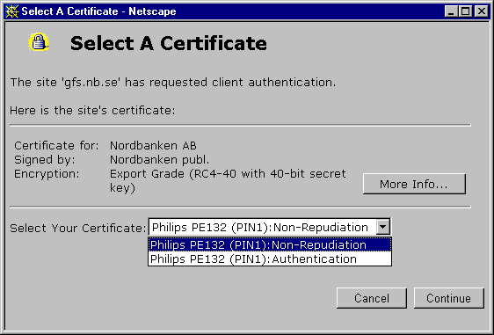

Sending signed e-mail with Netscape Messenger
To send a signed e-mail, you start creating a new message as usual. Select Communicator | Security info again and click "Messenger". You must select which certificate to use for signing. Available certificates are those containing an e-mail address.
At this stage, Messenger allows you to choose between all available certificates. Later, when the key usage for the certificate is checked, your choice has to be a certificate for non-repudiation. Therefore, you should choose one of the certificates with the name xxx:Non-Repudiation.
Click Send and, if requested, type your PIN code. The PIN is only necessary the first time.

Receiving signed e-mail with Netscape Messenger
If Messenger does not already have the CA certificate of an incoming e-mail in its certificate store, it will add it without any notice. When looking at the security info of the e-mail, the signature will indicated as invalid. The reason is that Messenger only adds the CA certificate and you must edit it yourself to tell that the CA certificate should be trusted. The received user certificate is automatically added to “People Certificates”, which means that you now can send encrypted mail in response to this person.

Sending encrypted e-mail with Netscape Messenger
Create a new message as usual. You will need the e-mail certificate for that specific e-mail address you will be sending to. You may either get it from a signed e-mail that has been sent to you or you have to search for it in a directory. The encrypted e-mail can only be read by you and by the receiver.

Receiving encrypted e-mail with Netscape Messenger
Open the e-mail. You will not be able to read the encrypted message if the correct token is not present. If the token is present, you may be requested to type your PIN code. The PIN is only necessary the first time. If the token is not present, the e-mail cannot be read since no decryption can take place.

Installation
iD2 Cryptographic Library is installed using a standard Install Shield setup procedure. The installation is meant to be self-explanatory. If details on the different installation steps are required, they can be found in the “Guide to iD2 Cryptographic Library”.
The installation may be customized prior to distribution of the end-user product. How this is done is described in the section "Programmer’s view" on page 11.
Note The user installing iD2 Cryptographic Library must have the permission to install the iD2 Smart Card Server, i.e., in Windows NT he/she must have administrator privileges.

User’s view

Install Shield – Media
iD2 Cryptographic Library installation is available in two different formats, on diskettes or in a “setupex”-file, called SetupiD2CryptographicLibrary.exe. Both formats are created through standard Install Shield procedures.

Diskette
The diskette installation of iD2 Cryptographic Library consists of different files on (currently) two diskettes. Pre-installation information may be found in the README.HTM file on the first diskette. The installation is started through the setup.exe file.

Package for the Web
The other available format is the SetupiD2CryptographicLibrary.exe file. This version is only a “package” of the installation diskettes, where the diskette files have been “compressed” into one single file.
This installation format is preferably used when distributing the product via the web.
To the end-user, this installation format will differ from the diskette installation in one way only. When the file SetupiD2CryptographicLibrary.exe is started, it self-extracts and displays an extra information message.

Installation – user options
During the installation, the user may specify a number of options. Customizing the installation may change some options, and some may be hidden to the end-user. The options are:
- whether or not to install documentation and help
- to name the program folder
- to name of file folder
Further details on these options are found in the following sections and in the “Guide to iD2 Cryptographic Library”.

Program folder
The installation procedure creates a program folder with the default name iD2 Cryptographic Library. This folder may contain the following icons (depending on choices made during the installation):
- Administration Utility
- Guide to iD2 Cryptographic Library

Files and file folders
The various files of iD2 Cryptographic Library are installed in two different file folders, the system file folder (i.e., c:/winnt/system32 in Windows NT and c:/Windows/System in Windows 95) and a program file folder (i.e., c:/Program Files/iD2 with subfolder iD2CryptographicLibrary).
The name of the program file folder may be changed during the installation procedure. The folder contains a number of subfolders for the various components. These may vary depending on choices made during the installation.
The names of the individual files may be found in the README file.

Configuration file
Configuration of the different components is made by parameters in two configuration files. The first file is located in the Windows system directory. This file, id2.ini, is created during the installation procedure. It contains information on how to retrieve the second configuration file.
The second configuration file, id2cbox.ini, is installed in the iD2/CryptographicLibrary program library. This file contains configuration data for installed Smart Card readers etc .
Example of an iD2 Cryptographic Library configuration file, with an ActivCard Smart Card reader installed on port COM2.
[Slot0]
CardTypeId=0
PinId=1
ReaderId=2
Setting=COM2:
Description= Smart Card Slot (PIN1)
Visible=1
[Slot1]
CardTypeId=0
PinId=2
ReaderId=2
Setting=COM2:
Description= Smart Card Slot (PIN2)
Visible=0
[CryptoBox]
Path=C:\Program Files\iD2\Cryptographic Library
ProductName=iD2 Cryptographic Library
InstallDate=5-12-1998
ProductVersion=v2.0
CustMin=0
[CardType0]
Name=Card Reader
Description=Card Reader is the token type for smart cards.
Type=1
[CardType1]
Name=Virtual Smart Card
Description=Virtual Smart Card is the token type for virtual smart cards.
Type=2
[Reader0]
Name=Philips PE112
Type=1
[Reader1]
Name=Philips PE122
Type=1
[Reader2]
Name=ActivCard ACTR-01
Type=1
[TokenType0]
Name=Universal token
ReaderId0=0
ReaderId1=1
ReaderId2=2
CardType0=0
CardType1=1

This file contains allowed card (“CardTypex”) and card reader (Readerx) settings along with the current settings for the local machine (Slot0 and Slot1).
The settings Slot1000 and TokenType0 are iD2 Cryptographic Library internal settings.

Programmer’s view
The installation may be customized prior to distributing the product.

Customization the "custom" folder
The first installation diskette contains a folder named “custom”. A number of different files that can be placed here will affect the behaviour of the installation procedure. The installation procedure will scan this folder for a number of files as specified below. The reserved size for files in this folder is 50 kB.

default.ini
The custom folder may contain a file called default.ini. This file may contain the following installation options:
- which slot to use (i.e., which card reader type on which COM port)
- minimum number of characters in the PIN code.
Example of a default.ini file:

[CryptographicLibrary]
; CardTypeId=0 ;for smart card.
; CardTypeId=1 ;for virtual smart card.
CardTypeId=0
; ReaderId=0 ; for Philips PE112.
; ReaderId=1 ; for Philips PE122.
; ReaderId=2 ; for ActivCard ACTR-01.
; ReaderId= ; for virtual smart card.
ReaderId=2
; Setting=COMx ; for smart card on port COMx.
; Setting= ; for virtual smart card.
Setting=COM2
; Description=Any text ; Text to be shown as a description for the default slot.
Description=Förvalt smart kort
; CustMin=x ; x should be between 2 and 8 and stands for min chars in PIN.
; ; The real value used will be min(max(CustMin, card.min), card.max).
CustMin=5

Key file
The file default.pse is installed as default key file if settings in default.ini define a Virtual Smart Card.
All the above files will normally be installed in the directory …/iD2/Certs.

Slot settings during installation
At least one slot is required. When a slot already exists, the installation procedure does not take any further actions. Otherwise, one slot is configured. The user is prompted with default values that may be change during the installation. When a PC/SC reader is installed, the configuration is automatic.

Setup parameters
The setup.exe program may be started with different parameters to affect the behaviour of the installation. This could be useful when starting the iD2 Cryptographic Library setup from other installation scripts. Available commands and switches are:
- setup –a0 ;perform a standard installation without displaying the “choose installation type” options to the user.
- setup –a1 ;perform a compact installation without displaying the “choose installation type” options to the user.
- setup –a2 ;perform a custom installation without displaying the “choose installation type” options to the user.
- setup –s; perform a customized OEM installation (see next section).

OEM installation
The installation procedure may be fully customized by starting the installation with the setup –s switch.
In this mode, the installation program uses the filename setup.iss to define how to proceed. With this file it is possible to hide dialog boxes, to set default installation parameters etc. A sample setup.iss file may be supplied by iD2 Technologies on request.
Any command line switches in the setup command will override setup.iss.

Installing a non-SDK version
Installation of a non-SDK version of iD2 Cryptographic Library can be accomplished through the above-described setup –s installation procedure.

Uninstall
iD2 Cryptographic Library can be uninstalled using the standard icon Add/Remove programs in the Control Panel. The name of the product is iD2 Cryptographic Library.
The uninstallation program removes all installed parts of iD2 Cryptographic Library. If you have installed multiple versions of iD2 Cryptographic Library on top of each other, the uninstallation program removes all of them.
If, for some reason, the uninstall procedure should fail, there are instructions in the README file on how to manually remove all files, registry settings etc. of iD2 Cryptographic Library.

Documentation and help

User’s Guide

Contents
iD2 Cryptographic Library is installed with an extensive on-line User’s Guide. It is HTML based, and may thus be read with your favourite browser.
The “Guide to iD2 Cryptographic Library” contains information on iD2 Cryptographic Library mainly from a user perspective. It has sections describing the installation procedure and the GUI in iD2 Cryptographic Library.

Program folder
The “Guide to iD2 Cryptographic Library” is found in the program folder iD2 Cryptographic Library.

Readme
Details and last minute information about iD2 Cryptographic Library are described in the README.HTML file. This file is found on the first installation diskette, but is also installed on your computer and may be found through the “Guide to iD2 Cryptographic Library”.

System Developers Kit
The SDK (System Developers Kit) consists of four parts; system documentation, include files, library file and sample code.
The SDK is installed (if specified in setup-parameters) in the program file folder …/iD2/Cryptographic Library/SDK. The following subfolders are created

Folder | Content
Document | This document
Include | Header files to be included in application
Library | Library file to be used when linking application
Samples | Sample code of iD2 Cryptographic Library usage

Help
iD2 Cryptographic Library includes on-line help functions for its end-user interface, i.e., the Administration Utility.

