iD2 WebSigner 2 for Funai TV Surfer
Technical Description

By iD2 Technologies

Copyright © iD2 Technologies 1998. All rights reserved.
Copying of this documentation or accompanying software is forbidden, according to copyright laws, without the express written consent of iD2 Technologies.
Information in this document is subject to change without notice and does not represent a commitment on the part of iD2 Technologies.
Unless otherwise noted, all names of companies, products, street addresses and persons contained herein are part of a completely fictitious scenario and are designed solely to document the use of iD2 WebSigner 2 for Funai TV Surfer.
Windows NT is a trademark of Microsoft Corporation in the USA and other countries.



August 14th, 1998

Contents
Introduction 1
Overview 1
Components 1
User’s view 3
Graphical User Interface 3
Signature panes 3
Programmer’s view 5
iD2 WebSigner parameters 5
Example of iD2 WebSigner activation 6
Formatting text in WSXDataToSign parameter 6
Error messages 9
Message descriptions 9
Glossary of Terms 11

Introduction

Overview
The iD2 WebSigner applet is activated by the HTML <APPLET> tag. iD2 WebSigner will display a text that the user will be asked to sign digitally. If the user accepts to sign the text, he types his PIN code and the signed text will be submitted to the web server.
iD2 WebSigner uses internal functions of the iD2 Cryptographic Library to achieve its signing capabilities. To generate signatures, the private key and its associated certificate, from iD2 Cryptographic Library, is used.
When iD2 WebSigner is activated, the text to be signed will be displayed in a signature pane. There are two different ways to display this signature pane, either in a separate dialog box or embedded in the HTML page. The user is asked for his PIN code. A correct PIN code will give access to the signing capabilities on the Smart Card. The Smart Card will compute the digital signature. If the PIN code is incorrect, the user will be notified by an error message. If the Smart Card is not present during the signing procedure, this situation will be detected when the iD2 WebSigner applet tries to access the Smart Card, and the user will be notified by an error message.

Components
The following components are contained in iD2 WebSigner for Funai TV Surfer:
- The iD2 WebSigner applet, named WebSignerApplet.
- iD2 Cryptographic Library 2.0

User’s view

Graphical User Interface
The interface between iD2 WebSigner and the user is the signature pane.
When iD2 WebSigner is activated the user will see the signature pane that may occur in two variants named “normal view” and “hidden view”. The normal view consists of a text area displaying the text to be signed, an input field for the PIN code and one or two control buttons. The hidden view displays a View button instead of the text area. The user may sign without seeing the data. If the user wants to see the data before signing, he can click the View button. The data will then be displayed in a separate dialog box.
In normal view, when the signature pane is displayed in a dialog box, there will be two control buttons, OK and Cancel. If the signature pane is embedded in the HTML page, there will only be one button, i.e., the OK button. To cancel, instead of signing, the user can chose any other URL to leave the current location.
In addition, the signature pane will also display the destination’s URL. To the user, this URL indicates which destination the signed text will be sent to.
The user checks the data and the destination before signing. To sign, the PIN code is entered and the OK button is clicked.
Problems that may occur are indicated by error messages (see “Error messages” on page 9).

Signature panes
The signature pane will appear in different design depending on the parameters in the APPLET tag (see “iD2 WebSigner parameters” on page 5).
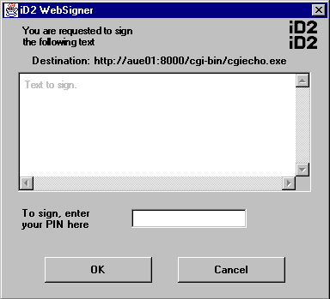
Signature pane displayed as a dialog box when parameter WSXView = “ShowData”. The text to sign is visible but gray in the text area and thus the user cannot change it.
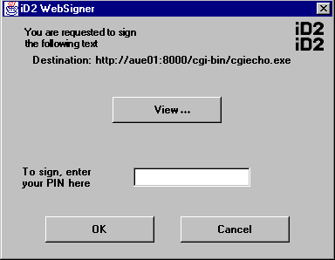
Signature pane when parameter WSXView = “HideData”
If the View button is clicked the following dialog box will appear displaying the text to sign in a separate dialog box.
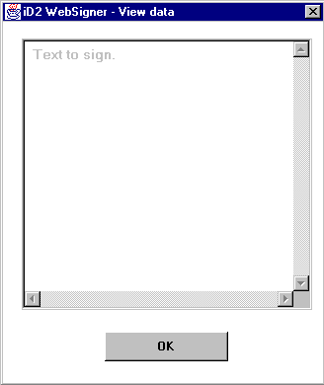
The text to sign is visible but gray in the text area and thus the user cannot change it. When the text has been controlled, the user clicks OK to return to the previous dialog box where the signing takes place.

Programmer’s view
The iD2 WebSigner applet is activated through an applet tag. Parameters to iD2 WebSigner are passed as PARAM in that tag. An example of this is given in “Example of iD2 WebSigner activation” on page 6.

iD2 WebSigner parameters
The following parameters can be passed to iD2 WebSigner:
- WSXName defines the name of the HTML form field, which will contain the data, that iD2 WebSigner posts. WSXName is optional and if not present the default is “SignedData”.
- WSXSrc is the current file or link to the data to be signed. This parameter is ignored if WSXDataToSign is defined. For this to work, the applet must be allowed to open URLs relative to the document base. The document base is the URL from which the page was loaded.
- WSXAction defines the absolute URL of the destination to which iD2 WebSigner will post the signed data. WSXAction is mandatory and if not present, an error message will be shown.
- WSXFormat defines the format of the output data, currently only the PKCS#7 signed-data content type format is supported. After its creation, the signature will be URL-encoded in order to allow it to be sent as a WWW form element. The value “PKCS#7SIGNED” specifies this format. This parameter is optional and if omitted, the default will be “PKCS#7SIGNED”.
- WSXDataToSign is used to specify the data to be signed. If not present the iD2 WebSigner applet will use the data specified by WSXSrc. In order for the new line character to work correctly the data to be signed must be sent URL-encoded (see Formatting text in WSXDataToSign parameter). iD2 WebSigner will decode the message and display it in the signature pane. The message to be signed is always the one shown in the signature pane.
- WSXDataReturnName: If the data to be signed, as defined by WSXDataToSign or WSXSrc, is to be included in the HTML form posted by iD2 WebSigner, the name of the variable holding this unsigned data should be specified by this parameter. WSXDataReturnName is optional and if not present iD2 WebSigner will not post the unsigned data.
- WSXBase64: If the signature is to be base64 encoded before it is URL-encoded this parameter is set to “YES”. WSXBase64 is optional, if omitted or set to ”NO”, no base64 encoding is performed.
- WSXCustomImage: This parameter defines a custom URL, absolute or relative, pointing at a picture file to be displayed in the iD2 WebSigner applet. Supported formats are .jpg and .gif. If this parameter is omitted no picture is displayed. The OK button is disabled until the whole file has been downloaded.
- WSXType: This parameter defines the appearance of the WebSigner applet on the screen. If the value is “BUTTON”, a button will appear within the HTML page. When this button is clicked, a dialog containing iD2 WebSigner will pop up. If the value is “AUTOMATIC” the dialog with iD2 WebSigner will pop up when loading the HTML page. The third option is “INSERTED” in which iD2 WebSigner appears embedded in the HTML page. The default type is “BUTTON”.
- WSXView determines which of the two signature panes that iD2 WebSigner should display. The value “HideData” causes iD2 WebSigner to activate the “hidden view” where the data to be signed is shown in a separate dialog box when the View button is clicked. The default value is “ShowData” by which the data to be signed is presented in a text area directly in iD2 WebSigner.

Example of iD2 WebSigner activation

signdata.html
<html>
<META HTTP-EQUIV="Cache-Control" CONTENT="no cache">
<META HTTP-EQUIV="Pragma" CONTENT="no cache">
<head>
<title>
iD2 WebSigner
</title>
</head>
<body>
<APPLET CODE="com.id2tech.nc.WebSignerApplet.class"
WIDTH=120 HEIGHT=50>
<PARAM NAME=WSXSrc VALUE=”DataToSign.txt”>
<PARAM NAME=WSXAction VALUE="http://www.id2tech.com/cgi/script1.exe">
</APPLET>
</body>
</html>

Comments
The following rows are necessary to avoid cashing problems:
<META HTTP-EQUIV="Cache-Control" CONTENT="no cache">
<META HTTP-EQUIV="Pragma" CONTENT="no cache">

DataToSign.txt
Text in DataToSign.txt.

Comments
The contents “Text in DataToSign.txt.” will be signed by iD2 WebSigner. The file DataToSign.txt should be placed in the same directory as the HTML page.

Formatting text in WSXDataToSign parameter
iD2 WebSigner does not accept all characters in the WSXDataToSign parameter and must be URL-encoded. The table shows the allowed characters and the URL-encoding of these characters.

Characters | Encoding
0x0D (carriage return) | %0d
0x0A (line feed) | %0a
0x09 (tab) | %09
0x20 (space) | +
0x21-0x24 (standard ASCII characters) | The characters themselves
0x25 (%) | %25
0x26-0x2a (standard ASCII characters) | The characters themselves
0x2b (+) | %2b
0x2c-0x7E (standard ASCII character) | The characters themselves
0xA0-0xFF (character set dependent) | %XX, where XX is the hex code for the character

If WSXDataToSign="hello%0d%0aworld+earth" the printed text would be formatted as:

hello
world earth

Error messages

Message descriptions
“Incorrect PIN”
Reason: The entered PIN code does not correspond with the PIN code associated with the certificate on the Smart Card.
Action: Enter the correct PIN code.

“Internal program error code XX”
Reason: This message indicates some kind of program error in WebSigner or the functions called by WebSigner.
Action: Contact your support organization.

“No signature certificate found. Smart Card invalid or missing”
Reason: This message indicates that there is a problem with data on the card or that the card has not been inserted in the card reader.
Action: Make sure that the correct Smart Card has been inserted. Try again. If the problem remains the card may be invalid.

“Signature key not found. Smart Card has been removed or replaced”
Reason: This message may occur if the Smart Card is removed during the signing procedure.
Action: Insert the card in a proper way and repeat the action.

“The destination URL is invalid. iD2 WebSigner is not able to send data to the destination”
Reason: The URL must be defined by a parameter (WSXAction) in the HTML page. This error message indicates that the parameter does not apply to the rules for URLs or that it is missing. A valid parmeter should have the following format:
protocol://domain[:port]/[file]
Action: Contact the support organization responsible for the web.

Glossary of Terms

digital signature
The digital signature scheme used in iD2 WebSigner 2 is the based on the RSA algorithm.

document base
The document base is the URL from which the current page was loaded.

hidden view
The data to be signed is not displayed in a text area of the signature pane. A View button may be used to display the data in a separate dialog box.

normal view
The data to be signed is displayed in a text area of the signature pane.

post
The act of sending the HTML forms to the destination URL.

signature pane
The part of the application window used by WebSigner.

text area
The part of the signature pane in which the text to be signed is presented.

