OUR TOWN

Programming Support Fall 2014

Copyright © 2014 EichelbergerB

Table of Contents

1. Brief Introduction
2. Basic Instructions
3. Basic Goal / Setting
4. EULA

1. Brief Introduction

Welcome to Our Town, a work of interactive fantasy in which you are the main character and an unanticipated guest. It's a quirky little place, with unexpected characters showing up all the time. Although it appears to nothing more than a quaint, outdated little rural town in the Midwest, appearances can be deceiving. Take nothing for granted as you wander the streets. Be careful when entering a building. Most residents don't care much for unexpected visitors. You will be your own guide

This game was created as an exercise for the Programming Support Class at Northeast Iowa Community College. It is similar in design and format to one of the earliest interactive fiction creations titled Zork. Commands are fairly straight forward. The plot and goal of this game is anything but straight forward! It is a work in progress. Nothing is ever truly finished here. Take everything with a grain of salt.

2. Basic Instructions

You (the main character) are located in the Town Square at the onset of the game. Your current location appears in the uppermost left corner of the screen, underneath are the available exits. The prompt (>) is waiting for your instruction in the form of a direction to move or a verbal command. Press the Enter key after entering your instruction.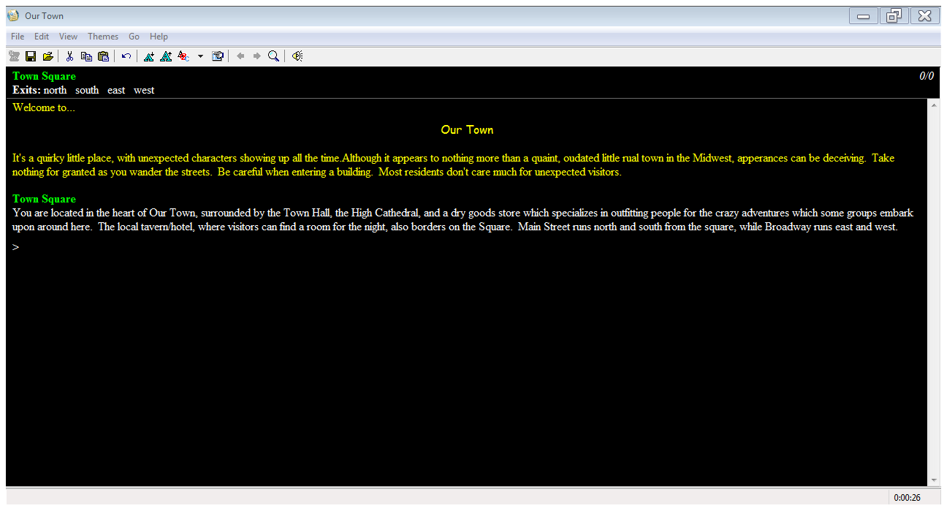

A. Moving Around

Moving around in the game involves entering very basic directions (Cardinal Directions) North, South, East, West and Up or Down at the command prompt. Acronyms may be used in place of the direction name as follows:  
 North: N  
 South: S  
 East: E  
 West: W

Northeast, Southeast, Southwest and Northwest (Primary InterCardinal Directions) may possibly be used.

B. Basic Commands

Basic commands involve the use of a verb in order to act upon an object, for example:

“take the ornate key”.

Examples of some basic command verbs are: take, drop, look, read, unlock, open…

As the player you can take it a step further by acting upon an object with an object, for example:

“unlock the gate with the ornate key”.

The “Quit” command allows you to leave the game.

Use your imagination; try anything, however, pay close attention to your surroundings.

C. Interaction with NPCs (Non Playing Characters)

Some NPC’s are conversational and can be spoken to and respond back. To speak to NPCs you can use:   
talk to, hello, ask about, give to, show to, or even, yes or no.

Other NPCs are invoked by the use of special verbs or spells. These are usually learned as game play progresses  
 

3. Basic Goal / Setting

The object of this game is to solve puzzles, attain points and avoid death while exploring Our Town. Keep in mind things are not so obvious as they appear, use your imagination.

4. EULA

(End User License Agreement)

Our Town is the sole property of Barry Eichelberger and the Programming Support Class of   
Northeast Iowa Community College. You merely get to use it. Limitations of Liabilities are non-existent (liabilities are potentially unlimited). No warranty or guarantees currently exist for Our Town, use it at your own risk.