Barry Keenan

Graphics Coursework
Contents

Introduction 2
The Scenegraph 3
Alternative Layout 4
Top Level Description of Person 5
Arm 7
Leg 8
Complete Scenegraph 9

Introduction

I have modelled an articulated manikin in Java3D. Probably the easiest way to describe the project is through a discussion of its scenegraph. A scenegraph is a hierarchical data structure used to hold all the objects, transformations and properties of a java3D program.
The scenegraph is made up of sub graphs – namely branch groups and transform groups. Attached to these sub graphs are the leaf nodes – namely Visual Objects and Animation Interpolators.
Branch groups provide a sensible way to hold collections of nodes. Transform groups have rotation, translation and scale properties that can be used to position any visual object attached to the group.
Examples of visual objects are spheres, cylinders, boxes, etc. These objects have attributes such as geometry and appearance that describe how they appear on the screen.
Interpolators point at a target transform group and adjust that transform group’s values, instead of them remaining static. This adjustment of values over time provides animation capabilities.
The Scenegraph

Here is a standard scenegraph representation of my project:

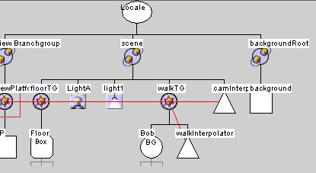

Immediately you can see the three top level branch groups – View Branchgroup, scene, and backgroundRoot.
The view branch group holds the standard view platform that must be included in the scene graph – or else nothing will be visible on the screen.
The background root holds the background object – I have used a large sphere as the background’s geometry and a sky image as the backgrounds texture.
Now we can move into the scene branch graph. You can see it has two lights attached. First, an ambient light that shines equally in all directions. Second, a directional light that shines over a particular area creating diffuse and specular highlights. I have given the directional light a slight yellow tint.
The floor is represented by a large shallow box with a grassy texture. It is not attached directly to the scene however; instead a transform group is attached and only then is the floor object is added. Inserting a transform group in this way allows objects to be rotated and placed exactly where you want them.
My animated character bob is an instance of the person class. Bob is added to the scene graph via the transform group walkTG. Adjusting the values of walkTG allows me to position Bob wherever I want in the scene.
I could then leave walkTG’s values as they are, but I want Bob to move along the floor. In order to make Bob move, we need to attach a Position Interpolator to the transform group. Note on the scene graph that walkInterpolator points at walkTG.
The last thing in the graph is another interpolator – camInterpolator that points at viewPlatformTG. This adjusts the position and rotation of the camera to give a more interesting view of Bob than if the camera remained static. Interpolators require Alpha objects to control their timing behaviour, but I will discuss this later.

Alternative Layout

With a lot of objects and branches, a scene graph can quickly become very wide. A more compact way of organising the scene graph’s nodes is in a circular fashion. The hierarchy works outwards from the root at centre, towards the leaves on the periphery.

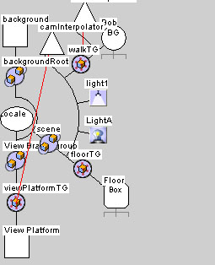

Currently the only node of note is Bob – an instance of my person class. The person class contains many nodes and sub graphs of its own. They are hidden here for clarity.
Top Level Description of Person

Now I’ll expand Bob so you can see the next level of nodes:

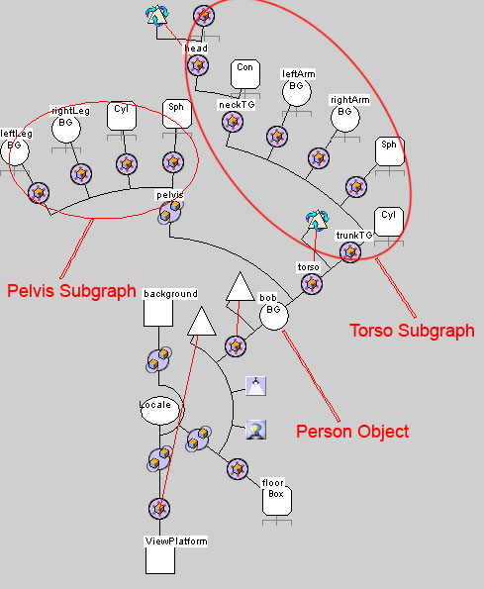

Bob has two main sub graphs – a torso transform group, and a pelvis branch group. Everything else is attached to these groups.
The pelvis is made up of a cylinder and a sphere. Both of these objects have an appearance – cordsAppearance. I have opted to store all my appearances such as, shirtAppearance, shoeAppearance, skinAppearance, etc. in one class. This helped me keep track of them and made it easier to re-use them among objects as needed.
You can see two legs are also attached to the pelvis. They are instances of my leg class. Both legs are essentially the same, so it made sense to write the code once, and re-use it twice.
The torso is slightly more complicated with two arms and a head. Again the arms are two instances of a single arm class. The torso also has a rotation interpolator attached to it. This gives the torso and shoulders a slight wobble as Bob walks along.
The final thing in the torso is the neck and head, let’s expand this node now:

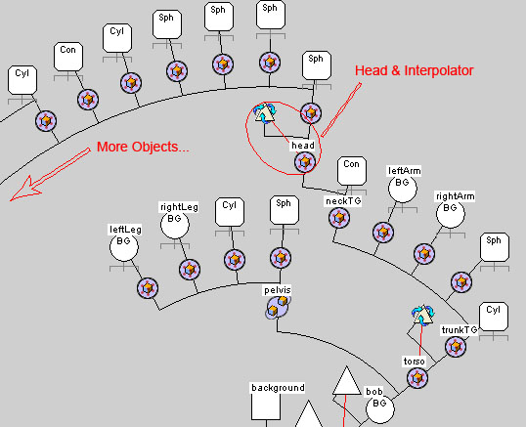

The head nods happily up and down with the aid of another interpolator. Lots of objects are used to make up the head, cone for the nose, cylinders for the glasses, spheres for the face and hair. The only interesting thing to mention here is the use of transparency for the glasses and sun visor.

Arm

The arm class has two articulated joints at the shoulder and elbow. The joints are spheres and the arm components are cylinders.

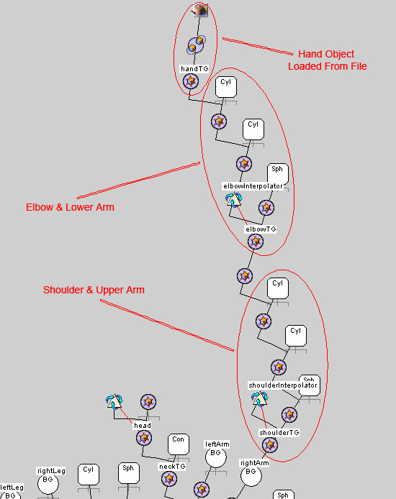

I have used a hand shape included with Sun’s Java3D examples. It has been created in a 3D drawing package such as 3DStudio Max and its geometry information is saved to a file. The file is loaded into the program and a Shape3D object is created from the geometry. This object can then be used like any other Java3D primitive.
Leg

The leg has three articulated joints – at the hip, knee and ankle. Again the joints are spheres and leg components are cylinders. The foot is similarly constructed from primitives.

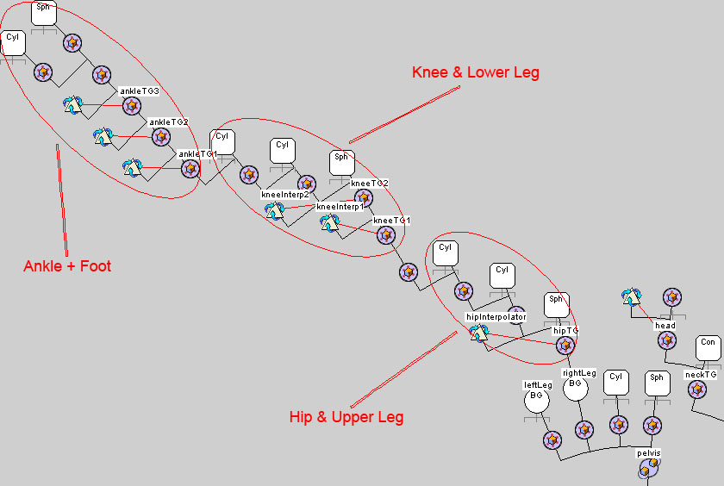

The hip simply has one interpolator. The angle of the upper leg is gradually changed from 29° to -12° but I don’t want the leg to move uniformly between these two angles. I have used an Alpha object that describes when I want the interpolator to reach its minimum and maximum values. In this case the alpha is essentially a graph of angle against time of the form y=x².
When walking the lower leg moves back slightly at first, and then flexes to a greater angle as the foot leaves the ground. To capture this behaviour the angle/time graph for the knee has two turning points, so two alpha objects are needed. Two pairs of interpolator and transform group are also required – one pair for each alpha.
Finally the movement of the foot is modelled. It has three movement phases, requiring three pairs of interpolator and transform group.
Complete Scenegraph

The following is the compete scenegraph of my project. The hierarchy goes down as far as the Visual Object level which I believe to be sufficient – This does not include each individual object’s Appearance and Geometry attributes.

