Balony – Instruction Manual

Contents

Introduction 2

Installation 3

System Requirements 3

Program Download and Installation 3

Features 4

Overview 4

Image Pane 5

# Introduction

I started writing Balony in the summer of 2009 because I was struggling to find software that I could use to analyze the plates from our SGA experiments. After looking at a few of the other options, I realized that the Particle Analyzer module of ImageJ would provide a useful base for the main function of the program – to measure the sizes of colonies on plates. The challenge was to find a way

# Installation

## System Requirements

In theory, any computer that can run Java 8 programs can run Balony. In practice, you’ll want something vaguely modern with at least 2 GB of memory. Installers for Windows and macOS are provided; for other platforms you can download the platform-independent .jar file and run this manually.

As hinted above, your system will need to have a version of Java 8 installed. You should be able to download the latest version from Oracle here: <https://www.java.com/en/download/>

You’ll also want to have a screen resolution of at least 1024x768. Anything less than this and you might be missing the bottom of the interface.

## Program Download and Installation

The latest stable version should be available for download from: <https://github.com/barrypyoung/balony/releases>

Save the appropriate file and run the installer. With any luck, a Balony icon should be available in the usual place in your operating system.

If this doesn’t work, as a last resort you can download the Balony.jar file instead. You should be able to run this by double clicking the icon, but if this doesn’t work, as an absolute last resort, you can use the following command:

java -Xmx2048m -jar Balony.jar

# Features

## Overview

The main Balony window consists of five separate tabbed panes, each of which represents a different step in the analysis of one or more images; with the exception of the final pane which contains miscellaneous options and settings. Briefly, these panes are:

1. SCAN: Initial preparation of image files, including steps such as separating composite images in to single plate images, file renaming, rotation and resizing.
2. IMAGE: Basic quantitation of individual plate images, including steps such as image thresholding, gridding, colony location and measurement
3. SCORING: Conversion of raw quantitation data into analysis files; maps array positions to definition files, normalizes colony sizes, correction of positional effects
4. ANALYSIS: Interrogation of scored data files, basic statistical analysis, sorting and filtering of data, defining hits, summarizing and comparing multiple screens, and more!
5. OPTIONS: Miscellaneous options related to the interface and software updating

## Image Pane

The purpose of this pane is to take an input file (or files) and process it to produce one or more output files. It is useful if multiple plates have been captured as a single image, such as if using a flatbed scanner. It also names the output files appropriately so that they can be correctly identified in the subsequent steps of analysis. It can also perform a few simple transformations to rotate or resize plates.

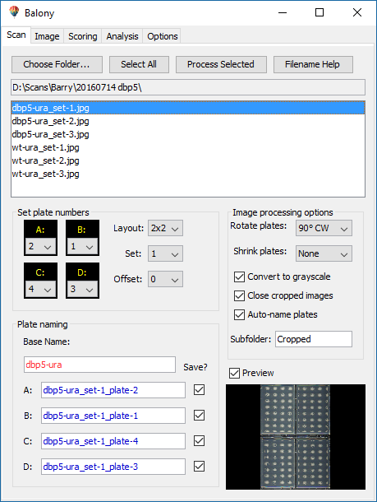

**5**

**6**

**4**

**3**

**2**

**1**

1. Opens the dialog box to choose the folder to scan for images.
2. Selects all the images in the current folder.
3. Process the selected images according to the settings below.
4. Displays a helpful guide to show how output images will be named based on the input image.
5. The currently selected folder
6. The list of image files in the currently selected folder
7. Composite image plate mapping: for images consisting of multiple plates, the “plate number” assigned to each plate will be according to the values selected for each position.
8. Enables the selection of different layouts for multiple plate images.
9. Set number for the current file. Will attempt to identify from file name.
10. Offset: this number will be added to the plate numbers defined in (7). Will also attempt to identify from the file name.
11. Base name for each output file. Set and plate numbers will be added automatically. Derived from the input file name but can be overridden manually.
12. Output file names, based on base name, file name mapping, set and offset. Can be manually overridden. Checkbox enables only specific plates to be saved.
13. Rotation of output images.
14. Optional resizing of output images.
15. Option to convert saved images to grayscale.
16. Automatically close files after processing.
17. Automatically create names for output files based on settings, mapping and input file.
18. Name of subfolder where output images are stored, relative to the input file’s folder.
19. Optional preview of the currently selected file.