BIOL435 Microbes and Disease 2016/2017

Barry Rowlingson (b.rowlingson@lancaster.ac.uk)

**Computer modelling of infectious diseases**

This workshop provides a brief introduction to various mathematical models commonly used to describe the transmission of infectious diseases. Some web pages have been created to allow you to run the models and see how the epidemics progress.

The text contains a series of questions which you should answer as you work through the examples. These questions form part of the assessed score for the module. At the end, hand in these notes. Further copies of this worksheet will be available on the Moodle page for the course.

You can ask the workshop tutors for help, but as this is assessed work the level of help might not extend to giving you the answers!

Total mark for the worksheet is 50.

Name:

# Getting Started

Log in to a PC and start a web browser. If Firefox or Chrome are available, use those, otherwise start Internet Explorer. Go to this web page:

http://barryrowlingson.github.io/epimodel or http://git.io/vDKkr

and you should see the following: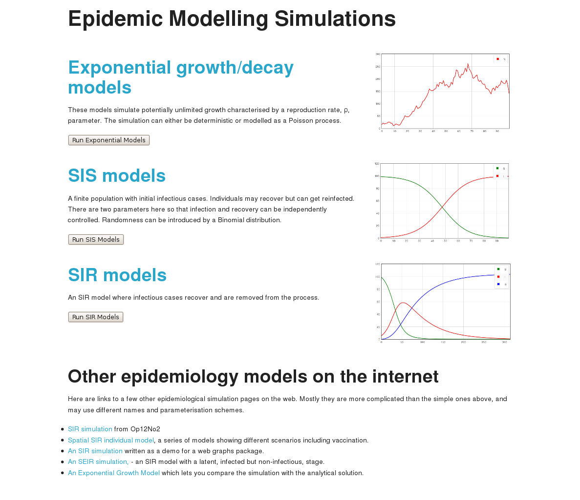

# Exponential Growth/Decay Models

Select the exponential models page:

All the model pages have controls for the parameters on the left, and plots on the right. 

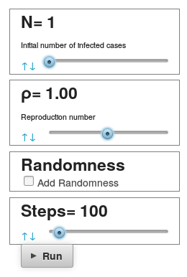

You can adjust the parameters by grabbing the indicator with your mouse or by clicking on the indicator, the blue up and down arrows, and using the arrow keys on your keyboard. After adjusting the parameters, the **Run** button will update the plot with the model. Cross-hairs on the plot will help you identify points on the curves and you can read off the locations of the cross-hairs under the plot.

With the parameters set like this, hit the **Run**   button.

What are N and ρ? [1 mark]

Why is the graph a flat line? [1 mark]

Now set **N to 10**, and **ρ to 1.01** – **use the arrows** for fine adjustments. Make sure “randomness” is not ticked. Set the number of steps to **100** and run the model.

How long does it take for the infected population to double in size from its initial value? [1 mark]

From that point, how long does it then take to double again? (You may need to increase the number of steps to 200) [1 mark]

Now set **ρ to 0.96** and **N to 128**. Run the simulation. You may need to change the number of steps and re-run to answer the following:

How long does it take for the population to halve? [1 mark]

How much further time to does it take to halve again? [1 mark]

Check the time it takes to halve once more and comment on this. [2 marks]

# SIS Models

## Deterministic Modelling

Go back to the model list page and choose the **SIS** model section.

For this section make sure the randomness box is not checked. Deterministic modelling is completely defined by the initial conditions.

In an SIS model (also sometimes called an SI model) the population is divided into two classes, susceptible and infected. Susceptible people become infected, and infected people can stop being infectious. Those people **can** then become **reinfected**. It is an appropriate model for **endemic** diseases. The degree of endemicity in a population can be **stable**, **increasing**, or **decreasing** depending on the infection and recovery parameters.

With the parameters unchanged (**S=100, I=10, α=0, β=0.001, Steps=100**) run the simulation.

Why do the two curves seem to mirror each other? [2 mark]

What happens to the number of infectious people, and why? [2 marks]

Here α is the rate that infected people become susceptible again. Raise it to **0.2** and re-run.

How does this endemic behaviour differ from the previous run? [2 marks]

Now raise β, the infection rate, to **0.005** and run.

Now what is the long-term state of the endemic? What fraction of the population are infected? [2 marks]

Now keeping **S=100, I=10 and α=0.2**, vary β and run.

What is the critical value of β that determines if the disease dies out or remains endemic in the population? [2 marks]

The formula for updating the number of susceptible cases is . The change in S is then .

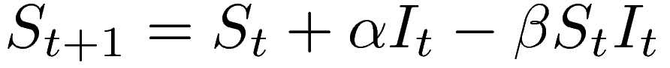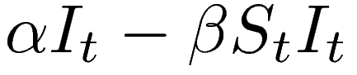

If S and I don't change from their initial values, and α is 0.2, what does that give for β? Does that compare to your value in the previous question? [3 marks]

## Stochastic Modelling

Set the SIS model parameters to **S=100, I=10, α=0.18, β=0.002, Steps=100**. Run the simulation. The epidemic should increase until it stabilises at 90 susceptibles and 20 infectious cases.

Now tick the “Add Randomness” box. With this selected, instead of an exact number of new infections occurring at each step, each susceptible person effectively tosses a weighted coin, and catches the infection if the coin turns up heads. Note that the coin is not a fair coin with an equal chance of heads or tails, but the chances of turning up heads depends on the number of infectious cases present and the β parameter. Similarly the chances of an infectious case clearing up and becoming susceptible again is decided by another weighted coin toss based on the α parameter.

Run the model about ten or twenty times with the random process.

Comment on the similarity to the deterministic process. [2 marks]

Sometimes 100 steps is not enough to see the full behaviour of a random process. **Increase the number of steps to 1000**.

Run the model ten times and write down the approximate time at which the epidemic dies out each time. Write “>1000” if the epidemic is still going at the end of the plot. [1 mark]

If you increased β, the rate of infection, would you expect the epidemics to die out more or less quickly? [2 marks]

Increase β to 0.004 and run ten times – record the number of simulations that are still going after 1000 steps. [1 mark]

# SIR Modelling

Go back to the model list and select the SIR model page. Run the model with the settings unchanged (**S=99, I=1, R=0, α=0, β=0.001, Steps=100**).

Why does the number of recovered people stay at zero? [1 mark]

Increase the α parameter to **0.04** and run the model. **Increase the number of steps** and re-run until you can see **how the model settles down**.

After how many steps does the number of infectious cases peak? [1 mark]

How many people are still susceptible at that point? [1 mark]

How many people remain uninfected by the end of the epidemic? [1 mark]

By varying **β** we can see the effect of changing the **infectivity** of an infected individual on the progress of an epidemic.

What measures might be used to reduce individual infectivity in a real-life situation? [3 marks]

Play with the **β** parameter from about **0.0007 to 0.004** and watch how the **infection peak** changes.

How does the time and level of peak intensity, and the duration of an epidemic change as β increases? [3 marks]

## Historical Example (based on a true story! http://www.eyamplaguevillage.co.uk/)

It is the summer of 1665. In a small village with a **population of 261** there are **seven cases of plague**. Unusually for the time, the entire village is immediately isolated, and the disease left to run its course. Later, an analysis of infection rates (as recorded by the local rector) found that the course of the epidemic could be described by an **SIR** model with death rate **α=0.09** (per day) and infection rate **β=0.0006** (per day).

Explain why an SIR model might be a reasonable assumption for the plague epidemic in the village, and why this might not be applicable to other villages affected with plague around that time. [4 marks]

Set up an SIR model with the initial conditions as described.

If the epidemic started on June 1st, on what calendar day (roughly) did the epidemic peak? [1 mark]

How many infected individuals were there then? [1 mark]

In what month did the epidemic effectively end? [1 mark]

How many people survived? Note that plague is always fatal after infection. [2 marks]

The plague returned to the village the next summer, even though the isolation was kept through the year.

Given the epidemiology of plague, briefly comment on why this might have happened. [4 marks]

Make sure your name is on the worksheet and hand it in before leaving the lab,