Coroutine

sudo find /usr -name "ucontext.h"
/usr/include/asm/ucontext.h
/usr/include/sys/ucontext.h
/usr/include/ucontext.h

在代码里使用context需要包含ucontext.h（/usr/include/ucontext.h）系统头文件。
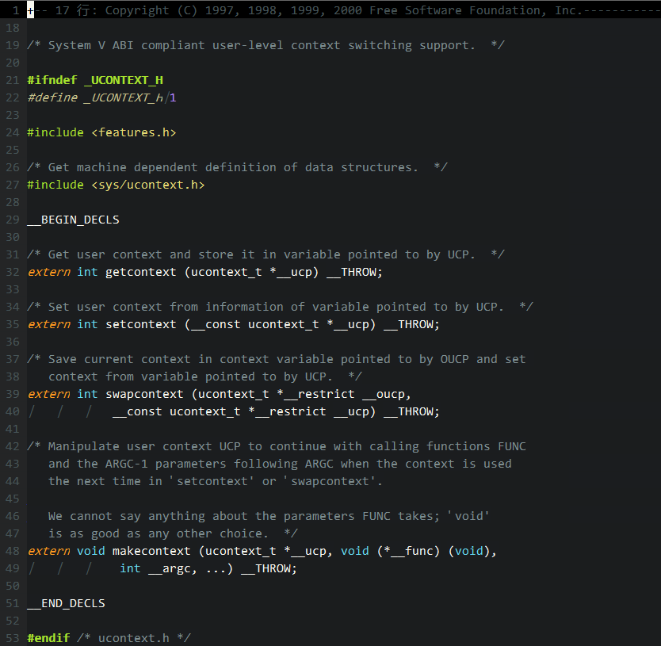
此头文件列出了POSIX下关于context operation的interface。并且可以看到此头文件还会引用另一个头文件/usr/include/sys/ucontext.h。
补充说明：
(1) setcontext function transfers control to the context in ucp. Execution continues from the point at which the context was stored in ucp. setcontext does not return.
(2) getcontext saves current context into ucp. This function returns in two possible cases: after the initial call, or when a thread switches to the context in ucp via setcontext or swapcontext. The getcontext function does not provide a return value to distinguish the cases (its return value is used solely to signal error), so the programmer must use an explicit flag variable, which must not be a register variable and must be declared volatile to avoid constant propagation or other compiler optimizations.
(3) makecontext function sets up an alternate thread of control in ucp, which has previously been initialized using getcontext. The ucp.uc_stack member should be pointed to an appropriately sized stack; the constant SIGSTKSZ is commonly used. When ucp is jumped to using setcontext or swapcontext, execution will begin at the entry point to the function pointed to bye func, with argc arguments as specified. When func terminates, control is returned to ucp.uc_link.
(4) swapcontext transfers control to ucp and saves the current execution state into oucp.

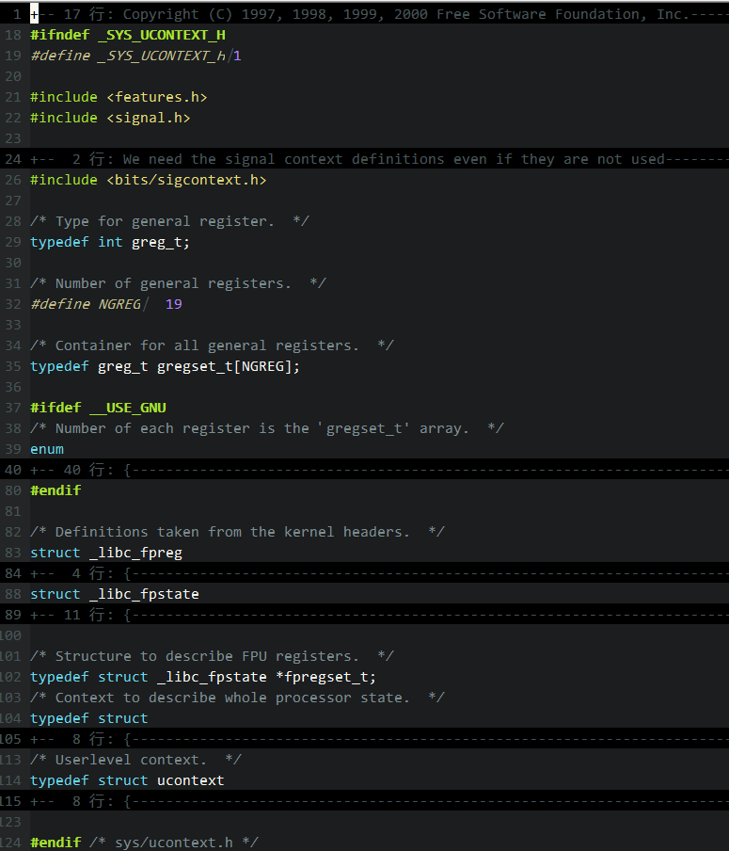
头文件/usr/include/sys/ucontext.h主要是定义了相关的Register和DS，用户需要关心的是Userlevel context的ucontext_t类型。
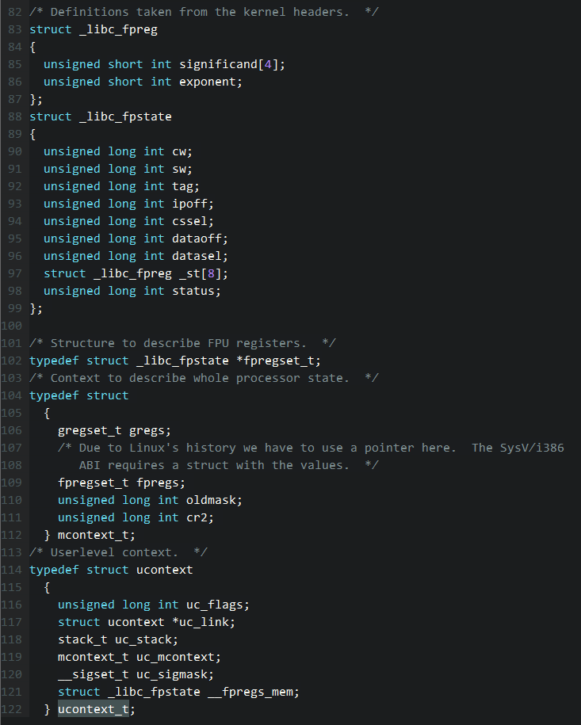

关于ucontext_t members的explaination：
(1) uc_link points to the context which will be resumed when the current context exits, if the context was created with makecontext (a secondary context).
(2) uc_stack is the stack used by the context.
(3) uc_mcontext stores execution state, including all registers and CPU flags, the instruction pointer, and the stack pointer. mcontext_t is an opaque type.
(2) uc_sigmask is used to store the set of signals blocked in the context.

http://en.wikipedia.org/wiki/Setcontext

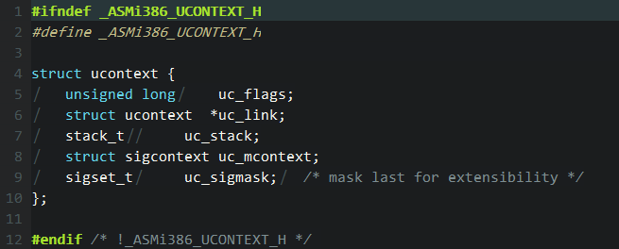

usr/include/bits/sigstack.h:#define SIGSTKSZ 8192

