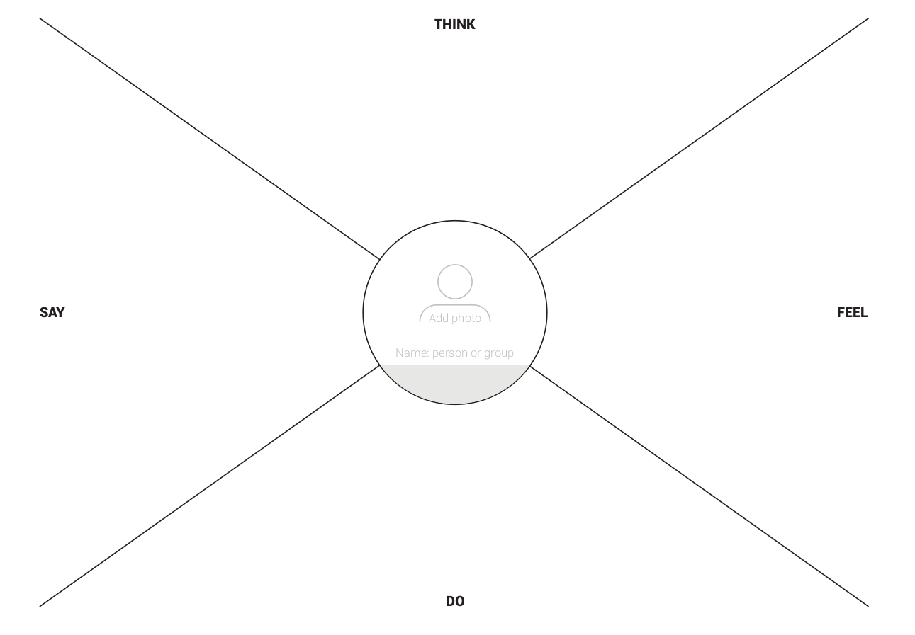

Dolor Amit
- Regularly backs up files

- Tends to start work early each day

- Tries to find balance between his work, studies, and relationships, and creative pursuits
- Anxious about data loss

- Annoyed when his routine is disrupted

- Often overwhelmed by workloads and hours
- Wonders how updates to the system will be handled in the future

- Automation of repetitive tasks is a good thing as it frees him up to focus on more important work
I don’t like apps that try to do too much but I like the idea of an all-in-one platform as long as it simplifies my work-flow

