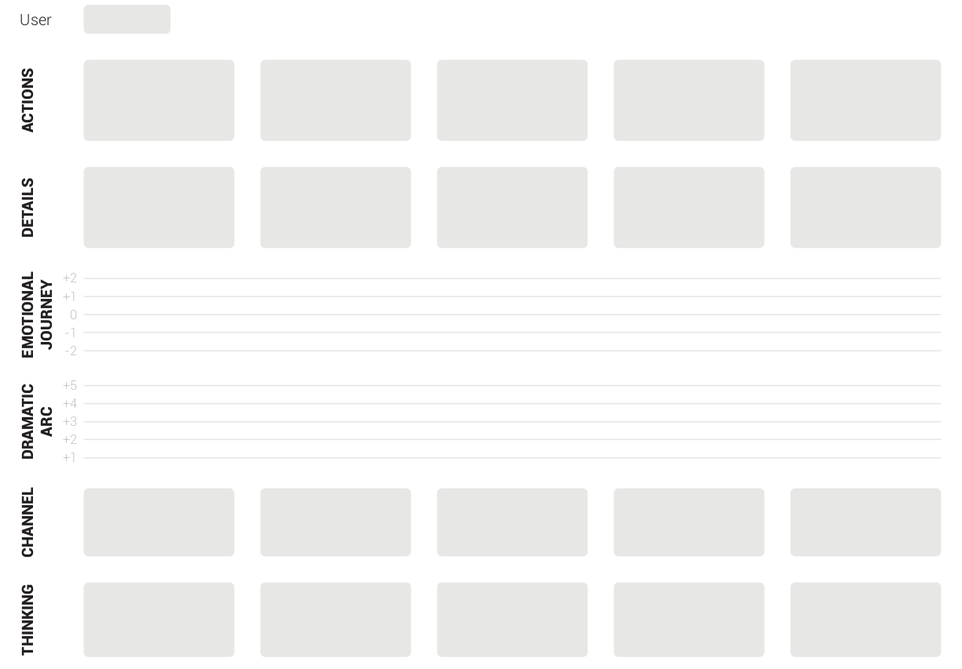
Lorem Ipsum
Signup
Provides signup info
UI
How will I remember this login, what happens if I forget?
Waiting for services to start
Sees loading spinner with percentage complete
UI
How long will this take?
First sees dashboard
Dashboard with welcome message appears
UI
Will there be a tutorial?
Navigates through all features
Looks through each feature and integration
UI
There’s a lot of initial setup for the integrations
Sets up all integrations
Provides info to interact with other applications
UI
I’m glad I could do all that from the same page

