**Atomic Structure:** JJ Thompson developed Kelvin’s idea into plum pudding model (+ charged sphere w/ electrons inside)

If this model was correct there would be no back scattering and a small no. deflected

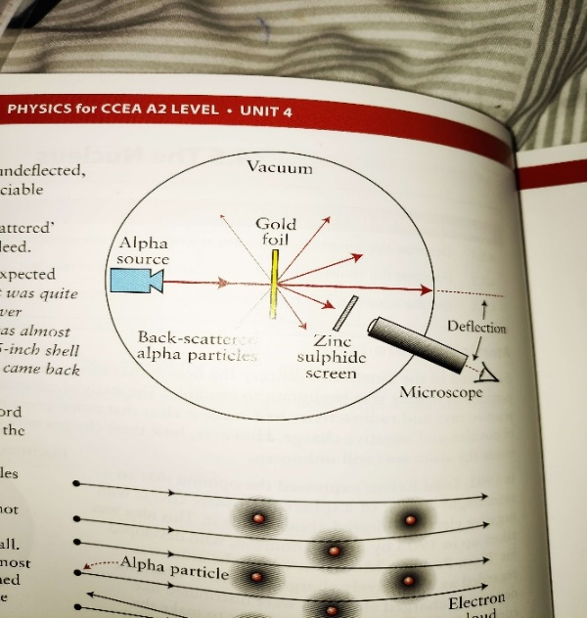**Rutherford, Marsden & Geiger Experiment** - α particles in vacuum to avoid deflection by collisions with air molecules, incident on gold foil, detected by scintillations produced on hitting fluorescent screen. Microscope moved to position, angle & no. flashes measures, microscope moved to new angle and repeat.

1. most particles passed though (didn’t come close enough to any repulsive charge) therefore atom mostly empty space

2. Particles + charged & deflected therefore nucleus + charged

3. 1/8000 scattered back therefore nucleus much more massive than particle (factor 50)

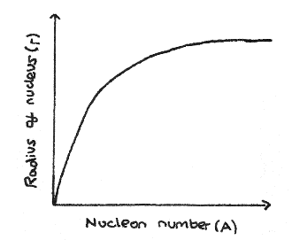Edge of nucleus doesn’t have sharp edge

$r = r_{0}A^{\frac{1}{3}}$, $r_{0}=1.2x{10}^{-15}$ m, $V = \frac{4πr^{3}}{3} = \frac{4π{r_{0}}^{3}A}{3}$, M=Am, $ρ = \frac{M}{V} = \frac{3Am}{4π{r_{0}}^{3}A} = \frac{3m}{4π{r_{0}}^{3}}$, $r_{0} = radius of nucleon$

Ratio of ${10}^{15}$ between atomic and nuclear density as atomic diameter ${\sim 10-}^{10}$ and volume ${\sim 10-}^{30}$, whereas nucleus diameter ${\sim 10-}^{15}$ and volume ${\sim 10-}^{45}$

Nucleons (protons & neutrons) held together by strong interaction (stronger than repulsion between nucleons). Isotopes – nuclei w/ same no. protons but differing no. neutrons

${}_{Z}^{A}X$, A: mass no. (no. nucleons), Z: atomic no. (no. protons)

|  |  |  |  |  |
| --- | --- | --- | --- | --- |
|  | Charge | Penetration | Ionization | 🡪 |
| α | + | Low (4cm air) | High | $${}_{Z-2}^{A-4}Y + {}_{2}^{4}{He}$$ |
| β | - | Medium (meters air) | Medium | $${}_{Z+1}^{A}Y + {}_{-1}^{0}e$$ |
| γ | no | High | Low | $${}_{Z}^{A}X + γ$$ |

**Radioactive decay** – unstable isotopes disintegrate spontaneously to a more stable nucleus with the release of α, β, or γ radiation. 1Bq = 1 disintegration/sec

α is slow (5% c) He nucleus, E loss by ionization, stopped by paper

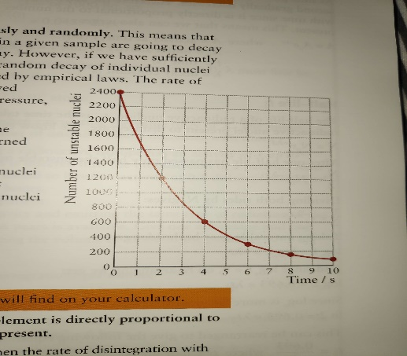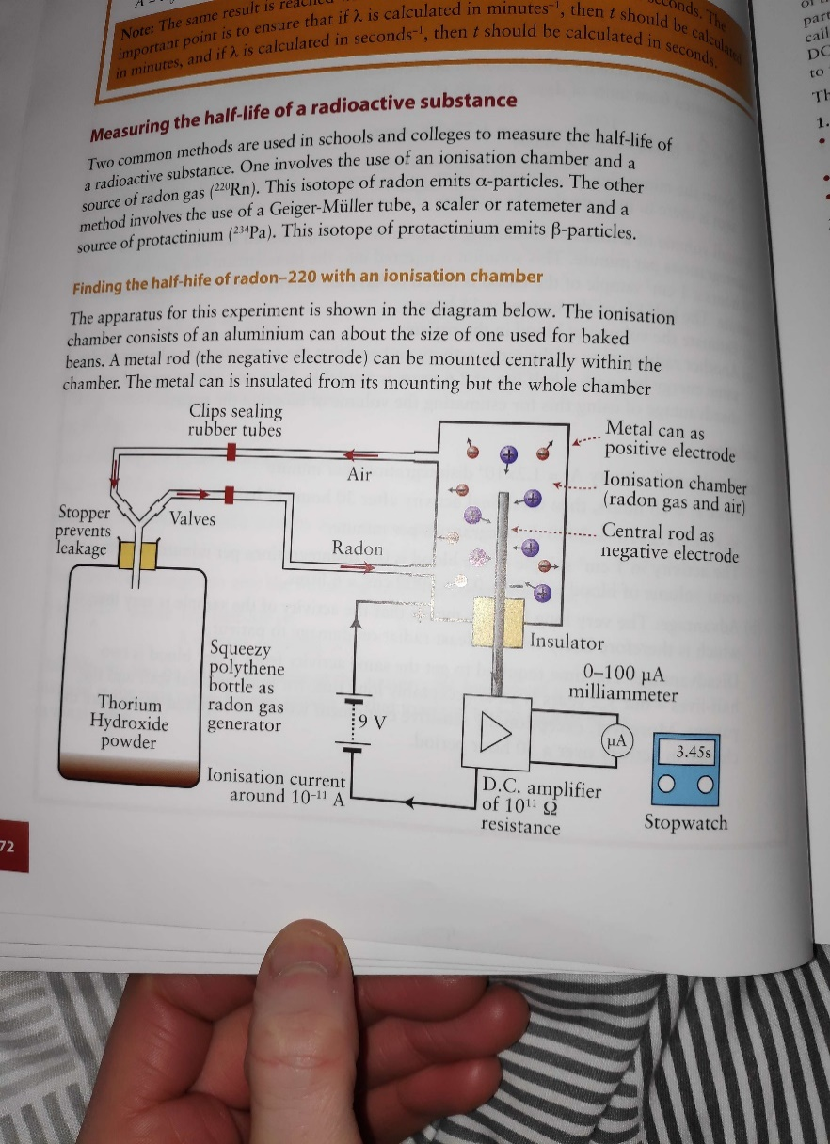**Ionization** – electrically neutral atoms convert to ions as decay particle causes electron ejection from atom, **Ion-Pair**: +&- ion produced together. **Decay** unaffected by temp, chem reactions etc

$N = N_{0}e^{-λt }$, Rate of decay directly proportional to no. unstable nuclei, A = - $λ$ N, $decay const. = fraction unstable nuclei that decay/sec$, $t_{\frac{1}{2}}$ = time for half nuclei to disintegrate/ activity to fall to half original = 0.693/ $λ$ from $\frac{N_{0}}{2} = N_{0}e^{-λt_{\frac{1}{2}} }$, Longer $t_{\frac{1}{2}}$ means low A so less radiation

Why consider $t_{\frac{1}{2}}$ when source used for medical imaging: must be long enough to remain in bloodstream and be carries around body for detection. Must be short enough for minimal exposure

**Finding $t_{\frac{1}{2}}$ w/ ionization chamber** Adjust amplifier, fill chamber w/ gas (release clips/squeeze bottle), Start clock, read I every 10s for 3min

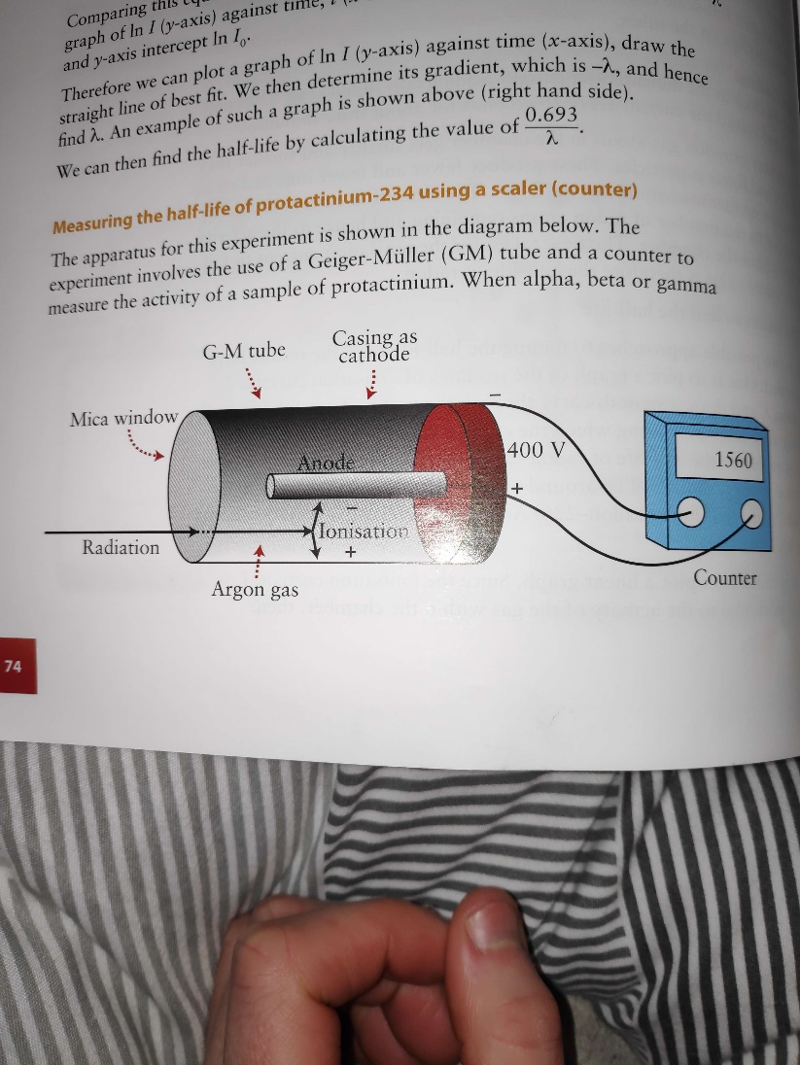Ionization current directly proportional to no. & activity of gas atoms, $I = I_{0}e^{-λt }$, $lnI = -λt + lnI_{0}$, y=mx+c

**Finding $t_{\frac{1}{2}}$ w/ counter**

Correct for background radiation (avg over 30min)

Protactinium-234 source from U-238 compound in bottle

Reading in counts/ min from GM tube and ratemeter

Characteristic of isotope that makes it suitable for exp: half life between 50s and 6 hrs (roughly), short half life

Plot count rate/ t, find t to half, repat+avg, or plot ln (corrected count rate) / t, grad = - $λ$, safety: shielding, distance, duration