|  |  |  |  |
| --- | --- | --- | --- |
|  | Displacement | Velocity | Acceleration |
| Variation w/ t |  |  | - |
| Max | Amplitude=A | At fixed point (equilibrium) x=0, v= | Extremity of x, |
| Min | At fixed point (equilibrium), 0 | Extremity of x, 0 | At fixed point, 0 |
| Variation w/ x |  |  |  |

s=r, , v=r,

, , Tension = ke, F=kx, E=k

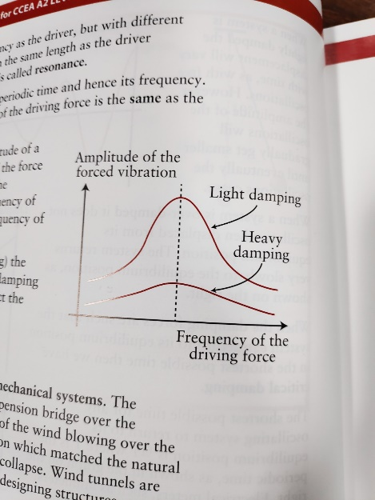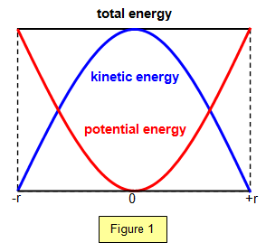Free vibration/undamped – no E transfer to/from system, Forced vibration (ex Barton’s Pendulums) – forced to oscillate at freq. of eternal oscillator which is giving it E, Condition for resonance: driving freq. = natural freq. Example of resonating system: singer and class, how to damp this system: fill with water, Oscillate in water to increase damping

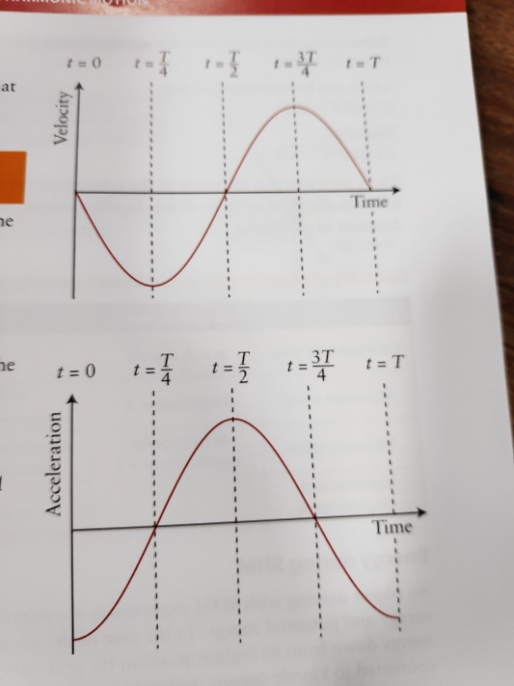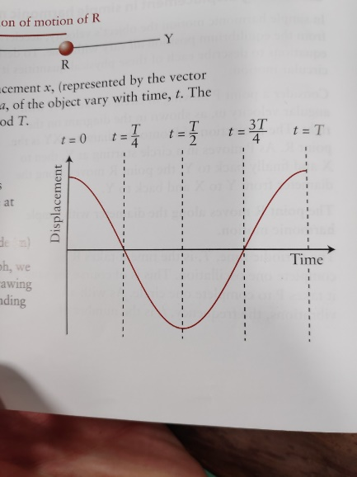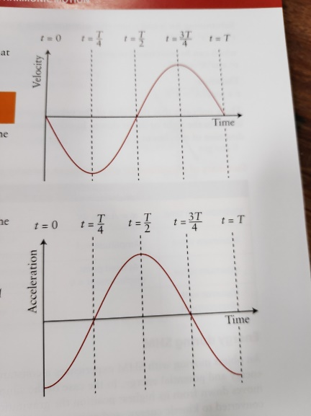

Shifted left

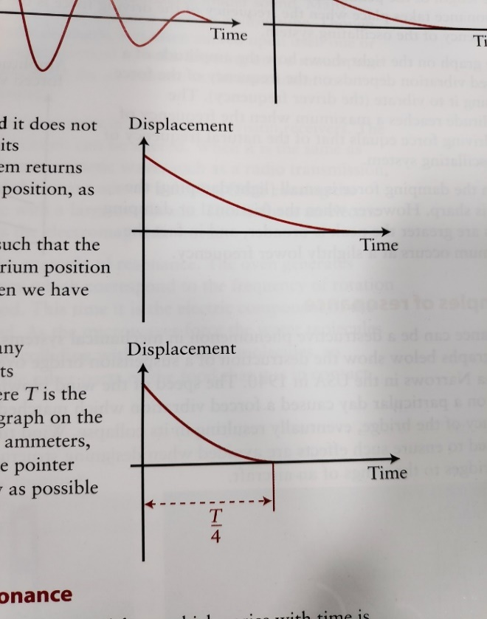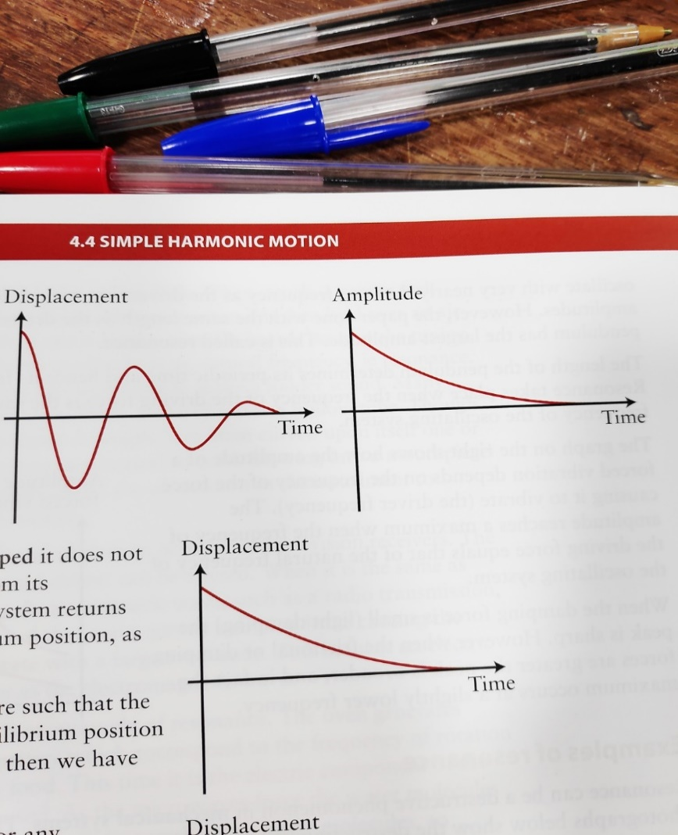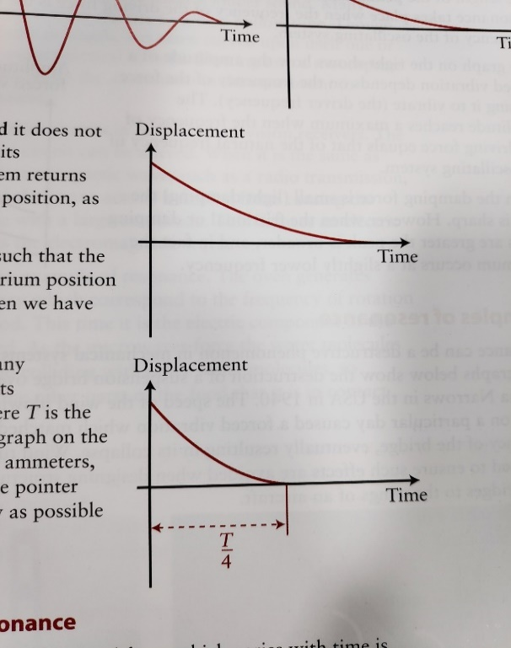

**First**: lightly damped, **Second**: overdamped, **Third**: overdamped, **Fourth**: critically damped

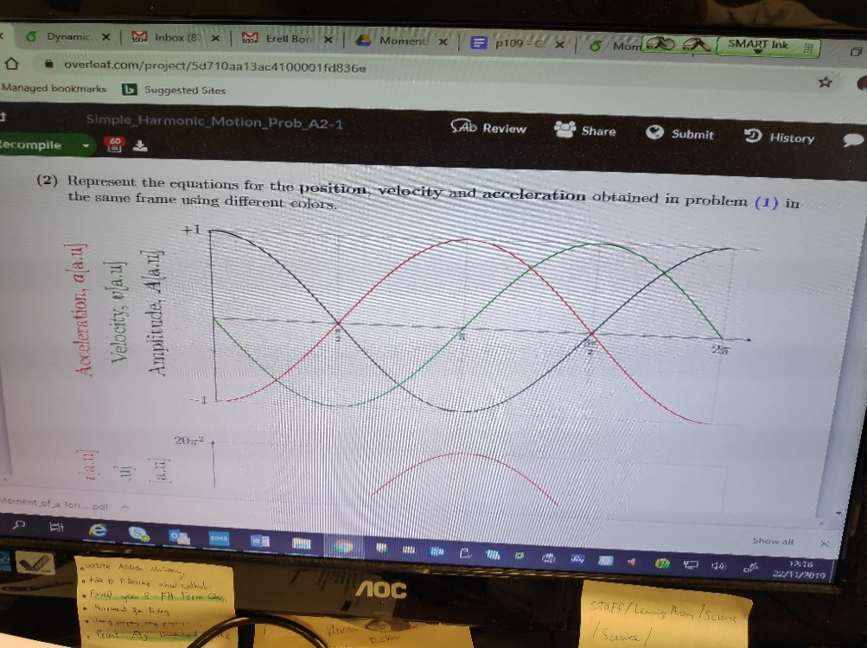**Cyclist on bend** has as they sweep an angle over time, Fr between tyres&road permit the UCM. **SHM**: a directly proportional to d from fixed point & direted towards fixed point**. Cause of damping** for moving obj is fr, effect is E loss and <A, **how travel in circle at const speed but have a?** direction & thus v changing, a is rate of change of v. **When obj first reaches equilibrium**:

|  |  |  |
| --- | --- | --- |
|  | SHM | UCM |
| T | T for one oscillation | T for one revolution/orbit |
| F | Acts toward equilibrium | Acts toward centre of circle |
| Varies depending on position of object | Const. |

Both overdamped and critically damped systems lose E and return to equilibrium position without oscillating, Critically damped does so in the quickest possible time, **Total E of system is not conserved** as E leaves the system to move air particles/ due to air resistance

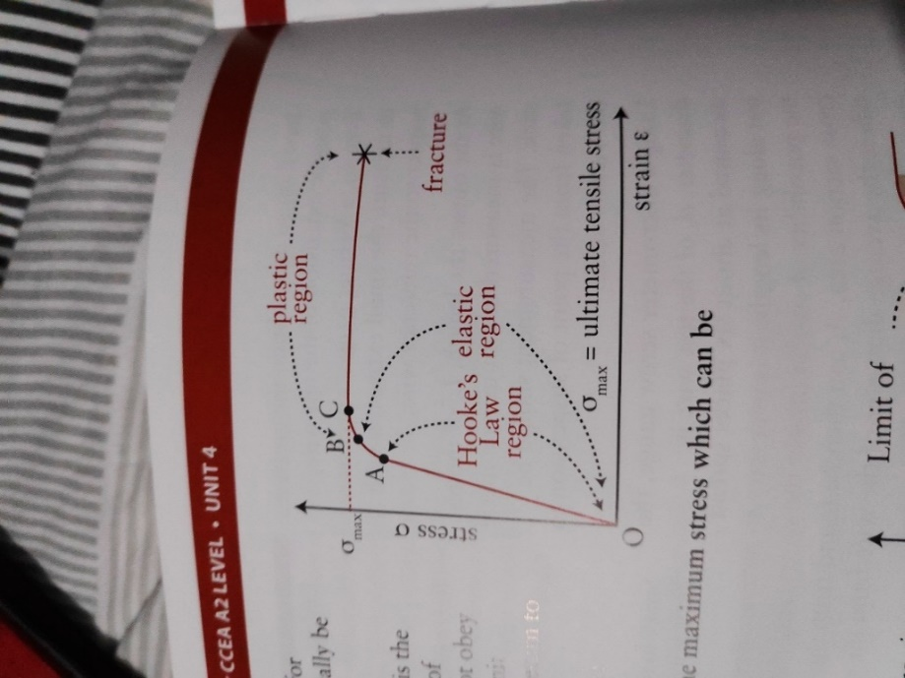**Why chain w/ hammer can’t be horz**: W_hammer acts downwards and must be balanced by vertical tension component

**Hooke’s Law:** F directly proportional to x produced provided proportional limit not exceeded, F=-kx

F is restoring force

**Elastic Limit:** max load specimen can experience and return to original length when deforming F removed. **Elastic Deformation,** after this is **Plastic Deformation**

**UTS**: max stress applied to wire without breaking/fracturing

**Elastic Strain Energy**: Es = (work done in stretching material held as Ep)

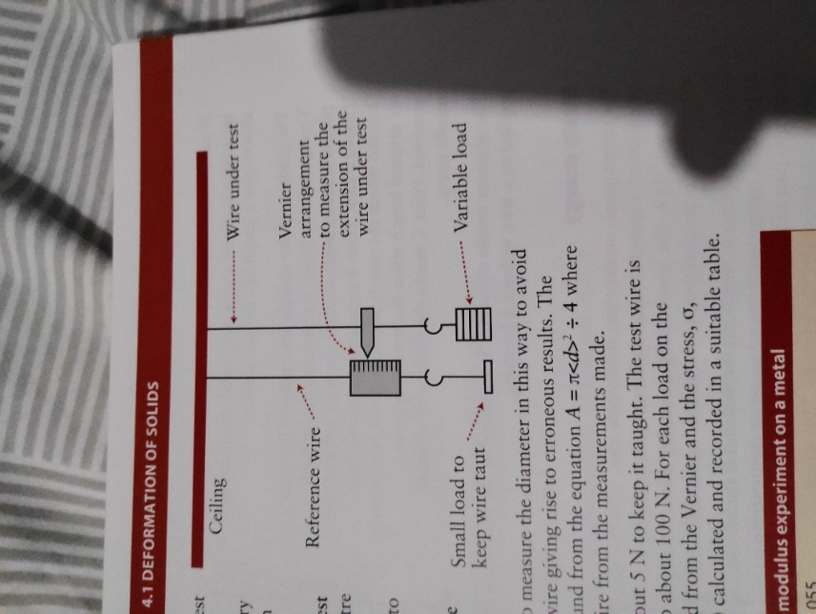**Strain gauge** to measure crack width in walls

**Experiment:** measure unstretched L. Measure x for range of F, L with metre rule clamped to pointer, x with ruler, d of wire at several places with micrometre gauge and avg, wear goggles as wire could break under tension

**Combined spring constant: Series**: // F is same for all springs. **Parrallel**: // x is the same for all springs