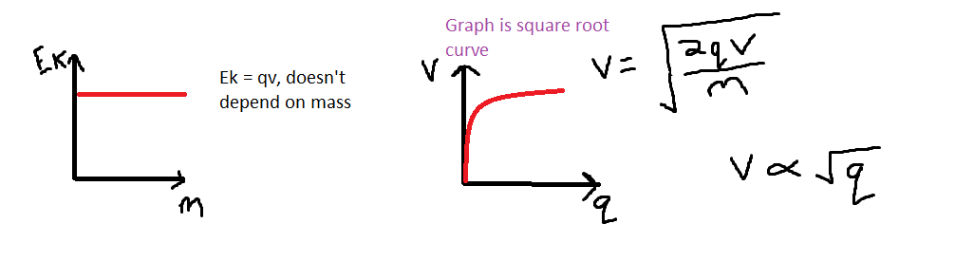**Experiment**: beams of electrons produced by electron gun. Electrons with sufficient energy escape from the surface of heated wire filament (thermionic emission). They emerge into an electric field created by P.D between cathode & anode. They are accelerated – losing potential and gaining kinetic energy. Beam emerges through opening in anode. Fluorescent screen emits green light when struck by electrons. Positive Maltese cross electrode deflects electrons away from screen so shadow can be observed.

Be careful which mass to use in deflection questions as it varies based on whether it says electron or proton beam

Parabolic path within uniform electric field. Final velocity of electron is resultant of the horizontal and vertical components of the velocity.

Particles move in circular arc as force acts at right angles to velocity. , lower v gives an arc of lower r

Flemings left hand rule considers conventional current flow.

, ,

Note there is still an initial Ek due to the horizontal velocity

F = qE, if q is negative, force has negative sign so is opposite direction to field. If q is positive, force is same direction as field

F = qvB Sin(α), If v and B aligned, then α = 0 so F = 0

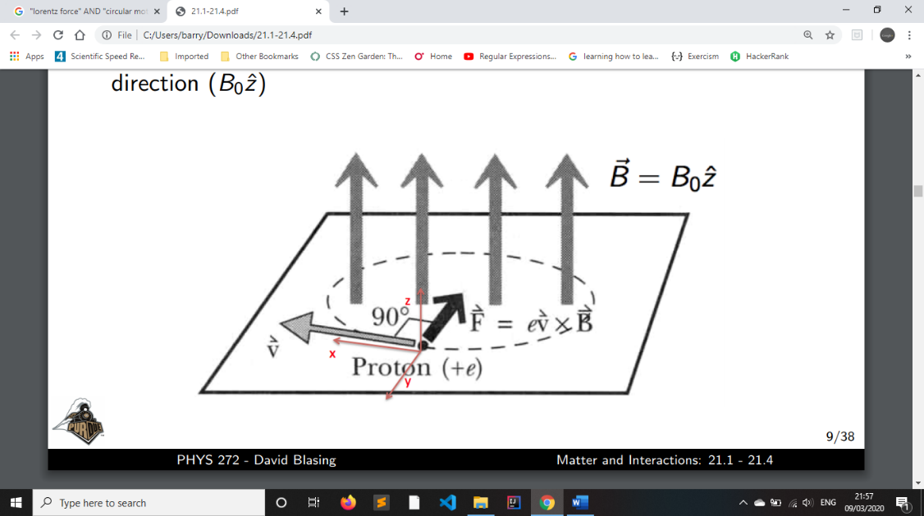Work Done = qv

The Lorentz (EM force) is a combination of the fields. Derication of for the specific geometry shown (magnetic field only in z plane with origin of circle at 0,0) shows that the example path of charged particles in a constant B field perpendicular to v is:

The circular motion is a result of eigenvectors of a rotation matrix as the magnetic field is a rotating plane and thus the field does no work on the moving charge.

**Synchrotron:** Confines accelerated particles confined to circle of constant radius by B field in vacuum (to prevent energy loss by unintended collisions/ interaction with air particles). May collide particles (multiple loops to increase speed, which increases relativistic mass which weakens repulsive force) or be used to study radiation. Sends data to scientists globally. Max energy of around 6.5 Tev

Particles accelerated by high frequency alternating voltage (P.D ) at acceleration cavities (allows B field to only be applied to circumference). Cavities contain alternating electric fieldssynchronized with orbital period to accelerate charges as they reach and pass through each cavity. Particles are repelled from one electrode and attracted to the next. Particles may be accelerated in a booster ring and moved to a storage ring until needed. Electrodes connected to high frequency alternating voltage give particles energy.

As particle speed increases, frequency of a.c supply and thus magnetic force must increase to provide centripetal force to maintain synchronous acceleration. This ensures fixed radius as it takes particle less time to complete orbit. Unless it’s an electron synchrotron as they travel close to c, so frequency is roughly const. and so a const. accelerating voltage is used. Large radius required to reach high energy as particles would collide with the side of a smaller loop due to the limitation on magnetic field strength. Linear accelerator injects particles into synchrotron at tangent.

Neutrons can’t be used in synchrotrons as they aren’t charged and can’t experience a magnetic force in the same way as protons/electrons.

**Magnets:** Incoming beam deflected into orbit by dipole magnet and outgoing, accelerated beam deflected out. There are several extraction points at tangents to allow multiple groups of scientists to work simultaneously. Quadrupole magnets maintain circular orbit by focusing beam which means the intensity (particles per unit area/sec) increases and smaller gaps are required between magnet poles.

**Why superconducting electromagnets used & how state achieved**: Reduce resistance of coils to 0 to increase current and achieve large magnetic field strength. State reached by cooling electromagnets in liquid helium to their critical/transition temp.

**Relativistic Mass Increase:** mass increases with speed but is negligible in ordinary situations like speed of car, however close to c, it is significant.

No object with a rest mass can exceed the speed of light. Particles in synchrotrons are close to c, so the current applied to the coils (and thus B (flux density)) is increased under computer control. They can continue to gain Ek but not v as their m increases, where

**Antimatter:** material composed of anti-particles. **Anti-particles:** same m as ordinary matter but opposite charge/spin. Every particle has corresponding anti-particle (some of which have been produced in particle accelerators). First anti-particle was the anti-electron (positron).

Positron slightly above horizontal velocity vector and electron slightly below initially. Both can’t be on one side as momentum must be conserved so there can’t eb a resultant vertical momentum.

**Annihilation:** 2 protons emitted when particle and anti-particle collide as mass must be conserved (converted to energy of photons, E = m, each have 0.5 of total E). Momentum must also be conserved so there must be 2 photons travelling in opposite directions.

Annihilation of x kg of antimatter releases E = 2x

**Positron emission tomography:** injected into patient, decays to emit positron, annihilation w/ electron, produces γ photons, detected by scintillations when reach scanning device, used to produce image of tissue

If for example the increase in speed is a factor of 8.09 then the % increase in mass is 709%

The 3 particles in the nucleus of if it were composed entirely of anti-matter would be 2 anti-protons and an anti-neutron.

It is unknown why there are not equal amounts of matter & anti-matter in the universe or why anti-matter is so uncommon in interstellar space

2hf =

**Electron-Positron Collision:**

**Pair production: Photon to electron and positron, energy transfer:**