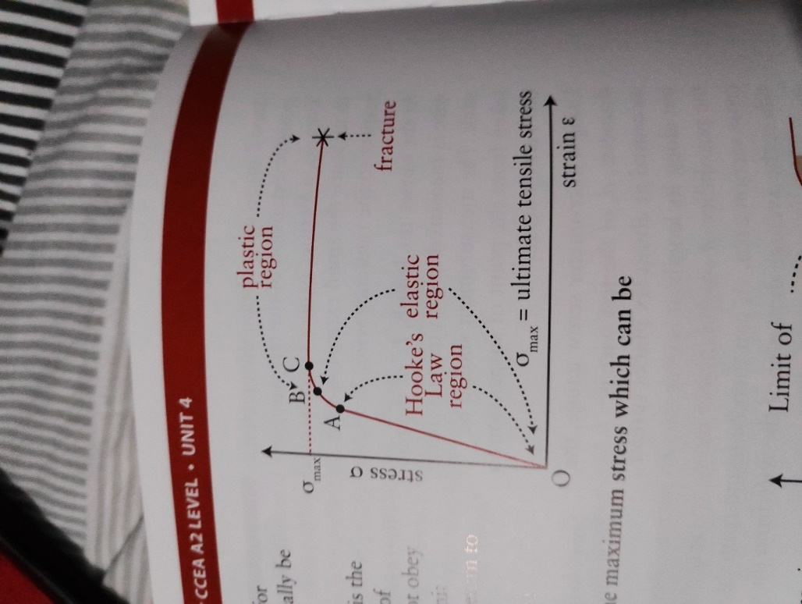**Hooke’s Law:** F directly proportional to x produced provided proportional limit not exceeded, F=-kx

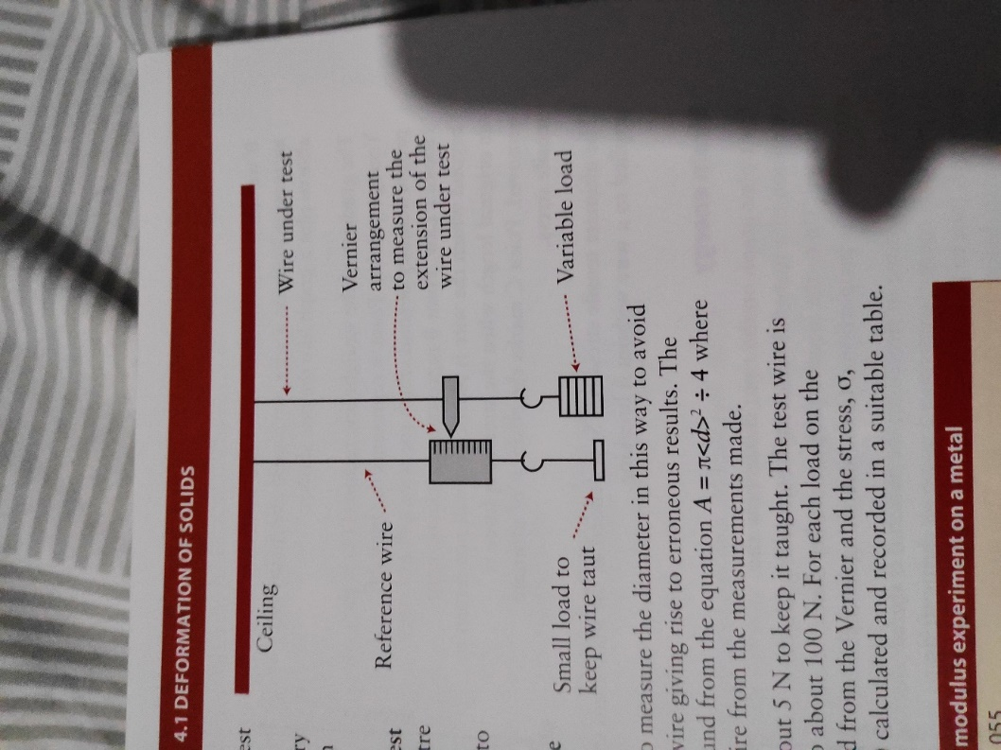F is restoring force

**Elastic Limit:** max load specimen can experience and return to original length when deforming F removed. **Elastic Deformation,** after this is **Plastic Deformation**

$$δ = \frac{F}{A}, ε = \frac{∆L}{L_{0}}, E = \frac{δ}{ε}$$

**UTS**: max stress applied to wire without breaking/fracturing

**Elastic Strain Energy**: Es = $\frac{1}{2}kx^{2}$ (work done in stretching material held as Ep)

**Strain gauge** to measure crack width in walls

measure unstretched L. Measure x for range of F, L with metre rule clamped to pointer, x with ruler, d of wire at several places with micrometre gauge and avg, wear goggles as wire could break under tension

**Combined spring constant: Series**: $x_{T}= x_{1}+ x_{2}= \frac{F}{k_{T}} = \frac{F}{k_{1}}+\frac{F}{k_{2}} ∴ \frac{1}{k_{T}} = \frac{1}{k_{1}}+\frac{1}{k_{2}} ∴ k_{T} = \frac{k_{1k_{2}}}{k_{1{+k}_{2}}}$//F is same for all springs. **Parrallel**: $F_{T}= F_{1}+ F_{2 = }k_{1}x + k_{2}x = k_{T}x ∴ k_{1} + k_{2} = k_{T}$//x is the same for all springs

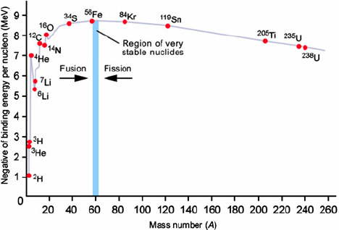Reduction in m when E released. **Binding E\***: E that must be supplied to separate nucleus to an infinite distance. **Mass Defect**: difference between total no. constituent nucleons that make up nucleus & mass of nucleus when nucleons are combined. $E = ∆mc^{2}$. **Fission**: massive nucleus divides into two less massive nuclei. Avg binding E of fragments > original. Due to >E, some mass of original nucleus converted to Ek of fragments. Release of E via fission only with heavier nuclei. **Fusion:** joining of 2 smaller nuclei to produce heavier more stable nucleus. Release of E since avg binding E of products>original. Due to >E, some mass of original nucleus converted to Ek of products. Mass heavier nucleus < combined mass of lighter nuclei. E release via fusion only with lighter nuclei. No fusion at room temp due to repulsive electric force between +ve charged nuclei. Only when speed of colliding nuclei is great enough to overcome repulsion and enter range of strong nuclear F is fusion triggered. 15 million °C for H nuclei. **Exam Technique:** work out Δm in u, convert to kg, multiply by $c^{2}$ to get E in J, convert to MeV by dividing by $1⋅6×{10}^{-13}$, Binding E per nucleon = E/no. nucleons **Fusion v Fission:** more than 3 times as much E released per nucleon in fusion than fission. Fusion has no long-lived radioactive waste products. Almost unlimited supply of fuel for fusion.

Figure 1- note that graph doesn't go over 9 MeV, peak at A=60 and downslope doesn't go below 6MeV

* E required to split nucleus into component nucleons

Nuclei to left of peak undergo fusion to move up curve – fusion of light nuclei to heavier nucleus

Nuclei to right of peak undergo fission to move up curve – fission of heavy nucleus to lighter nuclei

Nucleons w/ > BE/n more stable as it takes more E to disintegrate them

How $E = ∆mc^{2}$. used for nuclear reactions: m_nuclei b4 reaction > m_nuclei after reaction, therefore $∆m$ linked to E

Why heat generated in fission: Ek of fragments

How melting control rods leads to uncontrollable reaction: amount U > critical value, no control over neutrons

Why could U 🡪 Ba + Kr + 2n + Q occur spontaneously? Daughter products are further up BE/n curve & are more stable than U